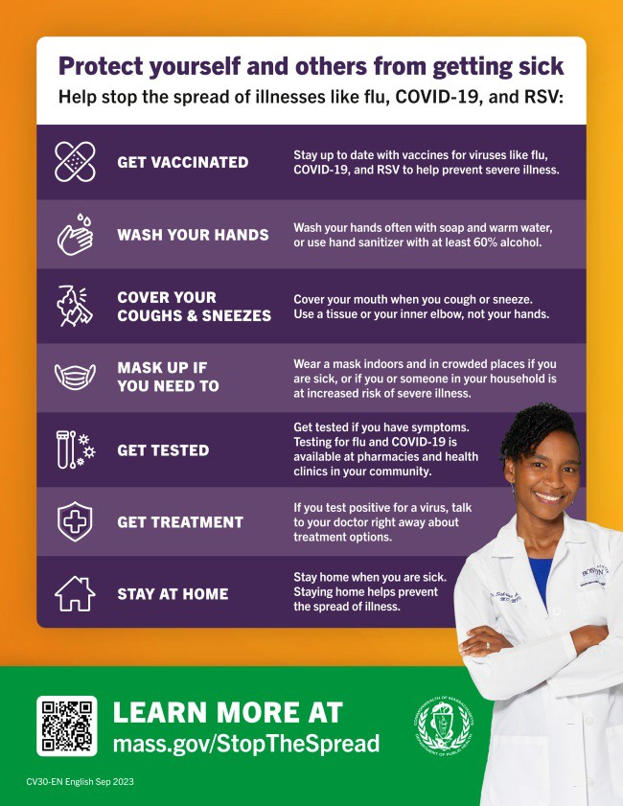
UPDATED COVID-19 ISOLATION GUIDANCE NOW ON MASS.GOV
April 12, 2024
Here are the latest resources for promoting COVID-19 vaccination to share with your colleagues
and networks across Massachusetts. If you received this from a colleague, subscribe today.
View this email online.
What's New
Building on the CDC's relaxing of COVID-19 isolation guidance, DPH has updated its COVID-19 isolation recommendations.
The new guidance states that people who are feeling better may begin to resume normal activities with precautions if they:
have not had a fever for at least 24 hours without the use of fever reducing medicines; AND
their other symptoms are improving
Because people may still be able to spread the virus that made them sick, even if they are feeling better, the guidance gives additional recommendations for preventing spread.
Reminders

NEW IN THE VAX PROMOTION TOOLKIT: SLIDESHOWS AND SOCIAL MEDIA GRAPHICS!
Adults ages 65 and older are now recommended to get an additional updated COVID-19 vaccine dose.

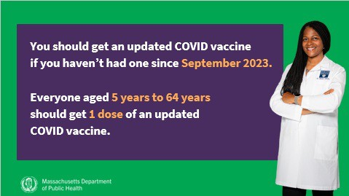
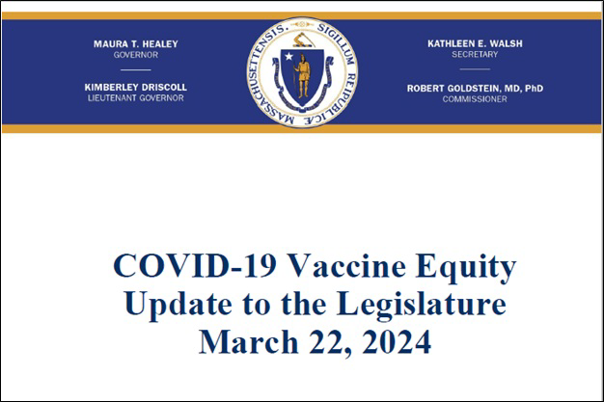
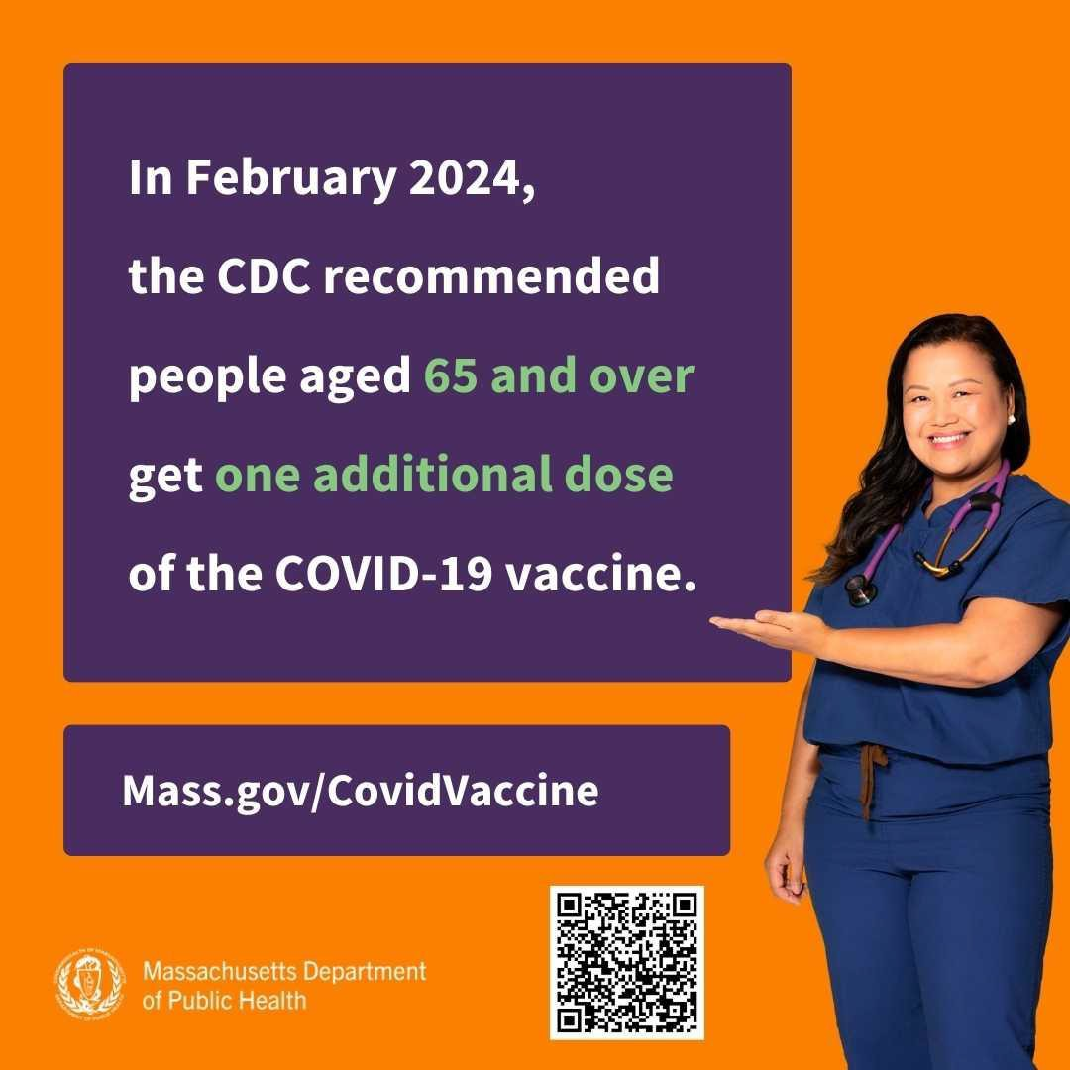
Help spread the word with a PowerPoint
OUTREACH AND EDUCATION MATERIALS
COVID-19 Vaccine Information
COVID-19 Therapeutic Information (including telehealth)
Archive of COVID-19 Vaccine Communications Updates (past editions of VEI Roundup)
Key Resources
slideshow with the updated guidance (in English and Spanish) and social media graphics (also in English and Spanish).

COVID-19 VACCINE EQUITY PLAN: 60-DAY UPDATE
DPH submits a Vaccine Equity report to the Legislature every 60 days that outlines the progress and results made through the Vaccine Equity Initiative.
Read the most recent report, submitted on March 22.

ADULTS 65+ CAN NOW RECEIVE AN ADDITIONAL COVID-19 VACCINE DOSE
In February, the CDC voted to recommend an additional COVID-19 vaccine dose for adults ages 65 and older.
Looking for a COVID-19 vaccine? You can: Search vaccines.gov for appointments
Find a local mobile clinic near you Learn more about in-home vaccination
If you have questions, please call 211 or (877) 211-6277 and press 1. Calls are answered Monday through Friday, 9 a.m. to 5 p.m.

Help spread the word! Click to download the shareable social media graphic pictured above.

OneHolyoke CDC used the month of
January to support community events and also assess and grow their own capacity. For Three Kings’ Day, they partnered with Nueva Esperanza, a Holyoke-based organization focused on improving housing and social needs for residents.
OneHolyoke CDC supported the celebration by helping with set-up and gift wrapping, as well as giving out COVID tests and health resources to attendees.
Read More Highlights
Visit the VEI Website
Share This Email
Share This Email
Share This Email

FIND A COVID-19 VACCINE DOSE
Use Vaccines.gov to sign up for a COVID-19 vaccine appointment Find a community COVID-19 vaccination clinic near you
Learn about the COVID-19 In-Home Vaccination Program and request a visit Request a copy of your vaccine card
Highlights

Vaccine Equity Initiative | 250 Washington Street, Boston, MA 02108 Unsubscribe vaccineequityinitiative@mass.gov
Constant Contact Data Notice
Sent by vei@vaccineequityinitiative.ccsend.com powered by
Try email marketing for free today

