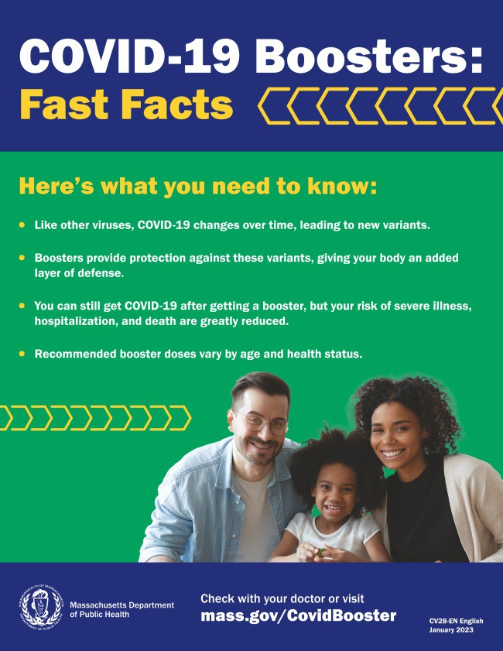

**NEED A COVID-19 VACCINE OR BOOSTER? HERE'S HOW TO FIND ONE**

**Free COVID-19 vaccine clinics are being held throughout Massachusetts!**

To find a COVID-19 vaccine clinic near you: Search [**vaccines.gov**](http://vaccines.gov/)for appointments

Find a [**local mobile clinic**](http://mass.gov/mobilevax)near you [Learn more about **in-home vaccination**](https://www.mass.gov/info-details/covid-19-in-home-vaccination-program#download-in-home-vaccination-flyer-)

**Questions?** Call 211 (or 877-211-6277) and press 1. Calls are answered Monday through Friday, 9 a.m. to 5 p.m.

[You can also **learn more about how to prepare for your vaccine appointment**](http://mass.gov/guides/how-to-prepare-for-your-covid-19-vaccine-appointment)**.**

[***Flyers***](https://www.mass.gov/info-details/covid-19-booster-frequently-asked-questions#covid-19-boosters---fast-facts---in-multiple-languages-)*and other resources are available to help*

*promote COVID-19 vaccines and boosters. Our vaccine promotion* [***toolki***](https://www.mass.gov/info-details/covid-19-vaccine-promotion-toolkit)***t*** *will also continue to be updated.*

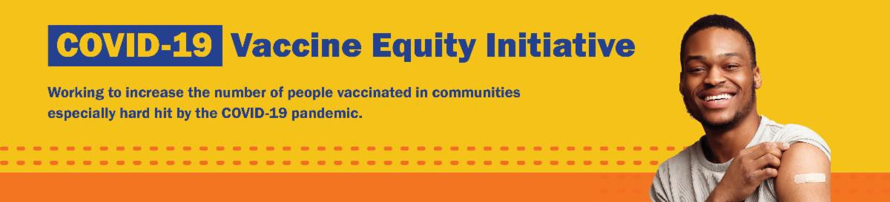

**April 14, 2023**

Here are the latest resources for promoting COVID-19 vaccination to share with your colleagues

and networks across Massachusetts. If you received this from a colleague, [**subscribe today**](https://lp.constantcontactpages.com/su/9wFTcRU/VEIWeeklyRoundup?source_id=66b75519-ed90-48f7-8245-fa05a99e9b70&source_type=em&c)**.**

[**View this email online**](https://campaignlp.constantcontact.com/em/1138003900342/66b75519-ed90-48f7-8245-fa05a99e9b70)**.**

**Please note:** Moving forward, the VEI Roundup will be published on a biweekly basis. The

next edition will be sent out on April 28.

**What's New**

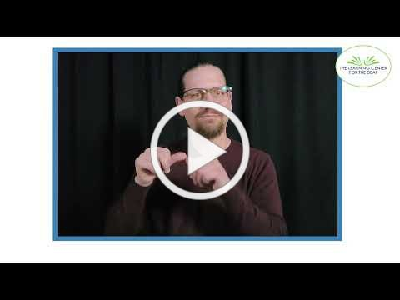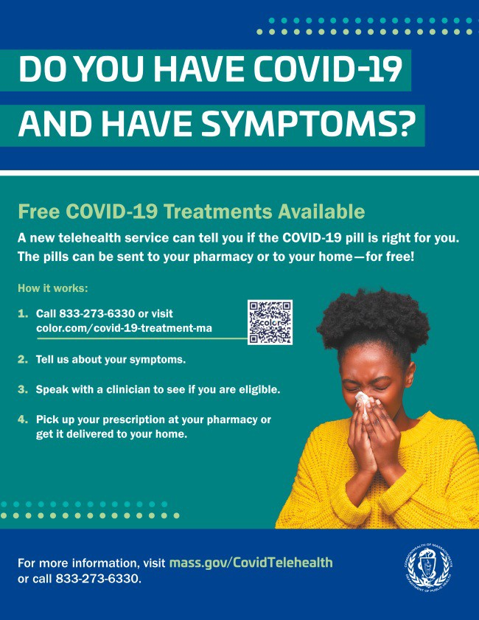

**Reminders**

# MASSHEALTH REDETERMINATION STARTS NOW: HELP MEMBERS KEEP THEIR HEALTH CARE COVERAGE

In 2023, all current MassHealth members will need to renew their health coverage to ensure they still qualify for their current benefit.

These renewals will take place over 12 months, starting this month. MassHealth is working to help members maintain coverage and raise awareness about the renewal process and other coverage options, if needed.

*Info about MassHealth redetermination (*[***intro***](https://www.youtube.com/watch?v=B7BXRoQouN4)*and* [***key points***](https://www.youtube.com/watch?v=WMMQHkAQhAA)*) is also available in ASL, courtesy of the Learning Center for the Deaf.*

Here's how you can help:

**Remind members to update their addresses, report household changes, and read all mail from MassHealth**

Share informational and outreach materials from this [**toolkit**](https://www.mass.gov/info-details/redeterminations-outreach-toolkit-phase-2)

Sign up for [**email notifications**](https://www.mass.gov/forms/masshealth-eligibility-redeterminations-email-list-sign-up)from MassHealth

# FREE COVID-19 TREATMENT AVAILABLE VIA PHONE OR ONLINE

[**Free, safe, and effective treatments for COVID-19** are available across](https://www.mass.gov/get-treated-for-covid-19) Massachusetts. They can help prevent hospitalizations and reduce the risk of severe disease.

Telehealth consultations are **available via phone** at 833-273-6330, in addition

to [**online**](https://home.color.com/consults/covid_antivirals/request/about?partner=covid-19-treatment-ma). Consultations can be accessed in 10+ languages.

[**Please share:** Flyers are **now available in 12 languages**!](https://www.mass.gov/info-details/free-telehealth-for-covid-19-treatment-with-paxlovid#covid-19-treatment-flyers-)

# FOLLOW THESE SEVEN STEPS TO HELP PROTECT AGAINST COVID-19

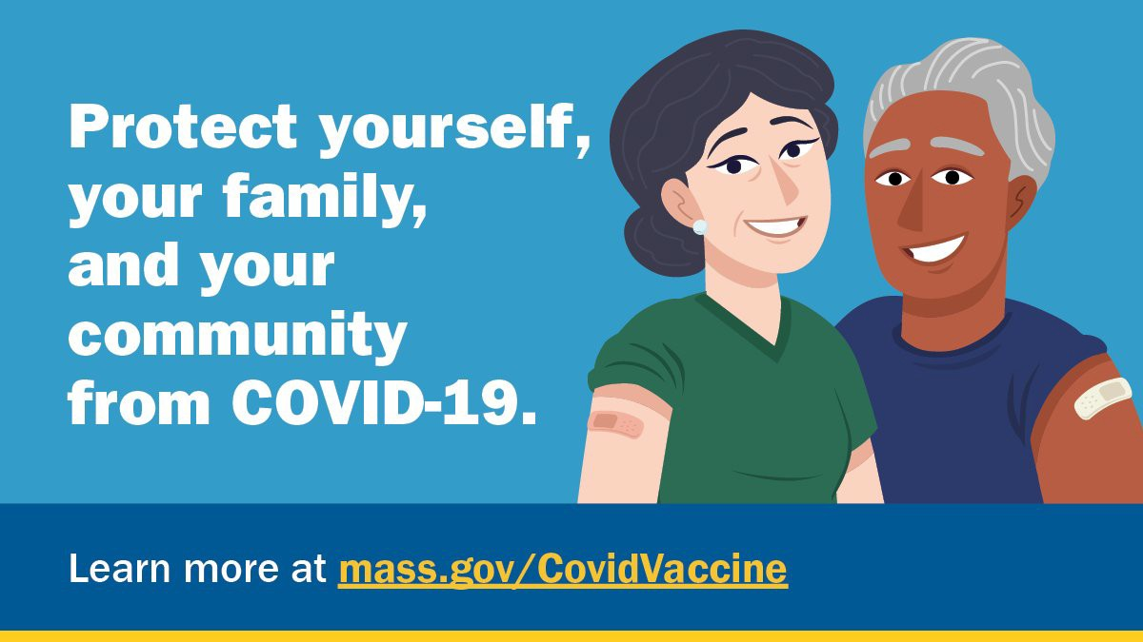

There are a number of steps that you can take to help protect yourself, your family, and your community from COVID-19.

[Available in multiple languages, **this flyer** features a checklist with these](https://www.mass.gov/lists/protect-yourself-your-family-and-your-community-from-covid-19-flyer)

steps. Please share it with your networks.

**Key Resources**

**OUTREACH AND EDUCATION MATERIALS**

[**COVID-19 Vaccine FAQs**](https://www.mass.gov/info-details/covid-19-vaccine-frequently-asked-questions)

[**COVID-19 Therapeutic Information**](https://www.mass.gov/get-treated-for-covid-19)(including [**telehealth**](https://www.mass.gov/info-details/free-telehealth-for-covid-19-treatment-with-paxlovid)) [**Weekly Provider Bulletin**](https://www.mass.gov/lists/covid-19-vaccine-provider-bulletins)

[**Trust the Facts, Get the Vax Campaign Materials**](https://www.mass.gov/resource/trust-the-facts-get-the-vax-campaign-materials)(organized by audience, including general, parents, youth, and young adults; available in 12 languages)

[**Multilingual COVID-19 Materials**](https://www.mass.gov/resource/multilingual-covid-19-materials)(videos and printables; organized by language) [**Archive of COVID-19 Vaccine Communications Updates**](https://www.mass.gov/lists/archive-of-covid-19-vaccine-communications-updates)(past editions of VEI Roundup)

# FIND A COVID-19 VACCINE OR BOOSTER

[**Find a COVID-19 Vaccine or Booster Appointment**](http://vaccines.gov/)

[**Find, Schedule, or Sign Up for a Mobile COVID-19 Vaccination**](https://www.mass.gov/covid-19-mobile-vaccinations) [**COVID-19 In-Home Vaccination Program**](https://www.mass.gov/info-details/covid-19-in-home-vaccination-program)

[**Request a Copy of Your Vaccine Card**](https://www.mass.gov/info-details/requesting-a-copy-of-your-covid-19-vaccination-record)

**Highlights**

**Boston**

[**JAHAN Women and Youth Intercultural**](https://www.facebook.com/people/JAHAN-Women-and-Youth-Intercultural/100069221739451/)sponsored the Islamic Society of Boston Cultural Center's Ramadan Bazaar on March 11. Local businesses were invited to participate as vendors selling halal food and drinks, clothing, jewelry, art, and more. In total, 18 businesses participated (13 of which were women-owned), and around 600 people attended. JAHAN also partnered with Charles River Community Health to host an on-site COVID-19 vaccine clinic. In addition, there was an info table offering COVID-19 resources and MassHealth application assistance.

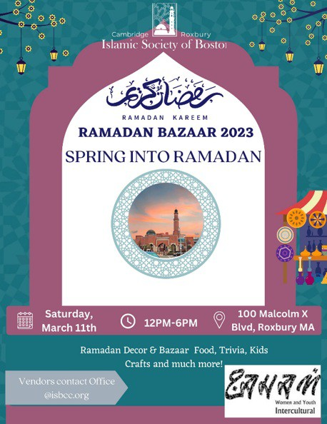

[**Read More Highlights**](https://www.mass.gov/info-details/covid-19-vaccine-equity-initiative-highlights)

[**Visit the VEI Website**](https://www.mass.gov/info-details/covid-19-vaccine-equity-initiative)

[Share This Email](https://www.linkedin.com/sharing/share-offsite/?url=https%3A//campaignlp.constantcontact.com/em/1138003900342/66b75519-ed90-48f7-8245-fa05a99e9b70)

[Share This Email](https://twitter.com/intent/tweet?text=VEI%2BRoundup%3A%2Bhttps%3A//campaignlp.constantcontact.com/em/1138003900342/66b75519-ed90-48f7-8245-fa05a99e9b70)

[Share This Email](https://www.facebook.com/sharer/sharer.php?u=https%3A//campaignlp.constantcontact.com/em/1138003900342/66b75519-ed90-48f7-8245-fa05a99e9b70)

Vaccine Equity Initiative | 250 Washington Street, Boston, MA 02108

[Unsubscribe vaccineequityinitiative@mass.gov](mailto:Unsubscribevaccineequityinitiative@mass.gov) [Constant Contact Data Notice](http://www.constantcontact.com/legal/about-constant-contact)

Sent by [vaccineequityinitiative@mass.gov](mailto:vaccineequityinitiative@mass.gov) in collaboration with



[Try email marketing for free today](http://www.constantcontact.com/index.jsp?cc=nge&rmc=VF21_CPE&nav=66b75519-ed90-48f7-8245-fa05a99e9b70)!