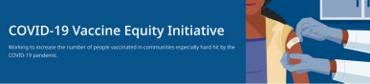April 15, 2022
Here are the latest resources for promoting COVID-19 vaccination. Please share this newsletter with your colleagues and networks across Massachusetts. If you received this newsletter from a colleague, subscribe today.
What's New
APRIL SCHOOL VACATION WEEK CLINICS (APRIL 18-24)
DPH is again hosting family-friendly
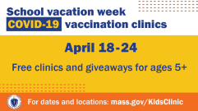
COVID-19 vaccination clinics with local
communities and businesses for school
vacation week.
Clinics will be held at trampoline parks,
zoos, bowling alleys, and Six Flags
amusement park, with giveaways like
free admissions for people who get
vaccinated. Read more, and view the
full schedule.
You can also watch a clip about the
clinics on Telemundo, including an
interview with Eduardo Nettle, the
Vaccine Equity Initiative's Community
Liaison to Boston!
EARN $10 IN 10 MINUTES: TAKE A COVID-19 VACCINATION SURVEY
We want to hear from you! If you live in
Fall River, Springfield, or New Bedford
and would like to share your thoughts
about the COVID-19 vaccine, please
consider taking a short survey.
The survey is private and available in
English, Spanish, or Portuguese.
Answer a few short questions to see if
you qualify. The survey takes about 10
minutes.
Learn more here or scan the QR code
at right. Please share!

Reminders
NOW IN 12 LANGUAGES:
SEVEN STEPS TO PROTECT YOURSELF & YOUR FAMILY FROM COVID-19
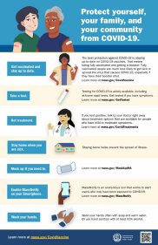
This new flyer is now available in
multiple languages. It features a
checklist to help protect yourself, your
family, and your community from
COVID-19. Please share it with your
networks.
ADDITIONAL $4.5 MILLION AWARDED FOR COVID-19 VACCINE EQUITY EFFORTS

News release (4/8) - Baker-Polito
administration awards additional $4.5
million for COVID-19 vaccine equity
efforts

ENABLE MASS NOTIFY ON YOUR SMARTPHONE
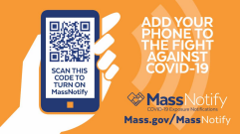
MassNotify is a tool that works through
smartphones – with a focus on privacy –
to alert users who may have been
exposed to COVID-19. Enable
MassNotify on your smartphone to add
another tool in our fight against COVID
19. Learn more.
BECOME A VACCINE CHAMPION: LEARN WAYS TO IMPROVE CONFIDENCE IN COVID-19 VACCINES
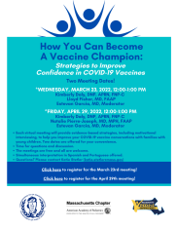
DPH and other partners are offering
trainings on strategies to improve
confidence in COVID-19 vaccines.
Meetings are free, and all are welcome.
Learn more, or register for April 29.
Key Resources
OUTREACH AND EDUCATION MATERIALS
- COVID-19 Vaccine FAQs
- COVID-19 Booster FAQs
- Weekly Provider Bulletin (published 4/13)
- Trust the Facts, Get the Vax Campaign Materials (organized by audience, including general, parents and pregnant people, youth, young adults; available in 12 languages)
- Trust the Facts, Get the Vax Creative Materials Toolkit (updates ongoing, including pediatric eligibility)
- Additional Education and Outreach Materials (includes social media graphics, vaccine updates, guides to hosting a forum, and more)
- Multilingual COVID-19 Materials (videos and printables; organized by language)
- COVID-19 Funeral Assistance from FEMA (including 1-pager with key info available in multiple languages)
- COVID-19 Vaccination Tools for Employers
- Archive of COVID-19 Vaccine Communications Updates (past editions of VEI Roundup)
FIND A COVID-19 VACCINE OR BOOSTER
- Vaccine Finder
- Find, Schedule, or Sign Up for a Mobile COVID-19 Vaccination
- COVID-19 In-Home Vaccination Program
- Request a Copy of Your Vaccine Card
COVID-19 VACCINE STANDING ORDERS (FROM CDC)
- Pfizer
  - 5-11 (updated 3/31/22)
  - 12 + Gray Cap (updated 4/1/22)
  - 12 + Purple Cap (updated 4/1/22)
- Moderna (updated 3/31/22)
- Janssen (updated 4/1/22)
Recent Highlights
Brockton
Throughout February, Pinnacle Partnerships teamed up with area Girl Scout troops for vaccination clinics and outreach. The troops sold cookies and engaged the public at school-based Saturday clinics that saw 300+ people receive a vaccine. The scouts also did day-of street outreach, drawing community members to the clinic.

Springfield
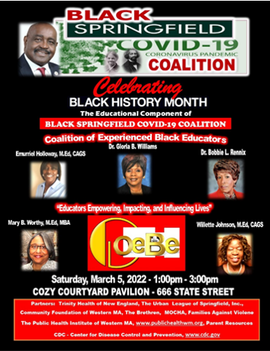
As part of Black History Month, Black Springfield
COVID-10 Coalition hosted a series of talks at the
Cozy Cafe. On March 5, the last series talk was led
by a coalition of experienced Black educators who
spoke to families about keeping schools safe during
the pandemic, including the importance of masking
and vaccinations. Many attendees had questions
about strategies to keep students safe and were
grateful to have experienced educators to answer
their questions. Vaccinations services were also
available. Learn more about how to protect
children against COVID.

Read More Highlights
Visit the VEI Website
Vaccine Equity Initiative | 250 Washington Street, Boston, MA 02108
Unsubscribe vaccineequityinitiative@mass.gov
Constant Contact Data Notice
Sent by vaccineequityinitiative@mass.gov in collaboration with
Try email marketing for free today!

