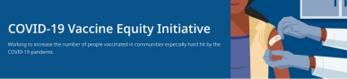April 22, 2022
Here are the latest resources for promoting COVID-19 vaccination. Please share this newsletter with your colleagues and networks across Massachusetts. If you received this newsletter from a colleague, subscribe today.
What's New
SCHOOL VACATION WEEK CLINICS CONTINUE THROUGH APRIL 24
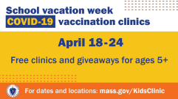
DPH is again hosting family-friendly
COVID-19 vaccination clinics with local
communities and businesses for school
vacation week.
Clinics are being held at trampoline
parks, zoos, bowling alleys, and Six Flags
amusement park, with giveaways like
free admissions for people who get
vaccinated. View the full schedule.
There is still time to promote these
clinics—please help us spread the word
today! Flyers, email/newsletter
content, and more resources are
available online.
Check out some of the media coverage
of vacation week clinics, including from
Boston.com and WWLP in Springfield.
Reminders
EARN $10 IN 10 MINUTES: TAKE A COVID-19 VACCINATION SURVEY FROM DPH PARTNER MARKET STREET RESEARCH
We want to hear from you! If you live in
Fall River, Springfield, or New Bedford
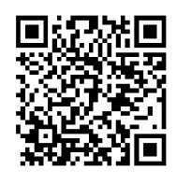
and would like to share your thoughts
about the COVID-19 vaccine, please
consider taking a short survey.
The survey is private and available in
English, Spanish, or Portuguese.
Answer a few short questions to see if
you qualify. The survey takes about 10
minutes.
Learn more here or scan the QR code
at right. Please share!
SECOND BOOSTER AVAILABLE FOR PEOPLE 50+ OR
IMMUNOCOMPROMISED
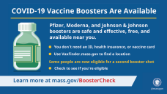
A second booster dose for individuals 50+
and people with certain health conditions
is now available. Learn more about
eligibility and keeping up to date with
COVID-19 vaccinations.
Questions? Our booster FAQ is available
in 12 languages.
FREE COVID-19 TREATMENTS: WIDESPREAD USE OF COVID-19 PILL COULD PREVENT FUTURE HOSPITAL SURGES
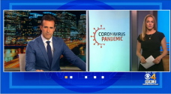
Patients recently diagnosed with COVID-19
have options for treatment, available at no
cost at sites across MA. Learn more
about treatment options (info
also available in 12 languages), or locate
treatment.
Watch this clip from CBS Boston to learn
more: Experts Say Widespread Use Of
COVID-19 Pill Could Prevent Future
Hospital Surges

MY VAX RECORDS - DIGITAL COVID-19 VACCINE CARD FOR MA RESIDENTS
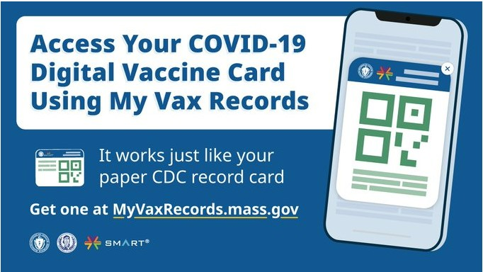
Need a copy of your COVID-19 vaccination
record? MA residents can use My Vax
Records to get a digital vaccine card to
show they’ve been vaccinated against
COVID-19, if they choose. Learn more.
Key Resources
OUTREACH AND EDUCATION MATERIALS
- COVID-19 Vaccine FAQs
- COVID-19 Booster FAQs
- Weekly Provider Bulletin (published 4/13)
- Trust the Facts, Get the Vax Campaign Materials (organized by audience, including general, parents and pregnant people, youth, young adults; available in 12 languages)
- Trust the Facts, Get the Vax Creative Materials Toolkit (updates ongoing, including pediatric eligibility)
- Additional Education and Outreach Materials (includes social media graphics, vaccine updates, guides to hosting a forum, and more)
- Multilingual COVID-19 Materials (videos and printables; organized by language)
- COVID-19 Funeral Assistance from FEMA (including 1-pager with key info available in multiple languages)
- COVID-19 Vaccination Tools for Employers
- Archive of COVID-19 Vaccine Communications Updates (past editions of VEI Roundup)
FIND A COVID-19 VACCINE OR BOOSTER
- Vaccine Finder
- Find, Schedule, or Sign Up for a Mobile COVID-19 Vaccination
- COVID-19 In-Home Vaccination Program
- Request a Copy of Your Vaccine Card
COVID-19 VACCINE STANDING ORDERS (FROM CDC)
- Pfizer
  - 5-11 (updated 3/31/22)
  - 12 + Gray Cap (updated 4/1/22)
  - 12 + Purple Cap (updated 4/1/22)
- Moderna (updated 3/31/22)
- Janssen (updated 4/1/22)

Recent Highlights
Brockton
New Life Community Empowerment Center has been working with Brockton-area childcare centers on a "Healthy Handwashing" campaign. They have provided handwashing lessons at four different locations and are looking to do more. Mitigation strategies, like handwashing, are a critical source of protection against COVID, especially for children not yet eligible for a COVID vaccine. New Life has heard gratitude from parents and families, even those unvaccinated but still concerned about COVID’s potential impacts. Learn more about strategies to help protect yourself and your family from COVID.
Lowell
The Cambodian Mutual Assistance Association has begun a new COVID outreach strategy in which they go on walks with elders. These walks show elders ways that they can feel safe while returning to community post-vaccination, as well as demonstrate the types of activities not-yet-vaccinated (but still self-isolating) older people can safely do. The association hopes that the walks will help reduce loneliness and isolation experienced by this elder, immigrant population.
Read More Highlights
Visit the VEI Website
Vaccine Equity Initiative | 250 Washington Street, Boston, MA 02108
Unsubscribe vaccineequityinitiative@mass.gov
Constant Contact Data Notice
Sent by vaccineequityinitiative@mass.gov in collaboration
with
Try email marketing for free today!

