# MAY 29 WEBINAR: IMPROVING VACCINE CONFIDENCE

DPH's Division of Immunization invites you to attend its **May 29** webinar: **Vaccine Confidence - Improving the Vaccination Experience to Reduce Anxiety-Related Vaccine Hesitancy.**

After the webinar, attendees should be able to:

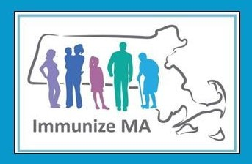

**ADULTS 65+ CAN NOW RECEIVE AN ADDITIONAL COVID-19 VACCINE DOSE**

In February, the [**CDC voted to recommend**](https://www.cdc.gov/media/releases/2024/s-0228-covid.html)an additional COVID-19 vaccine dose for adults ages 65 and older.

You can:

Search [**vaccines.gov**](http://vaccines.gov/)for

**Reminders**

**April 26, 2024**

Here are the latest resources for promoting COVID-19 vaccination to share with your colleagues

and networks across Massachusetts. If you received this from a colleague, [**subscribe today**](https://lp.constantcontactpages.com/su/9wFTcRU/VEIWeeklyRoundup?source_id=8c3c69c8-ce23-4d41-b8b6-95d054aef5a9&source_type=em&c)**.**

[**View this email online**](https://campaignlp.constantcontact.com/em/1138003900342/8c3c69c8-ce23-4d41-b8b6-95d054aef5a9)**.**

**What's New**

Review effective approaches to vaccine discussions

Identify ways to address common vaccine concerns, including COVID- 19

The speaker will be Kelly Moore, MD, MPH, and president and CEO of Immunize.org.

*The vaccine confidence webinar takes place via Zoom on* ***May 29 from 1-2 p.m.***

appointments

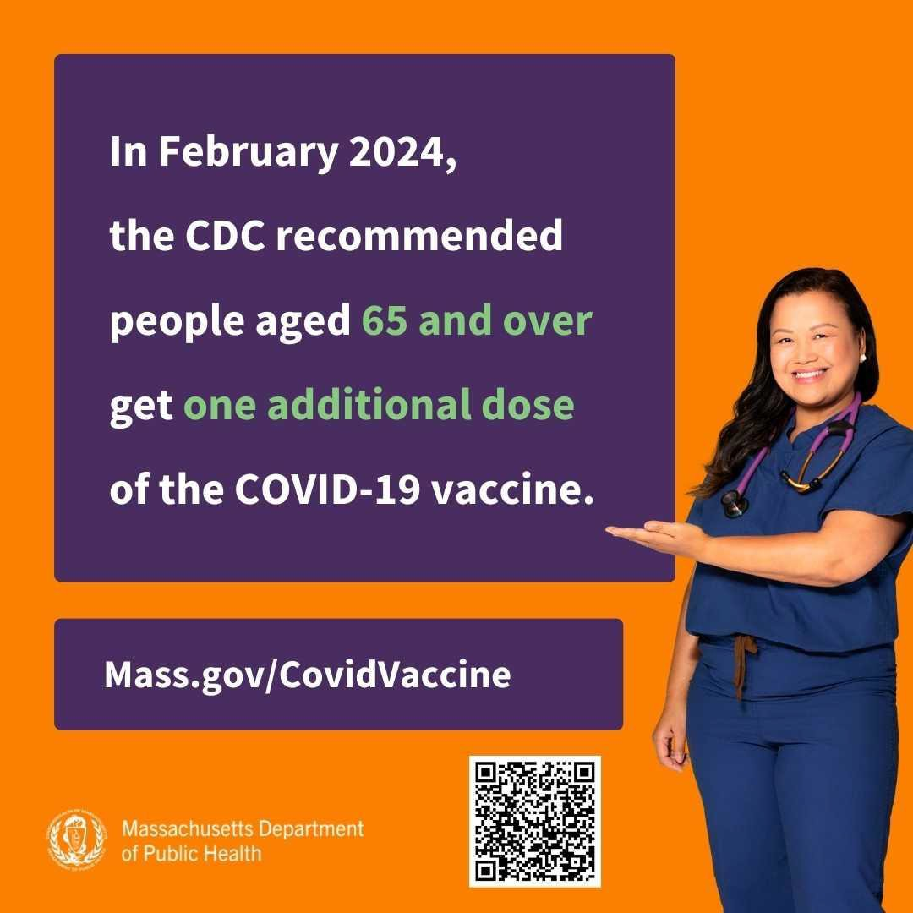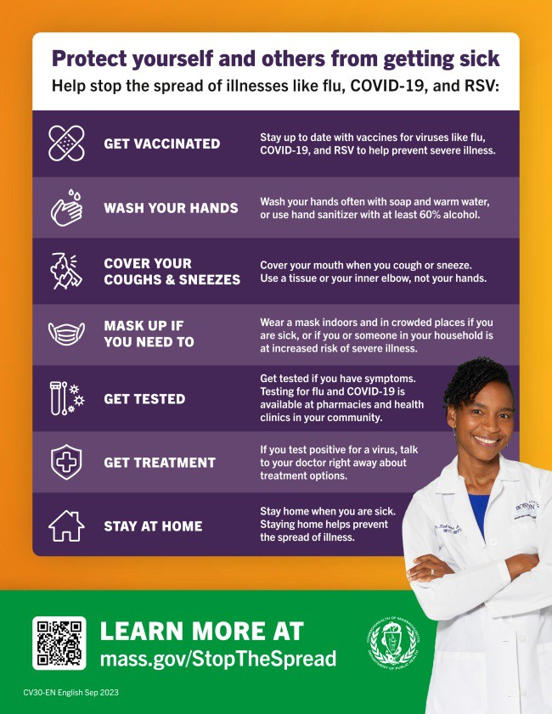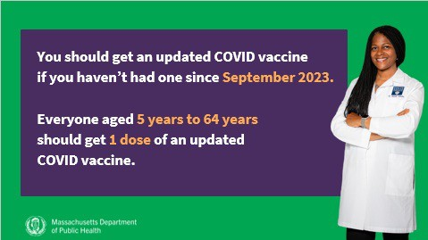

Find a [**local mobile clinic**](http://mass.gov/mobilevax)near you [Learn more about **in-home vaccination**](https://www.mass.gov/info-details/covid-19-in-home-vaccination-program#download-in-home-vaccination-flyer-)

If you have questions, please call 211 or (877) 211-6277 and press 1. Calls are answered Monday through Friday, 9 a.m. to 5 p.m.

*Help spread the word!* [***Click to download the shareable social media graphic pictured.***](https://files.constantcontact.com/6b77156f801/39641f96-984c-4053-b447-4043627fa120.jpg?rdr=true)

# UPDATED COVID-19 ISOLATION GUIDANCE NOW ON MASS.GOV

Building on the CDC's relaxing of COVID-19 [isolation guidance, **DPH has updated its COVID-19 isolation recommendations**.](https://www.mass.gov/info-details/staying-home-to-prevent-the-spread-of-respiratory-viruses?_gl=1%2A1pteeo5%2A_ga%2AMzQyODgzOTg3LjE2NDUyMDY5MTI.%2A_ga_MCLPEGW7WM%2AMTcxMjkzNDQxNC4xLjAuMTcxMjkzNDQxNC4wLjAuMA)

The new guidance states that people who are feeling better may begin to resume normal activities with precautions if:

They have not had a fever for at least 24 hours without the use of fever-reducing medicines, AND Their other symptoms are improving

Because people may still be able to spread the virus that made them sick, even if they are feeling better, the guidance gives additional recommendations for preventing spread.

# NEW IN THE VAX PROMOTION TOOLKIT: SLIDESHOWS AND SOCIAL MEDIA GRAPHICS!

Adults ages 65 and older are now recommended to get an additional updated COVID-19 vaccine dose.

Help spread the word with a **PowerPoint slideshow** with the updated guidance (in [**English**](https://www.mass.gov/doc/english-zip)and [**Spanis**](https://www.mass.gov/doc/spanish-zip)**h**) and **social media graphics** (also in [**English**](https://www.mass.gov/doc/english-jpg-3)and [**Spanis**](https://www.mass.gov/doc/spanish-jpg-1)**h**).



**OUTREACH AND EDUCATION MATERIALS**

[**COVID-19 Vaccine Information**](https://www.mass.gov/info-details/covid-19-vaccine-frequently-asked-questions)

[**COVID-19 Therapeutic Information**](https://www.mass.gov/get-treated-for-covid-19)(including [**telehealth**](https://www.mass.gov/info-details/free-telehealth-for-covid-19-treatment-with-paxlovid))

[**Archive of COVID-19 Vaccine Communications Updates**](https://www.mass.gov/lists/archive-of-covid-19-vaccine-communications-updates)(past editions of VEI Roundup)

**FIND A COVID-19 VACCINE DOSE**

Use [**Vaccines.gov**](http://vaccines.gov/)to sign up for a COVID-19 vaccine appointment Find a [**community COVID-19 vaccination clinic**](http://mass.gov/mobilevax)near you

Learn about the [**COVID-19 In-Home Vaccination Program**](https://www.mass.gov/info-details/covid-19-in-home-vaccination-program)and request a visit Request a [**copy of your vaccine card**](https://www.mass.gov/info-details/requesting-a-copy-of-your-covid-19-vaccination-record)

**Highlights**

**Key Resources**

[On March 14, **ACEDONE** and **True Alliance Center**, in a collaborative effort with the](https://www.truealliancecenter.org/) Equity Now & Beyond Coalition, hosted a vaccination clinic that saw over 400 individuals. The clinic offered a wide range of support, including job assistance, immigration advice, and resources from Boston Public Schools, among others.

These comprehensive services were detailed in the clinic's flyer (*see image*), highlighting the event's holistic approach to community well-being.

[**Read More Highlights**](https://www.mass.gov/info-details/covid-19-vaccine-equity-initiative-highlights)

[Share This Email](https://www.facebook.com/sharer/sharer.php?u=https%3A//campaignlp.constantcontact.com/em/1138003900342/8c3c69c8-ce23-4d41-b8b6-95d054aef5a9)

[Share This Email](https://twitter.com/intent/tweet?text=VEI%2BRoundup%2B-%2BReminder%3A%2BCDC%2Brecommends%2Badditional%2BCOVID-19%2Bvaccine%2Bdose%2Bfor%2Badults%2B65%2B%3A%2Bhttps%3A//campaignlp.constantcontact.com/em/1138003900342/8c3c69c8-ce23-4d41-b8b6-95d054aef5a9)

[Share This Email](https://www.linkedin.com/sharing/share-offsite/?url=https%3A//campaignlp.constantcontact.com/em/1138003900342/8c3c69c8-ce23-4d41-b8b6-95d054aef5a9)

[**Visit the VEI Website**](https://www.mass.gov/info-details/covid-19-vaccine-equity-initiative)

Vaccine Equity Initiative | 250 Washington Street, Boston, MA 02108 [Unsubscribe vaccineequityinitiative@mass.gov](mailto:Unsubscribevaccineequityinitiative@mass.gov)

[Constant Contact Data Notice](http://www.constantcontact.com/legal/about-constant-contact)

Sent by [vei@vaccineequityinitiative.ccsend.com](mailto:vei@vaccineequityinitiative.ccsend.com) powered by



[Try email marketing for free today](http://www.constantcontact.com/landing1/vr/home?cc=nge&utm_campaign=nge&rmc=VF21_CPE&utm_medium=VF21_CPE&utm_source=viral&nav=8c3c69c8-ce23-4d41-b8b6-95d054aef5a9)!