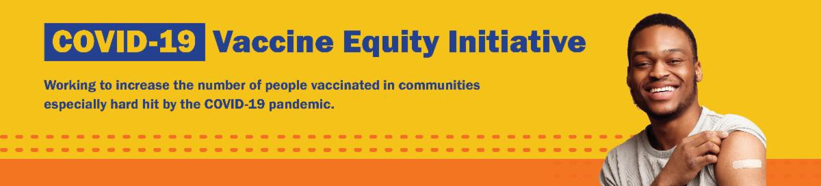
April 28, 2023
Here are the latest resources for promoting COVID-19 vaccination to share with your colleagues
and networks across Massachusetts. If you received this from a colleague, subscribe today.

View this email online.
What's New

CDC UPDATES COVID-19 VACCINE RECOMMENDATIONS

On April 19, the CDC updated their COVID-19 vaccine recommendations.

Updated recommendations include the following:

Individuals ages 6 years and older are recommended to get one updated (bivalent) booster dose, regardless of whether they have completed a primary series.
Key takeaway: If someone 6 years or older has never gotten a COVID-19 vaccine, they now only need to get one updated (bivalent) dose.

Adults ages 65 years and older can now get one additional bivalent dose, if it has been at least four months since their previous (bivalent) dose.

Read more on the CDC website. And watch for more guidance in the next edition of the VEI Roundup!

Anyone with questions about COVID-19 vaccination can also call 2-1-1 (or 877-211-6277) and press 1.

COVID-19 VACCINE PROMOTION TOOLKIT — NEW FLYERS AVAILABLE!

Our COVID-19 vaccine promotion toolkit

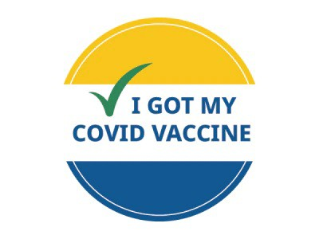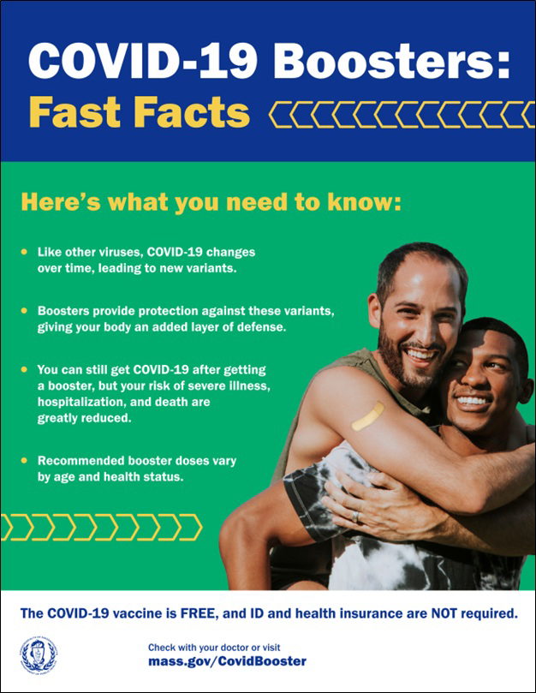
has been updated with several new items!

This includes:
Customizable flyers for promoting clinics
New COVID-19 Boosters: Fast Facts flyers in English and Spanish

The toolkit will continue to be updated as new items are ready.

Don't see what you need? Email us and let us know!
Reminders

NEED A COVID-19 VACCINE? HERE'S HOW TO FIND ONE

Free COVID-19 vaccine clinics are being held throughout Massachusetts!

To find a COVID-19 vaccine clinic near you: Search vaccines.gov for appointments
Find a local mobile clinic near you Learn more about in-home vaccination

Questions? Call 211 (or 877-211-6277) and press 1. Calls are answered Monday through Friday, 9 a.m. to 5 p.m.

You can also learn more about how to prepare for your vaccine appointment.

MASSHEALTH REDETERMINATION: HELP MEMBERS KEEP THEIR HEALTH CARE COVERAGE

In 2023, all current MassHealth members will need to renew their health coverage to ensure they still qualify for their current benefit.

These renewals will take place over 12 months, starting this month. MassHealth is working to help members maintain coverage and raise awareness about the renewal process and other coverage options, if needed.

Here's how you can help:

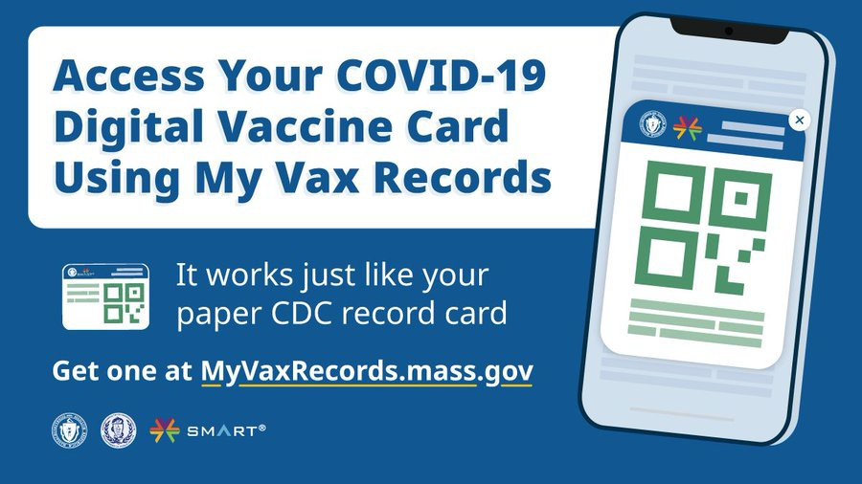
Remind members to update their addresses, report household changes, and read all
mail from MassHealth
Share informational and outreach materials from this toolkit
Sign up for email notifications from MassHealth
MY VAX RECORDS: A DIGITAL VACCINE CARD FOR MASSACHUSETTS
RESIDENTS

Need a copy of your COVID-19 vaccination record? Massachusetts residents can use My Vax Records to get a digital vaccine card to show they’ve been vaccinated against COVID-19, if they choose. Learn more.
Info about My Vax Records is available in ASL,
courtesy of the Learning Center for the Deaf.
Key Resources
Info about MassHealth redetermination ( intro and key points) is also available in ASL, courtesy of the Learning Center for the Deaf.

OUTREACH AND EDUCATION MATERIALS

COVID-19 Vaccine FAQs
COVID-19 Therapeutic Information (including telehealth) Weekly Provider Bulletin
Trust the Facts, Get the Vax Campaign Materials (organized by audience, including general, parents, youth, and young adults; available in 12 languages)
Multilingual COVID-19 Materials (videos and printables; organized by language) Archive of COVID-19 Vaccine Communications Updates (past editions of VEI Roundup)

FIND A COVID-19 VACCINE OR BOOSTER

Find a COVID-19 Vaccine or Booster Appointment
Find, Schedule, or Sign Up for a Mobile COVID-19 Vaccination COVID-19 In-Home Vaccination Program
Request a Copy of Your Vaccine Card

Highlights

The Chappaquiddick Tribe of the

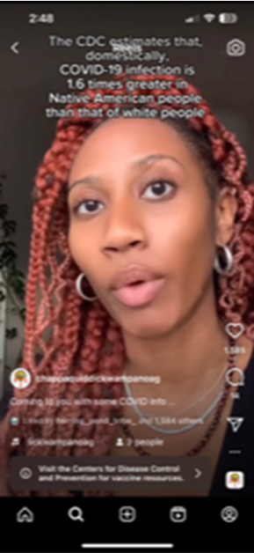Wampanoag Nation (based in Edgartown
and serving tribal communities in Boston, as well as north of Boston, south of Boston, Central Massachusetts, and the South Shore, and Cape and Islands) created informational COVID-19 videos that are displayed on their social media pages (see photo). The videos feature tribal members sharing information about COVID-19, including where to find related resources and more information. The campaign has been reaching tribal and non-Native communities — some of the videos have had over 18,000 views!

Read More Highlights

Share This Email
Share This Email
Share This Email

Visit the VEI Website

Vaccine Equity Initiative | 250 Washington Street, Boston, MA 02108 Unsubscribe vaccineequityinitiative@mass.gov
Constant Contact Data Notice
Sent by vaccineequityinitiative@mass.gov in collaboration with
Try email marketing for free today!

