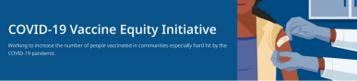April 29, 2022
Here are the latest resources for promoting COVID-19 vaccination to share with your colleagues and networks across Massachusetts. If you received this from a colleague, subscribe today.
What's New
APRIL 30: YMCA HEALTHY KIDS DAY COVID-19 VACCINATION CLINICS
DPH is partnering with the YMCA to
provide COVID-19 vaccination clinics in
several communities as part of the YMCA’s
Healthy Kids Day, April 30. Clinics will be
held through early May. View the
schedule.
Healthy Kids Day celebrates children’s
mental and physical health. Learn more.
NEW SPANISH-LANGUAGE VIDEO ABOUT COVID-19 TREATMENTS
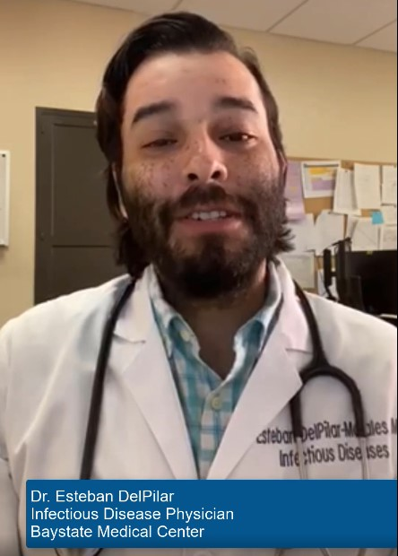
This new Spanish-language video features Dr.
Esteban DelPilar of Baystate Medical. Dr.
DelPilar explains that if you test positive for
COVID-19 and have any condition that puts
you at high risk — like asthma, diabetes, and
obesity, among others — you may qualify for
one or more COVID treatment(s). Please
share!
Got questions about COVID-19 treatments?
Information is available in 12 languages.

Reminders
FREE COVID-19 TREATMENTS: WIDESPREAD USE OF COVID-19 PILL COULD PREVENT FUTURE HOSPITAL SURGES
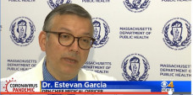
COVID-19 treatment is available at no cost
at sites across the Commonwealth. DPH
Chief Medical Officer Dr. Estevan Garcia
recently talked with CBS Boston about the
safety and availability of the COVID pill in
MA.
IN-HOME VACCINATIONS AVAILABLE
The COVID-19 In-Home Vaccination
Program is a resource for anyone who has
difficulty getting to or using a community
vaccination location.
MULTILINGUAL COVID-19 MATERIALS FROM DPH
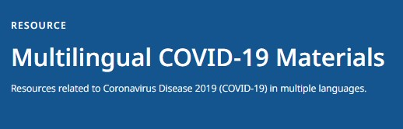
Resources to support COVID-19 vaccine
promotion and education, organized by
language. Includes videos and printables
on topics like vaccine safety, pregnancy
and the vaccine, and FAQs.
EARN $10 IN 10 MINUTES: TAKE A COVID-19 VACCINATION SURVEY FROM DPH PARTNER MARKET STREET RESEARCH
We want to hear from you! If you live in
Fall River, Springfield, or New Bedford
and would like to share your thoughts
about the COVID-19 vaccine, please
consider taking a short survey.
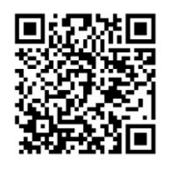
The survey is private and available in
English, Spanish, or Portuguese.
Answer a few short questions to see if
you qualify. The survey takes about 10
minutes.
Learn more here or scan the QR code
at right. Please share!
Key Resources
OUTREACH AND EDUCATION MATERIALS
- COVID-19 Vaccine FAQs
- COVID-19 Booster FAQs
- Weekly Provider Bulletin (published 4/13)
- Trust the Facts, Get the Vax Campaign Materials (organized by audience, including general, parents and pregnant people, youth, young adults; available in 12 languages)
- Trust the Facts, Get the Vax Creative Materials Toolkit (updates ongoing, including pediatric eligibility)
- Additional Education and Outreach Materials (includes social media graphics, vaccine updates, guides to hosting a forum, and more)
- Multilingual COVID-19 Materials (videos and printables; organized by language)
- COVID-19 Funeral Assistance from FEMA (including 1-pager with key info available in multiple languages)
- COVID-19 Vaccination Tools for Employers
- Archive of COVID-19 Vaccine Communications Updates (past editions of VEI Roundup)
FIND A COVID-19 VACCINE OR BOOSTER
- Vaccine Finder
- Find, Schedule, or Sign Up for a Mobile COVID-19 Vaccination
- COVID-19 In-Home Vaccination Program
- Request a Copy of Your Vaccine Card

COVID-19 VACCINE STANDING ORDERS (FROM CDC)
- Pfizer
  - 5-11 (updated 3/31/22)
  - 12 + Gray Cap (updated 4/1/22)
  - 12 + Purple Cap (updated 4/1/22)
- Moderna (updated 3/31/22)
- Janssen (updated 4/1/22)
Recent Highlights
April School Vacation Week Clinics Vaccinate 1,000+
Cities in our Vaccine Equity Initiative — including Brockton, Chelsea, Everett, Lowell, Malden, Methuen, New Bedford, Randolph, and Springfield — held 43 clinics for children and families to get vaccinated during April School Vacation Week (April 18-24). Clinics were held at a variety of family-friendly locations, including trampoline parks, zoos, bowling alleys, and even Six Flags New England. In total, 1,068 people were vaccinated. Thank you to our local partners who helped make this effort possible!
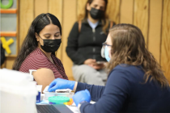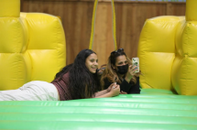Above: Images from the clinic at Boston Playground in Chelsea.
Read More Highlights
Visit the VEI Website

Vaccine Equity Initiative | 250 Washington Street, Boston, MA 02108
Unsubscribe vaccineequityinitiative@mass.gov
Constant Contact Data Notice
Sent byvaccineequityinitiative@mass.govin collaboration
with
Try email marketing for free today!

