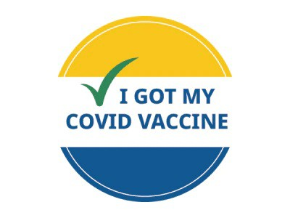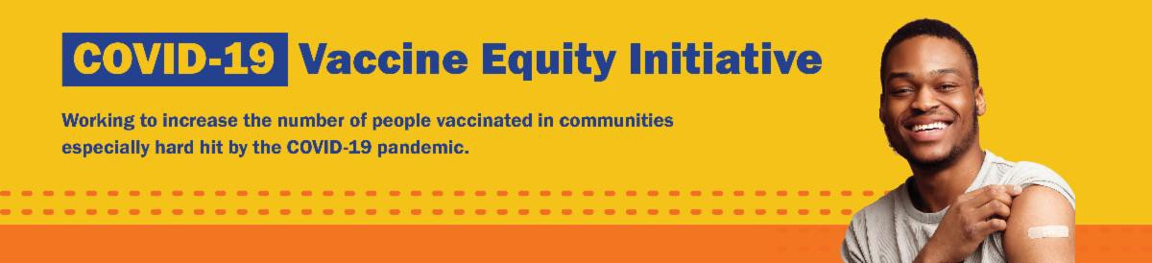
NEED A COVID-19 VACCINE OR BOOSTER? HERE'S HOW TO FIND ONE

Free COVID-19 vaccine clinics are still being held throughout Massachusetts!

To find COVID-19 vaccination opportunities, you can:
Search vaccines.gov for appointments
Find a local mobile clinic near you Learn more about in-home
Reminders

GET BOOSTED CAMPAIGN RESULTS IN NEARLY 80,000 VACCINATIONS!

From October 2022 through March 2023, hundreds of Get Boosted clinics were held throughout Vaccine Equity Initiative communities for individuals and families to get their COVID-19 vaccines and boosters.

Preliminary data shows that nearly 80,000 individuals received COVID-19 vaccinations as part of the campaign.

Thank you to all of our partners who helped make this program possible!
What's New
April 7, 2023
Here are the latest resources for promoting COVID-19 vaccination to share with your colleagues
and networks across Massachusetts. If you received this from a colleague, subscribe today.

View this email online.

vaccination

If you have questions, please call 211 (or 877-211-6277) and press 1. Calls are answered Monday through Friday, 9 a.m. to 5 p.m.

MASSHEALTH REDETERMINATION STARTS NOW: HELP MEMBERS KEEP THEIR HEALTH CARE COVERAGE

In 2023, all current MassHealth members will need to renew their health coverage to ensure they still qualify for their current benefit.

These renewals will take place over 12 months, starting in April 2023.
MassHealth is working to help members maintain coverage and raise awareness about the renewal process and other coverage options, if needed.

Here's how you can help:

Remind members to update their addresses, report household changes, and read all mail from MassHealth
Share informational and outreach materials from this toolkit
Sign up for email notifications from MassHealth

Info about MassHealth redetermination ( intro and key points) is also available in ASL, courtesy of the Learning Center for the Deaf.

FREE IN-HOME COVID-19 VACCINATION AVAILABLE

Massachusetts offers in-home COVID-19 vaccinations for anyone who has difficulty getting to or using a community clinic, including young children. Learn more, or call 833-983-0485 to sign up for an in- home appointment.

Help spread the word with

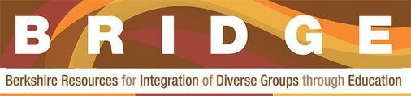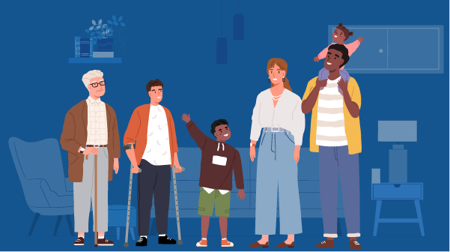

Lee
Berkshire Resources for the Integration of Diverse Communities (BRIDGE) had a busy start to their year. Throughout January, BRIDGE distributed over 900 resource kits into the community. The kits contained cleaning supplies, PPE, and clinic schedules and up-to-date guidance for COVID-19 and flu vaccines. The kits also included tips for how to care for yourself when sick and when to contact a primary care provider. BRIDGE is currently in planning mode for their second annual community health event, to be scheduled in the spring.
Highlights
this informational flyer (in 12 languages)!
Key Resources

OUTREACH AND EDUCATION MATERIALS

COVID-19 Vaccine FAQs
COVID-19 Therapeutic Information (including telehealth) Weekly Provider Bulletin
Trust the Facts, Get the Vax Campaign Materials (organized by audience, including general, parents, youth, and young adults; available in 12 languages)
Multilingual COVID-19 Materials (videos and printables; organized by language) Archive of COVID-19 Vaccine Communications Updates (past editions of VEI Roundup)

FIND A COVID-19 VACCINE OR BOOSTER

Find a COVID-19 Vaccine or Booster Appointment
Find, Schedule, or Sign Up for a Mobile COVID-19 Vaccination COVID-19 In-Home Vaccination Program
Request a Copy of Your Vaccine Card

Read More Highlights

Visit the VEI Website

Share This Email
Share This Email
Share This Email

Vaccine Equity Initiative | 250 Washington Street, Boston, MA 02108

Unsubscribe vaccineequityinitiative@mass.gov Constant Contact Data Notice
Sent by vaccineequityinitiative@mass.gov in collaboration with
Try email marketing for free today!

