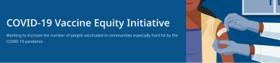April 8, 2022
See below for news and resources about COVID-19 vaccination. Please share this newsletter with colleagues, including local social service agencies, community organizations, or colleagues working to increase vaccination across Massachusetts. If you received this newsletter from a colleague, subscribe today.
What's New
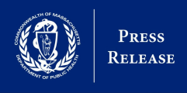
ADDITIONAL $4.5 MILLION AWARDED FOR COVID-19 VACCINE EQUITY EFFORTS
- News release (4/8) - Baker-Polito
administration awards
additional $4.5 million for
COVID-19 vaccine equity efforts
NOW IN 12 LANGUAGES:
SEVEN STEPS TO PROTECT YOURSELF & YOUR FAMILY FROM COVID-19
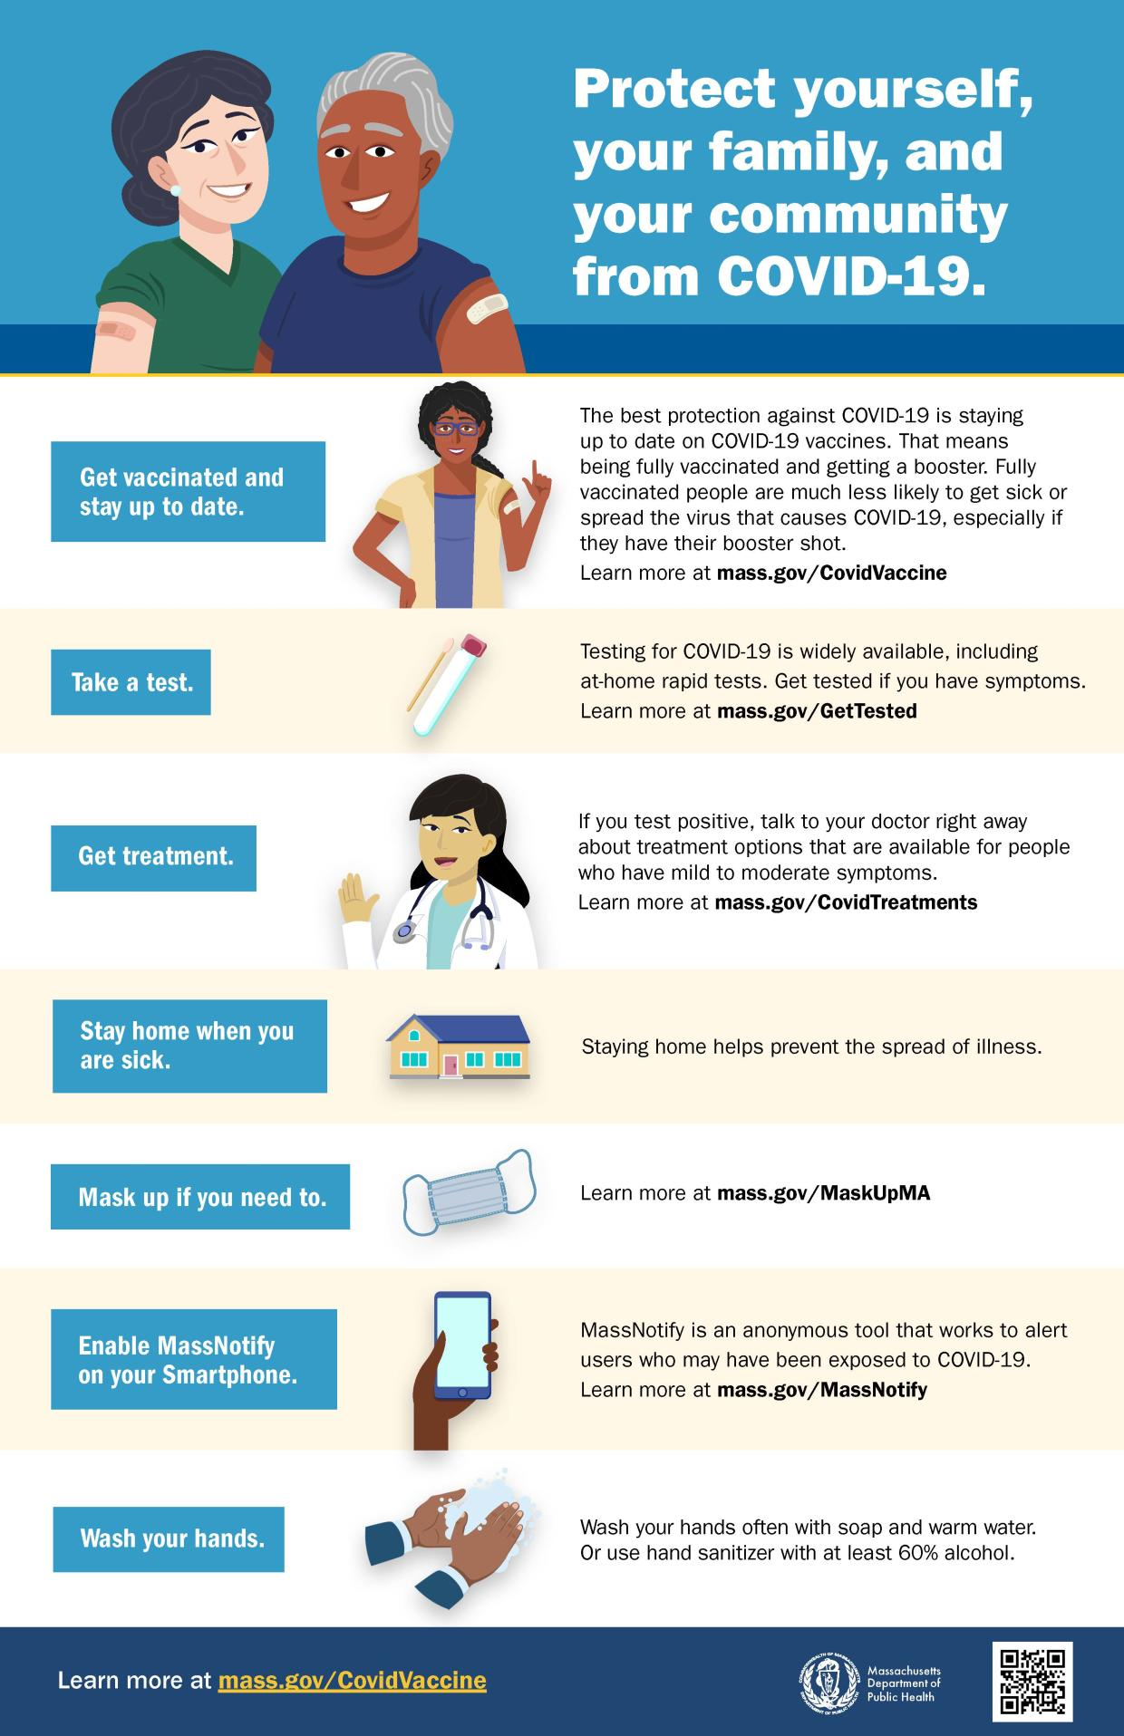
- This new flyer is now available in
multiple languages. It features a
checklist to help protect yourself,
your family, and your community
from COVID-19. Please share it
with your networks.

APRIL SCHOOL VACATION WEEK CLINICS (APRIL 18-24)
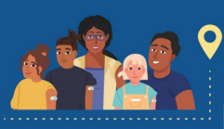
- DPH is again hosting family
friendly COVID-19 vaccination
clinics with local communities
and businesses during school
vacation week, April 18–24,
2022.
- Clinics will be held at trampoline
parks, zoos, bowling alleys, and
Six Flags amusement park, with
giveaways like free admissions
for people who get vaccinated.
View the schedule.
Reminders
SECOND COVID-19 BOOSTER AVAILABLE FOR INDIVIDUALS 50+ OR IMMUNOCOMPROMISED
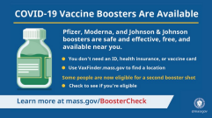
- News Release (3/30) - A second
booster dose for individuals 50+
and people with certain health
conditions is now available.
- “Vaccines, including boosters, are
the most effective and widely
available tool we have to prevent
COVID infection, severe disease,
and death.”—DPH’s Dr. Larry
Madoff

- Questions? Our booster FAQ is
available in 12 languages.
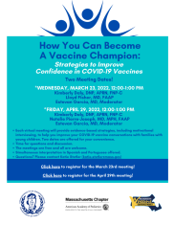
BECOME A VACCINE CHAMPION: LEARN WAYS TO IMPROVE CONFIDENCE IN COVID-19 VACCINES
DPH and other partners are
offering trainings on strategies to
improve confidence in COVID-19
vaccines. Meetings are free, and
all are welcome. Learn more, or
register for April 29.

FEDERAL COVID.GOV WEBSITE OFFERS "ONE-STOP SHOP" FOR COVID-19 RESOURCES
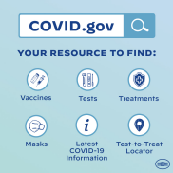
- COVID.gov is a new federal
website with info about how to
receive or locate free masks and
COVID tests, vaccines, and
treatment.
- The call line has 150+ languages
available: 1-800-232-0233.
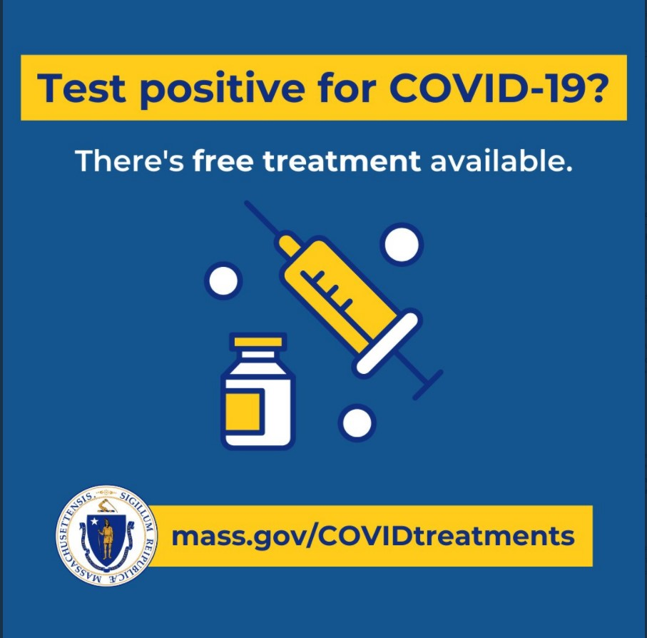
FREE COVID-19 TREATMENT OPTIONS
- Patients recently diagnosed with
COVID-19 have options for treatment,
available at no cost at sites across MA.
Learn more about treatment options
(info also available in 12 languages), or
locate treatment.

Key Resources
OUTREACH AND EDUCATION MATERIALS
- COVID-19 Vaccine FAQs
- COVID-19 Booster FAQs
- Weekly Provider Bulletin (published 4/6)
- Trust the Facts, Get the Vax Campaign Materials (organized by audience, including general, parents and pregnant people, youth, young adults; available in 12 languages)
- Trust the Facts, Get the Vax Creative Materials Toolkit (updates ongoing, including pediatric eligibility)
- Additional Education and Outreach Materials (includes social media graphics, vaccine updates, guides to hosting a forum, and more)
- Multilingual COVID-19 Materials (videos and printables; organized by language)
- COVID-19 Funeral Assistance from FEMA (including 1-pager with key info available in multiple languages)
- COVID-19 Vaccination Tools for Employers
- Archive of COVID-19 Vaccine Communications Updates (past editions of VEI Roundup)
FIND A COVID-19 VACCINE OR BOOSTER
- Vaccine Finder
- Find, Schedule, or Sign Up for a Mobile COVID-19 Vaccination
- COVID-19 In-Home Vaccination Program
- Request a Copy of Your Vaccine Card
COVID-19 VACCINE STANDING ORDERS (FROM CDC)
- Pfizer
  - 5-11 (updated 3/31/22)
  - 12 + Gray Cap (updated 4/1/22)
  - 12 + Purple Cap (updated 4/1/22)
- Moderna (updated 3/31/22)
- Janssen (updated 4/1/22)

Recent Highlights
Boston
Somali Parent Advocacy Center for Education (SPACE) has been tabling at the “Somali Mall” (in Nubian Square), holding monthly Zoom community meetings and one-on-one discussions, and sending COVID-focused educational materials via WhatsApp. They are finding that while pregnant people are hesitant to be vaccinated, with education, many are willing to do so after giving birth. More about the COVID vaccine and pregnancy here (also in multiple languages).
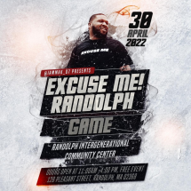
Randolph
On April 30, a basketball event called “Excuse
Me! Randolph” will be held at the Randolph
Intergenerational Community Center (flyer,
right). Ten local YouTube basketball
influencers will be participating in the game,
and teens ages 15+ will have opportunities to
play alongside them. A vaccination clinic will
be held in the center's cafeteria during the
free event, and vegan food options will be
available.

Read More Highlights
Visit the VEI Website
Vaccine Equity Initiative | 250 Washington Street, Boston, MA 02108
Unsubscribe vaccineequityinitiative@mass.gov
About Constant Contact
Sent byvaccineequityinitiative@mass.govin collaboration
with
Try email marketing for free today!

