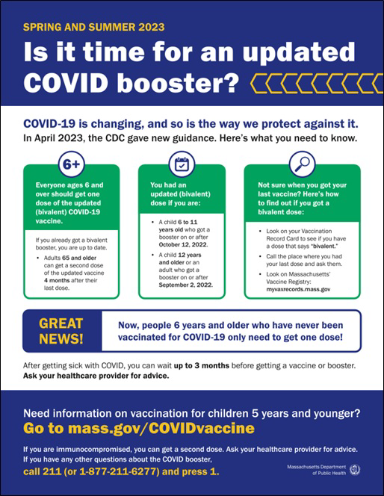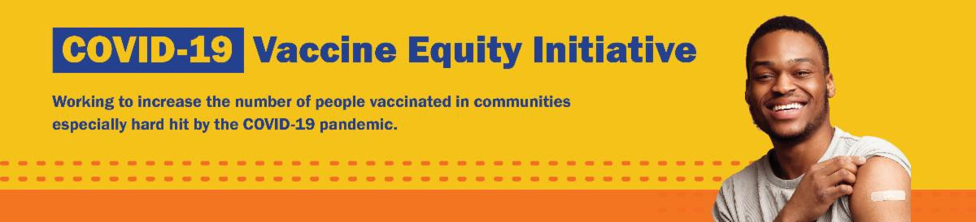
NEW FLYER: IS IT TIME FOR AN UPDATED COVID BOOSTER?

COVID-19 is changing, and so is the way we protect against it.

This new flyer overviews spring and summer 2023 guidance for COVID-19 vaccination, based on the CDC's recently updated vaccine recommendations. More languages available soon!

Other materials, like flyers and social media graphics, are also available in our online toolkit.
END OF THE COVID-19 PUBLIC HEALTH EMERGENCY: WHAT DOES IT MEAN?

The Federal and Massachusetts COVID-19 Public Health Emergency Declarations ended on May 11, 2023.

This new informational sheet overviews what will change—and what will stay the
May 12, 2023
Here are the latest resources for promoting COVID-19 vaccination to share with your colleagues
and networks across Massachusetts. If you received this from a colleague, subscribe today.

View this email online.
What's New

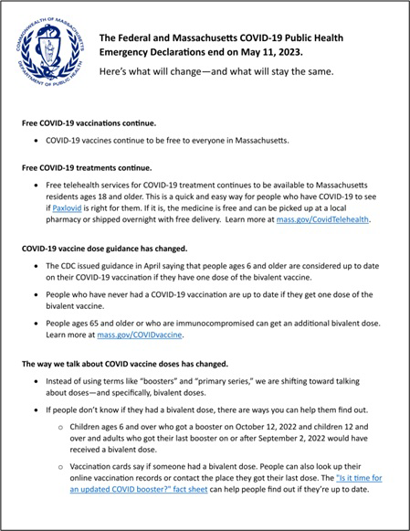
same.
Reminders

CDC UPDATES COVID-19 VACCINE RECOMMENDATIONS

In April, the CDC updated its COVID-19 vaccine recommendations.

Updated recommendations include the following:

Individuals ages 6 years and older are recommended to get one updated (bivalent) booster dose, regardless of whether they have completed a primary series.
Key takeaway: If someone 6 years or older has never gotten a COVID- 19 vaccine, they now only need to get one updated (bivalent) dose.

Adults ages 65 years and older and individuals who are immunocompromised can also get an additional bivalent dose.

Read more on the CDC website. Anyone with questions can also call 2-1-1 (or 877-211- 6277) and press 1.

View the "Is it time?" flyer to see if you are up-to-date on your COVID-19 vaccination.

FREE IN-HOME COVID-19 VACCINATION AVAILABLE

Massachusetts offers in-home COVID-19 vaccinations for anyone who has difficulty getting to or using a community clinic,

including young children. Learn more, or call
833-983-0485 to sign up for an in-home appointment.

Help spread the word with this informational flyer (in 12 languages)!

MASSHEALTH REDETERMINATION: HELP MEMBERS KEEP THEIR HEALTH CARE COVERAGE

In 2023, all current MassHealth members will need to renew their health coverage to ensure they still qualify for their current benefit.

These renewals will take place over 12 months, starting in April. MassHealth is working to help members maintain coverage and raise awareness about the renewal process.

Here's how you can help:
OUTREACH AND EDUCATION MATERIALS

COVID-19 Vaccine FAQs
COVID-19 Therapeutic Information (including telehealth) Weekly Provider Bulletin
Trust the Facts, Get the Vax Campaign Materials (organized by audience, including general, parents, youth, and young adults; available in 12 languages)
Multilingual COVID-19 Materials (videos and printables; organized by language) Archive of COVID-19 Vaccine Communications Updates (past editions of VEI Roundup)
FIND A COVID-19 VACCINE DOSE

Find a COVID-19 Vaccine Appointment
Find, Schedule, or Sign Up for a Mobile COVID-19 Vaccination COVID-19 In-Home Vaccination Program
Key Resources

Remind members to update their addresses, report household changes, and read all mail from MassHealth Share informational and outreach materials from this toolkit
Sign up for email notifications from MassHealth

Info about MassHealth redetermination (intro and key points) is also available in ASL, courtesy of the Learning Center for the Deaf.

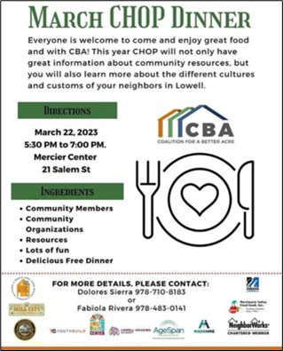Request a Copy of Your Vaccine Card

Highlights

Lowell
In late March, Coalition for a Better Acre hosted its first Community Health Outreach Program (CHOP) Dinner of the year. The goal of CHOP Dinners is to share health and COVID-related information and resources and to support Lowell residents in building connections with each other. At the March CHOP Dinner, Coalition for a Better Acre held a vaccine clinic and offered $75 gift cards for those who got vaccinated. They also provided attendees with assistance and resources regarding COVID, as well as housing and other social services.

Read More Highlights

Share This Email
Share This Email
Share This Email

Visit the VEI Website

Vaccine Equity Initiative | 250 Washington Street, Boston, MA 02108 Unsubscribe vaccineequityinitiative@mass.gov
Constant Contact Data Notice
Sent byvaccineequityinitiative@mass.govin collaboration with
Try email marketing for free today!

