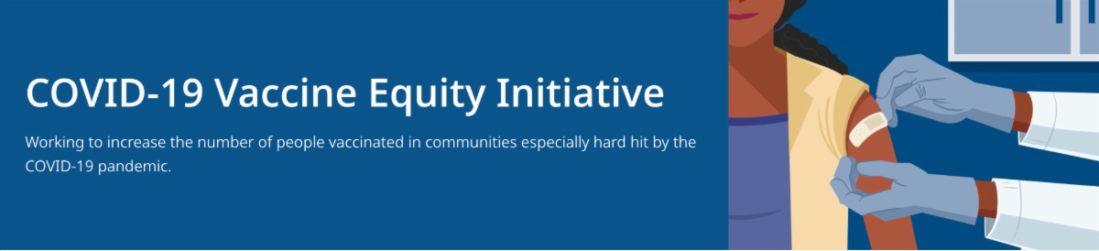
May 13, 2022
Here are the latest resources for promoting COVID-19 vaccination to share with your colleagues
and networks across Massachusetts. If you received this from a colleague, subscribe today.
What's New

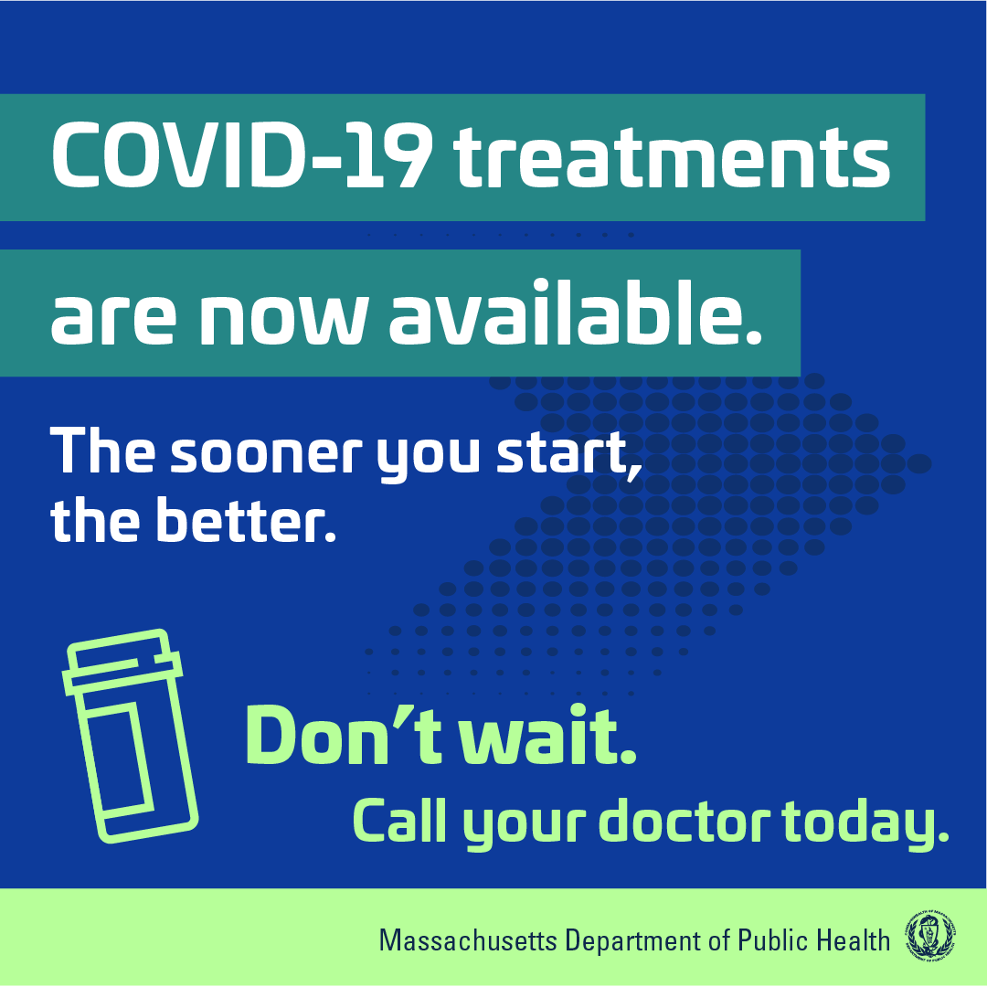MA RESIDENTS MAY QUALIFY FOR IN-HOME COVID TREATMENT

MA is making it more convenient for eligible residents to receive approved treatments for COVID-19 by making these treatments available at home. Learn more about eligibility.

FREE TELEHEALTH VISITS FOR COVID TREATMENT FOR MA RESIDENTS

A newly launched, free telehealth service can help MA residents more easily access Paxlovid, a COVID-19 treatment pill.

In a telehealth visit, residents who test positive for COVID and have symptoms can be evaluated directly for COVID-19 treatment, without contacting their health care provider. If approved, prescriptions can then be picked up at a local pharmacy or sent via free overnight delivery. The telehealth service is also available in multiple languages. Learn more.

Questions about free COVID treatments?
Info is available in 12 languages.
Reminders

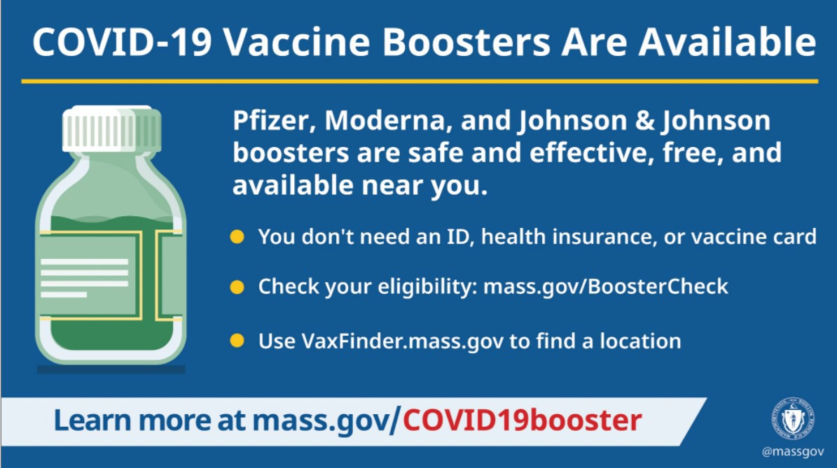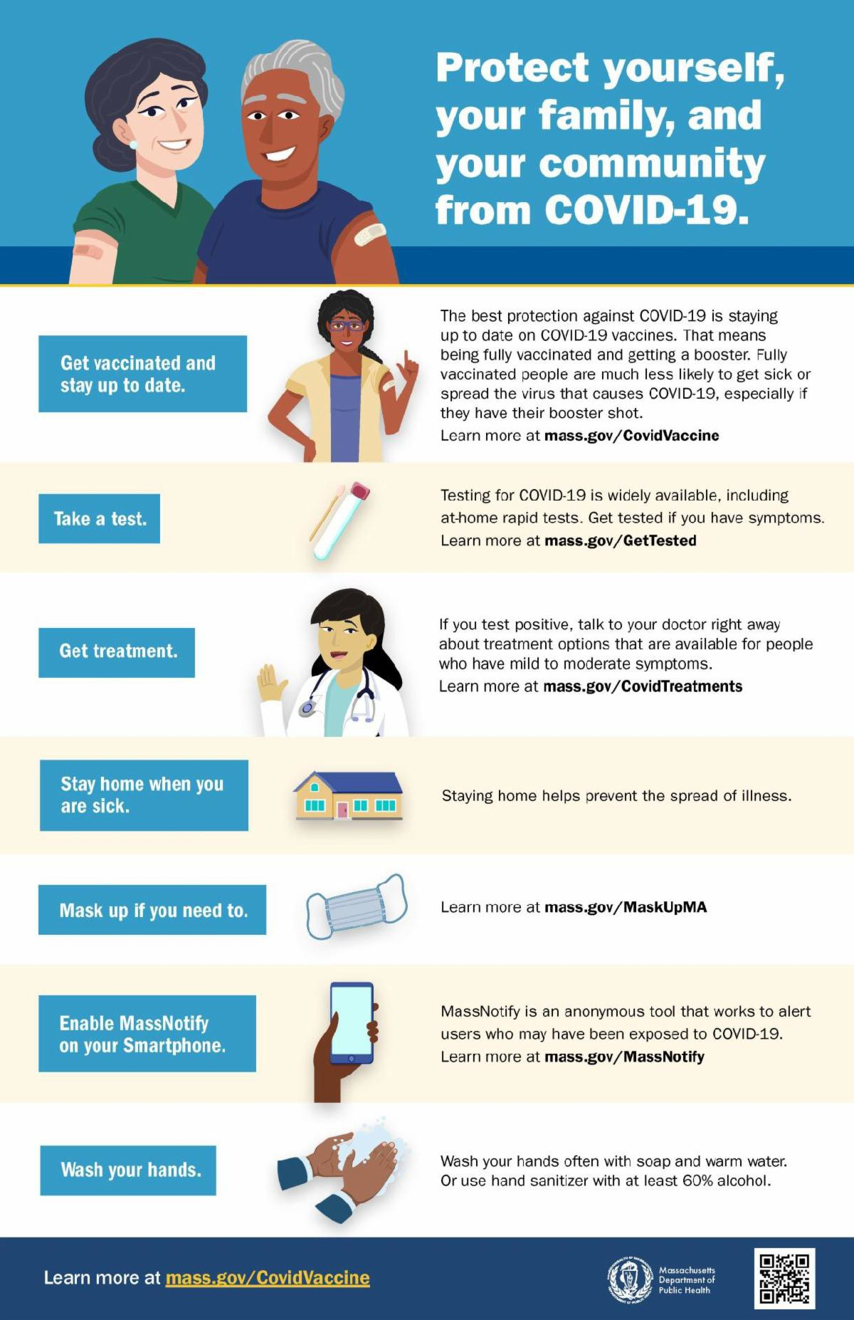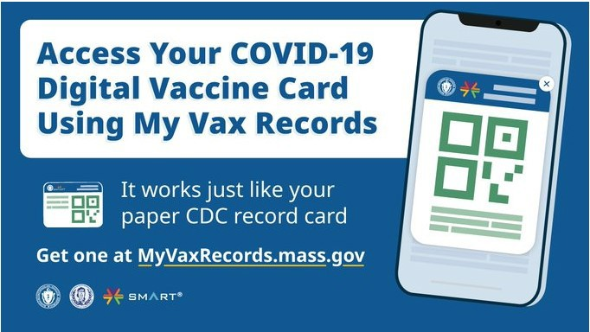FIND A BOOSTER APPOINTMENT NEAR YOU

Booster shots help reduce your risk of serious illness, hospitalization, and death. Some people are now eligible for a second booster dose. Learn more.

Info about boosters is also available in 12 languages.

SEVEN STEPS TO PROTECT YOURSELF AND YOUR FAMILY FROM COVID-19

Available in multiple languages, this flyer features a checklist to help protect yourself, your family, and your community from COVID-19. Please share it with your networks.

MY VAX RECORDS - DIGITAL COVID-19 VACCINE CARD FOR MA RESIDENTS

Need a copy of your COVID-19 vaccination record? MA residents can use My Vax Records to get a digital vaccine card to show they’ve been vaccinated against COVID-19, if they choose. Learn more.

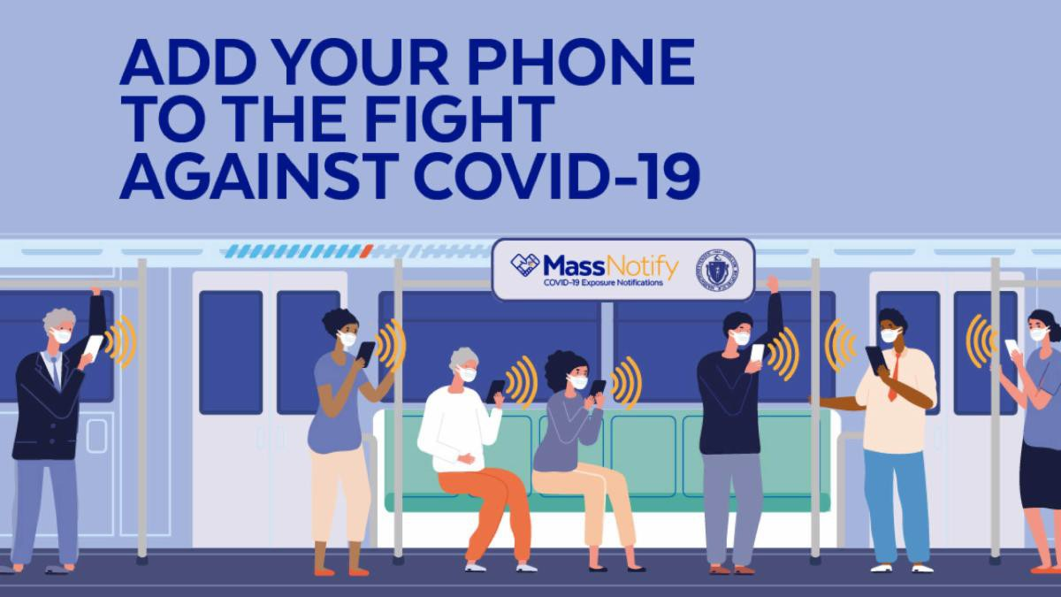
ENABLE MASSNOTIFY ON YOUR SMARTPHONE

More than 2 million MA residents now use MassNotify, a tool that works through smartphones—with a focus on privacy—to alert users who may have been exposed to COVID-19. Enable MassNotify on your smartphone. Learn more.
Key Resources

OUTREACH AND EDUCATION MATERIALS

COVID-19 Vaccine FAQs COVID-19 Booster FAQs
Weekly Provider Bulletin (published 5/10)
Trust the Facts, Get the Vax Campaign Materials(organized by audience, including general, parents and pregnant people, youth, young adults; available in 12 languages)
Trust the Facts, Get the Vax Creative Materials Toolkit(updates ongoing, including pediatric eligibility)
Additional Education and Outreach Materials(includes social media graphics, vaccine updates, guides to hosting a forum, and more)
Multilingual COVID-19 Materials (videos and printables; organized by language)
COVID-19 Funeral Assistance from FEMA(including one-pager with key info available in multiple languages)
COVID-19 Vaccination Tools for Employers
Archive of COVID-19 Vaccine Communications Updates (past editions of VEI Roundup)

FIND A COVID-19 VACCINE OR BOOSTER

Vaccine Finder
Find, Schedule, or Sign Up for a Mobile COVID-19 Vaccination COVID-19 In-Home Vaccination Program
Request a Copy of Your Vaccine Card

COVID-19 VACCINE STANDING ORDERS (FROM CDC)

Pfizer
5-11 (updated 3/31/22)
12 + Gray Cap(updated 4/22/22)
12 + Purple Cap (updated 4/22/22)
Moderna (updated 4/22/22)
Janssen (updated 4/26/22)

Recent Highlights

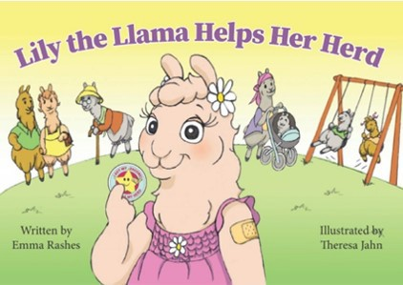Framingham

Jewish Family Services of Metrowest joined the MetroWest YMCA for their Healthy Kids Day Event on Saturday, April
30. They shared copies of Lily the Llama, a book they co-produced as part of their work to prevent the spread of COVID and explain the importance of vaccines in an age-appropriate way (see image). The Jewish Family Services team also shared masks, PPE, and information around COVID mitigation practices with parents of children who are not yet old enough to receive a vaccine.

Read More Highlights

Share This Email
Share This Email
Share This Email

Visit the VEI Website

Vaccine Equity Initiative | 250 Washington Street, Boston, MA 02108 Unsubscribe vaccineequityinitiative@mass.gov
Constant Contact Data Notice
Sent by vaccineequityinitiative@mass.gov in collaboration with
Try email marketing for free today!

