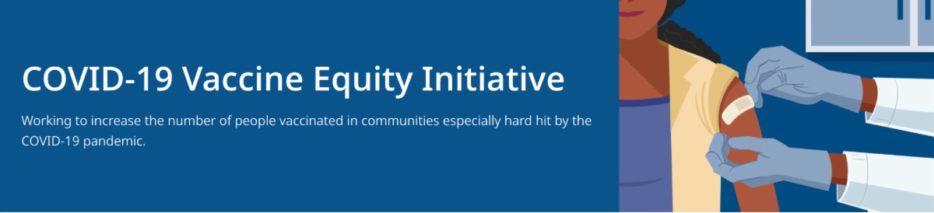
May 20, 2022
Here are the latest resources for promoting COVID-19 vaccination to share with your colleagues
and networks across Massachusetts. If you received this from a colleague, subscribe today.
What's New

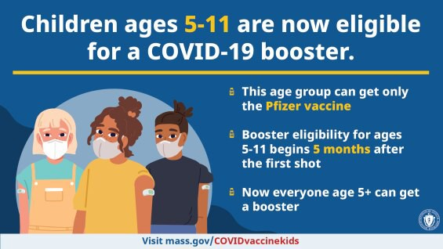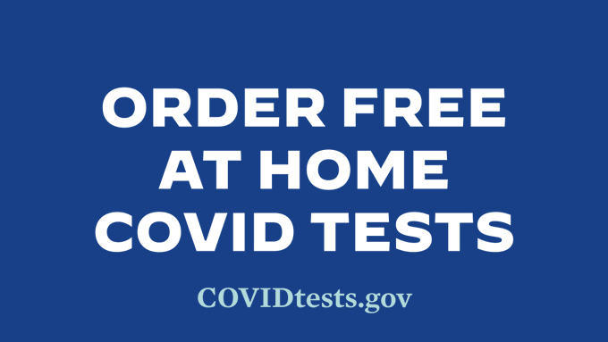
CHILDREN AGES 5-11 NOW ELIGIBLE FOR A COVID-19 BOOSTER

Following updated guidance from the CDC, all MA residents ages 5-11 are now eligible to receive a Pfizer
COVID-19 booster, beginning five months after their initial Pfizer vaccination series. Learn more.
MORE AT-HOME COVID TESTS AVAILABLE FREE VIA US POSTAL SERVICE

Every U.S. household is now eligible to order a third round of free at-home COVID-19 tests. Learn more and order yours today.
Reminders

MA RESIDENTS MAY QUALIFY FOR IN-HOME COVID TREATMENT

In MA, eligible residents can receive

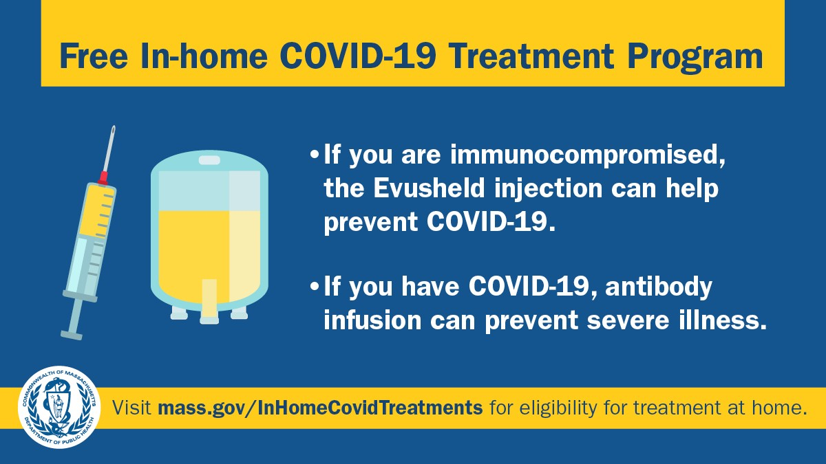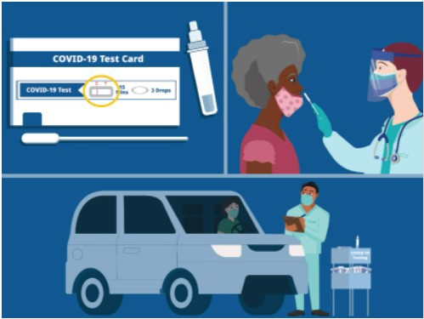in-home treatments like Evusheld to
OUTREACH AND EDUCATION MATERIALS

COVID-19 Vaccine FAQs COVID-19 Booster FAQs Weekly Provider Bulletin
Trust the Facts, Get the Vax Campaign Materials(organized by audience, including general, parents and pregnant people, youth, young adults; available in 12 languages)
Trust the Facts, Get the Vax Creative Materials Toolkit(updates ongoing, including pediatric eligibility)
Additional Education and Outreach Materials(includes social media graphics, vaccine updates, guides to hosting a forum, and more)
Multilingual COVID-19 Materials (videos and printables; organized by language)
COVID-19 Funeral Assistance from FEMA(including one-pager with key info available in
Key Resources
prevent COVID-19 and monoclonal antibody infusion to prevent severe illness. Learn more about eligibility.

CHOOSE THE COVID-19 TEST THAT IS RIGHT FOR YOU

There are a variety of COVID-19 tests to choose from. Learn more about the difference between a PCR and rapid antigen self-test.

TRUST THE FACTS. GET THE VAX. CAMPAIGN MATERIALS AVAILABLE FOR USE

Campaign materials include animations, videos, and flyers. Organized by audience, including general, parents and pregnant people, youth, young adults; available in 12 languages. Learn more.

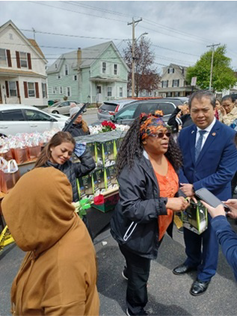
Lowell
Dwelling House of Hope recently held Mother’s Day outreach events, distributing over 600 baskets of food and 350 Mother’s Day gift bags. In addition to the food, these boxes and bags contained PPE, information about upcoming COVID clinics throughout Greater Lowell, and self-care items for moms and the whole family. They were joined by MA State Representative Vanna Howard and Mayor for the City of Lowell Sokhary Chau.
Image (from left to right): Rep. Vanna
Howard, Dwelling House of Hope Executive Director Levenia Furusa, Mayor Sokhary Chau
Read More Highlights
multiple languages)
COVID-19 Vaccination Tools for Employers
Archive of COVID-19 Vaccine Communications Updates (past editions of VEI Roundup)
FIND A COVID-19 VACCINE OR BOOSTER

Vaccine Finder
Find, Schedule, or Sign Up for a Mobile COVID-19 Vaccination COVID-19 In-Home Vaccination Program
Request a Copy of Your Vaccine Card
COVID-19 VACCINE STANDING ORDERS (FROM CDC)

Pfizer
5-11 (updated 3/31/22)
12 + Gray Cap(updated 4/22/22)
12 + Purple Cap (updated 4/22/22)
Moderna (updated 4/22/22)
Janssen (updated 4/26/22)
Recent Highlights

Please note: There will be no VEI Roundup on May 27. Wishing everyone a happy,
healthy, and safe Memorial Day weekend!
Visit the VEI Website
Share This Email
Share This Email
Share This Email

Vaccine Equity Initiative | 250 Washington Street, Boston, MA 02108

Unsubscribe vaccineequityinitiative@mass.gov Constant Contact Data Notice
Sent byvaccineequityinitiative@mass.govin collaboration with
Try email marketing for free today!

