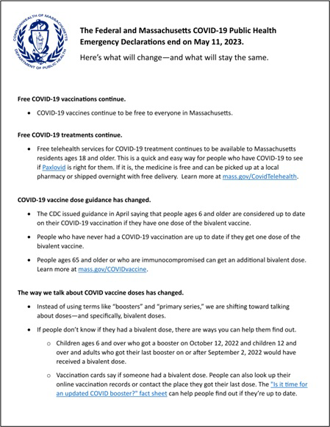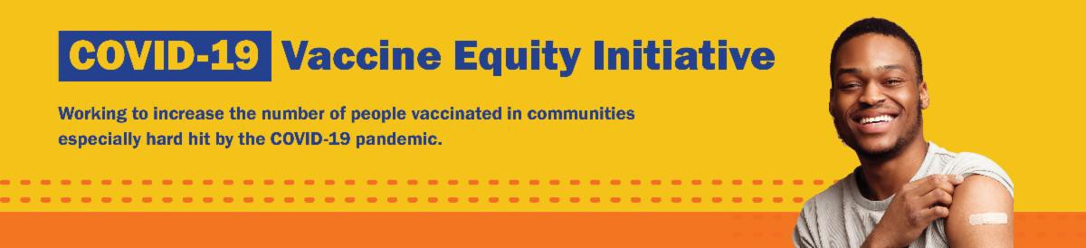

END OF THE COVID-19 PUBLIC HEALTH EMERGENCY: WHAT DOES IT MEAN?

The Federal and Massachusetts COVID-19 Public Health Emergency Declarations ended on May 11, 2023.

Now in 13 languages, this informational sheet gives an overview of what has changed — and what has stayed the same.
Reminders
May 26, 2023
Here are the latest resources for promoting COVID-19 vaccination to share with your colleagues
and networks across Massachusetts. If you received this from a colleague, subscribe today.

View this email online.
What's New

NEW FLYER: IS IT TIME FOR AN UPDATED COVID BOOSTER?

COVID-19 is changing, and so is the way we protect against it.

This new flyer overviews spring and

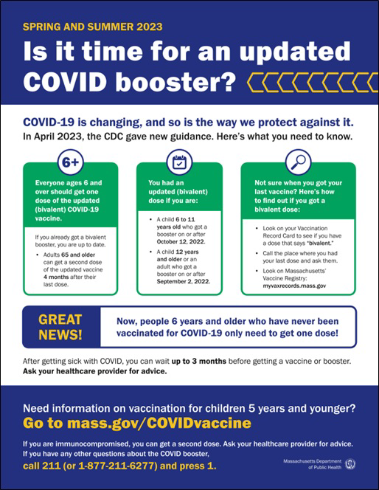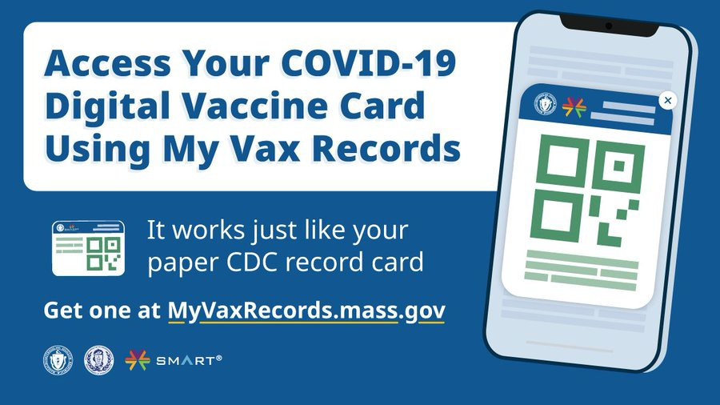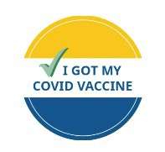summer 2023 guidance for COVID-19
vaccination, based on the CDC's recently updated vaccine recommendations. More languages available soon!

Other materials, like flyers and social media graphics, are also available in our online toolkit.

MY VAX RECORDS: A DIGITAL VACCINE CARD FOR MASSACHUSETTS RESIDENTS

Can't remember when you had your last COVID dose? Need a copy of your COVID vaccination record? Massachusetts residents can use My Vax Records to get a digital vaccine card. Learn more.

Info about My Vax Records is available in ASL, courtesy of the Learning Center for the Deaf.

NEED A COVID-19 VACCINE? HERE'S HOW TO FIND ONE

Free COVID-19 vaccine clinics are being held throughout Massachusetts!

To find a COVID-19 vaccine clinic near you: Search vaccines.gov for appointments Find a local mobile clinic near you Learn more about in-home vaccination

Questions? Call 211 (or 877-211-6277) and press 1. Calls are answered Monday through Friday, 9 a.m. to 5 p.m.

You can also learn more about how to prepare for your vaccine appointment.
Key Resources

OUTREACH AND EDUCATION MATERIALS
This spring, Asian Women for Health
(AWFH) has cohosted three educational events in Boston and Lowell, reaching over 500 attendees. At these events, they have been addressing attendees' questions about the COVID-19 vaccine, including discussing the safety of the vaccine for pregnant people and the vaccine's halal status. AWFH has also been distributing multilingual COVID-19 educational materials, including materials in Khmer, Chinese, Vietnamese, Korean, and Japanese.
Read More Highlights
Visit the VEI Website
Share This Email
Share This Email
Share This Email
Highlights

COVID-19 Vaccine FAQs
COVID-19 Therapeutic Information (including telehealth) Weekly Provider Bulletin
Trust the Facts, Get the Vax Campaign Materials (organized by audience, including general, parents, youth, and young adults; available in 12 languages)
Multilingual COVID-19 Materials (videos and printables; organized by language) Archive of COVID-19 Vaccine Communications Updates (past editions of VEI Roundup)

FIND A COVID-19 VACCINE DOSE

Use Vaccines.gov to sign up for a COVID-19 vaccine appointment Find a community COVID-19 vaccination clinic near you
Learn about the COVID-19 In-Home Vaccination Program and request a visit Request a copy of your vaccine card

Vaccine Equity Initiative | 250 Washington Street, Boston, MA 02108

Unsubscribe vaccineequityinitiative@mass.gov Constant Contact Data Notice
Sent by vaccineequityinitiative@mass.gov in collaboration with
Try email marketing for free today!

