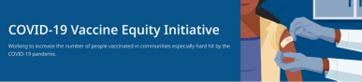May 6, 2022
Here are the latest resources for promoting COVID-19 vaccination to share with your colleagues and networks across Massachusetts. If you received this from a colleague, subscribe today.
Spotlight: Resources for Promoting COVID-19 Treatments
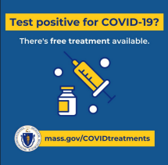
Free, safe, and effective treatments for
COVID-19 are available across MA. They
can help prevent hospitalizations and
reduce the risk of severe disease.
People who test positive for COVID-19 and
have any symptoms, even mild ones (such
as runny nose or cough) should contact
their doctor about available treatments.
The sooner treatment is started, the
better.
Please share the resources below with
your communities to help promote these
lifesaving treatments.
PROMOTIONAL MATERIALS
Flyers:
- Informational flyers are available for download in 12 languages
Videos featuring local physicians discussing COVID treatment options:
- Dr. Sandeep Jubbal, UMass Medical Center
- Dr. Estevan Garcia, Chief Medical Officer, DPH
- Dr. Esteban DelPilar, Baystate Medical (in Spanish)
Social media resources:
Retweet DPH, or use these sample tweets:
- If you have recently tested positive for #COVID19MA and are experiencing symptoms, there are free treatment options that may be right for you. Contact your doctor or call the self-referral line at 508-213-1380. mass.gov/covidtreatments

- Have you tested positive for COVID-19? Experiencing symptoms? Contact your doctor to find a treatment that’s right for you. mass.gov/covidtreatments
- The COVID-19 pills and monoclonal antibody treatments can help keep you out of the hospital. They are free and available statewide. Learn more: mass.gov/covidtreatments
HOW TO ACCESS FREE COVID-19 TREATMENT
These treatments are safe, effective, and free. MA has supply available to meet the needs of all residents who can benefit from these treatments. There are several ways to access treatment:
- Request a free telehealth consultation, where MA residents can be evaluated directly for COVID-19 treatment, without contacting their health care provider.
- Call your doctor right away to learn about treatment options if you are positive for COVID-19.
- Call 508-213-1380 to speak with a Gothams representative. If you're eligible for COVID-19 treatment, they can schedule an infusion appointment for you at one of their 7 sites in Massachusetts. Gothams COVID-19 Self-Referral Treatment Line is open Monday–Saturday from 8 a.m. to 6 p.m.
- Use the COVID-19 Therapeutic Locator to find health care facilities accepting referrals. This tool assists in locating health care facilities who have a supply of monoclonal antibodies or oral antivirals and are accepting referrals for therapy.
- In-home treatment is available for MA residents with difficulty accessing treatment in the community. Patients can get prescriptions through the program, or the program can work with a patient's health care provider.
For more information about COVID-19 treatments, visit mass.gov/covidtreatment. Reminders
YMCA HEALTHY KIDS DAY COVID-19 VACCINATION CLINICS CONTINUE
DPH is partnering with the YMCA to
provide COVID-19 vaccination clinics in
several communities as part of the YMCA’s
Healthy Kids Day. Clinics will be held
through early May. View the schedule.
Healthy Kids Day celebrates children’s
mental and physical health. Learn more.

Key Resources
OUTREACH AND EDUCATION MATERIALS
- COVID-19 Vaccine FAQs
- COVID-19 Booster FAQs
- Weekly Provider Bulletin (published 5/3)
- Trust the Facts, Get the Vax Campaign Materials (organized by audience, including general, parents and pregnant people, youth, young adults; available in 12 languages)
- Trust the Facts, Get the Vax Creative Materials Toolkit (updates ongoing, including pediatric eligibility)
- Additional Education and Outreach Materials (includes social media graphics, vaccine updates, guides to hosting a forum, and more)
- Multilingual COVID-19 Materials (videos and printables; organized by language)
- COVID-19 Funeral Assistance from FEMA (including 1-pager with key info available in multiple languages)
- COVID-19 Vaccination Tools for Employers
- Archive of COVID-19 Vaccine Communications Updates (past editions of VEI Roundup)
FIND A COVID-19 VACCINE OR BOOSTER
- Vaccine Finder
- Find, Schedule, or Sign Up for a Mobile COVID-19 Vaccination
- COVID-19 In-Home Vaccination Program
- Request a Copy of Your Vaccine Card
COVID-19 VACCINE STANDING ORDERS (FROM CDC)
- Pfizer
  - 5-11 (updated 3/31/22)
  - 12 + Gray Cap (updated 4/22/22)
  - 12 + Purple Cap (updated 4/22/22)
- Moderna (updated 4/22/22)
- Janssen (updated 4/26/22)
Recent Highlights
Randolph
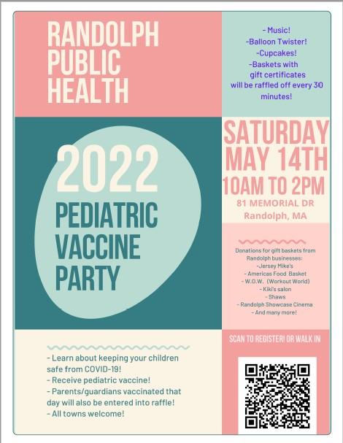
On Saturday, May 14, Randolph will host a
pediatric vaccine party from 10 a.m. to 2 p.m.
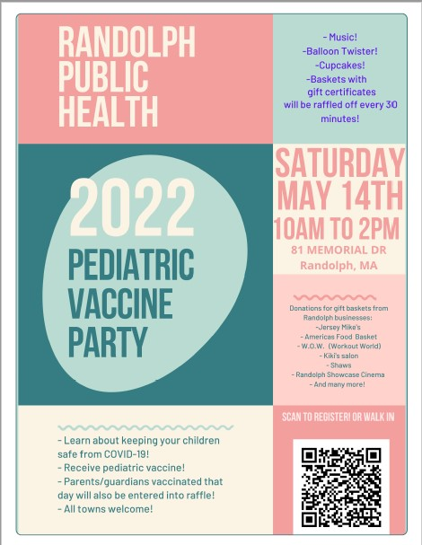
at 81 Memorial Drive (flyer, right). There will
be music, a balloon twister, and cupcakes, as
well as raffles for prizes from Randolph
businesses. Pediatric and adult vaccines will
be available; those vaccinated will be entered
into the raffle. Attendees can pre-register or
walk in. Learn more about COVID-19
vaccinations for children ages 5-11.
Read More Highlights
Visit the VEI Website
Vaccine Equity Initiative | 250 Washington Street, Boston, MA 02108
Unsubscribe vaccineequityinitiative@mass.gov
Constant Contact Data Notice
Sent byvaccineequityinitiative@mass.govin collaboration
with
Try email marketing for free today!

