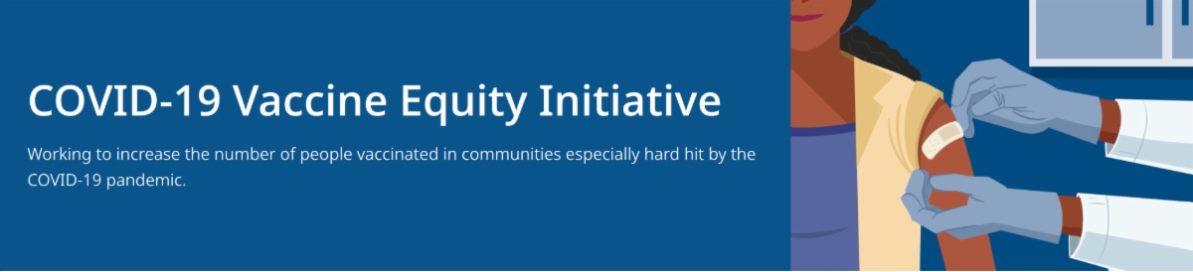
COVID-19 VACCINE CLINICS IN JUNE — $100 GIFT CARDS AVAILABLE

DPH is providing COVID-19 vaccination clinics with special giveaways in several communities during the month of June. People receiving a first dose will be eligible for a $100 grocery gift card (while supplies last). Families are welcome! View the full schedule.
UPDATED MASK ADVISORY FROM MA DPH

News release (6/10) - DPH has released updated guidance regarding the use of masks in MA. Effective July 1, the new guidance advises that masks indoors are optional for most individuals, regardless of vaccination status. MA residents have ready access to vaccines, rapid tests, and therapeutics – all the resources needed to prevent severe illness. Read more.

Reminders
June 10, 2022
Here are the latest resources for promoting COVID-19 vaccination to share with your colleagues
and networks across Massachusetts. If you received this from a colleague, subscribe today.

View this email online.
What's New

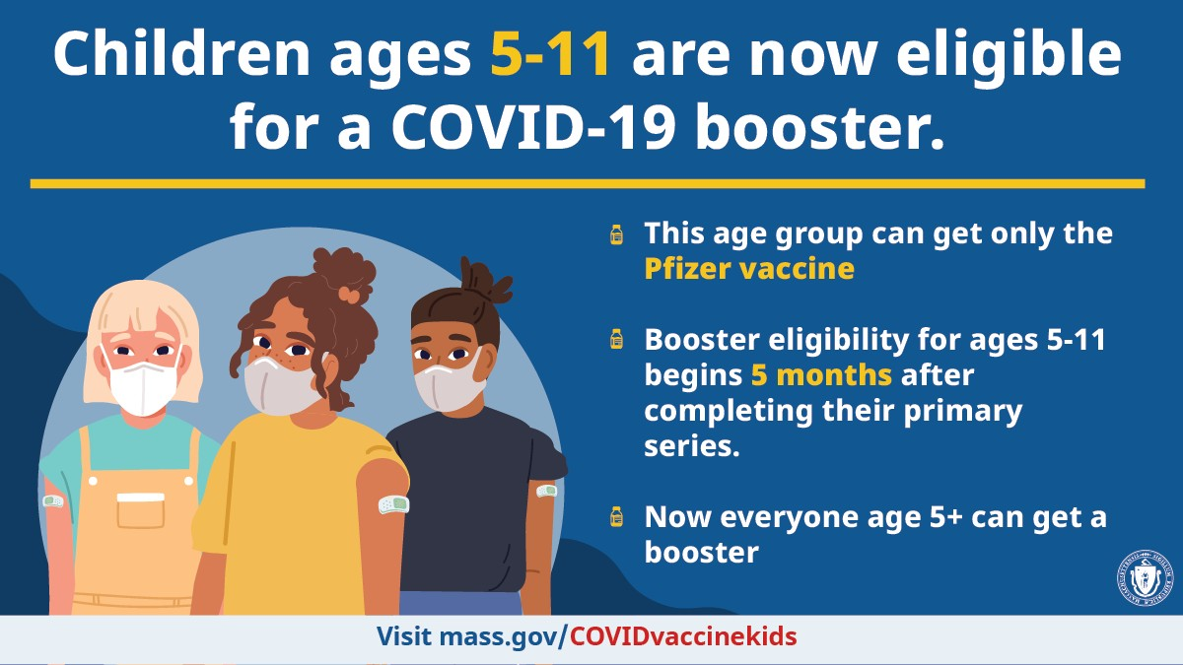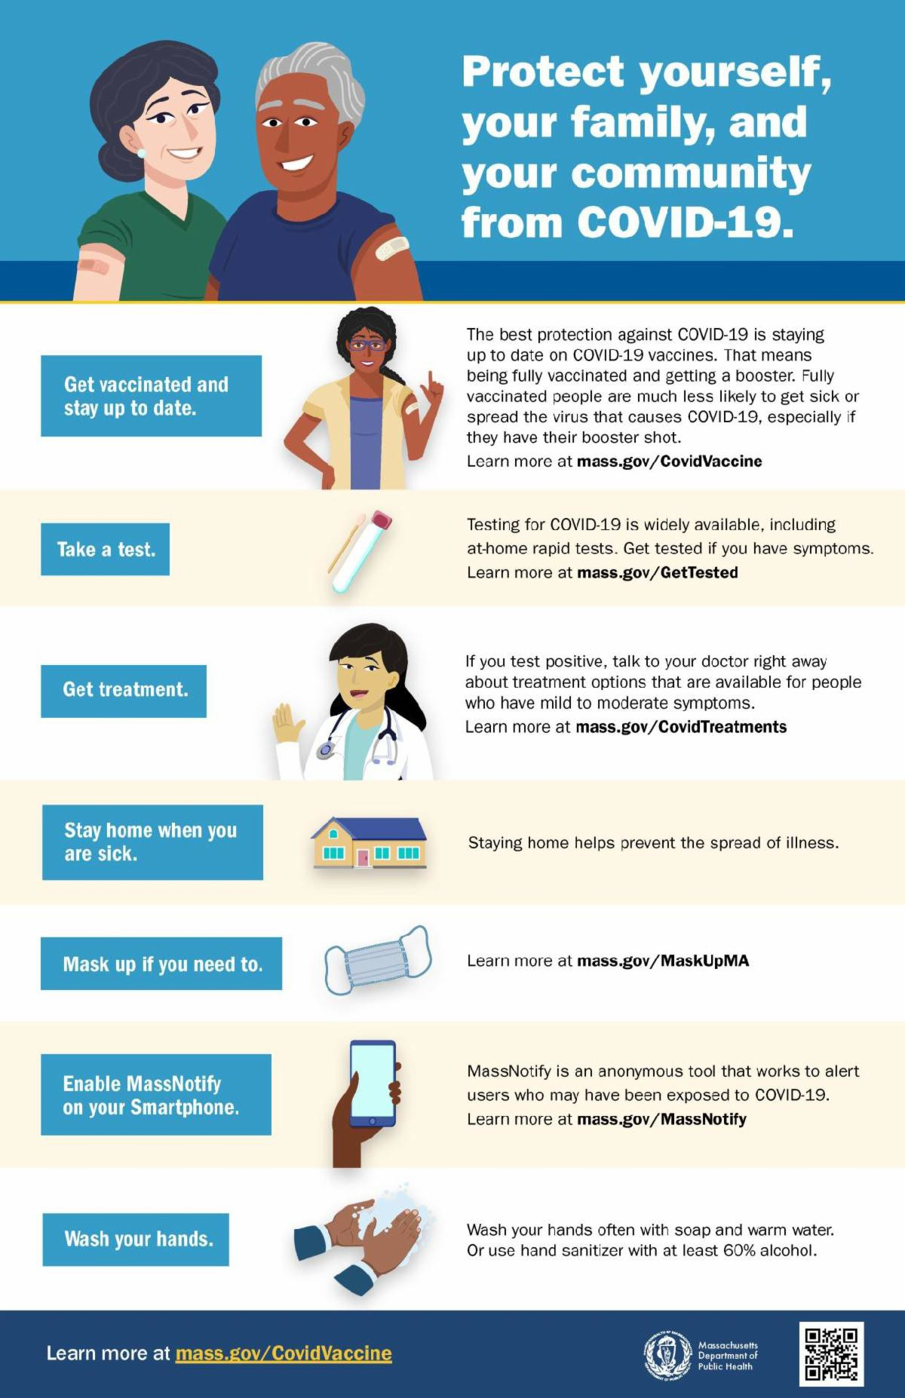CHILDREN AGES 5-11 NOW ELIGIBLE FOR A COVID-19 BOOSTER

All MA residents ages 5-11 are now eligible to receive a Pfizer COVID-19 booster, beginning five months after their initial Pfizer vaccination series. Learn more.

IN-HOME COVID-19 VACCINATIONS AVAILABLE

The COVID-19 In-Home Vaccination Program is a resource for anyone who has difficulty getting to or using a community vaccination location.

SEVEN STEPS TO PROTECT YOU AND YOUR FAMILY FROM COVID

Available in multiple languages, this flyer features a checklist to help protect
yourself, your family, and your community from COVID-19. Please share it with your networks.

COVID-19 ISOLATION AND QUARANTINE GUIDANCE

Updated COVID-19 isolation and quarantine guidance is available for the following groups:

General public
Children in child care, K-12, out-of- school time (OST) and recreational

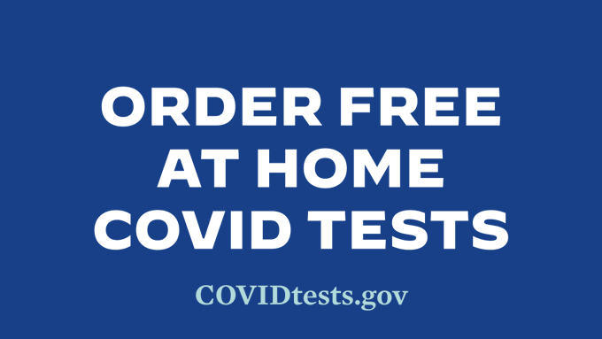
camp/program settings
MORE AT-HOME TESTS AVAILABLE FREE VIA US POSTAL SERVICE

Every U.S. household is now eligible to order a third round of free at- home COVID-19 tests. Learn more and order yours today.
Key Resources

OUTREACH AND EDUCATION MATERIALS

COVID-19 Vaccine FAQs COVID-19 Booster FAQs
Weekly Provider Bulletin (published 6/6/22)
Trust the Facts, Get the Vax Campaign Materials (organized by audience, including general, parents and pregnant people, youth, young adults; available in 12 languages) Trust the Facts, Get the Vax Creative Materials Toolkit (updates ongoing, including pediatric eligibility)
Additional Education and Outreach Materials (includes social media graphics, vaccine updates, guides to hosting a forum, and more)
Multilingual COVID-19 Materials (videos and printables; organized by language) COVID-19 Funeral Assistance from FEMA (including one-pager with key info available in multiple languages)
COVID-19 Vaccination Tools for Employers
Archive of COVID-19 Vaccine Communications Updates (past editions of VEI Roundup)

FIND A COVID-19 VACCINE OR BOOSTER

Vaccine Finder
Find, Schedule, or Sign Up for a Mobile COVID-19 Vaccination COVID-19 In-Home Vaccination Program
Request a Copy of Your Vaccine Card

COVID-19 VACCINE STANDING ORDERS (FROM CDC)

Pfizer
5-11 (updated 5/24/22)
12 + Gray Cap (updated 5/24/22)
12 + Purple Cap (updated 5/24/22)
Moderna (updated 5/24/22)
Janssen (updated 5/24/22)
Recent Highlights
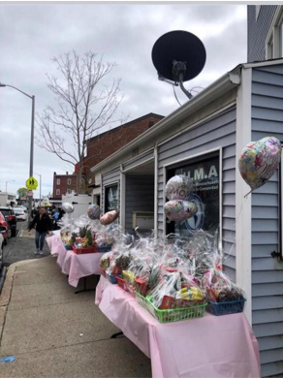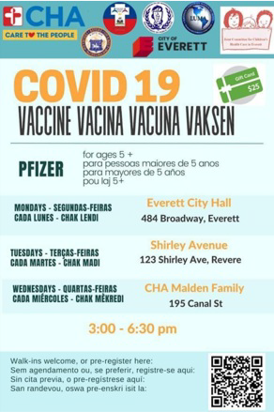Everett

Latinos Unidos en Massachusetts (LUMA) has been weaving COVID mitigation and vaccine clinic information into their many community programs and activities, such as by educating participants in their ESL classes (for whom they also provide PPE kits). LUMA distributed flyers with vaccine clinic information at a recent Earth Day event, as well as with the 100 fruit baskets they distributed for Mother’s Day (see images). LUMA promotes vaccine clinics on their website, where they also host COVID vaccine promotion videos they’ve created.
Videos in Portuguese will soon be ready, and all videos will be promoted through social media and on partner websites.

Read More Highlights

Share This Email
Share This Email
Share This Email

Visit the VEI Website

Vaccine Equity Initiative | 250 Washington Street, Boston, MA 02108 Unsubscribe vaccineequityinitiative@mass.gov
Constant Contact Data Notice
Sent by vaccineequityinitiative@mass.gov in collaboration with
Try email marketing for free today!

