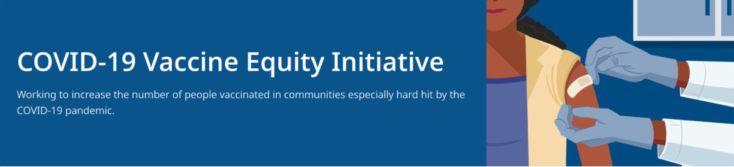
June 17, 2022
Here are the latest resources for promoting COVID-19 vaccination to share with your colleagues
and networks across Massachusetts. If you received this from a colleague, subscribe today.

View this email online.
A NOTE ON COVID-19 VACCINES FOR CHILDREN 6 MONTHS AND OLDER

The CDC is poised to approve two vaccines for children 6 months and older, as soon as this weekend. If this happens, vaccines could be available to young children starting on Tuesday. In next week’s VEI Roundup, we’ll share resources about vaccinations for ages 6 months to 5 years.
What's New

NEW RESOURCES FOR PROMOTING COVID-19 TREATMENTS

Free, safe, and effective treatments for COVID-19 are available across MA. They can help prevent hospitalizations and reduce the risk of severe disease.

Several new resources are available to help promote these treatments:

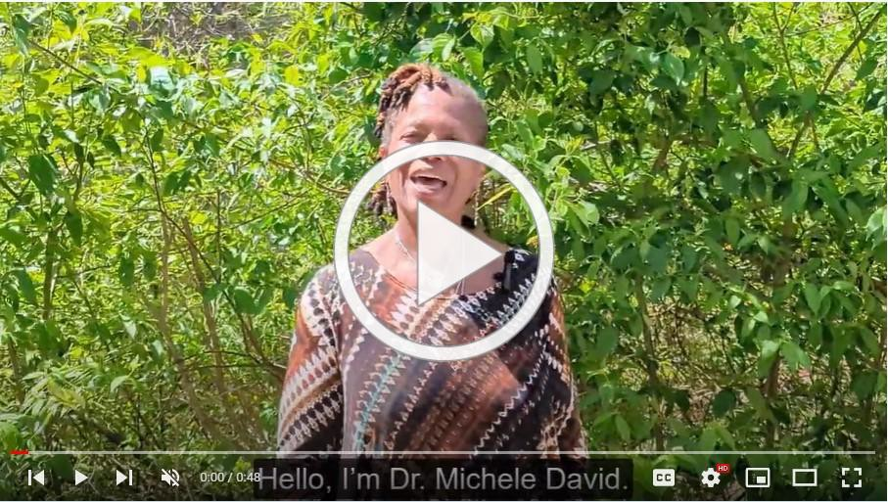Videos:
In this new video, Dr. Michele David of MIT Medical discusses COVID-19 treatments that are widely available in MA.

Flyers:
A new flyer promoting MA's free telehealth service is available in English, Spanish, Portuguese, and Haitian Creole.
The flyer is also available in a

double-sided, multilingual version.

Above: Dr. Michele David discusses available COVID-19 treatments.

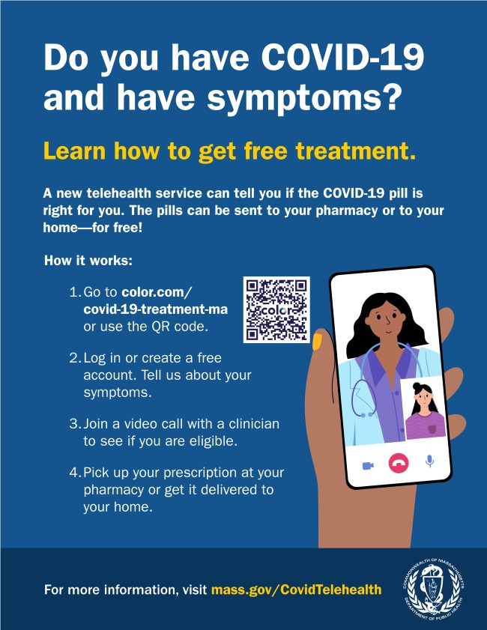
Please share these resources, and learn
more about treatments for COVID-19.
Reminders

COVID-19 VACCINE CLINICS IN JUNE — $100 GIFT CARDS AVAILABLE

DPH is providing COVID-19 vaccination clinics with special giveaways in several communities during the month of June. People receiving a first dose will be eligible for a $100 grocery gift card (while supplies last). Families are welcome! View the full schedule.

UPDATED MASK ADVISORY FROM MA DPH

News release (6/10) - DPH has released updated guidance regarding the use of masks in MA. Effective July 1, the new guidance advises that masks indoors are optional for most individuals, regardless of vaccination status. MA residents have ready access to vaccines, rapid tests, and therapeutics—all the resources needed to prevent severe illness. Read more.

ENABLE MASSNOTIFY ON YOUR SMARTPHONE

More than 2 million MA residents now use MassNotify, a tool that works through smartphones—with a focus on privacy —to alert users who may have been exposed to COVID-19. Learn more.

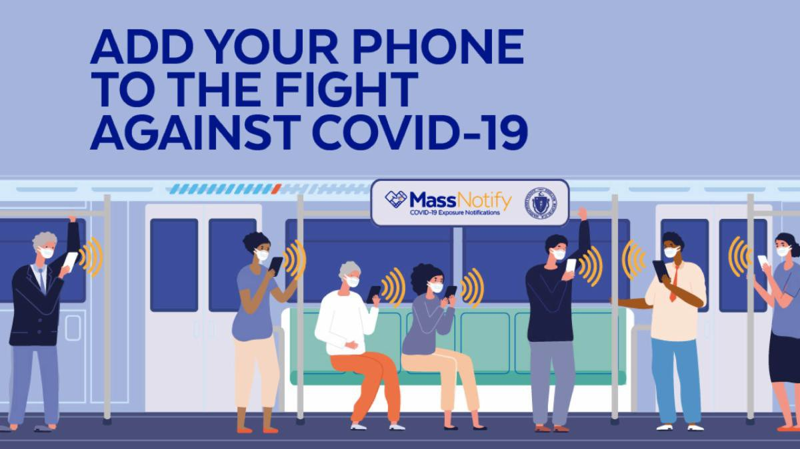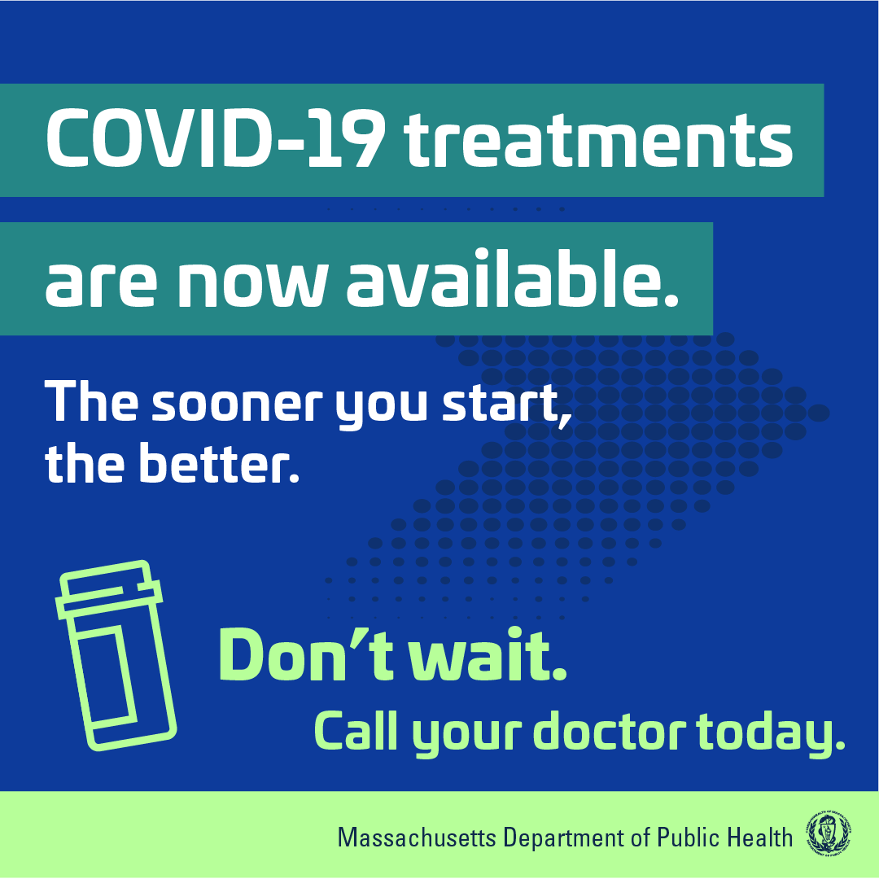
OUTREACH AND EDUCATION MATERIALS

COVID-19 Vaccine FAQs COVID-19 Booster FAQs Weekly Provider Bulletin
Trust the Facts, Get the Vax Campaign Materials (organized by audience, including general, parents and pregnant people, youth, young adults; available in 12 languages) Trust the Facts, Get the Vax Creative Materials Toolkit (updates ongoing, including pediatric eligibility)
Additional Education and Outreach Materials (includes social media graphics, vaccine updates, guides to hosting a forum, and more)
Multilingual COVID-19 Materials (videos and printables; organized by language)
COVID-19 Funeral Assistance from FEMA (including one-pager with key info
Key Resources

FREE COVID-19 TREATMENTS AVAILABLE

Have you tested positive for COVID-19? Free treatment options are available that can help reduce your symptoms and prevent you from getting seriously sick. The sooner you start, the better. Call your doctor ASAP and learn more.

MULTILINGUAL COVID-19 RESOURCES FROM DPH

Resources to support COVID-19 vaccine promotion and education, organized by language. Includes videos and printables on topics like vaccine safety, pregnancy and the vaccine, and FAQs.

Worcester
On May 22, UHAI for Health, Inc. hosted a “Mental Health Awareness, COVID-19 Update & Fundraiser” event. Medical and public health professionals spoke to youth and families about destigmatizing mental health conversations in the community, making space for self-care, and prioritizing their collective well-being. The youth hosted a cultural fashion show (see image), including food showcasing the variety of cultures in attendance. All attendees received COVID at-home test kits and masks; they also had the opportunity to be vaccinated on site.
Read More Highlights
Visit the VEI Website
Share This Email
Share This Email
Share This Email
available in multiple languages)
COVID-19 Vaccination Tools for Employers
Archive of COVID-19 Vaccine Communications Updates (past editions of VEI Roundup)
FIND A COVID-19 VACCINE OR BOOSTER

Vaccine Finder
Find, Schedule, or Sign Up for a Mobile COVID-19 Vaccination COVID-19 In-Home Vaccination Program
Request a Copy of Your Vaccine Card
COVID-19 VACCINE STANDING ORDERS (FROM CDC)

Pfizer
5-11 (updated 5/24/22)
12 + Gray Cap (updated 5/24/22)
12 + Purple Cap (updated 5/24/22)
Moderna (updated 5/24/22)
Janssen (updated 5/24/22)
Recent Highlights

Vaccine Equity Initiative | 250 Washington Street, Boston, MA 02108 Unsubscribe vaccineequityinitiative@mass.gov
Constant Contact Data Notice
Sent by vaccineequityinitiative@mass.gov in collaboration with
Try email marketing for free today!

