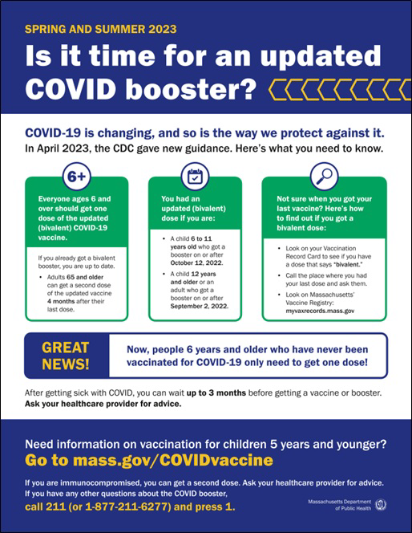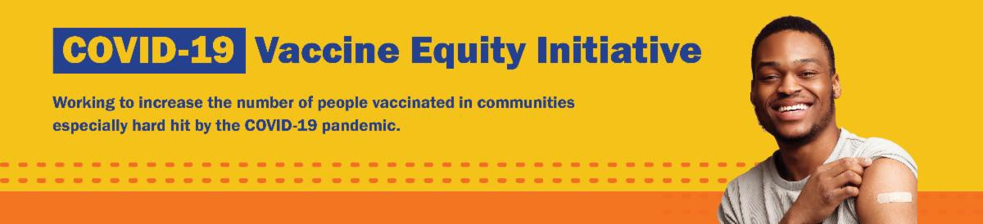

NOW IN 13 LANGUAGES: "IS IT TIME?" FACTSHEET

COVID-19 is changing, and so is the way we protect against it.

This flyer provides an overview of spring and summer 2023 guidance for COVID-19 vaccination. Now available in 13 languages!

Thanks to the Learning Center for the Deaf, this info is also available in ASL .

Can't remember when you had your last COVID vaccine dose? Massachusetts residents can use My Vax Records to get a digital vaccine card. Learn more.
Reminders
June 23, 2023
Here are the latest resources for promoting COVID-19 vaccination to share with your colleagues
and networks across Massachusetts. If you received this from a colleague, subscribe today.

View this email online.
What's New

NEED A COVID-19 VACCINE? HERE'S HOW TO FIND ONE

Free COVID-19 vaccine clinics are being held throughout Massachusetts!

To find a COVID-19 vaccine clinic near you:

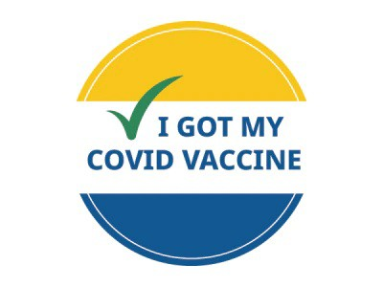
Search vaccines.gov for
appointments
Find a community vaccination clinic Learn more about in-home vaccination

Questions? Call 211 (or 877-211-6277) and press 1. Calls are answered Monday through Friday, 9 a.m. to 5 p.m.

You can also learn more about how to prepare for your vaccine appointment.

FREE COVID TREATMENT AVAILABLE VIA PHONE OR ONLINE

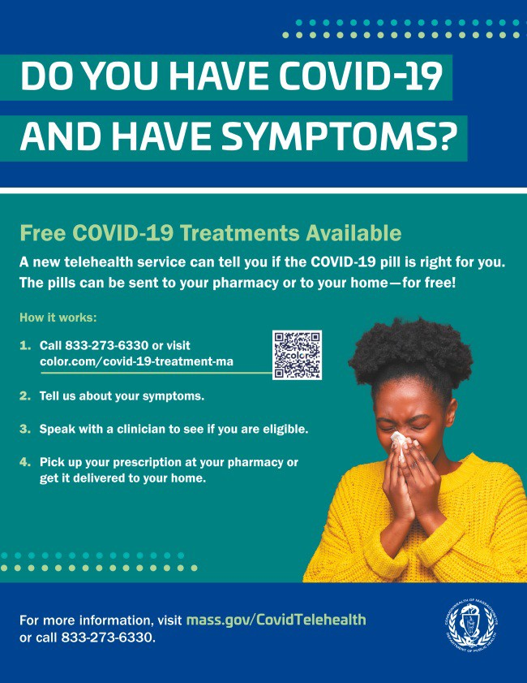
Free, safe, and effective treatments for COVID-19 are available across Massachusetts. They can help prevent hospitalizations and reduce the risk of severe disease.

Telehealth consultations are available via phone at 833-273-6330, in addition
to online. Consultations can be accessed in 10+ languages.

Please share: Flyers are available in multiple languages!

COVID-19 VACCINE PROMOTION TOOLKIT CONTINUES TO BE UPDATED

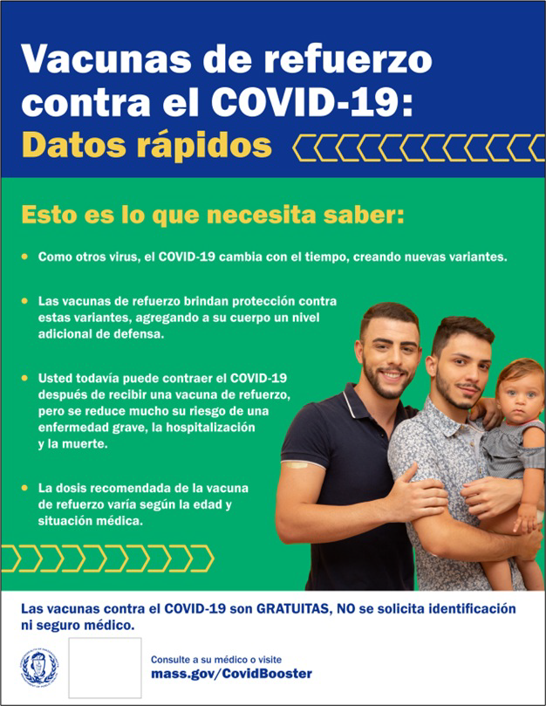
Our COVID-19 vaccine promotion toolkit continues to be updated with refreshed flyers, social media graphics, and more!

Recently updated items include customizable COVID-19 Boosters: Fast Facts flyers, available in 13 languages.

Don't see what you need? Looking for items in additional languages? Email us and let us know!

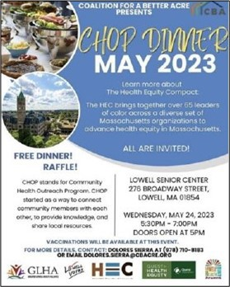
On May 24, Coalition for a Better Acre
(based in Lowell) hosted one of its monthly Community Health Outreach Program (CHOP) dinners, which aim to connect community members and share information about local health resources (see flyer). During the May dinner, community members learned about the Health Equity Compact, an organization that brings together leaders of color across Massachusetts to advance health equity.
COVID-19 vaccines were also available for attendees. The next CHOP dinner will be held on June 28.
Read More Highlights
Share This Email
Share This Email
Share This Email
Highlights
Key Resources

OUTREACH AND EDUCATION MATERIALS

COVID-19 Vaccine FAQs
COVID-19 Therapeutic Information (including telehealth) Weekly Provider Bulletin
Trust the Facts, Get the Vax Campaign Materials (organized by audience, including general, parents, youth, and young adults; available in 12 languages)
Multilingual COVID-19 Materials (videos and printables; organized by language) Archive of COVID-19 Vaccine Communications Updates (past editions of VEI Roundup)

FIND A COVID-19 VACCINE DOSE

Use Vaccines.gov to sign up for a COVID-19 vaccine appointment Find a community COVID-19 vaccination clinic near you
Learn about the COVID-19 In-Home Vaccination Program and request a visit Request a copy of your vaccine card

Visit the VEI Website

Vaccine Equity Initiative | 250 Washington Street, Boston, MA 02108

Unsubscribe vaccineequityinitiative@mass.gov Constant Contact Data Notice
Sent by vaccineequityinitiative@mass.gov in collaboration with
Try email marketing for free today!

