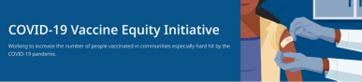June 24, 2022
Here are the latest resources for promoting COVID-19 vaccination to share with your colleagues and networks across Massachusetts. If you received this from a colleague, subscribe today.
View this email online.
What's New
CHILDREN AGES 6 MONTHS+ NOW ELIGIBLE FOR COVID-19 VACCINATION
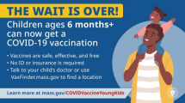
Children ages 6 months and older are now
eligible to get vaccinated against COVID
19. Call your child’s health care provider or
visit Vaxfinder.mass.gov to find an
appointment. Learn more.
Please help spread the word:
- Retweet DPH on Twitter
- Share this video about vaccine
safety and efficacy (in English and
Spanish)
- Use a DPH social media graphic
(option 1 & option 2)
EMPLOYMENT OPPORTUNITIES: MDPH COMMUNITY ENGAGEMENT UNIT
MDPH is seeking 11 dedicated professionals to join the new Community Engagement (CE) team within the Office of Health Equity (OHE). The OHE is dedicated to eliminating inequities and improving the quality of life in historically marginalized communities by addressing immediate health related social needs and strengthening community safety nets. Learn more.
Current job openings:
- Health Equity Managers: Contribute to policy development and strategic planning, work with the OHE senior team to implement the program launch process, and oversee daily implementation of community-based technical assistance. Apply here.
- Health Equity Strategists and Coordinators: Provide collaborative community engagement by providing technical assistance and trainings for community partners, dissemination of key resources, and supporting communication between the community and DPH for six priority populations in the following communities: LGBTQ+
Tribal & Indigenous - Apply here
Black & African American
Latino
Asian American & Pacific Islander
Immigrant & Refugee
Please note: Preference is given to applications received within 14 days of posting. Please consider applying by 7/6 for Manager roles and 6/29 for the Tribal & Indigenous role.
Reminders
NEW RESOURCES FOR PROMOTING COVID-19 TREATMENTS
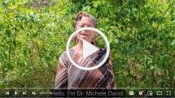
Free, safe, and effective treatments for
COVID-19 are available across MA. They
can help prevent hospitalizations and
reduce the risk of severe disease.
Several new resources are available to help
promote these treatments:
Videos:
In this new video, Dr. Michele David of MIT Medical discusses COVID-19 treatments that are widely available in MA.
Flyers:
New flyer is in English, Spanish,
Portuguese, and Haitian Creole. Other languages available in
a double-sided, multilingual
version.
Web resources:
Info about the telehealth program is available in English, Spanish,
Portuguese, and Haitian Creole.
Please share these resources, and learn more about treatments for COVID-19.

Above: Dr. Michele David discusses available COVID-19 treatments.
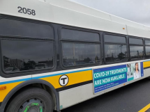
Above: DPH ads for COVID-19 treatments are "rolling out" at MBTA stations!
COVID-19 VACCINE CLINICS IN JUNE — $100 GIFT CARDS AVAILABLE
DPH is providing COVID-19 vaccination
clinics with special giveaways during the month of June. People receiving a first
dose will be eligible for a 100 grocery gift
card (while supplies last). Families are
welcome! View locations and schedule.
MY VAX RECORDS — DIGITAL VACCINE CARD FOR MA RESIDENTS
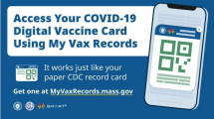
Need a copy of your COVID-19 vaccination
record? MA residents can use My Vax
Records to get a digital vaccine card to
show they’ve been vaccinated against
COVID-19, if they choose. Learn more.
DON'T FORGET ABOUT TESTING
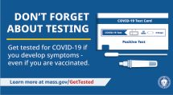
As you head out to gatherings this
summer, testing is a critical tool in the
fight against COVID-19. Get tested if you
develop symptoms — even if you're
vaccinated. Visit mass.gov/GetTested.
Key Resources
OUTREACH AND EDUCATION MATERIALS
- COVID-19 Vaccine FAQs
- COVID-19 Booster FAQs
- Weekly Provider Bulletin (published 6/20)
- Trust the Facts, Get the Vax Campaign Materials (organized by audience, including general, parents and pregnant people, youth, young adults; available in 12 languages)
- Trust the Facts, Get the Vax Creative Materials Toolkit (updates ongoing, including pediatric eligibility)
- Additional Education and Outreach Materials (includes social media graphics, vaccine updates, guides to hosting a forum, and more)
- Multilingual COVID-19 Materials (videos and printables; organized by language)
- COVID-19 Funeral Assistance from FEMA (including 1-pager with key info available in multiple languages)
- COVID-19 Vaccination Tools for Employers
- Archive of COVID-19 Vaccine Communications Updates (past editions of VEI Roundup)
FIND A COVID-19 VACCINE OR BOOSTER
- Vaccine Finder
- Find, Schedule, or Sign Up for a Mobile COVID-19 Vaccination
- COVID-19 In-Home Vaccination Program
- Request a Copy of Your Vaccine Card
COVID-19 VACCINE STANDING ORDERS (FROM CDC)
- Pfizer
  - 6 months - 4 years (updated 6/21/22)
  - 5-11 (updated 5/24/22)
  - 12 + Gray Cap (updated 5/24/22)
  - 12 + Purple Cap (updated 5/24/22)
- Moderna
  - 6 months - 5 years (updated 6/21/22)
  - 18+ years (updated 5/24/22)
- Janssen (updated 5/24/22)
Recent Highlights
Brockton
In Brockton, Health Imperatives and
Pinnacle Partnerships are supporting
COVID-19 vaccine outreach through
September. Pinnacle is working with the
City of Brockton, Brockton Public Schools,
and local organizations to support vaccine
clinics and COVID-19 test kit distribution,
and helping promote overall health and
well-being. Vaccinations are offered at
several locations in June, including at
children's parks in Brockton (photo: an ice
cream truck at a local Brockton clinic).
Read More Highlights

Visit the VEI Website
Vaccine Equity Initiative | 250 Washington Street, Boston, MA 02108
Unsubscribe vaccineequityinitiative@mass.gov
Constant Contact Data Notice
Sent byvaccineequityinitiative@mass.govin collaboration with
Try email marketing for free today!

