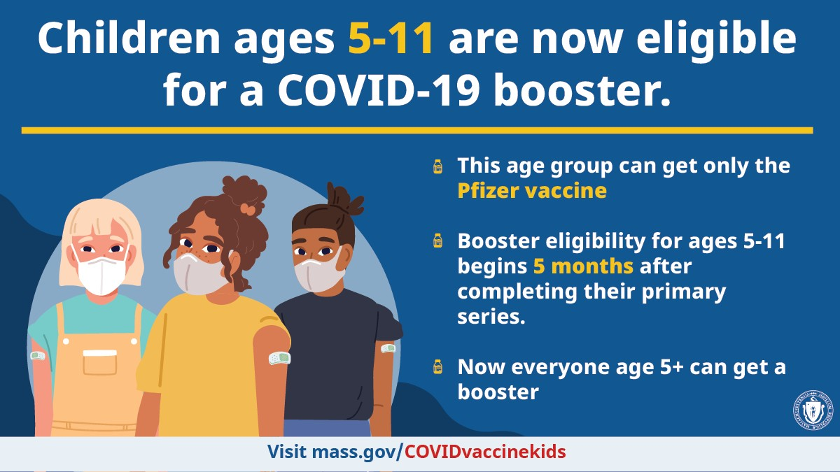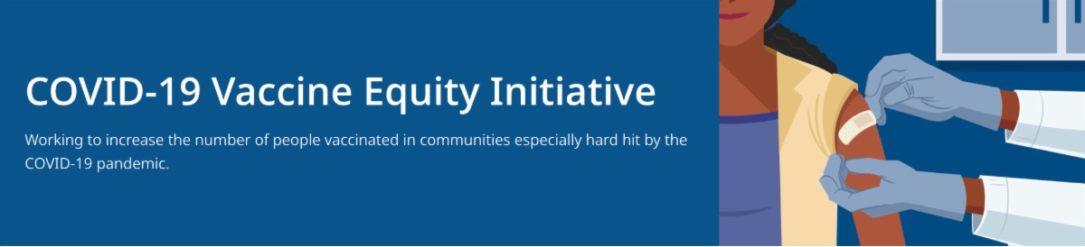
CHILDREN AGES 5-11 NOW ELIGIBLE FOR A COVID-19 BOOSTER

All MA residents ages 5-11 are now eligible to receive a Pfizer COVID-19 booster, beginning five months after their initial Pfizer vaccination series. Learn more.
FREE TELEHEALTH VISITS FOR COVID TREATMENT FOR MA RESIDENTS

COVID-19 ISOLATION AND QUARANTINE GUIDANCE

Updated COVID-19 isolation and quarantine guidance is available for the following groups:

General public
Children in child care, K-12, out-of- school time (OST) and recreational camp/program settings
Reminders
What's New
June 3, 2022
Here are the latest resources for promoting COVID-19 vaccination to share with your colleagues
and networks across Massachusetts. If you received this from a colleague, subscribe today.

View this email online.

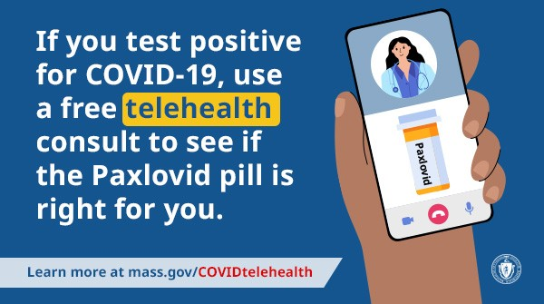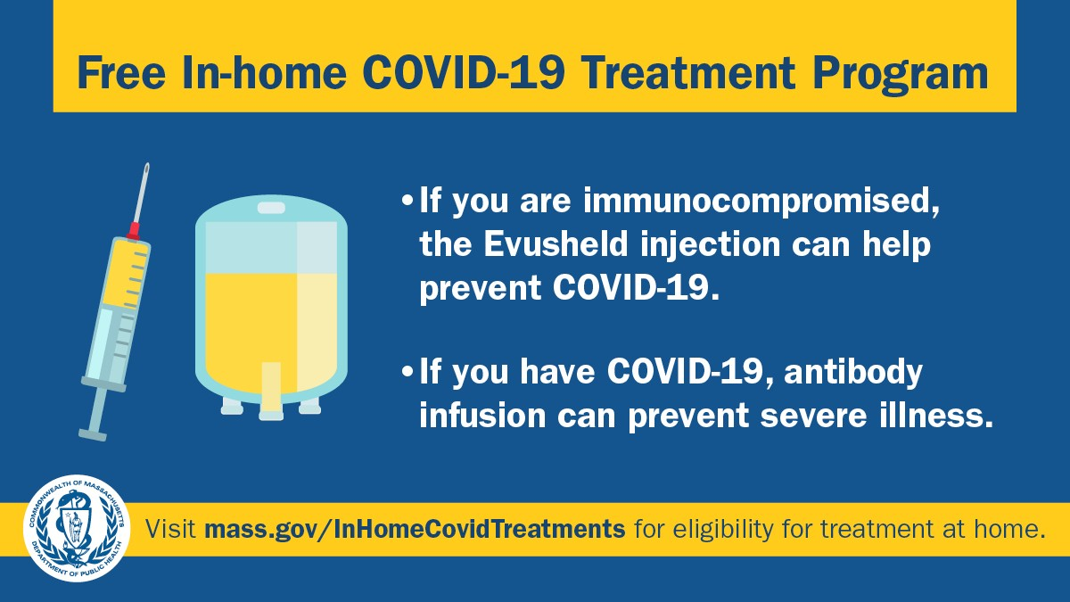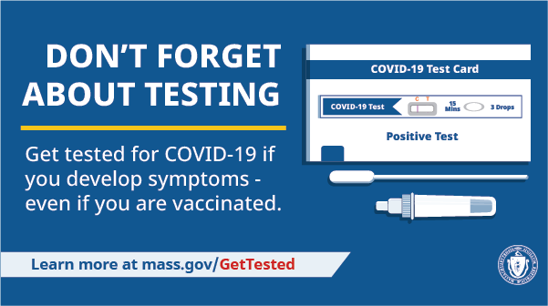A free telehealth service can help MA residents more easily access Paxlovid, a COVID-19 treatment pill.

Residents who test positive for COVID and have symptoms can be evaluated directly for treatment, without contacting their health care provider. If approved, prescriptions can be picked up at a local pharmacy or sent via free overnight delivery.
The service is available in multiple languages.

Questions about free COVID treatments? Info is available in 12 languages.

MA RESIDENTS MAY QUALIFY FOR IN-HOME COVID TREATMENT

In MA, eligible residents can receive in-home treatments like Evusheld to prevent COVID-19 and monoclonal antibody infusion to prevent severe illness. Learn more about eligibility.

DON'T FORGET ABOUT COVID-19 TESTING

As you head out to gatherings this summer, testing is a critical tool in the fight against COVID-19. Get tested if you develop symptoms—even if you're vaccinated. Visit mass.gov/GetTested.

CARING FOR YOUR EMOTIONAL HEALTH AND WELL-BEING DURING COVID

A variety of resources and tips are available from Massachusetts 211 to help boost emotional health, mental health, and well-being.

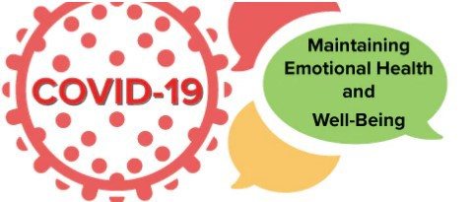
If you or someone you know
are experiencing a mental health crisis, find emergency/crisis supports in your area by
calling 877-382-1609 or visiting the emergency services web page.
Key Resources

OUTREACH AND EDUCATION MATERIALS

COVID-19 Vaccine FAQs COVID-19 Booster FAQs
Weekly Provider Bulletin (published 6/2/22)
Trust the Facts, Get the Vax Campaign Materials(organized by audience, including general, parents and pregnant people, youth, young adults; available in 12 languages)
Trust the Facts, Get the Vax Creative Materials Toolkit(updates ongoing, including pediatric eligibility)
Additional Education and Outreach Materials(includes social media graphics, vaccine updates, guides to hosting a forum, and more)
Multilingual COVID-19 Materials (videos and printables; organized by language)
COVID-19 Funeral Assistance from FEMA(including one-pager with key info available in multiple languages)
COVID-19 Vaccination Tools for Employers
Archive of COVID-19 Vaccine Communications Updates (past editions of VEI Roundup)

FIND A COVID-19 VACCINE OR BOOSTER

Vaccine Finder
Find, Schedule, or Sign Up for a Mobile COVID-19 Vaccination COVID-19 In-Home Vaccination Program
Request a Copy of Your Vaccine Card

COVID-19 VACCINE STANDING ORDERS (FROM CDC)

Pfizer
5-11 (updated 5/24/22)
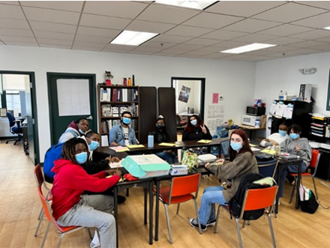Moderna (updated 5/24/22)
Janssen (updated 5/24/22)

Recent Highlights

Boston

In April, the Massachusetts Coalition for Occupational Safety and Health hosted a

training for teen workers through their
Teens Lead at Work program (see image). Thanks to COVID-19 Community Grants funding, 25 youth workers were able to participate and be compensated. Youth workers learned how to identify and address occupation and health safety in the workplace, such as assessing indoor air quality, taking COVID-19 mitigation measures, preventing workplace injuries, and organizing fellow youth workers to do the same. Prior to attending, several in the cohort got their first-ever COVID-19 vaccinations. Learn more about COVID vaccination for teens.

Read More Highlights

Share This Email
Share This Email
Share This Email

Visit the VEI Website

Vaccine Equity Initiative | 250 Washington Street, Boston, MA 02108 Unsubscribe vaccineequityinitiative@mass.gov
Constant Contact Data Notice
Sent by vaccineequityinitiative@mass.govin collaboration with
Try email marketing for free today!

