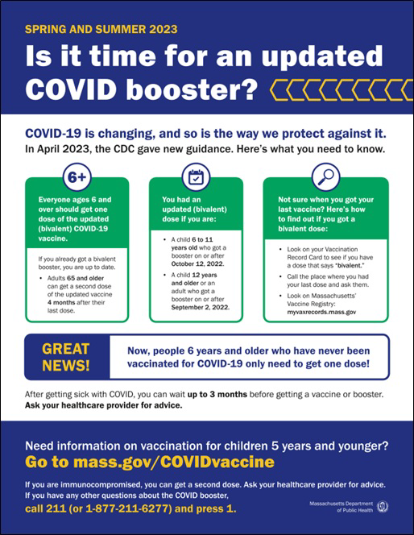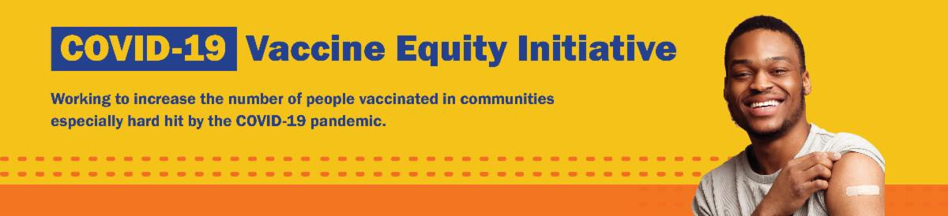

IS IT TIME FOR AN UPDATED COVID BOOSTER?

COVID-19 is changing, and so is the way we protect against it.

This flyer overviews spring and summer 2023 guidance for COVID-19 vaccination.

Now available in Spanish and Portuguese, with more languages coming soon!

Thanks to the Learning Center for the Deaf (TLC), this info is also available in ASL .
Reminders
June 9, 2023
Here are the latest resources for promoting COVID-19 vaccination to share with your colleagues
and networks across Massachusetts. If you received this from a colleague, subscribe today.

View this email online.
What's New

END OF THE COVID-19 PUBLIC HEALTH EMERGENCY: WHAT DOES IT MEAN?

The Federal and Massachusetts COVID-19 Public Health Emergency Declarations ended on May 11, 2023.

Now in 13 languages, this informational
sheet gives an overview of what has changed — and what has stayed the same.

This information is also available in ASL, courtesy of TLC.

MASSHEALTH REDETERMINATION IS ONGOING: HELP MEMBERS KEEP THEIR HEALTH CARE COVERAGE

In 2023, all current MassHealth members will need to renew their health coverage to ensure they still qualify for their current benefit.

These renewals started in April and will take place over 12 months. MassHealth is working to help members maintain coverage and raise awareness about the
renewal process. Info about MassHealth redetermination (intro and key points) is also available in ASL, courtesy of TLC.

Here's how you can help:

Remind members to update their addresses, report household changes, and read all mail from MassHealth
Share informational and outreach materials from this toolkit
Sign up for email notifications from MassHealth

FREE IN-HOME COVID-19 VACCINATION AVAILABLE

Massachusetts offers in-home COVID-19 vaccination for anyone who has difficulty getting to or using a community clinic, including children. Learn more, or call 833- 983-0485 to sign up for an appointment.

Info about in-home vaccination is available in multiple languages, including ASL (thanks to TLC).

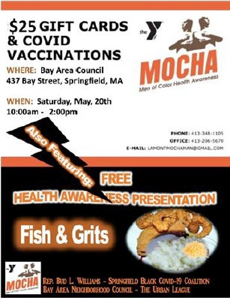
Black Springfield COVID-19 Coalition
hosted several events in May. On May 20, they cohosted a health awareness presentation with Men of Color Health Awareness (M.O.C.H.A.) to share information about the MassHealth redetermination and discuss long COVID (see flyer). On May 26, the Coalition hosted their Line Dance Re-Union, where community members were invited to an instructor-led dance class to encourage health and wellness through physical movement and dance. COVID-19 vaccines were offered at both events.
Read More Highlights
Visit the VEI Website
Share This Email
Share This Email
Share This Email
Highlights
Key Resources

OUTREACH AND EDUCATION MATERIALS

COVID-19 Vaccine FAQs
COVID-19 Therapeutic Information (including telehealth) Weekly Provider Bulletin
Trust the Facts, Get the Vax Campaign Materials (organized by audience, including general, parents, youth, and young adults; available in 12 languages)
Multilingual COVID-19 Materials (videos and printables; organized by language) Archive of COVID-19 Vaccine Communications Updates (past editions of VEI Roundup)

FIND A COVID-19 VACCINE DOSE

Use Vaccines.gov to sign up for a COVID-19 vaccine appointment Find a community COVID-19 vaccination clinic near you
Learn about the COVID-19 In-Home Vaccination Program and request a visit Request a copy of your vaccine card

Vaccine Equity Initiative | 250 Washington Street, Boston, MA 02108

Unsubscribe vaccineequityinitiative@mass.gov Constant Contact Data Notice
Sent by vaccineequityinitiative@mass.gov in collaboration with
Try email marketing for free today!

