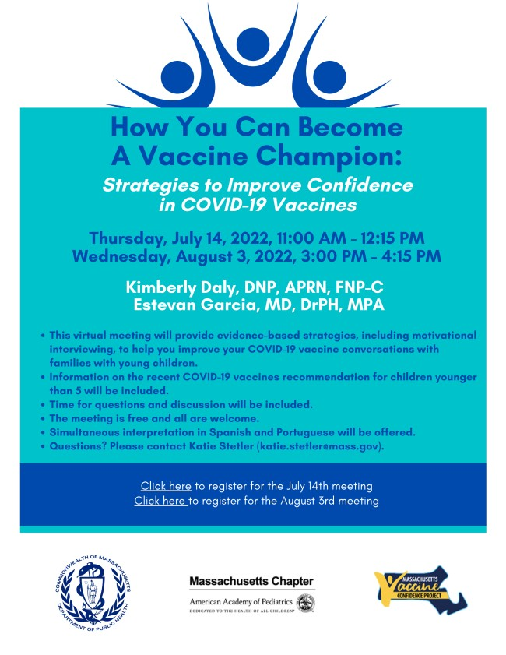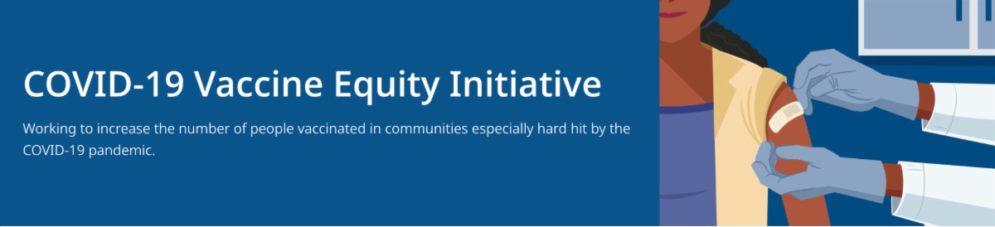
BECOME A VACCINE CHAMPION: LEARN STRATEGIES FOR IMPROVING
CONFIDENCE IN THE COVID-19 VACCINE

DPH and several partners are offering two upcoming trainings to help you improve confidence in COVID-19 vaccines.
Meetings are free, and all are welcome. Register for July 14 or August 3.

Please share! Flyers available in English, Spanish, and Portuguese.
ADDITIONAL $7M AWARDED TO COMMUNITY ORGANIZATIONS FOR
VACCINE EQUITY EFFORTS

News Release (6/29) - Baker-Polito
July 1, 2022
Here are the latest resources for promoting COVID-19 vaccination to share with your colleagues
and networks across Massachusetts. If you received this from a colleague, subscribe today.

View this email online.
What's New

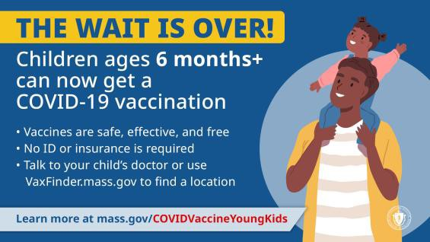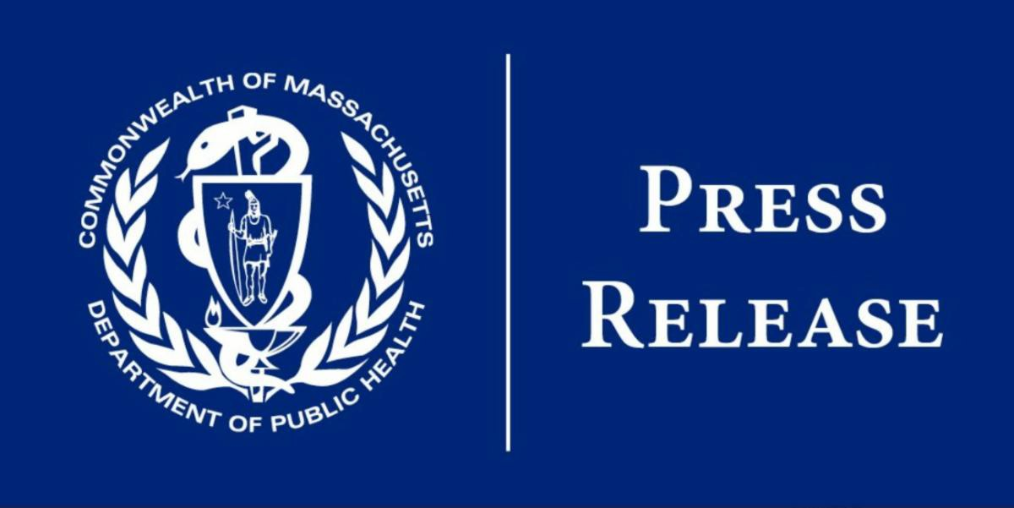
administration awards additional $7M for
COVID-19 vaccine equity efforts
Reminders

CHILDREN AGES 6 MONTHS+ NOW ELIGIBLE FOR COVID-19 VACCINATION

Children ages 6 months and older are now eligible to get vaccinated against COVID-
19. Call your child’s health care provider or visit Vaxfinder.mass.gov to find an appointment. Learn more.

Please help spread the word:
Retweet DPH on Twitter
Share this video about vaccine safety and efficacy (in English and Spanish)
Use a DPH social media graphic (option 1 & option 2)

EMPLOYMENT OPPORTUNITIES: DPH COMMUNITY ENGAGEMENT UNIT

DPH is seeking 11 dedicated professionals to join the new Community Engagement team within the Office of Health Equity (OHE). DPH is dedicated to eliminating inequities and improving the quality of life in historically marginalized communities by addressing immediate health-related social needs and strengthening community safety nets. Learn more.

Current job openings:

Health Equity Managers: Contribute to policy development and strategic planning, work with the OHE senior team on the program launch process, and oversee community-based technical assistance. Apply here.

Health Equity Strategists and Coordinators: Provide collaborative community engagement through technical assistance and trainings for community partners, disseminating resources, and supporting communication between the community and DPH for six priority populations:
Black & African American Latino
Asian American & Pacific Islander LGBTQ+
Tribal & Indigenous - Apply here
Immigrant & Refugee

Please note: Preference is given to applications received within 14 days of posting.

RESOURCES FOR PROMOTING COVID-19 TREATMENTS

Free, safe, and effective treatments for COVID-19 are available to help prevent hospitalizations and reduce the risk of severe disease.

Several resources are available to help promote these treatments:

Videos:
In this new video, Dr. Michele David of MIT Medical discusses COVID-19 treatments that are widely available in MA. Also in Haitian Creole.

Flyers:
Flyers are in English, Spanish, Portuguese, and Haitian Creole.
Other languages available in a double-sided, multilingual version.

Above: Dr. Michele David discusses available COVID-19 treatments.

Web resources:
Info about the telehealth program is available in English, Spanish, Portuguese, and Haitian Creole.

Please share these resources, and learn more about treatments for COVID-19.

Above: A DPH billboard ad for COVID-19 treatment.

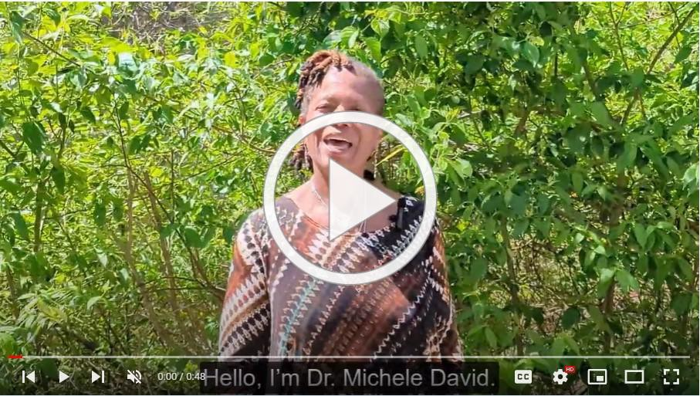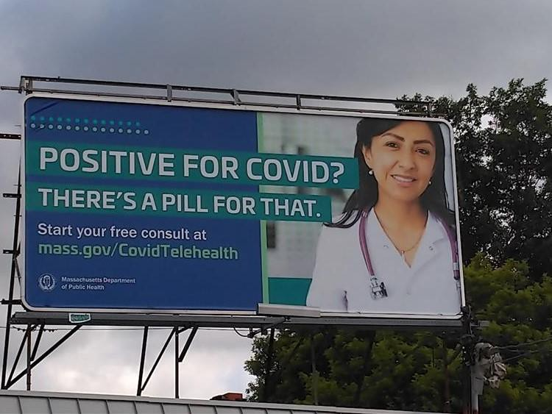
OUTREACH AND EDUCATION MATERIALS

COVID-19 Vaccine FAQs COVID-19 Booster FAQs
Weekly Provider Bulletin (updated 6/29/22)
Trust the Facts, Get the Vax Campaign Materials (organized by audience, including general, parents and pregnant people, youth, young adults; available in 12 languages) Trust the Facts, Get the Vax Creative Materials Toolkit (updates ongoing, including pediatric eligibility)
Additional Education and Outreach Materials (includes social media graphics, vaccine updates, guides to hosting a forum, and more)
Multilingual COVID-19 Materials (videos and printables; organized by language) COVID-19 Funeral Assistance from FEMA (including one-pager with key info available in multiple languages)
COVID-19 Vaccination Tools for Employers
Archive of COVID-19 Vaccine Communications Updates (past editions of VEI Roundup)
Key Resources

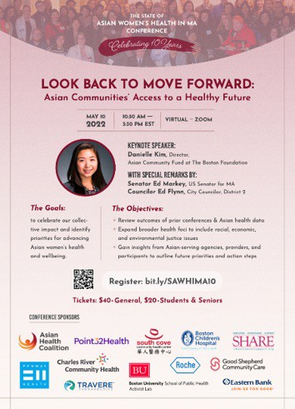
Boston
Asian Women for Health has been providing space for the Asian community to address the impacts of COVID-19 and anti-Asian violence on mental health. In May, at their annual State of Asian Women’s Health Conference, the organization provided data on how COVID- 19 has been experienced by different Asian communities and facilitated discussions on racial and environmental justice and culturally and linguistically responsive services (see flyer). Over the summer, the organization will also host the 13th Asian American Mental Health Forum and an acupressure workshop.
Read More Highlights
FIND A COVID-19 VACCINE OR BOOSTER

Vaccine Finder
Find, Schedule, or Sign Up for a Mobile COVID-19 Vaccination COVID-19 In-Home Vaccination Program
Request a Copy of Your Vaccine Card
COVID-19 VACCINE STANDING ORDERS (FROM CDC)

Pfizer
6 months - 4 years (updated 6/21/22)
5-11 (updated 5/24/22)
12 + Gray Cap (updated 5/24/22)
12 + Purple Cap (updated 5/24/22) Moderna
6 months - 5 years (updated 6/21/22)
18+ years (updated 5/24/22)
Janssen (updated 5/24/22)
Recent Highlights

Share This Email
Share This Email
Share This Email

Visit the VEI Website

Vaccine Equity Initiative | 250 Washington Street, Boston, MA 02108 Unsubscribe vaccineequityinitiative@mass.gov
Constant Contact Data Notice
Sent by vaccineequityinitiative@mass.gov in collaboration with
Try email marketing for free today!

