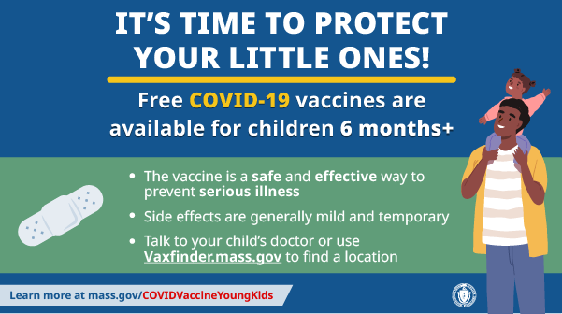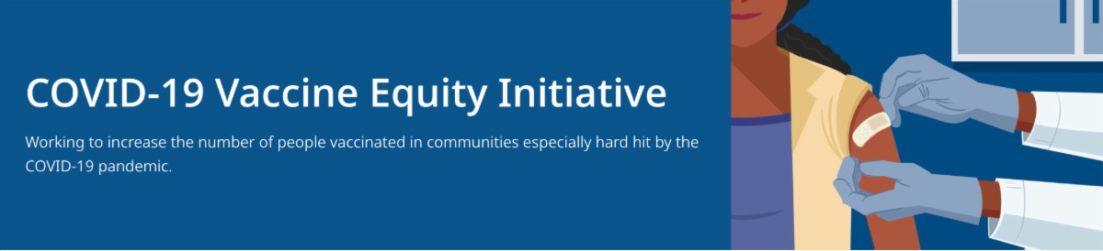
July 15, 2022
Here are the latest resources for promoting COVID-19 vaccination to share with your colleagues
and networks across Massachusetts. If you received this from a colleague, subscribe today.

View this email online.
What's New

NEW MATERIALS: COVID-19 VACCINATION FOR CHILDREN AGES 6 MONTHS AND OLDER

Several new materials are available to help promote COVID-19 vaccination for children ages 6 months+:

DPH social media graphic FAQs about the vaccine for children 6 months+ in multiple languages — now in Arabic!
Messages about the vaccine for children 6 months+ in multiple languages — now in Arabic!

Additional resources are also available, including this short video about vaccine safety and efficacy (in English and Spanish).

NEW JOB OPENINGS: DPH COMMUNITY ENGAGEMENT UNIT

DPH is seeking 11 dedicated professionals to join the new Community Engagement team within the Office of Health Equity (OHE). DPH is dedicated to eliminating inequities and improving the quality of life in historically marginalized communities by addressing immediate health-related social needs and strengthening community safety nets. Learn

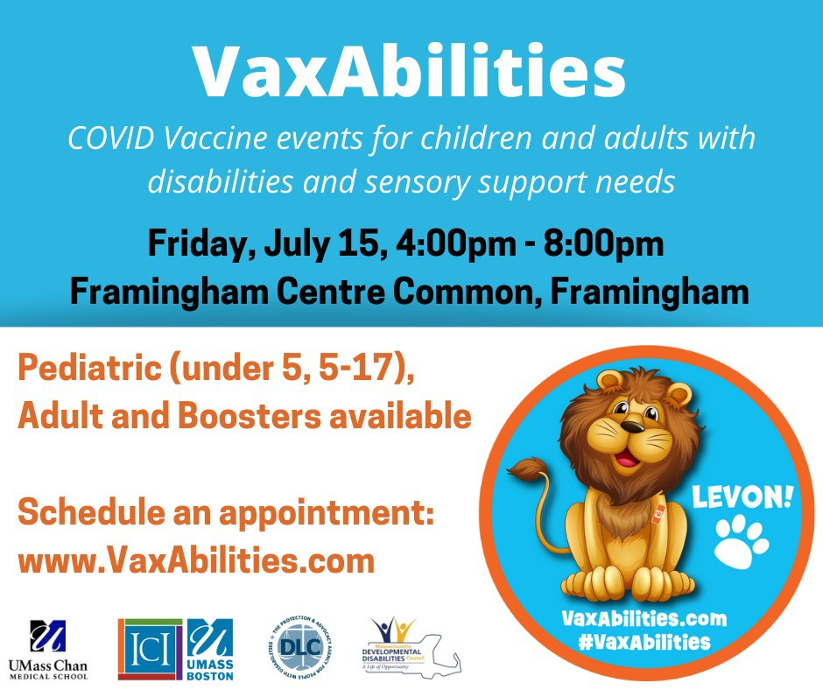more.
VAXABILITIES EVENTS IN FRAMINGHAM — STARTS TODAY (JULY 15)!

COVID-19 vaccines and boosters for people ages 6 months+ with disabilities or sensory support needs will be available at VaxAbilities events at Framingham Centre Common on July 15 and August 12 from 4- 8 p.m. These events will have additional clinical supports to help people get vaccinated as comfortably as possible.

To make an appointment: Go to VaxAbilities.com and go to “Sites and Dates.” Walk-ups will be accepted.

Please share! Flyers available in English
and Spanish.
DPH UPDATES COVID-19 DATA REPORTING

News Release (7/8) - Department of Public Health updates COVID-19 data reporting
Reminders

Current job openings:

Health Equity Managers: Contribute to policy development and strategic planning, work with the OHE senior team on the program launch process, and oversee community-based technical assistance. Apply here.

Health Equity Strategists and Coordinators: Provide collaborative community engagement through technical assistance and trainings for community partners, disseminating resources, and supporting communication between the community and DPH for six priority populations:
LGBTQ+ Health Equity Strategist: Apply here. Communities Healthy Equity Coordinators: Apply here.
Black & African American Latino
Asian American & Pacific Islander Immigrant & Refugee

Please note: Preference is given to applications received within 14 days of posting. Please consider applying by 7/26/22.

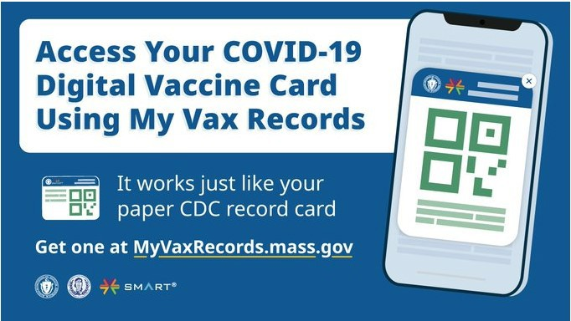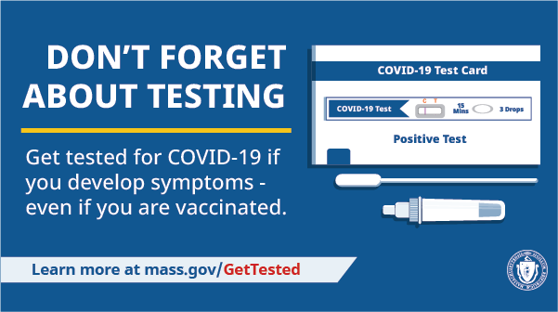
MY VAX RECORDS — DIGITAL COVID-19 VACCINE CARD FOR MA RESIDENTS

Need a copy of your COVID-19 vaccination record? MA residents can use My Vax Records to get a digital vaccine card to show they’ve been vaccinated against COVID-19, if they choose. Learn more.
DON'T FORGET ABOUT COVID TESTING

As you head out to gatherings this summer, testing is a critical tool in the fight against COVID-19. Get tested if you develop symptoms — even if you're vaccinated. Visit mass.gov/GetTested.
Key Resources

OUTREACH AND EDUCATION MATERIALS

COVID-19 Vaccine FAQs COVID-19 Booster FAQs
Weekly Provider Bulletin (latest edition published 7/13/22)
Trust the Facts, Get the Vax Campaign Materials (organized by audience, including general, parents and pregnant people, youth, young adults; available in 12 languages) Trust the Facts, Get the Vax Creative Materials Toolkit (updates ongoing, including pediatric eligibility)
Additional Education and Outreach Materials (includes social media graphics, vaccine updates, guides to hosting a forum, and more)
Multilingual COVID-19 Materials (videos and printables; organized by language) COVID-19 Funeral Assistance from FEMA (including one-pager with key info available in multiple languages)
COVID-19 Vaccination Tools for Employers
Archive of COVID-19 Vaccine Communications Updates (past editions of VEI Roundup)

FIND A COVID-19 VACCINE OR BOOSTER

Vaccine Finder
Find, Schedule, or Sign Up for a Mobile COVID-19 Vaccination COVID-19 In-Home Vaccination Program
Request a Copy of Your Vaccine Card

COVID-19 VACCINE STANDING ORDERS (FROM CDC)

Pfizer
6 months - 4 years (updated 6/21/22)
5-11 (updated 5/24/22)
12 + Gray Cap (updated 5/24/22)
12 + Purple Cap (updated 5/24/22) Moderna
6 months - 5 years (updated 6/21/22)
18+ years (updated 5/24/22)
Janssen (updated 5/24/22)
Recent Highlights

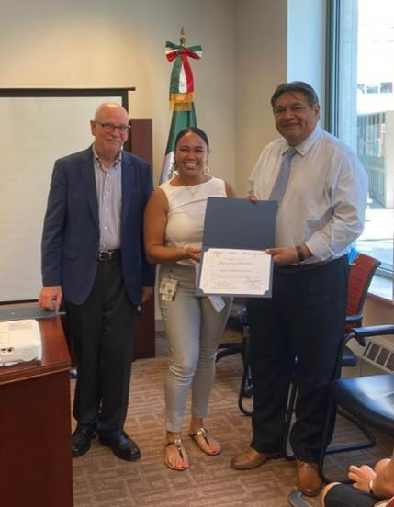
Boston

On July 15, Vaccine Equity Initiative partner Boston Medical Center (BMC) was recognized by the Consulate of Mexico for “distinguished collaboration in favor of the Mexican community of New England." Mobile COVID-19 Vaccine Event Coordinator Jessica Ortiz, AA, BS-BSN, received the recognition on BMC's behalf (see photo).
Read More Highlights
Visit the VEI Website
Share This Email
Share This Email
Share This Email

Vaccine Equity Initiative | 250 Washington Street, Boston, MA 02108 Unsubscribe vaccineequityinitiative@mass.gov
Constant Contact Data Notice
Sent byvaccineequityinitiative@mass.govin collaboration with

Try email marketing for free today!

