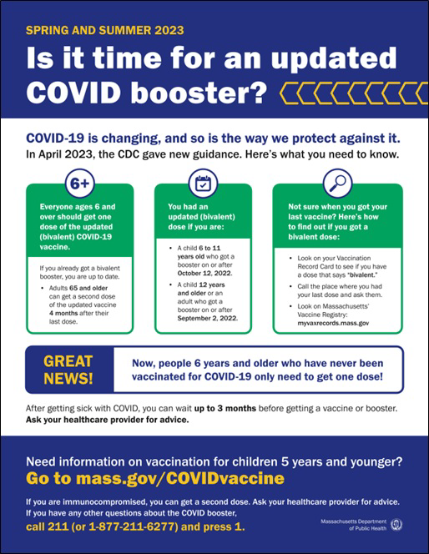
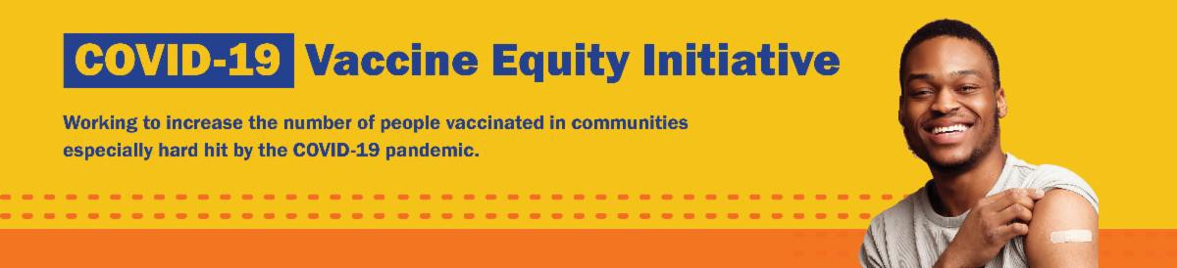
COVID-19 VACCINE PROMOTION TOOLKIT CONTINUES TO BE UPDATED

Our COVID-19 vaccine promotion toolkit continues to be updated with refreshed flyers, social media graphics, and more!

Recently updated items include the "Is It Time?" factsheet. This factsheet is available in 13 languages and provides an overview of spring and summer 2023 guidance for COVID-19 vaccination

Don't see what you need? Looking for items in additional languages? Email us and let us know!
Thanks to the Learning Center for the Deaf, this
info is also available in ASL.
Reminders
July 21, 2023
Here are the latest resources for promoting COVID-19 vaccination to share with your colleagues
and networks across Massachusetts. If you received this from a colleague, subscribe today.

View this email online.
What's New

Q&A: WHY DO THE EXPIRATION DATES ON COVID TESTS CHANGE?

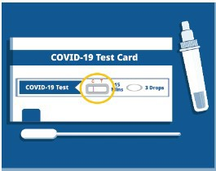
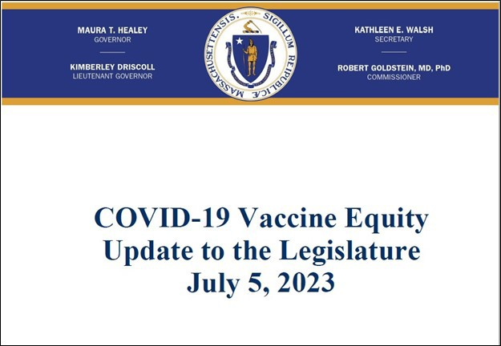
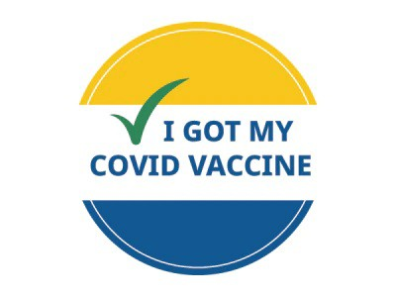
Q: Why does the expiration date on my COVID-19 test keep changing?

A: The companies that make the tests check them to see if they still work. If they do, the FDA extends the expiration date.

Learn more about COVID-19, including what to do if you test positive, at mass.gov/COVID.

What other questions are you hearing? Let us know!

COVID-19 VACCINE EQUITY PLAN: 60-DAY UPDATE

DPH submits a Vaccine Equity report to the Legislature every 60 days that outlines the progress and results made through the Vaccine Equity Initiative.

Read the most recent report, submitted on July 5.

NEED A COVID-19 VACCINE? HERE'S HOW TO FIND ONE

Free COVID-19 vaccine clinics are being held throughout Massachusetts!

To find a COVID-19 vaccine clinic near you: Search vaccines.gov for appointments
Find a community vaccination clinic Learn more about in-home vaccination

Questions? Call 211 (or 877-211-6277) and press 1. Calls are answered Monday through Friday, 9 a.m. to 5 p.m.

You can also learn more about how to prepare for your vaccine appointment.

Key Resources

OUTREACH AND EDUCATION MATERIALS

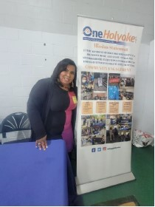
This spring, OneHolyokeCDC collaborated
with the Holyoke library to host a COVID-19 vaccine clinic during the library’s mini-golf event. OneHolyoke staff also distributed COVID-19 mitigation information and a newsletter with additional vaccine clinic schedules. At another event, OneHolyoke partnered with a local elementary school to host a vaccine clinic during the school’s career exploration day. OneHolyoke also gave away hand sanitizers and free to-go dinners.
Read More Highlights
Visit the VEI Website
Share This Email
Share This Email
Share This Email
COVID-19 Vaccine FAQs
COVID-19 Therapeutic Information (including telehealth) Weekly Provider Bulletin
Trust the Facts, Get the Vax Campaign Materials (organized by audience, including general, parents, youth, and young adults; available in 12 languages)
Multilingual COVID-19 Materials (videos and printables; organized by language) Archive of COVID-19 Vaccine Communications Updates (past editions of VEI Roundup)
FIND A COVID-19 VACCINE DOSE

Use Vaccines.gov to sign up for a COVID-19 vaccine appointment Find a community COVID-19 vaccination clinic near you
Learn about the COVID-19 In-Home Vaccination Program and request a visit Request a copy of your vaccine card
Highlights

Vaccine Equity Initiative | 250 Washington Street, Boston, MA 02108

Unsubscribe vaccineequityinitiative@mass.gov Constant Contact Data Notice
Sent by vaccineequityinitiative@mass.gov powered by
Try email marketing for free today!

