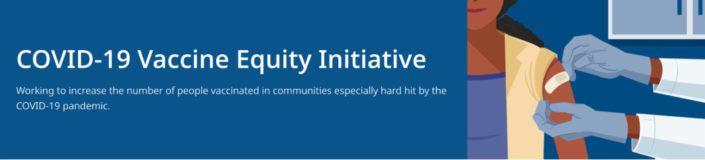
July 22, 2022
Here are the latest resources for promoting COVID-19 vaccination to share with your colleagues
and networks across Massachusetts. If you received this from a colleague, subscribe today.

View this email online.
What's New

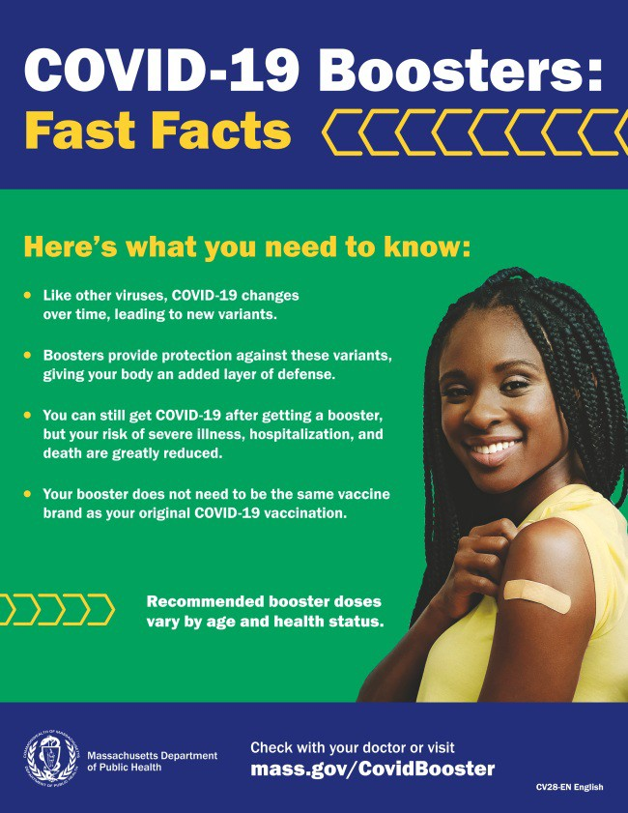

NEW MATERIALS: COVID-19 BOOSTER FAST FACTS

COVID-19 boosters provide protection against COVID-19 variants and greatly reduce your risk of severe illness, hospitalization, and death. Some people may be eligible for a second booster.

Booster fast facts flyers are available in 12 languages.
Reminders

SEVEN STEPS TO PROTECT YOURSELF AND YOUR FAMILY FROM COVID-19

Available in multiple languages, this flyer features a checklist to help protect

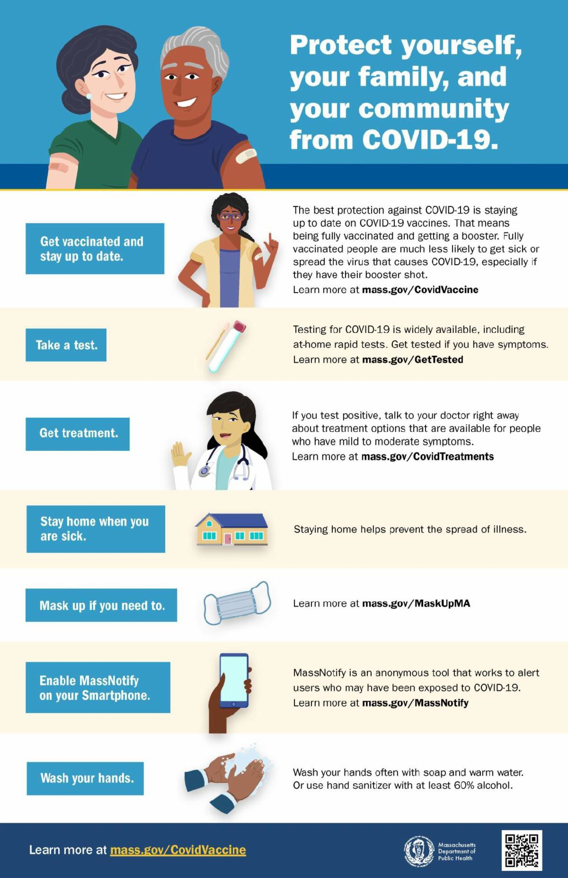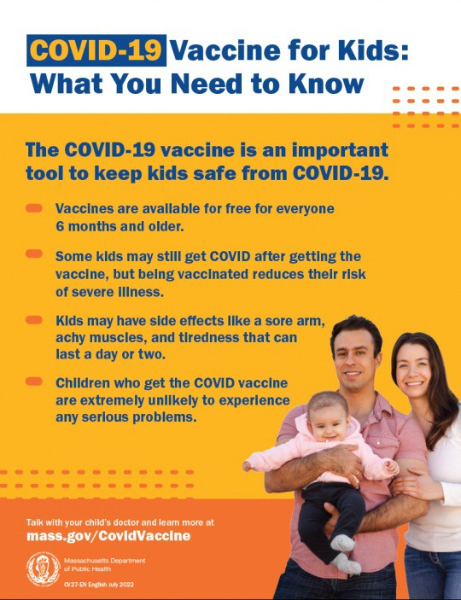yourself, your family, and your community
from COVID-19. Please share it with your networks.

COVID-19 VACCINATION FOR CHILDREN AGES 6 MONTHS AND OLDER

Several new materials are available to help promote COVID-19 vaccination for children ages 6 months+:

Basic fact sheet (in 12 languages) DPH social media graphic

FAQs about the vaccine for children 6 months+ in multiple languages
Messages about the vaccine for children 6 months+ in multiple languages

Additional resources are also available, including this short video about vaccine safety and efficacy (in English and Spanish).

COVID-19 FUNERAL ASSISTANCE AVAILABLE — UPDATED LETTER

If you or someone you know lost a loved one to COVID-19, you may be eligible for financial assistance or reimbursement for funeral expenses from FEMA. More information is available in multiple

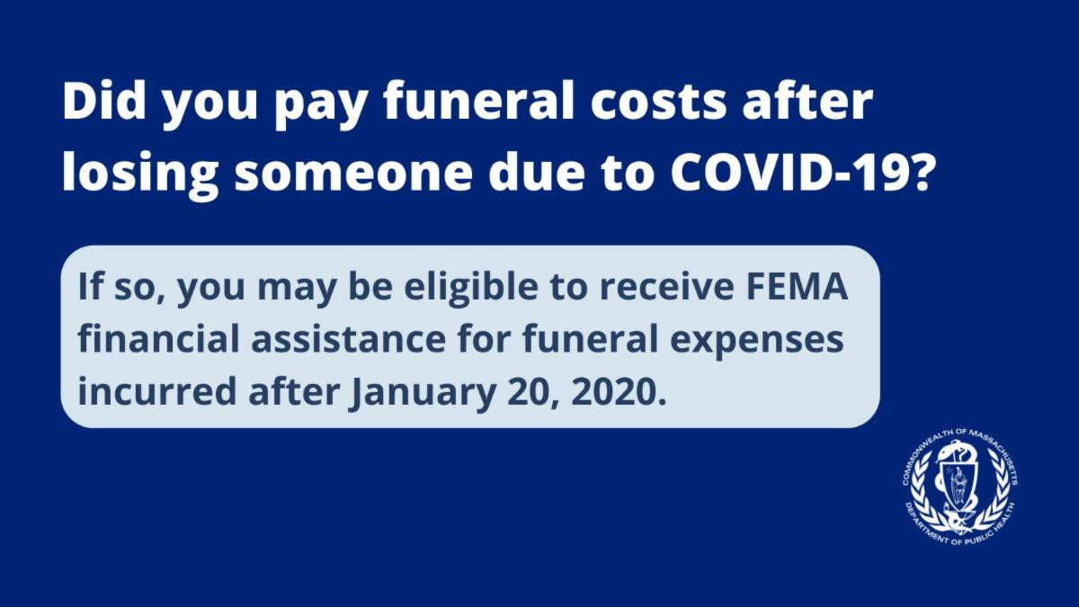languages (updated July 2022).

NEW JOB OPENINGS: DPH COMMUNITY ENGAGEMENT UNIT

DPH is seeking 11 dedicated professionals to join the new Community Engagement team within the Office of Health Equity (OHE). DPH is dedicated to eliminating inequities and improving the quality of life in historically marginalized communities by addressing immediate health-related social needs and strengthening community safety nets. Learn more.

Current job openings:

Health Equity Managers: Contribute to policy development and strategic planning, work with the OHE senior team on the program launch process, and oversee community-based technical assistance. Apply here.

Health Equity Strategists and Coordinators: Provide collaborative community engagement through technical assistance and trainings for community partners, disseminating resources, and supporting communication between the community and DPH for six priority populations:
LGBTQ+ Health Equity Strategist: Apply here. Communities Healthy Equity Coordinators: Apply here.
Black & African American Latino
Asian American & Pacific Islander Immigrant & Refugee

Please note: Preference is given to applications received within 14 days of posting. Please consider applying by 7/26/22.

BECOME A VACCINE CHAMPION: LEARN STRATEGIES FOR IMPROVING CONFIDENCE IN THE COVID-19 VACCINE

DPH and several partners are offering an upcoming training to help you improve confidence in COVID-19 vaccines.
Meetings are free, and all are welcome. Register for August 3.

Please share! Flyers available
in English, Spanish, and Portuguese.

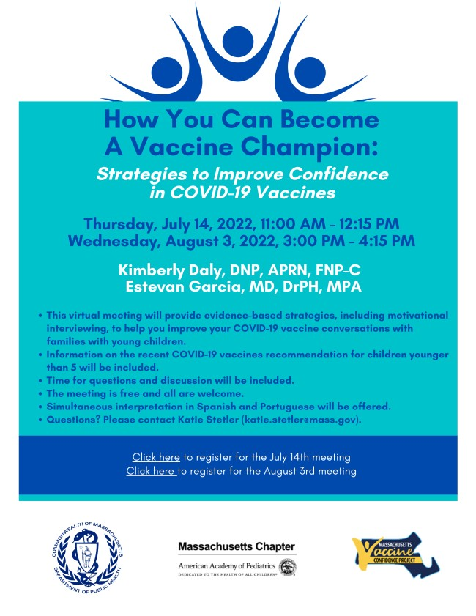
Key Resources

OUTREACH AND EDUCATION MATERIALS

COVID-19 Vaccine FAQs COVID-19 Booster FAQs
Weekly Provider Bulletin (latest edition published 7/22/22)
Trust the Facts, Get the Vax Campaign Materials (organized by audience, including general, parents and pregnant people, youth, young adults; available in 12 languages) Trust the Facts, Get the Vax Creative Materials Toolkit (updates ongoing, including pediatric eligibility)
Additional Education and Outreach Materials (includes social media graphics, vaccine updates, guides to hosting a forum, and more)
Multilingual COVID-19 Materials (videos and printables; organized by language) COVID-19 Funeral Assistance from FEMA (including one-pager with key info available in multiple languages)
COVID-19 Vaccination Tools for Employers
Archive of COVID-19 Vaccine Communications Updates (past editions of VEI Roundup)

FIND A COVID-19 VACCINE OR BOOSTER

Vaccine Finder
Find, Schedule, or Sign Up for a Mobile COVID-19 Vaccination COVID-19 In-Home Vaccination Program
Request a Copy of Your Vaccine Card

COVID-19 VACCINE STANDING ORDERS (FROM CDC)

Pfizer

6 months - 4 years (updated 6/21/22)
5-11 (updated 5/24/22)
12 + Gray Cap (updated 5/24/22)
12 + Purple Cap (updated 5/24/22) Moderna
6 months - 5 years (updated 6/21/22)
18+ years (updated 5/24/22)
Janssen (updated 5/24/22)

Recent Highlights
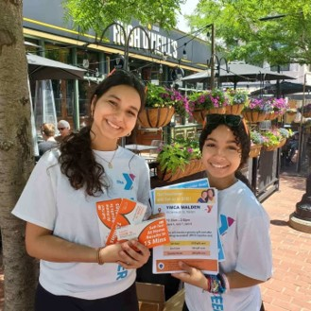Over the July Fourth weekend, VEI held eight clinics with community-based organizations and other partners, including the Malden YMCA, Springfield Indian Orchard Citizens Council, Greater Lawrence Community Action Council, Melita Farms (Lawrence/Methuen), Pope John High School (Everett), and America's Food Basket (Brockton).
These clinics resulted in 175 total vaccinations, including 126 first doses.

Image: Taken at a clinic on July 2 in Malden

Read More Highlights

Share This Email
Share This Email
Share This Email

Visit the VEI Website

Vaccine Equity Initiative | 250 Washington Street, Boston, MA 02108 Unsubscribe vaccineequityinitiative@mass.gov
Constant Contact Data Notice
Sent by vaccineequityinitiative@mass.gov in collaboration with
Try email marketing for free today!

