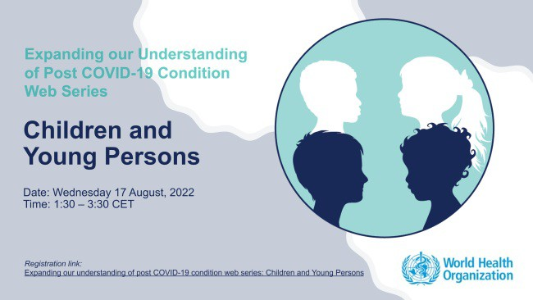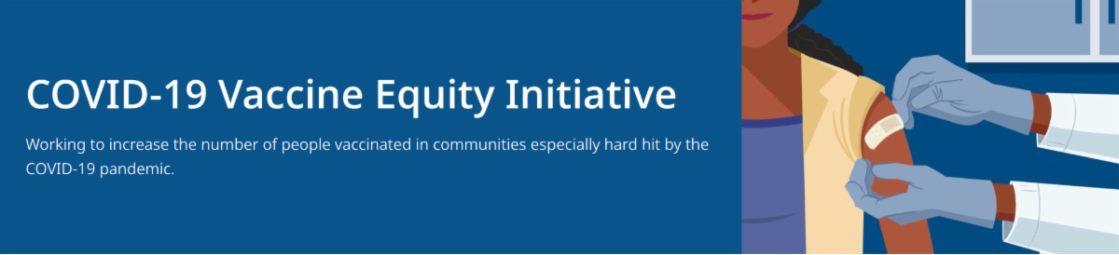
FREE, SAFE, AND EFFECTIVE COVID-19 TREATMENTS AVAILABLE

Free, safe, and effective treatments for COVID-19 are available across MA. They can help prevent hospitalizations and reduce the risk of severe disease.

Several resources are available to help promote these treatments:

Telehealth flyer (in English, Haitian Creole, Khmer, Spanish, and Portuguese)
Shareable video and factsheet
FROM THE WORLD HEALTH ORGANIZATION: UNDERSTANDING LONG COVID
IN CHILDREN AND YOUTH
The World Health Organization (WHO) will
be hosting a webinar that explores the long-term effects of COVID-19 infection in children and youth on August 17 at 7:30
a.m. EST. Learn more and register.
Reminders
What's New
July 29, 2022
Here are the latest resources for promoting COVID-19 vaccination to share with your colleagues
and networks across Massachusetts. If you received this from a colleague, subscribe today.

View this email online.

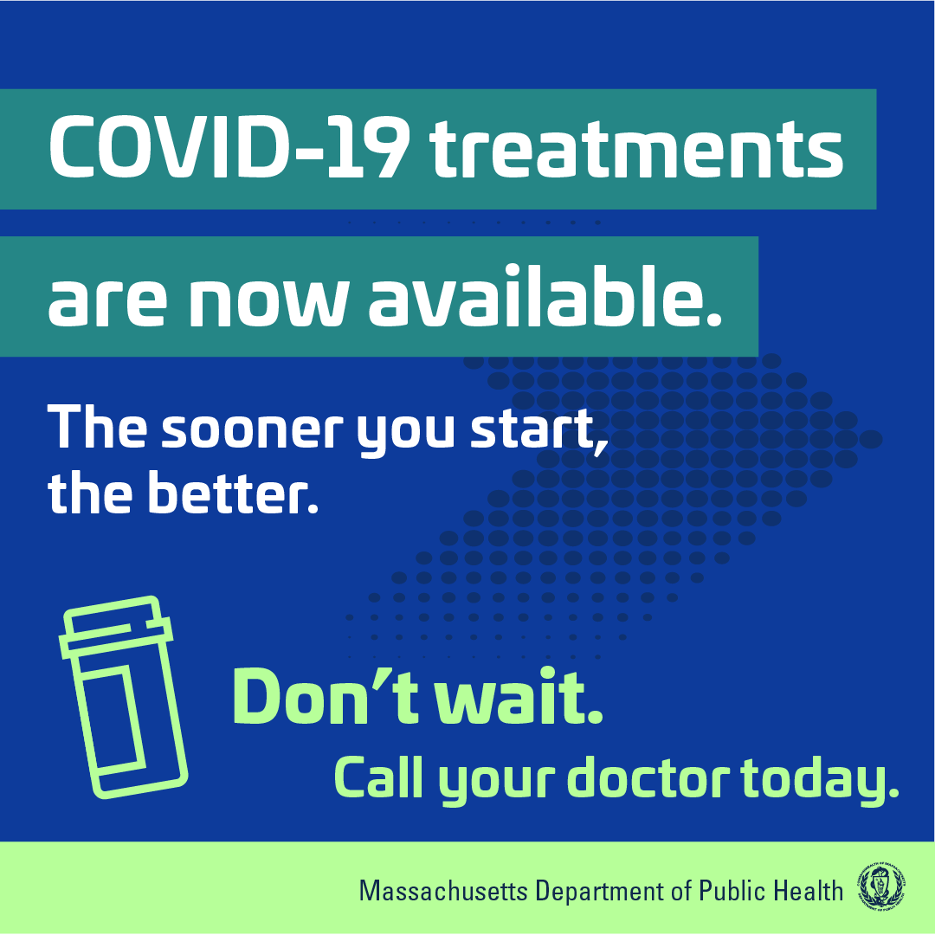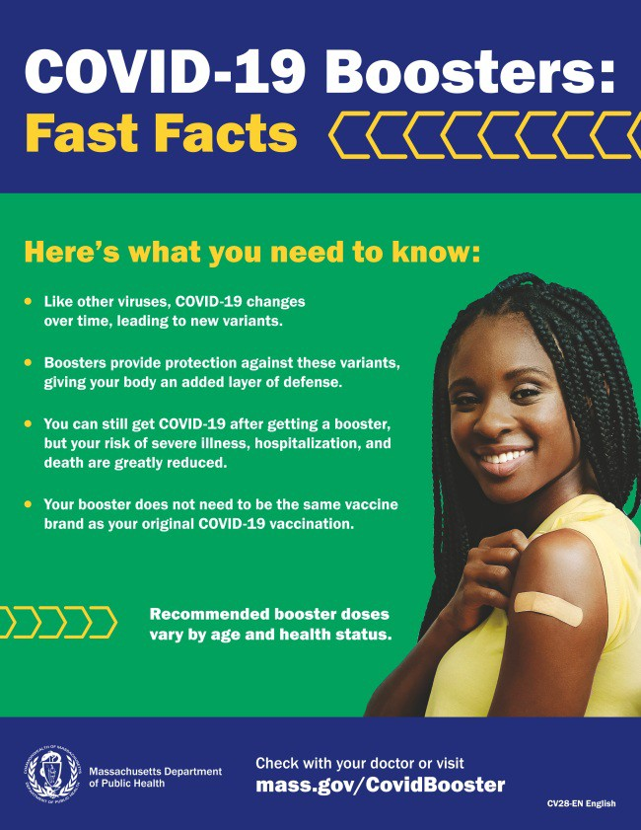Videos featuring local physicians
discussing COVID-19 treatment options (in English, Spanish, and Haitian Creole)

Learn more about how to access treatment, including telehealth and in- home options.

PLEASE SHARE: COVID-19 BOOSTER FAST FACTS

COVID-19 boosters provide protection against COVID-19 variants and greatly reduce your risk of severe illness, hospitalization, and death. Some people may be eligible for a second booster.

Booster fast facts flyers are available in 12 languages.

COVID-19 VACCINATION FOR CHILDREN AGES 6 MONTHS AND OLDER

Several new materials are available to help promote COVID-19 vaccination for children ages 6 months+:

Basic fact sheet (in 12 languages) DPH social media graphic
FAQs about the vaccine for children 6 months+ in multiple languages
Messages about the vaccine for children 6 months+ in multiple

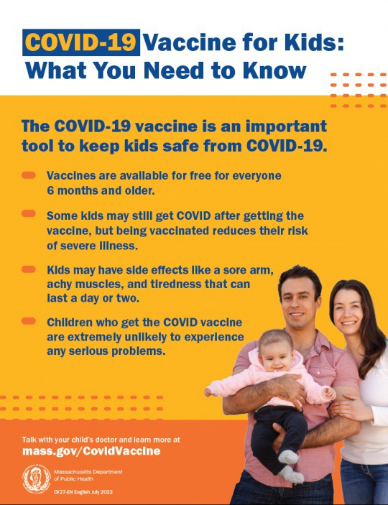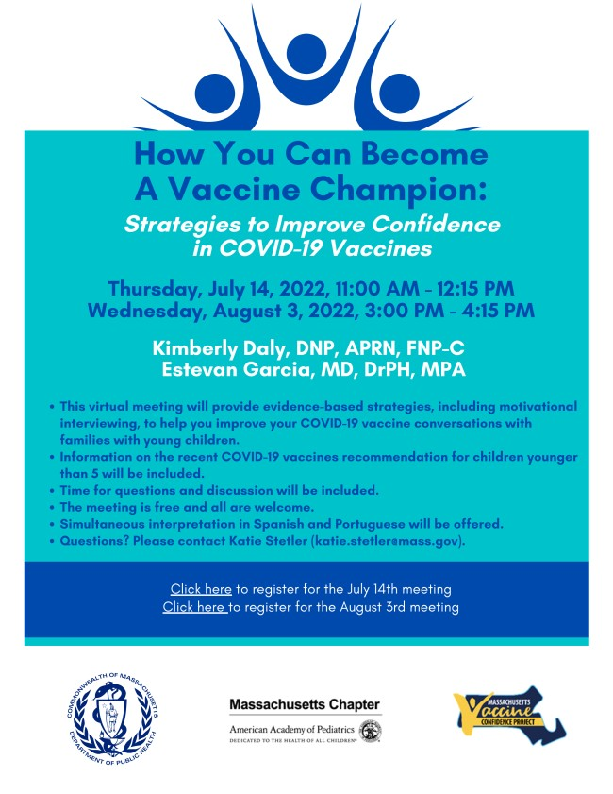languages
OUTREACH AND EDUCATION MATERIALS

COVID-19 Vaccine FAQs COVID-19 Booster FAQs
COVID-19 Therapeutic Information (including telehealth) Weekly Provider Bulletin (latest edition published 7/27/22)
Trust the Facts, Get the Vax Campaign Materials (organized by audience, including general, parents and pregnant people, youth, young adults; available in 12 languages) Additional Education and Outreach Materials (includes social media graphics, vaccine updates, guides to hosting a forum, and more)
Key Resources

Additional resources are also available, including this short video about vaccine safety and efficacy (in English and Spanish).

HAPPENING SOON - BECOME A VACCINE CHAMPION: LEARN STRATEGIES FOR IMPROVING CONFIDENCE IN THE COVID-19 VACCINE

DPH and several partners are offering an upcoming training to help you improve confidence in COVID-19 vaccines.
Meetings are free, and all are welcome. Register for August 3.

Please share! Flyers available
in English, Spanish, and Portuguese.

Multilingual COVID-19 Materials (videos and printables; organized by language)
COVID-19 Funeral Assistance from FEMA (including one-pager with key info
available in multiple languages)
COVID-19 Vaccination Tools for Employers
Archive of COVID-19 Vaccine Communications Updates (past editions of VEI Roundup)

FIND A COVID-19 VACCINE OR BOOSTER

Vaccine Finder
Find, Schedule, or Sign Up for a Mobile COVID-19 Vaccination COVID-19 In-Home Vaccination Program
Request a Copy of Your Vaccine Card

COVID-19 VACCINE STANDING ORDERS (FROM CDC)

Pfizer
6 months - 4 years (updated 6/21/22)
5-11 (updated 5/24/22)
12 + Gray Cap (updated 5/24/22)
12 + Purple Cap (updated 5/24/22)
Moderna
6 months - 5 years (updated 7/11/22)
18+ years (updated 7/11/22)
Janssen (updated 5/24/22)

Recent Highlights
Lawrence and Methuen

In June and July, VEI's Outreach and Engagement Team supported 21 clinics in Lawrence and Methuen in partnership with local boards of health. Outreach partners include Groundworks Lawrence and AgeSpan. More than 160 vaccinations, including 20 first doses in children under 5, were administered. VEI is also partnering with the Greater Lawrence Community Action Center (GLCAC) for summer/fall clinics, recently administering 63 vaccinations.

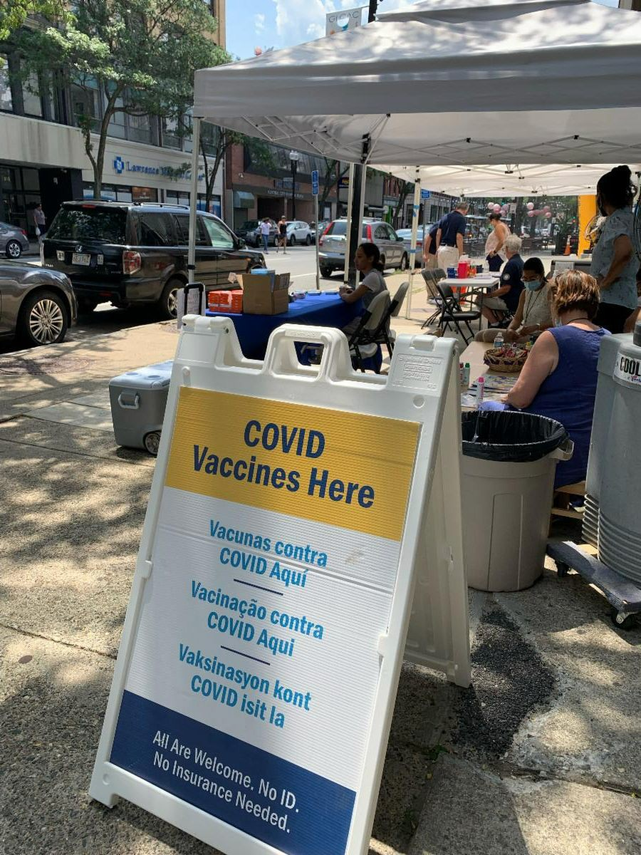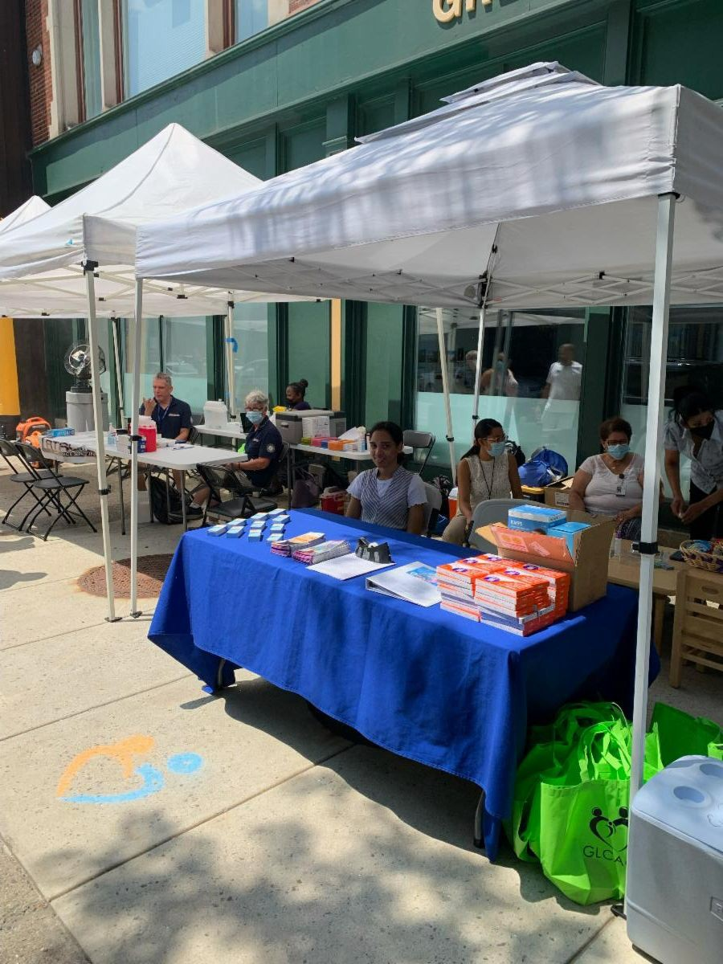

Images: Photos from a recent clinic in partnership with Greater Lawrence Community Action Center.

Read More Highlights

Share This Email
Share This Email
Share This Email

Visit the VEI Website

Vaccine Equity Initiative | 250 Washington Street, Boston, MA 02108 Unsubscribe vaccineequityinitiative@mass.gov
Constant Contact Data Notice
Sent by vaccineequityinitiative@mass.gov in collaboration with
Try email marketing for free today!

