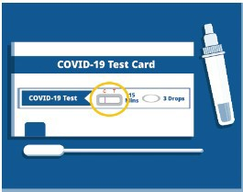
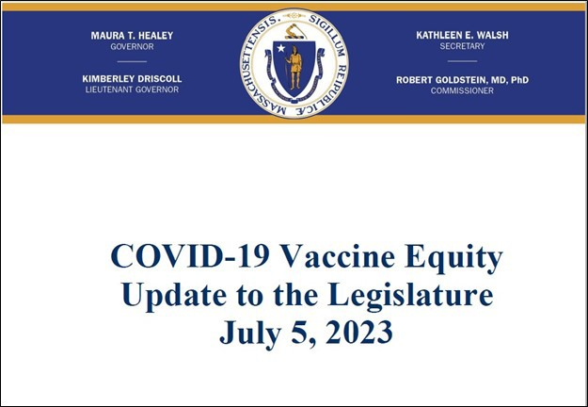
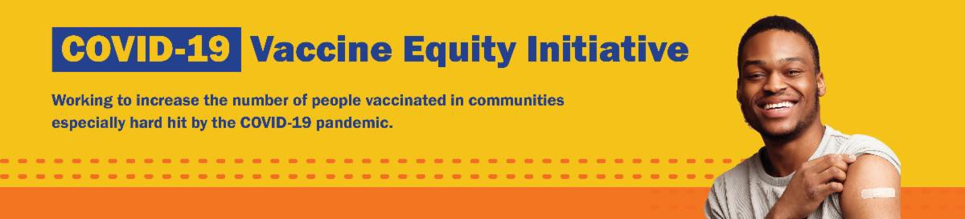
Q&A: WHY DO THE EXPIRATION DATES ON COVID TESTS CHANGE?

Q: Why does the expiration date on my COVID-19 test keep changing?

A: The companies that make the tests check them to see if they still work. If they do, the FDA extends the expiration date.

Learn more about COVID-19, including what to do if you test positive, at mass.gov/COVID.
What other questions are you hearing? Let us know!
COVID-19 VACCINE EQUITY PLAN: 60-DAY UPDATE

DPH submits a Vaccine Equity report to the Legislature every 60 days that outlines the progress and results made through the Vaccine Equity Initiative.

Read the most recent report, submitted on July 5.
July 7, 2023
Here are the latest resources for promoting COVID-19 vaccination to share with your colleagues
and networks across Massachusetts. If you received this from a colleague, subscribe today.

View this email online.
What's New

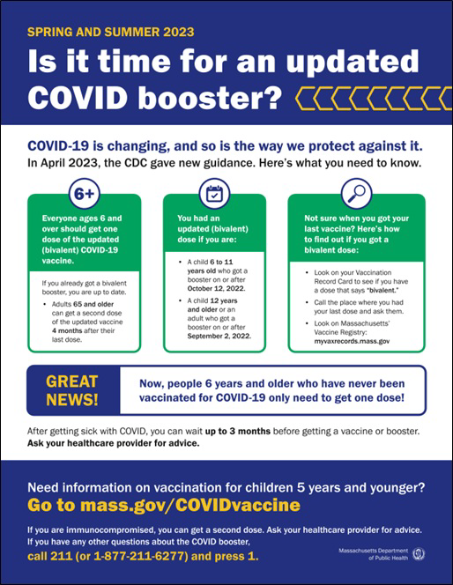
Reminders

NOW IN 13 LANGUAGES: "IS IT TIME?" FACTSHEET

COVID-19 is changing, and so is the way we protect against it.

This flyer provides an overview of spring and summer 2023 guidance for COVID-19 vaccination. Now available in 13 languages!

Thanks to the Learning Center for the Deaf, this info is also available in ASL .

Can't remember when you had your last COVID vaccine dose? Massachusetts residents can use My Vax Records to get a digital vaccine card. Learn more.

MASSHEALTH REDETERMINATION: HELP MEMBERS KEEP HEALTH CARE COVERAGE

In 2023, all current MassHealth members will need to renew their health coverage to ensure they still qualify for their current benefit.

These renewals started in April and will take place over 12 months. MassHealth is working to help members maintain coverage and raise awareness about the
renewal process. Info about MassHealth redetermination (intro and key points) is also available in ASL, courtesy of TLC.

Here's how to help:

Remind members to update their addresses, report household changes, and read all mail from MassHealth
Share informational and outreach materials from this toolkit
Sign up for email notifications from MassHealth

MY VAX RECORDS: A DIGITAL VACCINE CARD FOR MASSACHUSETTS RESIDENTS

Can't remember when you had your last COVID dose? Need a copy of your COVID

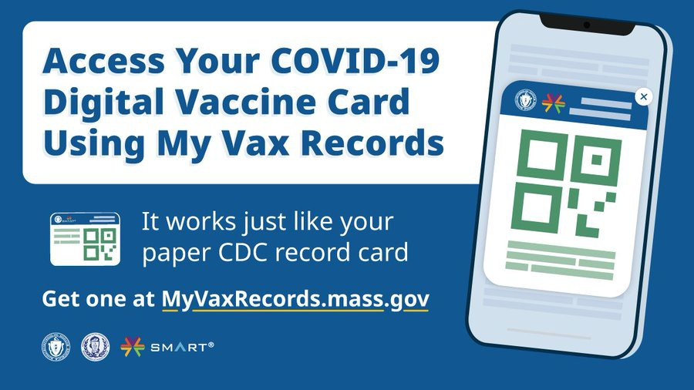
vaccination record?

Massachusetts residents can use My Vax Records to get a digital vaccine card. Learn more.
Info about My Vax Records is available in ASL,
courtesy of the Learning Center for the Deaf.
Key Resources

OUTREACH AND EDUCATION MATERIALS

COVID-19 Vaccine FAQs
COVID-19 Therapeutic Information (including telehealth) Weekly Provider Bulletin
Trust the Facts, Get the Vax Campaign Materials (organized by audience, including general, parents, youth, and young adults; available in 12 languages)
Multilingual COVID-19 Materials (videos and printables; organized by language) Archive of COVID-19 Vaccine Communications Updates (past editions of VEI Roundup)

FIND A COVID-19 VACCINE DOSE

Use Vaccines.gov to sign up for a COVID-19 vaccine appointment Find a community COVID-19 vaccination clinic near you
Learn about the COVID-19 In-Home Vaccination Program and request a visit Request a copy of your vaccine card

Highlights

Throughout May, La Colaborativa (based in Chelsea) continued to offer two weekly COVID-19 vaccine clinics at the same time as their weekly food pantry (see image). Offering the vaccine clinics and food pantry together has been a productive strategy for La Colaborativa, since many community members, including new immigrants, come for the food pantry and can be vaccinated while waiting in line or after they pick up their food.

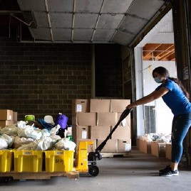

Read More Highlights

Visit the VEI Website
Share This Email
Share This Email
Share This Email

Vaccine Equity Initiative | 250 Washington Street, Boston, MA 02108

Unsubscribe vaccineequityinitiative@mass.gov Constant Contact Data Notice
Sent by vaccineequityinitiative@mass.gov powered by

Try email marketing for free today!

