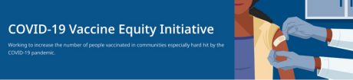July 8, 2022
Here are the latest resources for promoting COVID-19 vaccination to share with your colleagues and networks across Massachusetts. If you received this from a colleague, subscribe today.
View this email online.
What's New
NEW MATERIALS: COVID-19 VACCINATION FOR CHILDREN AGES 6 MONTHS+
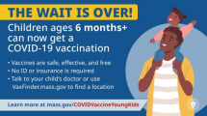
Help spread the word about COVID-19
vaccination for children ages 6 months
and older!
Several new flyers are available to help
promote pediatric vaccination:
Flyers:
- FAQs about the vaccine for
children 6 months to 5 years (in
multiple languages; Arabic version
available by 7/15)
- Messages about the vaccine for
children 6 months to 5 years (in
multiple languages; Arabic version
available by 7/15)
Additional resources are also available, including:
Videos:
- Short video about vaccine safety and efficacy (in English and Spanish)
Social media:
- Retweet DPH on Twitter
- Use a DPH social media graphic (option 1 & option 2)
How to find vaccine appointments:
- Call your child’s health care provider
- Visit Vaxfinder.mass.gov to locate an appointment near you
- In-home appointments are available for people with difficulty getting to or using a community location
UPCOMING VAXABILITIES EVENTS IN FRAMINGHAM
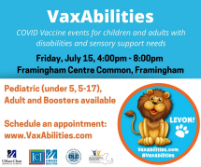
COVID-19 vaccines and boosters for people
ages 6 months+ with disabilities or sensory
support needs will be available at
VaxAbilities events at Framingham Centre
Common on July 15 and August 12 from
4pm–8pm. These events will have
additional clinical supports to help people
get vaccinated as comfortably as possible.
To make an appointment: Go to
VaxAbilities.com and go to “Sites and
Dates.” Walk-ups will be accepted.
Please share! Flyers available in English
and Spanish.
DPH UPDATES COVID-19 DATA REPORTING
News Release (7/8) - Department of Public
Health updates COVID-19 data reporting
Reminders
BECOME A VACCINE CHAMPION: LEARN STRATEGIES FOR IMPROVING CONFIDENCE IN THE COVID-19 VACCINE
DPH and several partners are offering two
upcoming trainings to help you improve
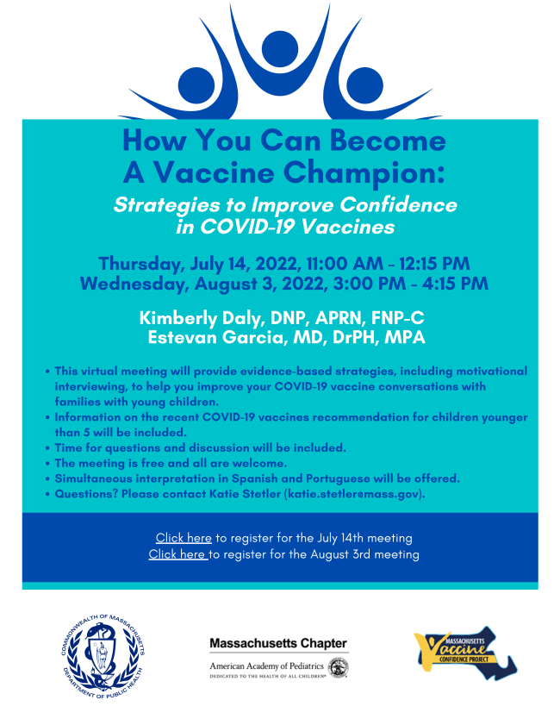
confidence in COVID-19 vaccines.
Meetings are free, and all are welcome.
Register for July 14 or August 3.
Please share! Flyers available in English,
Spanish, and Portuguese.

ADDITIONAL $7M AWARDED TO COMMUNITY ORGANIZATIONS FOR VACCINE EQUITY EFFORTS
News Release (6/29) - Baker-Polito
administration awards additional $7M for
COVID-19 vaccine equity efforts
EMPLOYMENT OPPORTUNITIES: DPH COMMUNITY ENGAGEMENT UNIT
DPH is seeking 11 dedicated professionals to join the new Community Engagement team within the Office of Health Equity (OHE). DPH is dedicated to eliminating inequities and improving the quality of life in historically marginalized communities by addressing immediate health-related social needs and strengthening community safety nets. Learn more.
Current job openings:
- Health Equity Managers: Contribute to policy development and strategic planning, work with the OHE senior team on the program launch process, and oversee community-based technical assistance. Apply here.
- Health Equity Strategists and Coordinators: Provide collaborative community engagement through technical assistance and trainings for community partners, disseminating resources, and supporting communication between the community and DPH for six priority populations:
  - Black & African American
  - Latino
  - Asian American & Pacific Islander
  - LGBTQ+
  - Tribal & Indigenous - Apply here
  - Immigrant & Refugee
Please note: Preference is given to applications received within 14 days of posting.
ENABLE MASSNOTIFY ON YOUR SMARTPHONE
More than 2 million MA residents now use
MassNotify, a tool that works through
smartphones — with a focus on
privacy — to alert users who may have
been exposed to COVID-19. Learn more.
Key Resources
OUTREACH AND EDUCATION MATERIALS
- COVID-19 Vaccine FAQs
- COVID-19 Booster FAQs
- Weekly Provider Bulletin (latest edition published 7/7/22)
- Trust the Facts, Get the Vax Campaign Materials (organized by audience, including general, parents and pregnant people, youth, young adults; available in 12 languages)
- Trust the Facts, Get the Vax Creative Materials Toolkit (updates ongoing, including pediatric eligibility)
- Additional Education and Outreach Materials (includes social media graphics, vaccine updates, guides to hosting a forum, and more)
- Multilingual COVID-19 Materials (videos and printables; organized by language)
- COVID-19 Funeral Assistance from FEMA (including 1-pager with key info available in multiple languages)
- COVID-19 Vaccination Tools for Employers
- Archive of COVID-19 Vaccine Communications Updates (past editions of VEI Roundup)
FIND A COVID-19 VACCINE OR BOOSTER
- Vaccine Finder
- Find, Schedule, or Sign Up for a Mobile COVID-19 Vaccination
- COVID-19 In-Home Vaccination Program
- Request a Copy of Your Vaccine Card
COVID-19 VACCINE STANDING ORDERS (FROM CDC)
- Pfizer
  - 6 months - 4 years (updated 6/21/22)
  - 5-11 (updated 5/24/22)
  - 12 + Gray Cap (updated 5/24/22)
  - 12 + Purple Cap (updated 5/24/22)
- Moderna
  - 6 months - 5 years (updated 6/21/22)
  - 18+ years (updated 5/24/22)
- Janssen (updated 5/24/22)
Recent Highlights
The Vaccine Equity Initiative is growing its partnership with food pantries because they offer a new, strong community connection. By partnering with food pantries, VEI meets individuals in a safe, convenient, and trusted environment and supports whole person health. In June 2022, VEI held clinics at several food pantries, including the Springfield Cupboard Food Pantry, Lowell's Dwelling House of Hope Food Distribution, and Malden's Bread of Life Food Pantry. We thank them for their support!
Read More Highlights
Visit the VEI Website
Vaccine Equity Initiative | 250 Washington Street, Boston, MA 02108
Unsubscribe vaccineequityinitiative@mass.gov
Constant Contact Data Notice
Sent by vaccineequityinitiative@mass.gov in collaboration
with
Try email marketing for free today!

