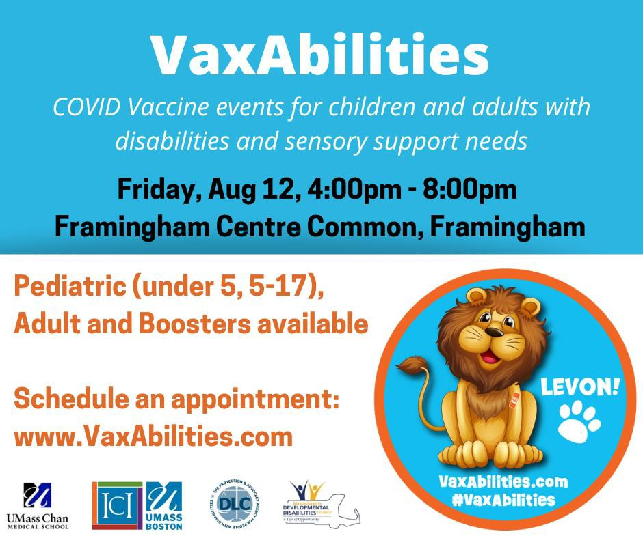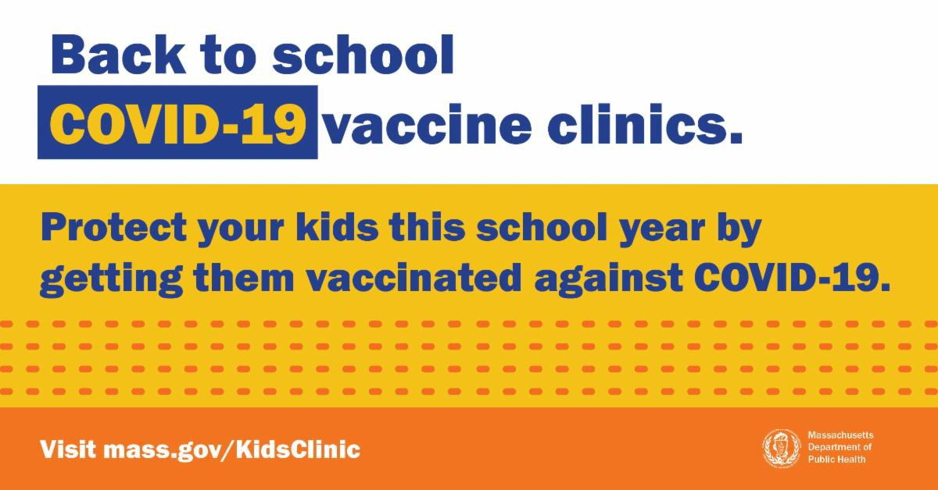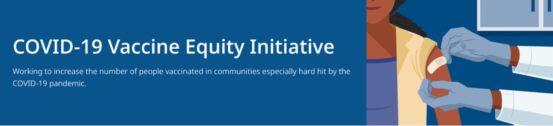
August 12, 2022
Here are the latest resources for promoting COVID-19 vaccination to share with your colleagues
and networks across Massachusetts. If you received this from a colleague, subscribe today.

View this email online.
What's New

HAPPENING TODAY (AUGUST 12) — VAXABILITIES EVENT IN FRAMINGHAM

COVID-19 vaccines and boosters for adults and children ages 6 months and older with disabilities or sensory support needs will be available at Framingham Centre Common on August 12, 4-8 p.m. These events will have additional clinical supports to help people get vaccinated as comfortably as possible.

To make an appointment: Go
to VaxAbilities.com, and click on “Sites and Dates.” Walk-ups will be accepted.

VACCINATIONS FOR BACK TO SCHOOL — FLYERS & GRAPHICS AVAILABLE

Getting ready for the return to school? Add COVID-19 vaccination and boosters to your back-to-school checklist!

Being vaccinated reduces children's risk of becoming very sick, missing school or day care, or needing a family member to miss work to care for them. Learn more.

Throughout this August and September, DPH is providing 480+ options for free

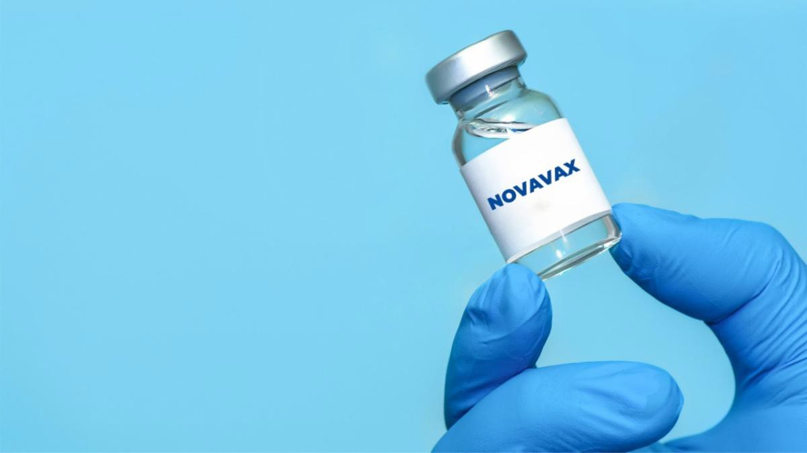
NOVAVAX AVAILABLE IN MA FOR INDIVIDUALS AGES 18 AND OLDER

Another COVID-19 vaccine is available in Massachusetts with the addition of Novavax for individuals ages 18 and older. The supply is limited. To locate a clinic offering Novavax, visit Vaxfinder at vaxfinder.mass.gov.
COVID-19 VACCINATION FOR CHILDREN AGES 6 MONTHS AND OLDER

Several materials are available to help promote COVID-19 vaccination for children ages 6 months+:

Fact sheet (12 languages) DPH social media graphic
FAQs re: children 6 months+ in multiple languages
Reminders
COVID-19 vaccination clinics. Find a clinic
near you.

NEW — Materials for sharing:
Flyers (general; now in multiple languages) Social media graphics for Twitter and Facebook Flyers for teachers and school staff
UPDATED: CHILDREN WITH COMPLEX MEDICAL NEEDS AND THE COVID-19
VACCINE FAQ

FAQs about the COVID-19 vaccine and children with complex medical needs, updated to reflect the eligibility of children ages 6 months and older. Also in Spanish.
COMMUNICATING WITH FAMILIES ABOUT COVID-19 VACCINATION

This resource from Head Start offers strategies for guiding conversations about COVID-19 vaccines for young children, including a sample conversation.

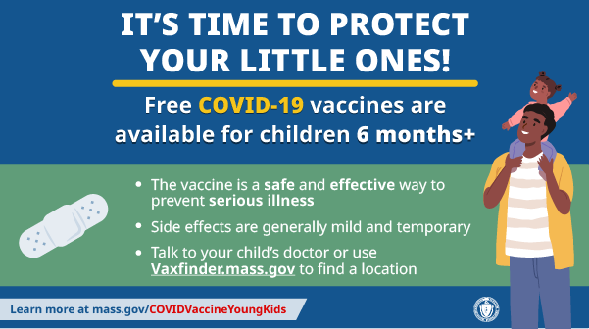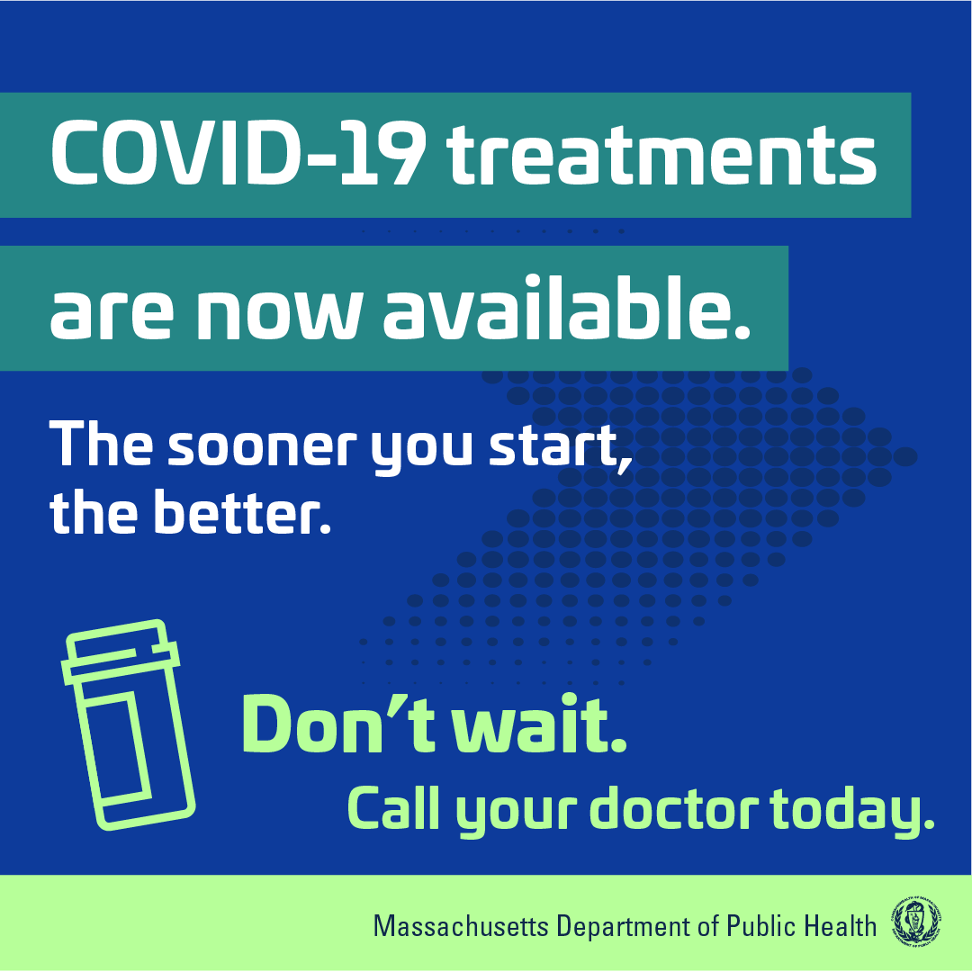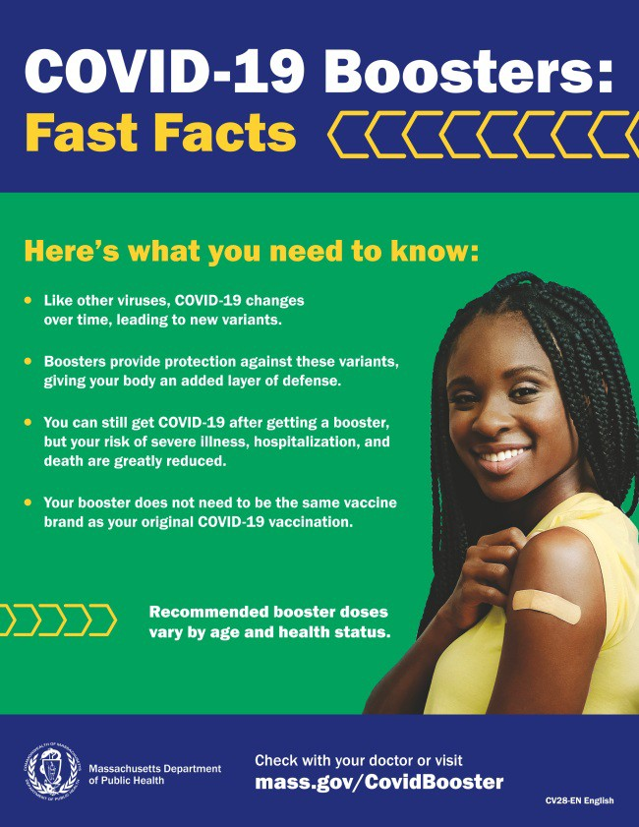Messages for children 6 months+ in
multiple languages
Short video about vaccine safety and efficacy (in English and Spanish)

FREE, SAFE, AND EFFECTIVE COVID-19 TREATMENTS AVAILABLE

Free, safe, and effective treatments for COVID-19 are available across MA. They can help prevent hospitalizations and reduce the risk of severe disease.

Several resources are available to help promote these treatments:

Telehealth flyer (in English, Haitian Creole, Khmer, Spanish, and Portuguese)
Shareable video and fact sheet Videos with local physicians discussing treatment options (in English, Spanish, and Haitian Creole)

Learn more about how to access treatment, including telehealth and in-home options.

PLEASE SHARE: COVID-19 BOOSTER FAST FACTS

COVID-19 boosters provide protection against COVID-19 variants and greatly reduce your risk of severe illness, hospitalization, and death. Some people may be eligible for a second booster.

Booster fast facts flyers are available in 12 languages.

Key Resources

OUTREACH AND EDUCATION MATERIALS

COVID-19 Vaccine FAQs COVID-19 Booster FAQs
COVID-19 Therapeutic Information (including telehealth) Weekly Provider Bulletin (latest edition published 8/2/22)
Trust the Facts, Get the Vax Campaign Materials (organized by audience, including general, parents and pregnant people, youth, young adults; available in 12 languages) Multilingual COVID-19 Materials (videos and printables; organized by language) COVID-19 Funeral Assistance from FEMA (including one-pager with key info available in multiple languages)
COVID-19 Vaccination Tools for Employers
Archive of COVID-19 Vaccine Communications Updates (past editions of VEI Roundup)

FIND A COVID-19 VACCINE OR BOOSTER

Mass.gov/KidsClinic (family-friendly clinics through September)
Vaccine Finder
Find, Schedule, or Sign Up for a Mobile COVID-19 Vaccination COVID-19 In-Home Vaccination Program
Request a Copy of Your Vaccine Card

COVID-19 VACCINE STANDING ORDERS (FROM CDC)

Pfizer
6 months - 4 years (updated 6/21/22)
5-11 (updated 5/24/22)
12 + Gray Cap (updated 5/24/22)
12 + Purple Cap (updated 5/24/22)
Moderna
6 months - 5 years (updated 7/11/22)
18+ years (updated 7/11/22)
Janssen (updated 5/24/22)
Novavax (updated 7/28/2022)

Recent Highlights
Fall River

In Fall River, VEI is working in close partnership with the local board of health and SER Jobs outreach workers, supporting a total of 33 clinics in July and August.
Throughout July, 194 vaccinations were given, including 57 first doses and 20

doses for children under 5. VEI will also
help support Fall River's second annual Back to School Block Party on August 20 at Kennedy Park (see flyer).

Read More Highlights

Share This Email
Share This Email
Share This Email

Visit the VEI Website

Vaccine Equity Initiative | 250 Washington Street, Boston, MA 02108 Unsubscribe vaccineequityinitiative@mass.gov
Constant Contact Data Notice
Sent by vaccineequityinitiative@mass.gov in collaboration with
Try email marketing for free today!

