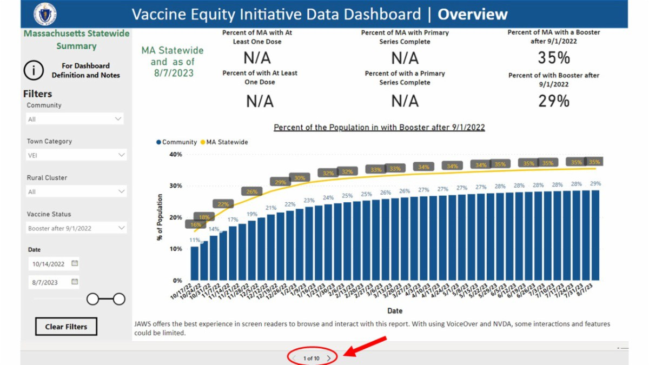
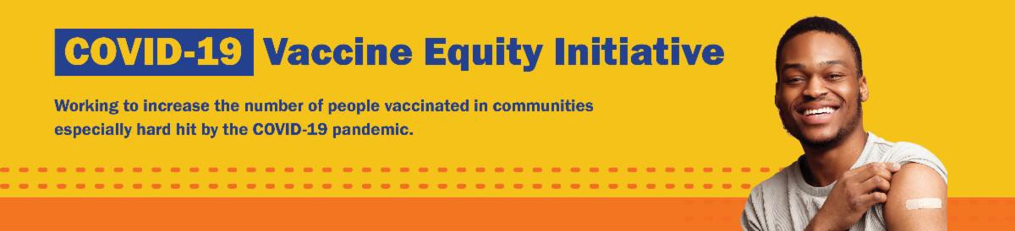
DID YOU KNOW? THE VEI DATA DASHBOARD IS UPDATED WEEKLY!

Community-specific COVID-19 vaccination data for all 20 VEI communities is publicly available!

Updated every Friday, the VEI community data dashboard provides access to weekly vaccination rates as compared to overall statewide rates.
You can click through to see COVID-19 vaccination rates broken down by race/ethnicity,
age, and other demographics by using the arrows at the bottom of the dashboard.
Reminders
What's New
August 18, 2023
Here are the latest resources for promoting COVID-19 vaccination to share with your colleagues
and networks across Massachusetts. If you received this from a colleague, subscribe today.

View this email online.

PLEASE SHARE: THE COMMUNITY HEALTH EQUITY SURVEY IS LIVE!

The Community Health Equity Survey is now open!

Residents can share their experiences to help shape the future of our health. DPH will use survey results to improve programs, make decisions about funding

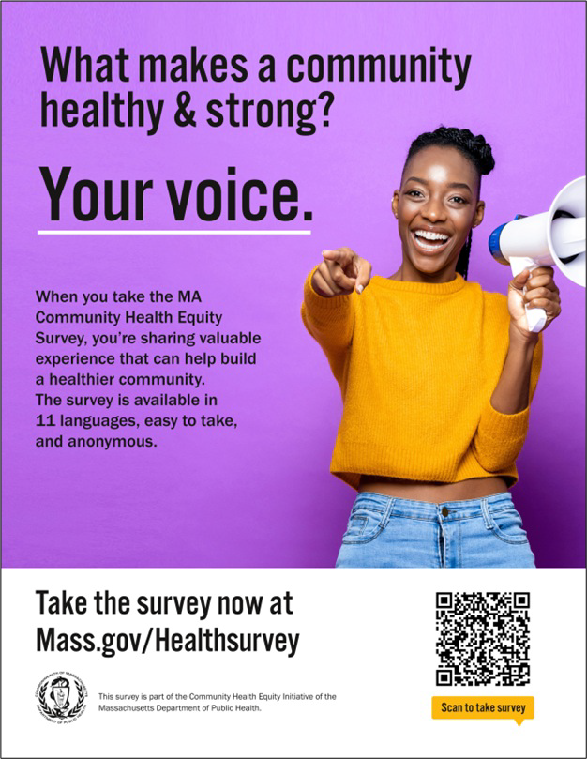
and resources, and support policies to
improve health inequities.

The survey is available in 11 languages (ASL available later this summer) and is anonymous. It is open to anyone ages 14 and older.

Get started at mass.gov/HealthSurvey.

Help get the word out! Find social media content, flyers, and other materials to help promote the survey in this toolkit.

MASSHEALTH REDETERMINATION: HELP MEMBERS KEEP THEIR COVERAGE

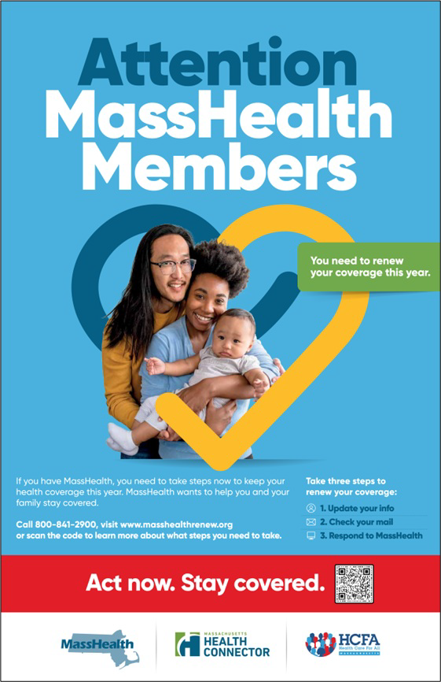
In 2023, all current MassHealth members will need to renew their health coverage to ensure they still qualify for their current benefit.

These renewals started in April and will take place over 12 months. MassHealth is working to help members maintain coverage and raise awareness about the renewal process.

You can help spread the word about MassHealth renewal using flyers, key messages, and other materials, which are available in nine languages in this toolkit .

Info about MassHealth redetermination (intro and key points) is also available in ASL, courtesy of the Learning Center for the Deaf (TLC).
Key messages to share with MassHealth members:

Update your address with MassHealth by calling MassHealth Customer Service at 800-841-2900 (TTY: 711)

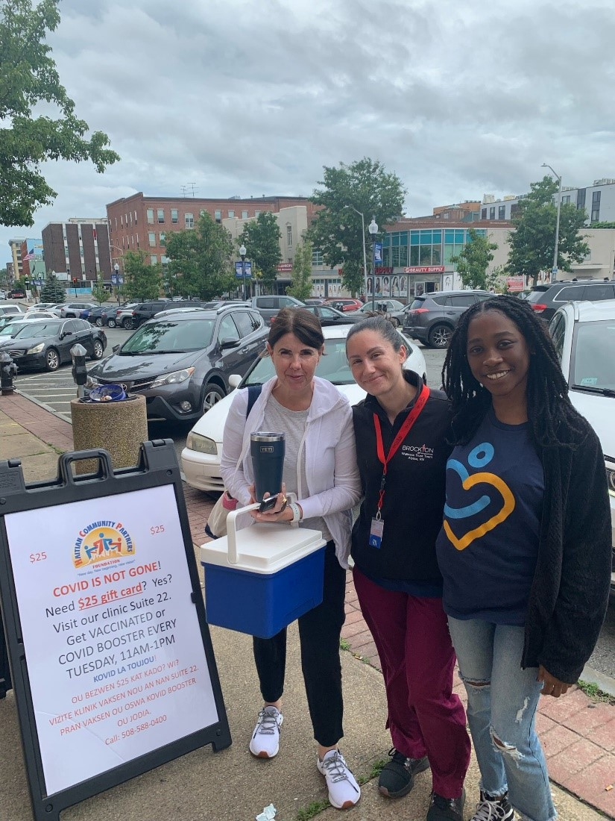
Brockton

Throughout June, Haitian Community Partners (HCP) hosted six educational events and four COVID-19 vaccine clinics in Brockton (see photo). In total, 20 people were vaccinated, and staff shared over 200 flyers with information about the COVID- 19 vaccine. More photos from HCP's June vaccination events can be viewed on their website.
Read More Highlights
Highlights
Key Resources
Look out for mail from MassHealth, especially a large blue envelope
Respond to MassHealth by the deadline on your notices. If you missed a deadline, call MassHealth at 800-841-2900 (TTY: 711) to learn more about your options.

OUTREACH AND EDUCATION MATERIALS

COVID-19 Vaccine FAQs
COVID-19 Therapeutic Information (including telehealth) Weekly Provider Bulletin
Trust the Facts, Get the Vax Campaign Materials (organized by audience, including general, parents, youth, and young adults; available in 12 languages)
Multilingual COVID-19 Materials (videos and printables; organized by language) Archive of COVID-19 Vaccine Communications Updates (past editions of VEI Roundup)

FIND A COVID-19 VACCINE DOSE

Use Vaccines.gov to sign up for a COVID-19 vaccine appointment Find a community COVID-19 vaccination clinic near you
Learn about the COVID-19 In-Home Vaccination Program and request a visit Request a copy of your vaccine card

Visit the VEI Website
Share This Email
Share This Email
Share This Email

Vaccine Equity Initiative | 250 Washington Street, Boston, MA 02108

Unsubscribe vaccineequityinitiative@mass.gov Constant Contact Data Notice
Sent by vaccineequityinitiative@mass.gov powered by
Try email marketing for free today!

