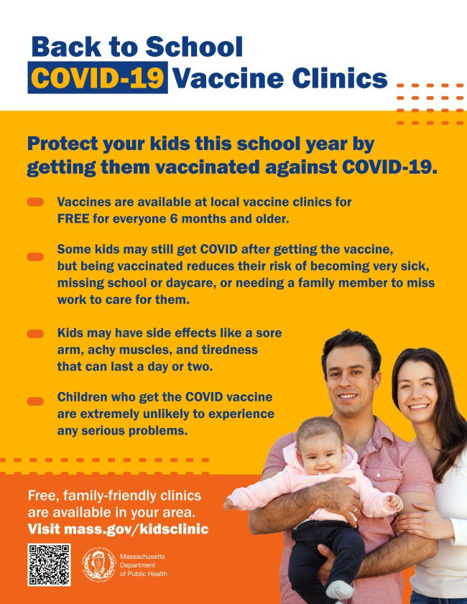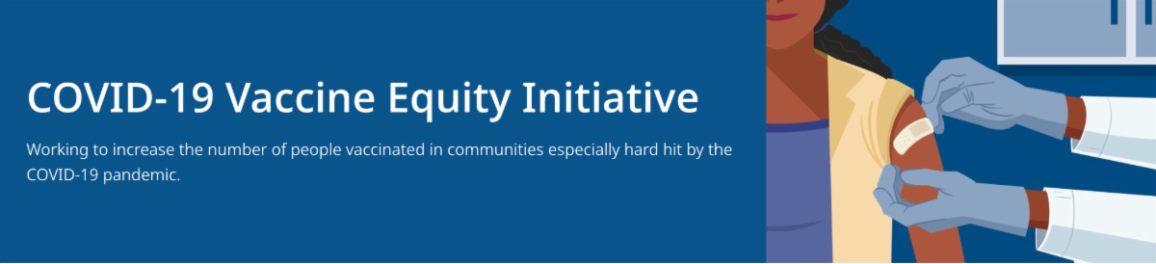
VACCINATIONS FOR BACK TO SCHOOL — NEW FLYERS AVAILABLE

Getting ready for the return to school? Add COVID-19 vaccination and boosters to your back-to-school checklist!

Being vaccinated reduces children's risk of becoming very sick, missing school or day care, or needing a family member to miss work to care for them. Learn more.

Throughout this August and September, DPH is providing 480+ options for free COVID-19 vaccination clinics. Find a clinic near you.
NEW — Materials for sharing:
Flyers (now in 12 languages)

More flyers and graphics also available:
Social media
graphics for Twitter and Facebook Flyers for teachers and school staff
FROM CDC: COVID-19 MISINFORMATION BRIEFING

The Centers for Disease Control and
August 19, 2022
Here are the latest resources for promoting COVID-19 vaccination to share with your colleagues
and networks across Massachusetts. If you received this from a colleague, subscribe today.

View this email online.
What's New

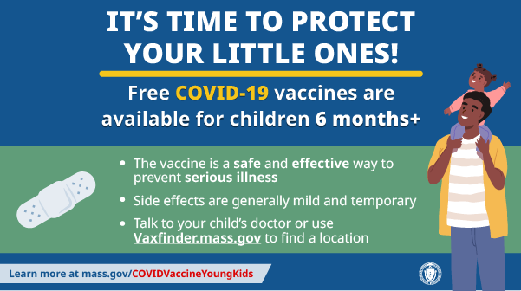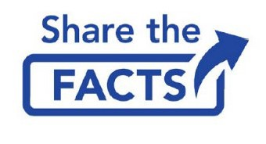
Prevention (CDC) and California Dept. of
Public Health (CDPH) are hosting a series of Joint COVID-19 Narrative Briefings.
Briefings will highlight insights into COVID- 19 vaccine hesitancy and prominent current rumors and inaccurate information about the COVID-19 vaccines. They will also provide proven strategies and trusted information about the vaccines.

Learn more, or register here.
Reminders

UPDATED: CHILDREN WITH COMPLEX MEDICAL NEEDS AND THE COVID-19 VACCINE FAQ

FAQs about the COVID-19 vaccine and children with complex medical needs, updated to reflect the eligibility of children ages 6 months and older. Also in Spanish.

COMMUNICATING WITH FAMILIES ABOUT COVID-19 VACCINATION

This resource from Head Start offers strategies for guiding conversations about COVID-19 vaccines for young children, including a sample conversation.

COVID-19 VACCINATION FOR CHILDREN AGES 6 MONTHS AND OLDER

Several materials are available to help promote COVID-19 vaccination for children ages 6 months+:

Fact sheet (12 languages) DPH social media graphic
FAQs re: children 6 months+ in multiple languages
Messages for children 6 months+ in multiple languages
Short video about vaccine safety and efficacy (in English and Spanish)

FREE, SAFE, AND EFFECTIVE COVID-19 TREATMENTS AVAILABLE

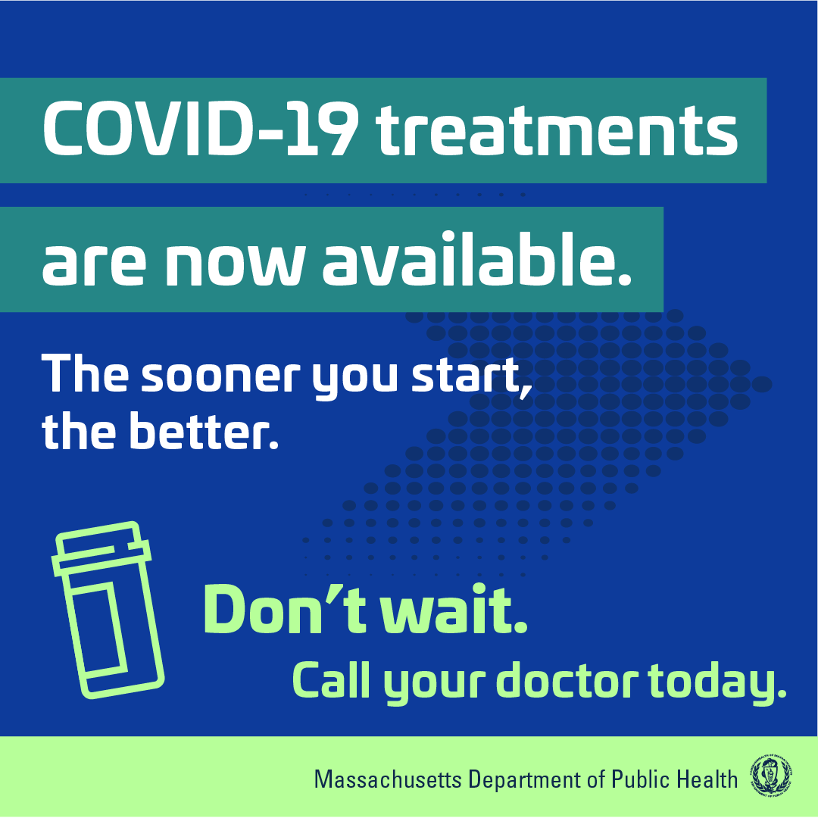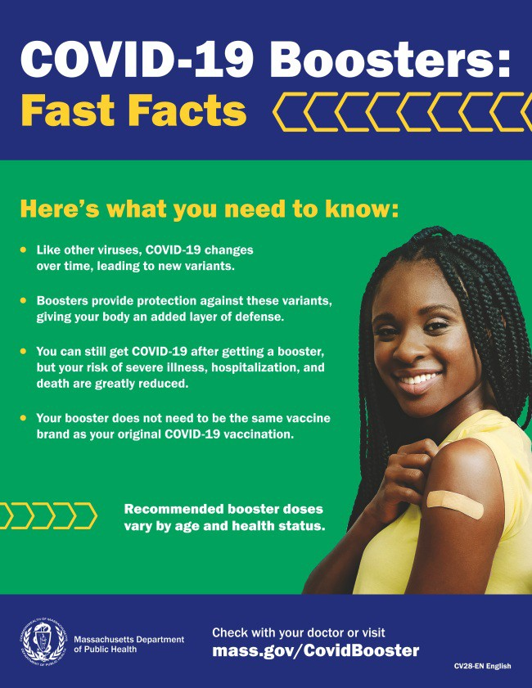Free, safe, and effective treatments for COVID-19 are available across MA. They can help prevent hospitalizations and reduce the risk of severe disease.
OUTREACH AND EDUCATION MATERIALS

COVID-19 Vaccine FAQs COVID-19 Booster FAQs
COVID-19 Therapeutic Information (including telehealth) Weekly Provider Bulletin (latest edition published 8/18/22)
Trust the Facts, Get the Vax Campaign Materials (organized by audience, including general, parents and pregnant people, youth, young adults; available in 12 languages) Multilingual COVID-19 Materials (videos and printables; organized by language)
Key Resources

Several resources are available to help promote these treatments:

Telehealth flyer (in English, Haitian Creole, Khmer, Spanish, and Portuguese)
Shareable video and fact sheet Videos with local physicians discussing treatment options (in English, Spanish, and Haitian Creole)

Learn more about how to access treatment, including telehealth and in-home options.

PLEASE SHARE: COVID-19 BOOSTER FAST FACTS

COVID-19 boosters provide protection against COVID-19 variants and greatly reduce your risk of severe illness, hospitalization, and death. Some people may be eligible for a second booster.

Booster fast facts flyers are available in 12 languages.

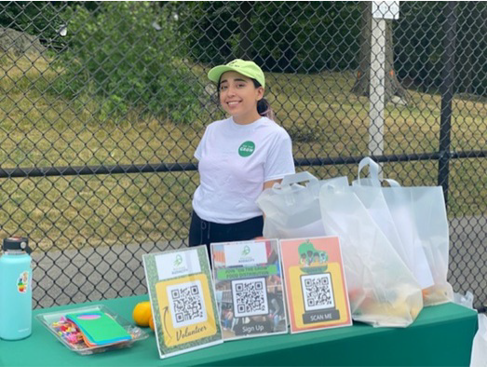COVID-19 Funeral Assistance from FEMA (including one-pager with key info
Lynn

Building Audacity (serving youth and families) recently teamed up with several community organizations, including fellow VEI grantee Black Boston COVID-19 Coalition, to host “Ball for Black Girls,” a basketball tournament. Building Audacity provided information about upcoming COVID vaccine clinics; masks, rapid tests, and other mitigation resources; and nutritious food for families (see photo).
Resources were distributed to 40 families.
Read More Highlights
Recent Highlights
available in multiple languages)
COVID-19 Vaccination Tools for Employers
Archive of COVID-19 Vaccine Communications Updates (past editions of VEI Roundup)

FIND A COVID-19 VACCINE OR BOOSTER

Mass.gov/KidsClinic (family-friendly clinics through September)
Vaccine Finder
Find, Schedule, or Sign Up for a Mobile COVID-19 Vaccination COVID-19 In-Home Vaccination Program
Request a Copy of Your Vaccine Card

COVID-19 VACCINE STANDING ORDERS (FROM CDC)

Pfizer
6 months - 4 years (updated 6/21/22)
5-11 (updated 5/24/22)
12 + Gray Cap (updated 5/24/22)
12 + Purple Cap (updated 5/24/22)
Moderna
6 months - 5 years (updated 7/11/22)
18+ years (updated 7/11/22)
Janssen (updated 5/24/22)
Novavax (updated 7/28/2022)

Share This Email
Share This Email
Share This Email

Visit the VEI Website

Vaccine Equity Initiative | 250 Washington Street, Boston, MA 02108

Unsubscribe vaccineequityinitiative@mass.gov Constant Contact Data Notice
Sent by vaccineequityinitiative@mass.gov in collaboration with
Try email marketing for free today!

