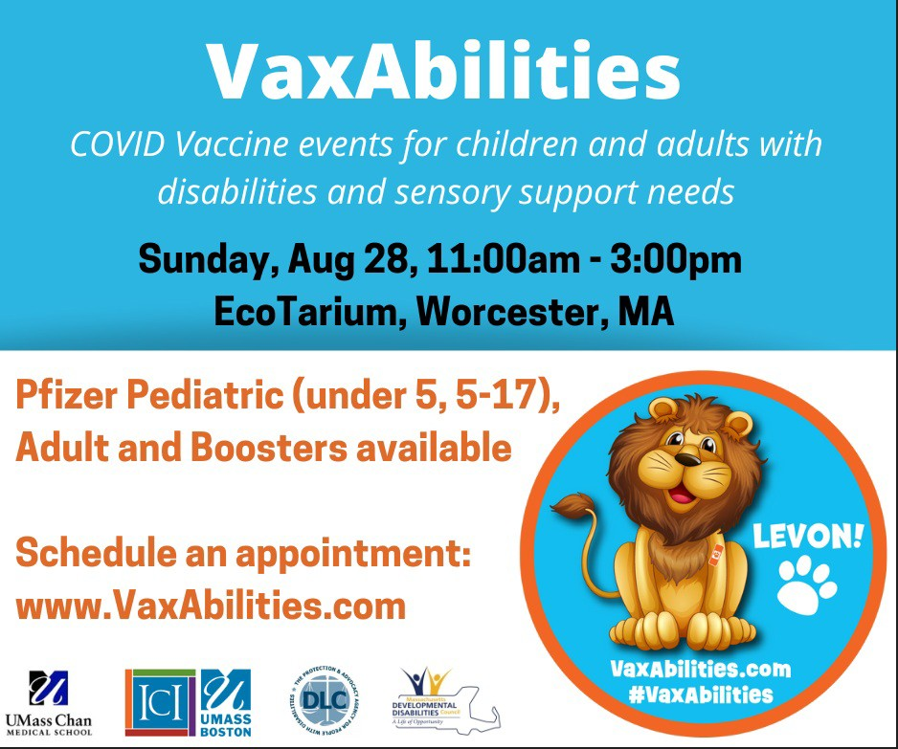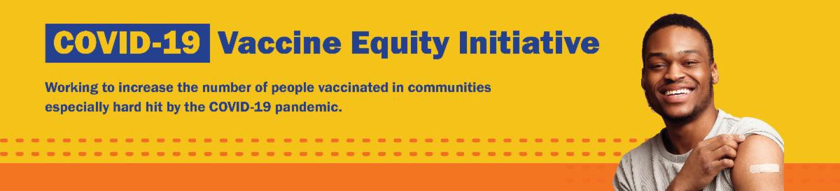
August 26, 2022
Here are the latest resources for promoting COVID-19 vaccination to share with your colleagues
and networks across Massachusetts. If you received this from a colleague, subscribe today.

View this email online.
What's New

HAPPENING SUNDAY (AUGUST 28) — VAXABILITIES EVENT IN WORCESTER

COVID-19 vaccines and boosters for adults and children ages 6 months and older with disabilities or sensory support needs will be available at the EcoTarium on August 28, 11 a.m. to 3 p.m. This event will have additional clinical supports to help people get vaccinated as comfortably as possible.

To make an appointment: Go
to VaxAbilities.com, and click on “Sites and Dates.”

VACCINATIONS FOR BACK TO SCHOOL — CLINIC SCHEDULE UPDATED!

Getting ready for the return to school? Add COVID-19 vaccination and boosters to your back-to-school checklist!

Being vaccinated reduces children's risk of becoming very sick, missing school or day care, or needing a family member to miss work to care for them. Learn more.

Throughout this August and September, DPH is providing 480+ options for free

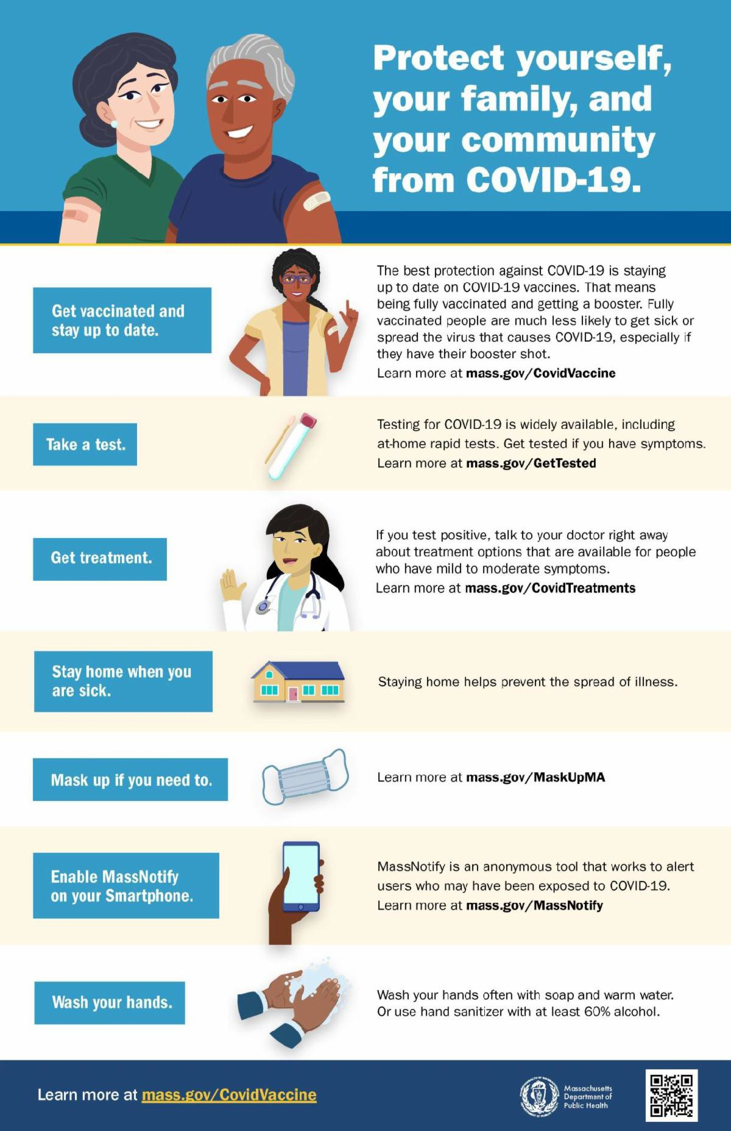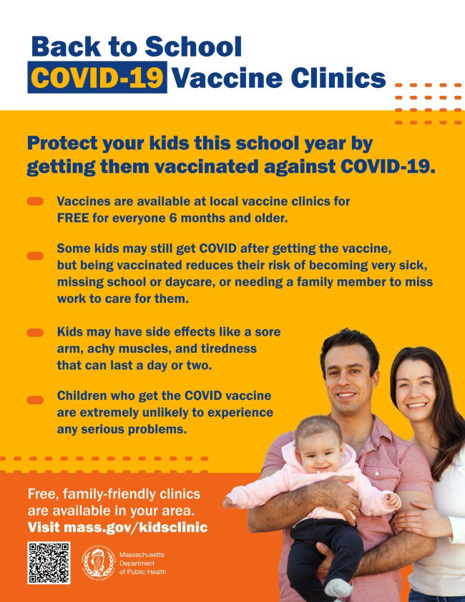
SEVEN STEPS TO PROTECT YOURSELF AND YOUR FAMILY FROM COVID

Available in multiple languages, this flyer features a checklist to help protect
yourself, your family, and your community from COVID-19. Please share it with your networks.
IN-HOME COVID-19 VACCINATION AVAILABLE

In-home COVID-19 vaccinations are available for anyone who has difficulty getting to or using a community clinic, including young children. All vaccine types are available. Learn more.
COVID-19 vaccination clinics. Find a clinic
near you.

Help spread the word:
Flyers (in 12 languages)
Graphics for Twitter and Facebook Flyer for teachers and school staff
Reminders

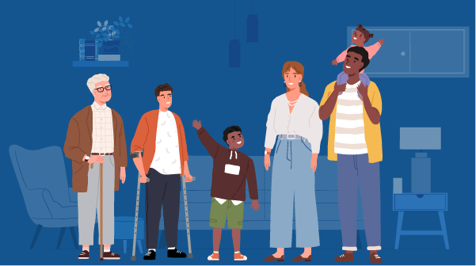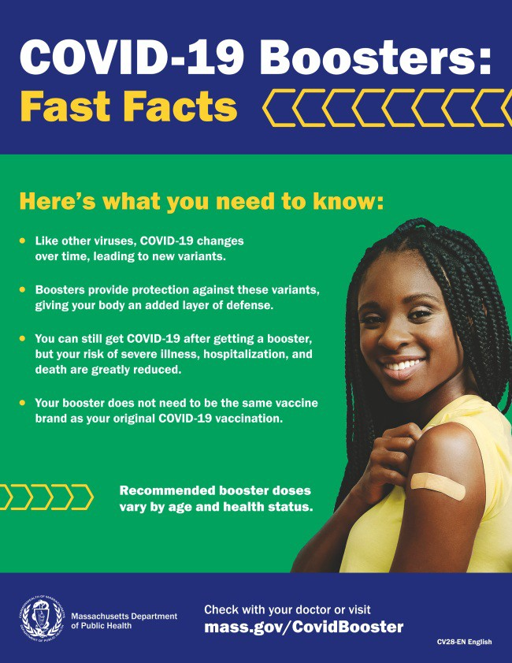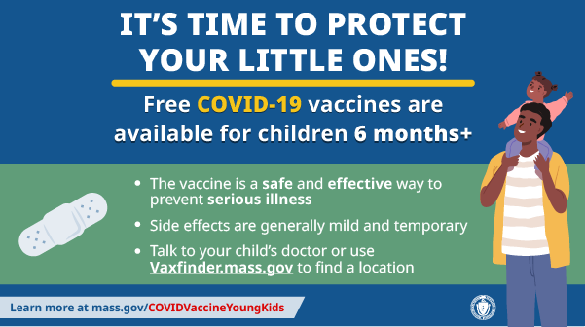

PLEASE SHARE: COVID-19 BOOSTER FAST FACTS

COVID-19 boosters provide protection against COVID-19 variants and greatly reduce your risk of severe illness, hospitalization, and death. Some people may be eligible for a second booster.

Booster fast facts flyers are available in 12 languages.

COVID-19 VACCINATION FOR CHILDREN AGES 6 MONTHS AND OLDER

Several materials are available to help promote COVID-19 vaccination for children ages 6 months+:

Fact sheet (12 languages) DPH social media graphic
FAQs re: children 6 months+ in multiple languages
Messages for children 6 months+ in multiple languages
Short video about vaccine safety and efficacy (in English and Spanish)

FREE, SAFE, AND EFFECTIVE COVID-19 TREATMENTS AVAILABLE

Free, safe, and effective treatments for COVID-19 are available across MA. They

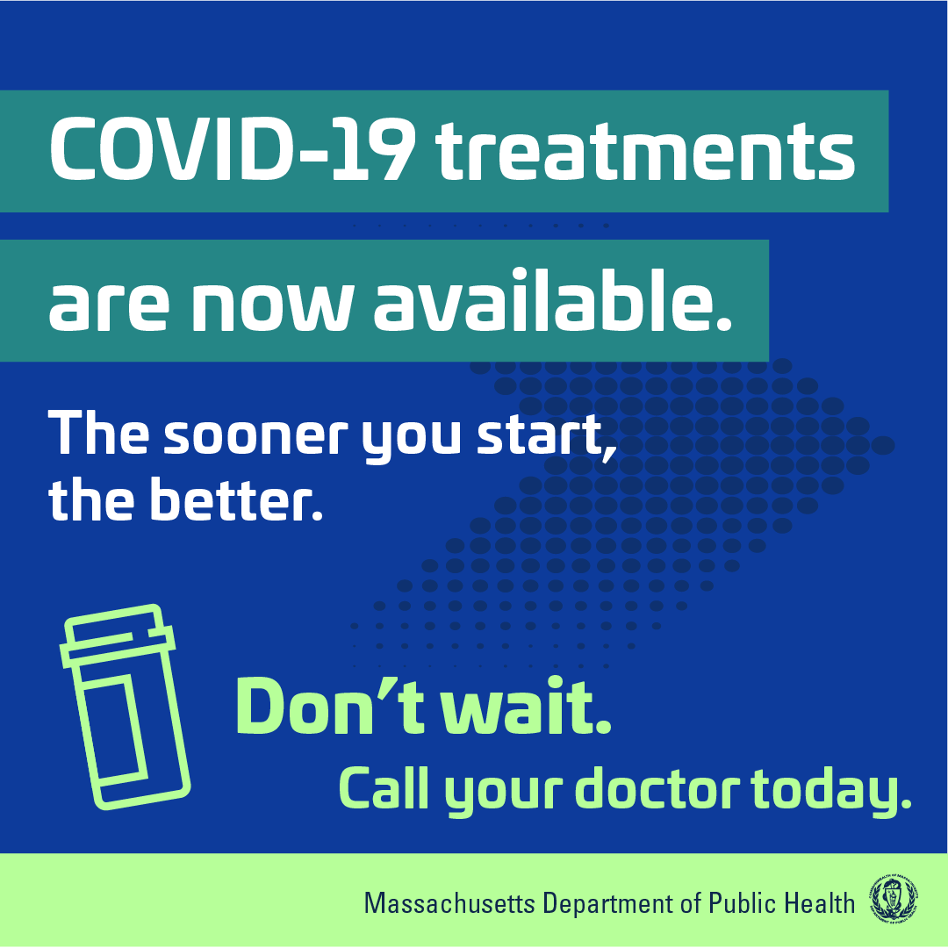
can help prevent hospitalizations and
reduce the risk of severe disease.

Several resources are available to help promote these treatments:

Telehealth flyer (in English, Haitian Creole, Khmer, Spanish, and Portuguese)
Shareable video and fact sheet Videos with local physicians discussing treatment options (in English, Spanish, and Haitian Creole)
Learn more about how to access treatment, including telehealth and in-home options.
Key Resources

OUTREACH AND EDUCATION MATERIALS

COVID-19 Vaccine FAQs COVID-19 Booster FAQs
COVID-19 Therapeutic Information (including telehealth) Weekly Provider Bulletin (latest edition published 8/24/22)
Trust the Facts, Get the Vax Campaign Materials (organized by audience, including general, parents and pregnant people, youth, young adults; available in 12 languages) Multilingual COVID-19 Materials (videos and printables; organized by language) COVID-19 Funeral Assistance from FEMA (including one-pager with key info available in multiple languages)
COVID-19 Vaccination Tools for Employers
Archive of COVID-19 Vaccine Communications Updates (past editions of VEI Roundup)

FIND A COVID-19 VACCINE OR BOOSTER

Mass.gov/KidsClinic (family-friendly clinics through September)
Vaccine Finder
Find, Schedule, or Sign Up for a Mobile COVID-19 Vaccination COVID-19 In-Home Vaccination Program
Request a Copy of Your Vaccine Card

COVID-19 VACCINE STANDING ORDERS (FROM CDC)

Pfizer
6 months - 4 years (updated 6/21/22)
5-11 (updated 5/24/22)
12 + Gray Cap (updated 5/24/22)
12 + Purple Cap (updated 5/24/22)
Moderna

6 months - 5 years (updated 7/11/22)
18+ years (updated 7/11/22)
Janssen (updated 5/24/22)
Novavax (updated 7/28/2022)

Recent Highlights
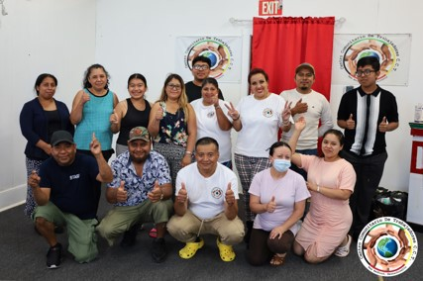New Bedford

Centro Comunitario de Trabajadores (CCT), which serves Central American and Maya K’iche’ communities, is holding six COVID-19 vaccine clinics throughout July and August. During one of the August clinics (see photo), CCT also distributed children's clothing, baby items, and maseca, a food staple used to make corn tortillas. Across the three clinics held so far, 54 vaccines have been administered, including 20 first doses.

Read More Highlights

Share This Email
Share This Email
Share This Email

Visit the VEI Website

Vaccine Equity Initiative | 250 Washington Street, Boston, MA 02108 Unsubscribe vaccineequityinitiative@mass.gov
Constant Contact Data Notice
Sent by vaccineequityinitiative@mass.gov in collaboration with
Try email marketing for free today!

