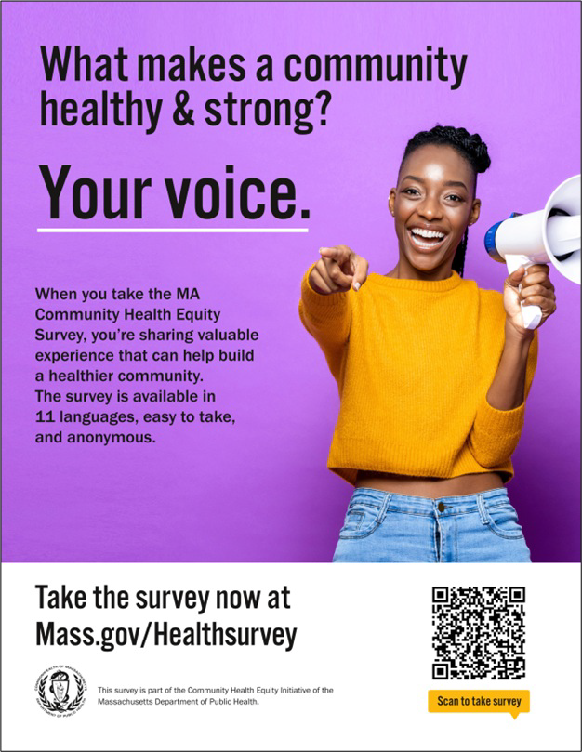
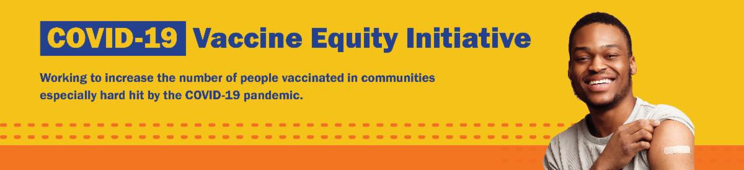
PLEASE SHARE: THE COMMUNITY HEALTH EQUITY SURVEY IS LIVE!

The Community Health Equity Survey is now open!

Residents can share their experiences to help shape the future of our health. DPH will use survey results to improve programs, make decisions about funding and resources, and support policies to improve health inequities.

The survey is available in 11 languages (ASL available later this summer) and is anonymous. It is open to anyone ages 14 and older.

Get started at mass.gov/HealthSurvey.
MASSHEALTH REDETERMINATION: HELP MEMBERS KEEP THEIR COVERAGE

In 2023, all current MassHealth members will need to renew their health coverage to
Help get the word out! Find social media content, flyers, and other materials to help promote the survey in this toolkit.
August 4, 2023
Here are the latest resources for promoting COVID-19 vaccination to share with your colleagues
and networks across Massachusetts. If you received this from a colleague, subscribe today.

View this email online.
What's New

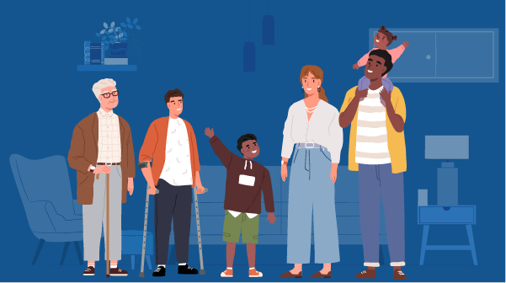
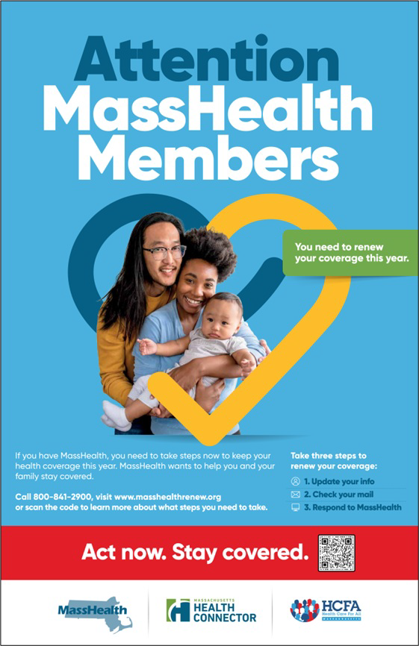
ensure they still qualify for their current
FREE IN-HOME COVID-19 VACCINATION AVAILABLE

Massachusetts offers in-home COVID-19 vaccination for anyone who has difficulty getting to or using a community clinic, including children. Learn more, or call 833- 983-0485 to sign up for an appointment.

Info about in-home vaccination is available in multiple languages, including ASL (thanks to TLC).
MY VAX RECORDS: A DIGITAL VACCINE CARD FOR MASSACHUSETTS
RESIDENTS
Reminders
benefit.

These renewals started in April and will take place over 12 months. MassHealth is working to help members maintain coverage and raise awareness about the renewal process.

You can help spread the word about MassHealth renewal using flyers, key messages, and other materials, which are available in nine languages in this toolkit .

Info about MassHealth redetermination (intro and key points) is also available in ASL, courtesy of the Learning Center for the Deaf (TLC).

Key messages to share with MassHealth members:

Update your address with MassHealth by calling MassHealth Customer Service at 800-841-2900 (TTY: 711)
Look out for mail from MassHealth, especially a large blue envelope
Respond to MassHealth by the deadline on your notices. If you missed a deadline, call MassHealth at 800-841-2900 (TTY: 711) to learn more about your options.

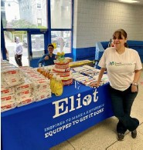
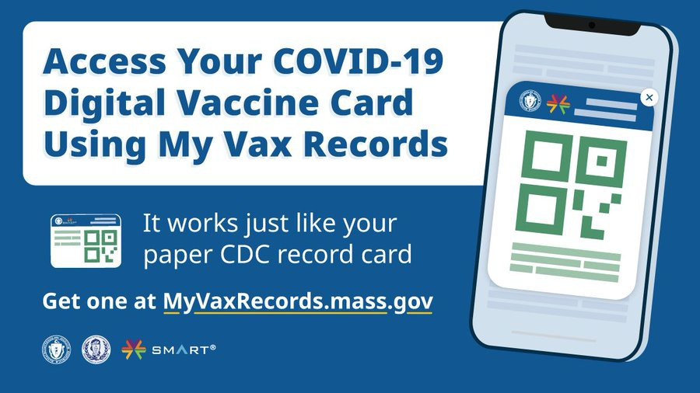

This spring, the Joint Committee for Children’s Health Care partnered with the Eliot Family Resource Center in Everett to host a community baby shower for over 100 new parents (see photo). All of the parents received diaper bags, diapers, wipes, board books, toys, and more. During the event, the Joint Committee promoted COVID-19 prevention strategies and shared vaccine clinic schedules. They also added flyers and hand sanitizers to goody bags for parents.
Highlights
Can't remember when you had your last
COVID vaccine dose? Need a copy of your COVID vaccination record?

Massachusetts residents can use My Vax Records to get a digital vaccine card. Learn more.
Info about My Vax Records is available in ASL,
courtesy of TLC.
Key Resources

OUTREACH AND EDUCATION MATERIALS

COVID-19 Vaccine FAQs
COVID-19 Therapeutic Information (including telehealth) Weekly Provider Bulletin
Trust the Facts, Get the Vax Campaign Materials (organized by audience, including general, parents, youth, and young adults; available in 12 languages)
Multilingual COVID-19 Materials (videos and printables; organized by language) Archive of COVID-19 Vaccine Communications Updates (past editions of VEI Roundup)

FIND A COVID-19 VACCINE DOSE

Use Vaccines.gov to sign up for a COVID-19 vaccine appointment Find a community COVID-19 vaccination clinic near you
Learn about the COVID-19 In-Home Vaccination Program and request a visit Request a copy of your vaccine card

Read More Highlights

Visit the VEI Website

Share This Email
Share This Email
Share This Email

Vaccine Equity Initiative | 250 Washington Street, Boston, MA 02108

Unsubscribe vaccineequityinitiative@mass.gov Constant Contact Data Notice
Sent by vaccineequityinitiative@mass.gov powered by
Try email marketing for free today!

