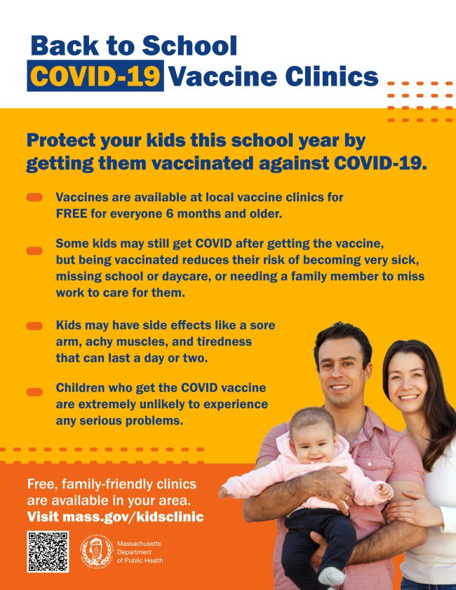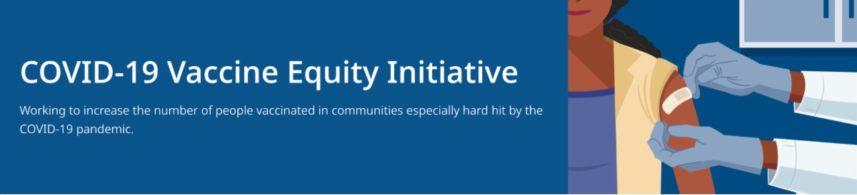
UPDATE VACCINATIONS FOR BACK TO SCHOOL

Getting ready for the return to school? Add COVID-19 vaccination and boosters to your back-to-school checklist!

Being vaccinated reduces children's risk of becoming very sick, missing school or day care, or needing a family member to miss work to care for them. Learn more.

Throughout this August and September, DPH is providing 480+ options for free COVID-19 vaccination clinics. Find a clinic near you.
Please help spread the word by sharing
this flyer!
NOVAVAX AVAILABLE IN MA FOR INDIVIDUALS AGES 18 AND OLDER
August 5, 2022
Here are the latest resources for promoting COVID-19 vaccination to share with your colleagues
and networks across Massachusetts. If you received this from a colleague, subscribe today.

View this email online.
What's New

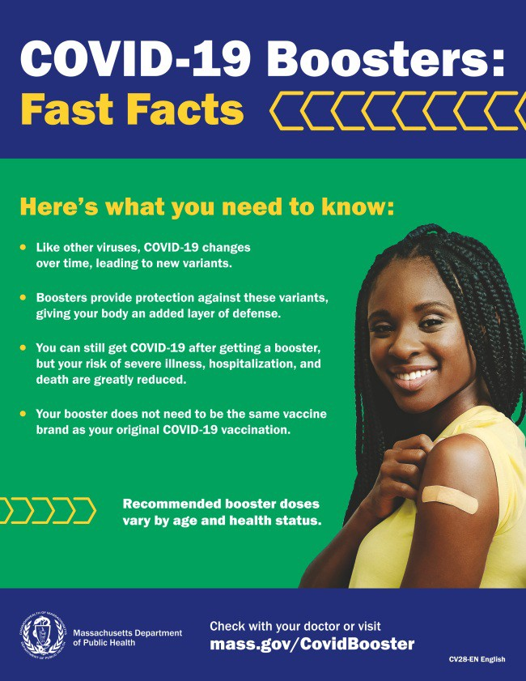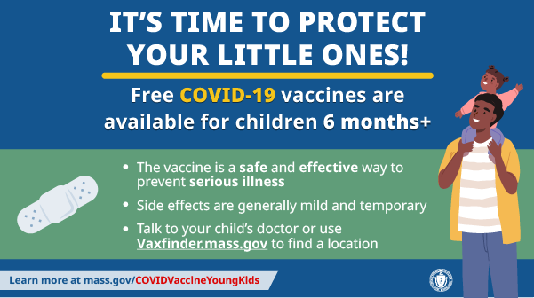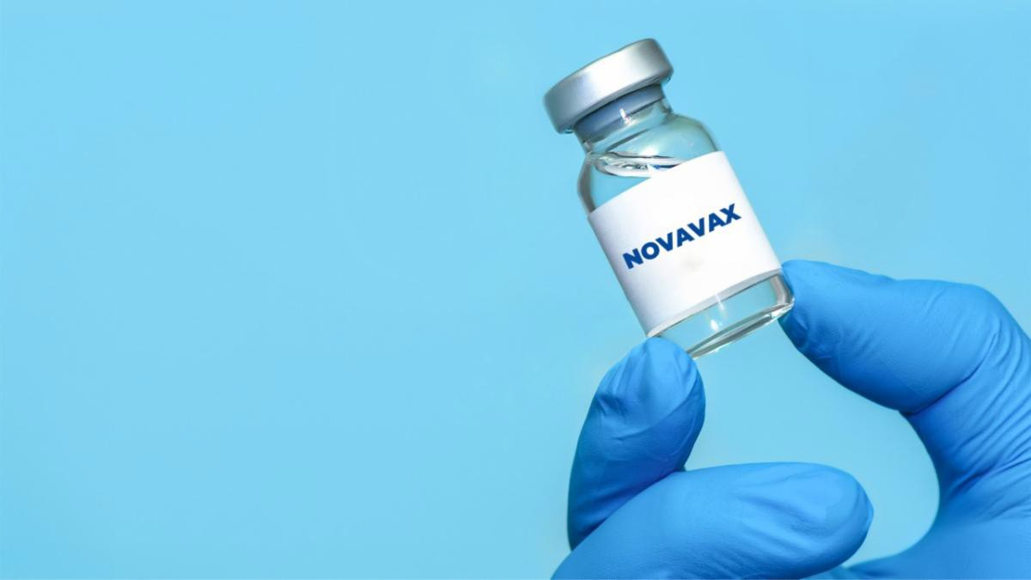
Another COVID-19 vaccine is available in Massachusetts with the addition of Novavax for individuals ages 18 and older. The supply is limited. To locate a clinic offering Novavax, visit Vaxfinder at vaxfinder.mass.gov.
Reminders

PLEASE SHARE: COVID-19 BOOSTER FAST FACTS

COVID-19 boosters provide protection against COVID-19 variants and greatly reduce your risk of severe illness, hospitalization, and death. Some people may be eligible for a second booster.

Booster fast facts flyers are available in 12 languages.

COVID-19 VACCINATION FOR CHILDREN AGES 6 MONTHS AND OLDER

Several materials are available to help promote COVID-19 vaccination for children ages 6 months+:

Basic fact sheet (in 12 languages) DPH social media graphic
FAQs about the vaccine for children 6 months+ in multiple languages Messages about the vaccine for children 6 months+ in multiple languages
Short video about vaccine safety and efficacy (in English and Spanish)

FREE, SAFE, AND EFFECTIVE COVID-19 TREATMENTS AVAILABLE

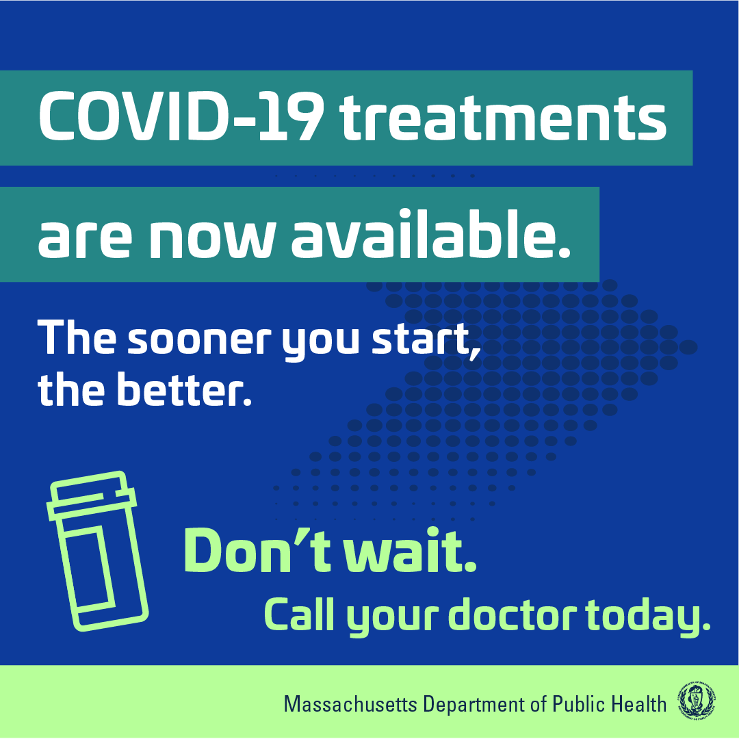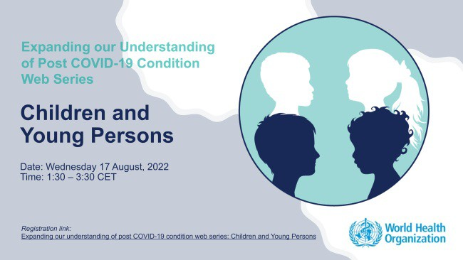Free, safe, and effective treatments for COVID-19 are available across MA. They can help prevent hospitalizations and reduce the risk of severe disease.

Several resources are available to help promote these treatments:

Telehealth flyer (in English, Haitian Creole, Khmer, Spanish, and Portuguese)
Shareable video and fact sheet Videos featuring local physicians discussing COVID-19 treatment options (in English, Spanish, and Haitian Creole)

Learn more about how to access treatment, including telehealth and in-home options.

FROM THE WORLD HEALTH ORGANIZATION: UNDERSTANDING LONG COVID IN CHILDREN AND YOUTH

The World Health Organization (WHO) will be hosting a webinar that explores the long-term effects of COVID-19 infection in children and youth on August 17 at 7:30
a.m. EST. Learn more and register.

Key Resources

OUTREACH AND EDUCATION MATERIALS

COVID-19 Vaccine FAQs COVID-19 Booster FAQs
COVID-19 Therapeutic Information (including telehealth) Weekly Provider Bulletin (latest edition published 8/2/22)
Trust the Facts, Get the Vax Campaign Materials (organized by audience, including general, parents and pregnant people, youth, young adults; available in 12 languages) Multilingual COVID-19 Materials (videos and printables; organized by language) COVID-19 Funeral Assistance from FEMA (including one-pager with key info available in multiple languages)

COVID-19 Vaccination Tools for Employers
Archive of COVID-19 Vaccine Communications Updates (past editions of VEI Roundup)

FIND A COVID-19 VACCINE OR BOOSTER

Vaccine Finder
Find, Schedule, or Sign Up for a Mobile COVID-19 Vaccination COVID-19 In-Home Vaccination Program
Request a Copy of Your Vaccine Card
COVID-19 VACCINE STANDING ORDERS (FROM CDC)

Pfizer
6 months - 4 years (updated 6/21/22)
5-11 (updated 5/24/22)
12 + Gray Cap (updated 5/24/22)
12 + Purple Cap (updated 5/24/22) Moderna
6 months - 5 years (updated 7/11/22)
18+ years (updated 7/11/22)
Janssen (updated 5/24/22)
Novavax (updated 7/28/2022)
Recent Highlights

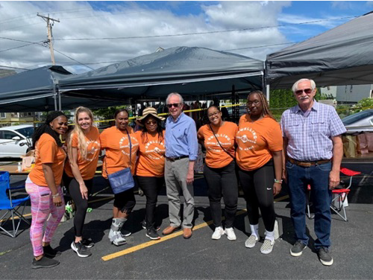
Lowell

Dwelling House of Hope recently held their Hygiene Day event, which combined a vaccine clinic with food and COVID-19 resource distribution for the community.
Over 100 people were vaccinated, including 20 first doses, some of which were for children under the age of five.
Image: Dwelling House of Hope Team (in orange)
poses with State Senator Ed Kennedy (center).
Read More Highlights
Visit the VEI Website
Share This Email
Share This Email
Share This Email

Vaccine Equity Initiative | 250 Washington Street, Boston, MA 02108

Unsubscribe vaccineequityinitiative@mass.gov

Constant Contact Data Notice
Sent by vaccineequityinitiative@mass.gov in collaboration with
Try email marketing for free today!

