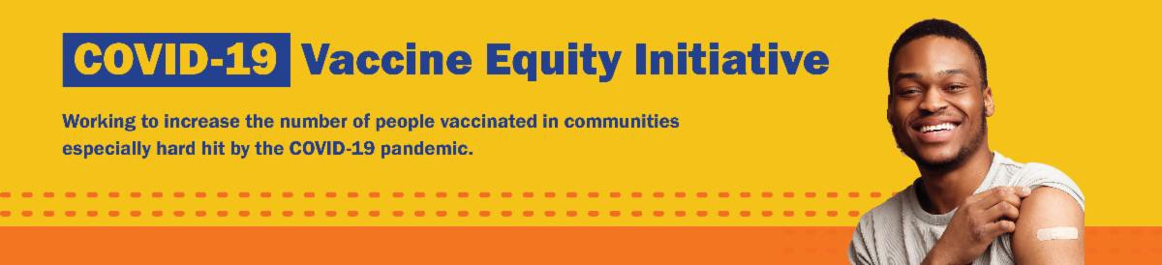
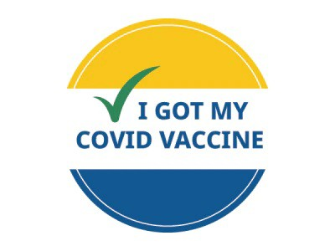
September 1, 2023
Here are the latest resources for promoting COVID-19 vaccination to share with your colleagues
and networks across Massachusetts. If you received this from a colleague, subscribe today.
View this email online.
What's New

LOST YOUR COVID VACCINE CARD? HERE'S HOW TO GET A NEW ONE
Can't remember when you had your last COVID vaccine dose? Need a copy of your COVID vaccination record?

If you were vaccinated at a health care center or by your primary care provider: contact the location where you got vaccinated.
If you were vaccinated at a pop-up clinic: contact your primary care provider, or explore the other options below.
If you were vaccinated at a retail pharmacy: you may be able to access your record online, or contact a pharmacist (varies by pharmacy). If you were vaccinated at a state mass vaccination site: follow these instructions.

You can also:
Get a digital copy from My Vax Records .
Fill out a state immunization record request form (available in English and Spanish). This will provide a record of all vaccines you've gotten. It may take several weeks to process.

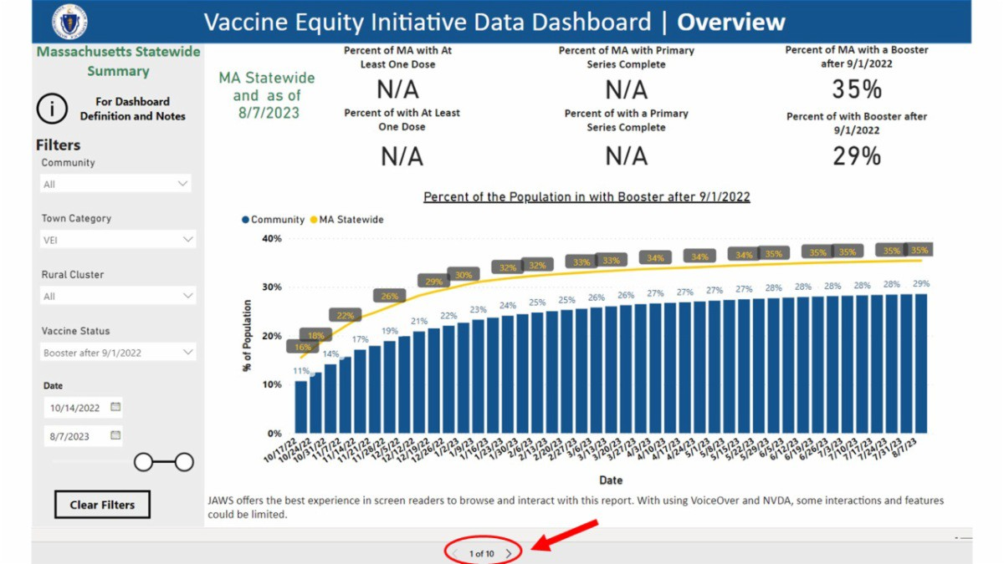
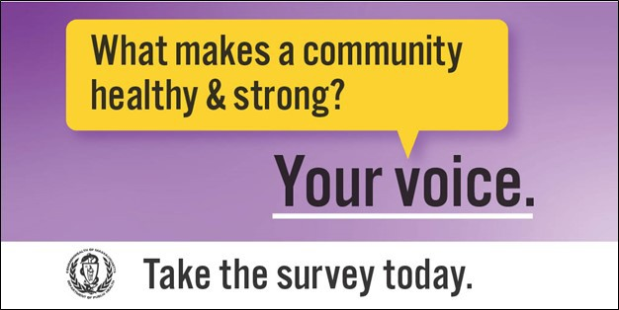
Learn more about these options, or call 2-1-1 with any questions.
Reminders

DID YOU KNOW? THE VEI DATA DASHBOARD IS UPDATED WEEKLY!
Community-specific COVID-19 vaccination data for all 20 VEI communities is publicly available!
Updated every Friday, the VEI community data dashboard provides access to weekly vaccination rates as compared to overall statewide rates.

You can click through to see COVID-19 vaccination rates broken down by race/ethnicity, age, and other demographics by using the arrows at the bottom of the dashboard.

PLEASE SHARE: THE COMMUNITY HEALTH EQUITY SURVEY IS LIVE!
The Community Health Equity Survey is now open for Massachusetts residents!
Results will help DPH improve programs, make decisions about funding and resources, and support policies to improve health inequities.

The survey is available in 11 languages and is anonymous. It is open to anyone ages 14 and older. Get started at mass.gov/HealthSurvey.
Help get the word out! Find talking points, flyers, and other materials to help promote the survey in this toolkit.

Q&A: WHY DO THE EXPIRATION DATES ON COVID TESTS CHANGE?

Q: Why does the expiration date on my COVID-19 test keep changing?
A: The companies that make the tests check them to see if they still work. If they do, the FDA extends the expiration date.
Learn more about COVID-19,

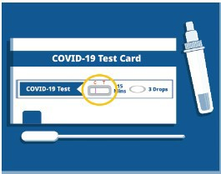
including what to do if you test
positive, at mass.gov/COVID.
What other questions are you hearing? Let us know!
Key Resources

OUTREACH AND EDUCATION MATERIALS

COVID-19 Vaccine FAQs
COVID-19 Therapeutic Information (including telehealth) Weekly Provider Bulletin
Trust the Facts, Get the Vax Campaign Materials (organized by audience, including general, parents, youth, and young adults; available in 12 languages)
Multilingual COVID-19 Materials (videos and printables; organized by language) Archive of COVID-19 Vaccine Communications Updates (past editions of VEI Roundup)

FIND A COVID-19 VACCINE DOSE

Use Vaccines.gov to sign up for a COVID-19 vaccine appointment Find a community COVID-19 vaccination clinic near you
Learn about the COVID-19 In-Home Vaccination Program and request a visit Request a copy of your vaccine card

Highlights

Throughout June, Making Opportunity Count hosted four COVID-19 vaccine clinics and educational events in Fitchburg, Leominster, Gardner, and Clinton (see photo). Staff shared flyers in Spanish and Portuguese at these events, and 15 people received COVID-19 vaccinations. The events also received positive community feedback. As one community member shared: “I am relieved that there are still

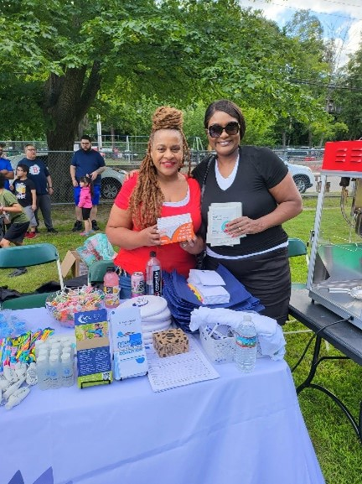
clinics where I was able to go and get my
vaccine, thank you!”

Read More Highlights

Visit the VEI Website
Share This Email
Share This Email
Share This Email

Vaccine Equity Initiative | 250 Washington Street, Boston, MA 02108 Unsubscribe vaccineequityinitiative@mass.gov
Constant Contact Data Notice
Sent by vaccineequityinitiative@mass.gov powered by

Try email marketing for free today!

