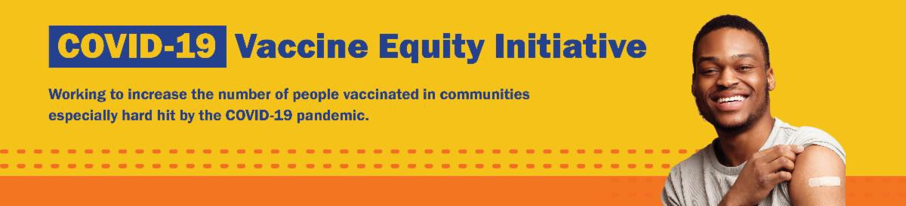
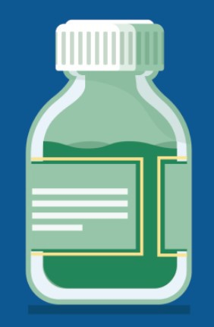
September 15, 2023
Here are the latest resources for promoting COVID-19 vaccination to share with your colleagues
and networks across Massachusetts. If you received this from a colleague, subscribe today.
View this email online.
What's New

CDC UPDATES COVID-19 VACCINE RECOMMENDATIONS
Earlier this week, the CDC updated their COVID-19 vaccine recommendations for fall 2023 and winter 2024.
The CDC recommends that everyone ages 6 months and older get one updated vaccine dose.
Key takeaway: Anyone aged 5 years and over only needs one dose of the updated vaccine to be up to date— even if they've never been vaccinated before!
You have had the updated COVID vaccine if you had a dose after September 12, 2023.
Updated vaccines have started shipping and will be available at clinics, pharmacies, and other locations in the coming week.
Once providers receive the updated vaccines, you will be able to search for appointments at vaccines.gov. Local community clinics will be posted on mass.gov/MobileVax.

Learn more on the CDC website, and watch out for more guidance in the next edition of the

VEI Roundup!

PLEASE SHARE: MA DISABILITY COMMUNITY HEALTH NEEDS ASSESSMENT
The Health and Disability Program in the Office of Health Equity recently announced the Massachusetts Disability Community Health Needs Assessment, a complement to the Community Health Equity Survey.
This online survey is available in 12 languages, including ASL, and will help identify and address the needs of people with disabilities throughout the Commonwealth.

If you are a person living with a disability in Massachusetts, please fill out the survey today — and please share it with your networks, colleagues, and partners.

Help spread the word! This flyer is available in
English, Haitian Creole, and Spanish.

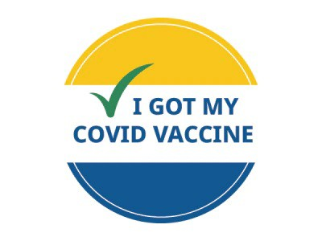
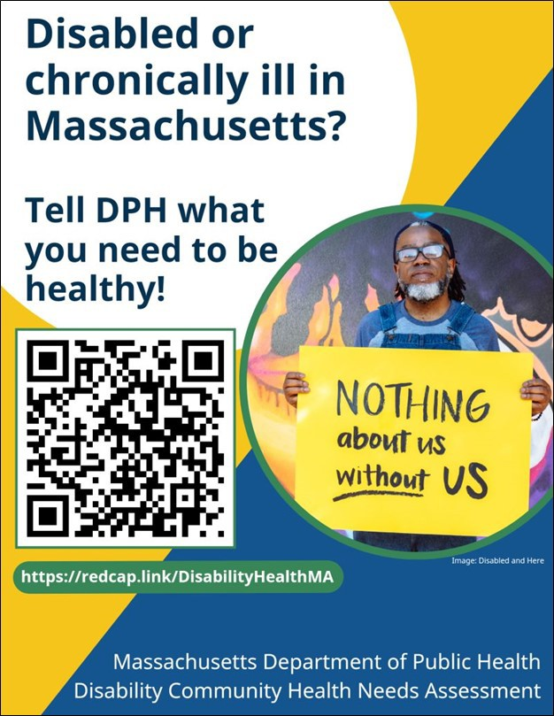
Reminders

LOST YOUR COVID VACCINE CARD? HERE'S HOW TO GET A NEW ONE
Can't remember when you had your last COVID vaccine dose? Need a copy of your COVID vaccination record?

If you were vaccinated at a health care center or by your primary care provider: contact the location where you got vaccinated.
If you were vaccinated at a pop-up clinic: contact your primary care provider, or explore the other options below.
If you were vaccinated at a retail pharmacy: you may be able to access your record online, or contact a pharmacist (varies by pharmacy). If you were vaccinated at a state mass vaccination site: follow these instructions.

You can also:
Get a digital copy from My Vax Records .
Fill out a state immunization record request form (available in English and Spanish).

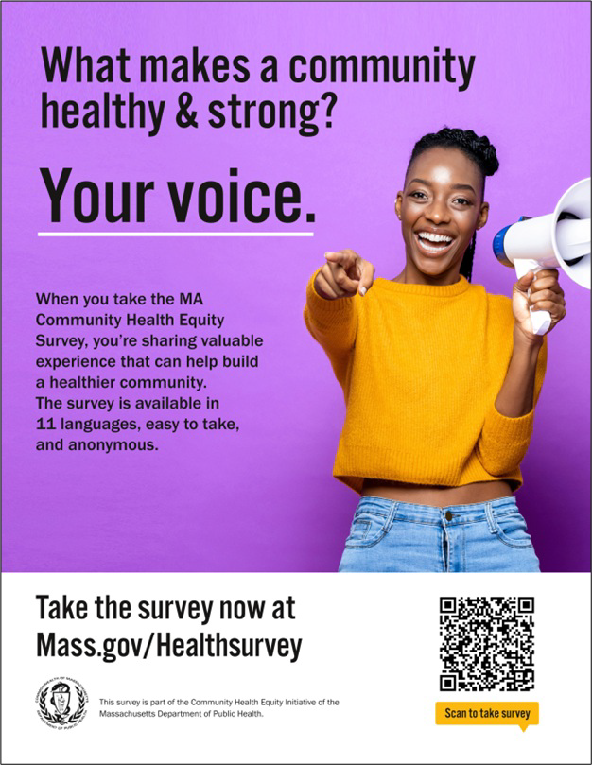
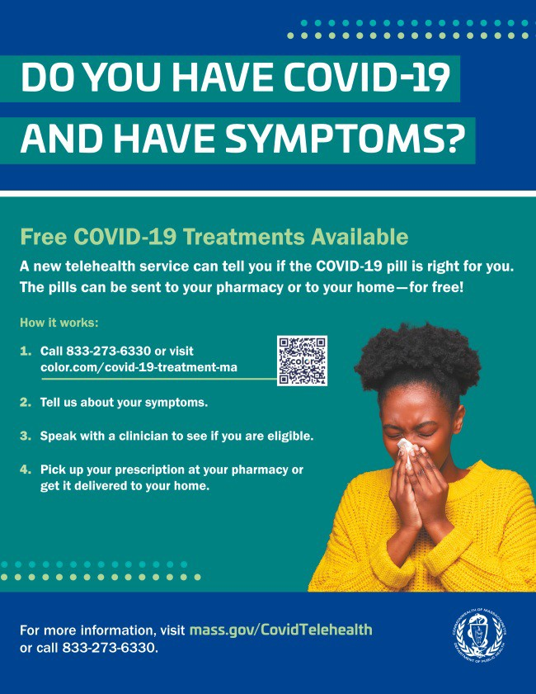
This will provide a record of all vaccines you've gotten. It may take several weeks to
OUTREACH AND EDUCATION MATERIALS
COVID-19 Vaccine FAQs
Key Resources
process.

Learn more about these options, or call 2-1-1 with any questions.

DON'T FORGET: THE COMMUNITY HEALTH EQUITY SURVEY IS LIVE!
The Community Health Equity Survey is now open for Massachusetts residents!
Results will help DPH improve programs, make decisions about funding and resources, and support policies to improve health inequities.
The survey is available in 11 languages and is anonymous. It is open to anyone ages 14 and older. Get started at mass.gov/HealthSurvey.

Help get the word out! Find talking points, flyers, and other materials to help promote the survey in this toolkit.

FREE COVID-19 TREATMENT AVAILABLE VIA PHONE OR ONLINE
Free, safe, and effective treatments for COVID-19 are available across Massachusetts. They can help prevent hospitalizations and reduce the risk of severe disease.
Telehealth consultations are available via phone at 833-273-6330, in addition
to online. Consultations can be accessed in 10+ languages.
Please share: Flyers are available in multiple languages!

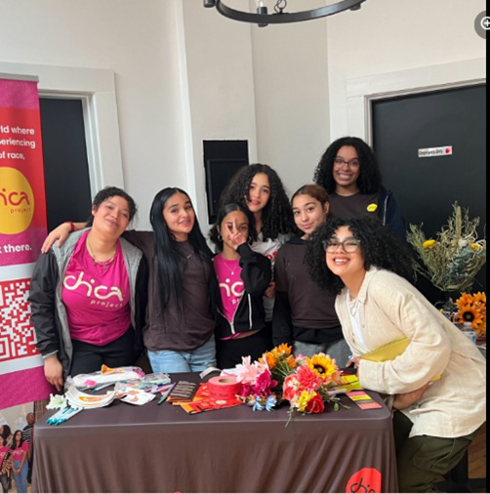
COVID-19 Therapeutic Information (including telehealth)
Weekly Provider Bulletin
Multilingual COVID-19 Materials (videos and printables; organized by language) Archive of COVID-19 Vaccine Communications Updates (past editions of VEI Roundup)
FIND A COVID-19 VACCINE DOSE
Use Vaccines.gov to sign up for a COVID-19 vaccine appointment Find a community COVID-19 vaccination clinic near you
Learn about the COVID-19 In-Home Vaccination Program and request a visit Request a copy of your vaccine card
Highlights

Earlier this summer, Chica Project hosted their “Watering the Garden” event, which was supported by several community partners, including the Boston Public Library, AdornMe Africa, and Soulside Skincare (see photo). In total, 30 attendees and 10 peer leaders joined the event.
Topics of discussion included relationships and sex education, COVID-19 vaccines and preparedness, and other vaccines such as flu and HPV. COVID-19 vaccines were available at the event, and vaccinators were on hand to answer questions.

Read More Highlights

Share This Email
Share This Email
Share This Email

Visit the VEI Website

Vaccine Equity Initiative | 250 Washington Street, Boston, MA 02108

Unsubscribe vaccineequityinitiative@mass.gov Constant Contact Data Notice
Sent by vaccineequityinitiative@mass.gov powered by
Try email marketing for free today!

