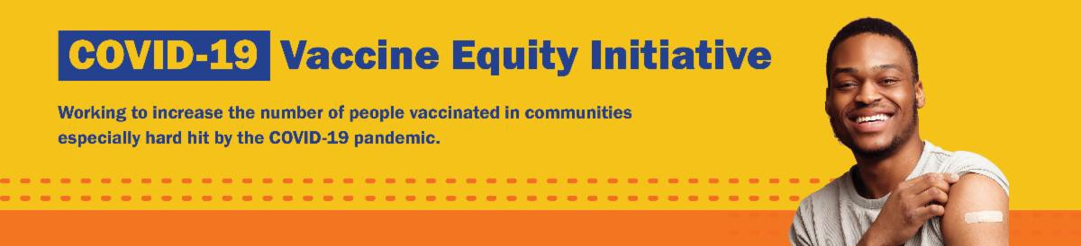
September 16, 2022
Here are the latest resources for promoting COVID-19 vaccination to share with your colleagues
and networks across Massachusetts. If you received this from a colleague, subscribe today.

View this email online.
What's New

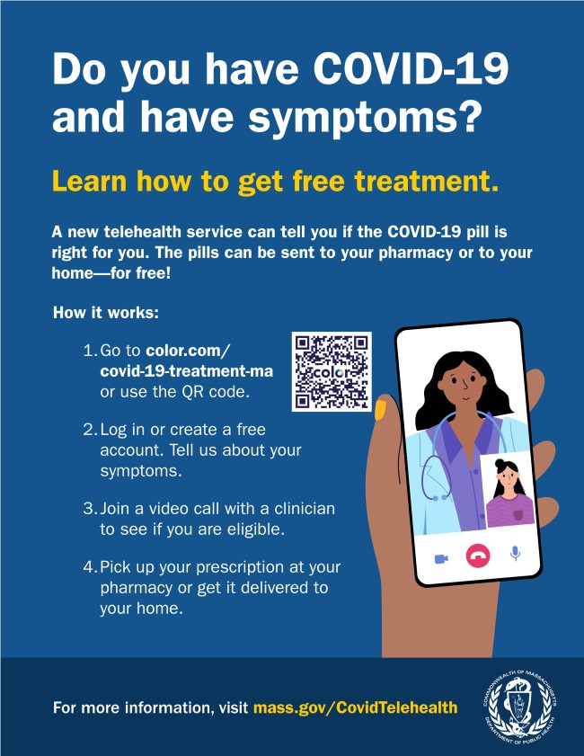FREE TELEHEALTH FOR COVID-19 TREATMENT — NOW WITH OPTION FOR PHONE CONSULTATION

Free, safe, and effective treatments for COVID-19 are available across MA. They can help prevent hospitalizations and reduce the risk of severe disease.

Telehealth consultations are now available via phone, in addition to video, once you’ve requested a
consultation online. Consultations can be accessed in 10+ languages.

Several resources are available to help promote these treatments:

Telehealth flyer (in multiple languages)
Shareable video
Videos with local physicians discussing treatment options (in English, Spanish, and Haitian Creole)

Learn more about how to access treatment, including in-home options.
Reminders

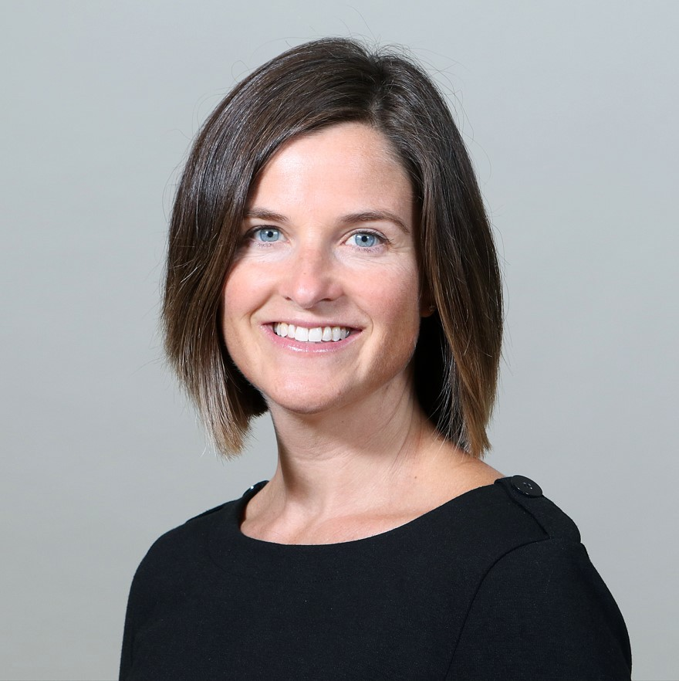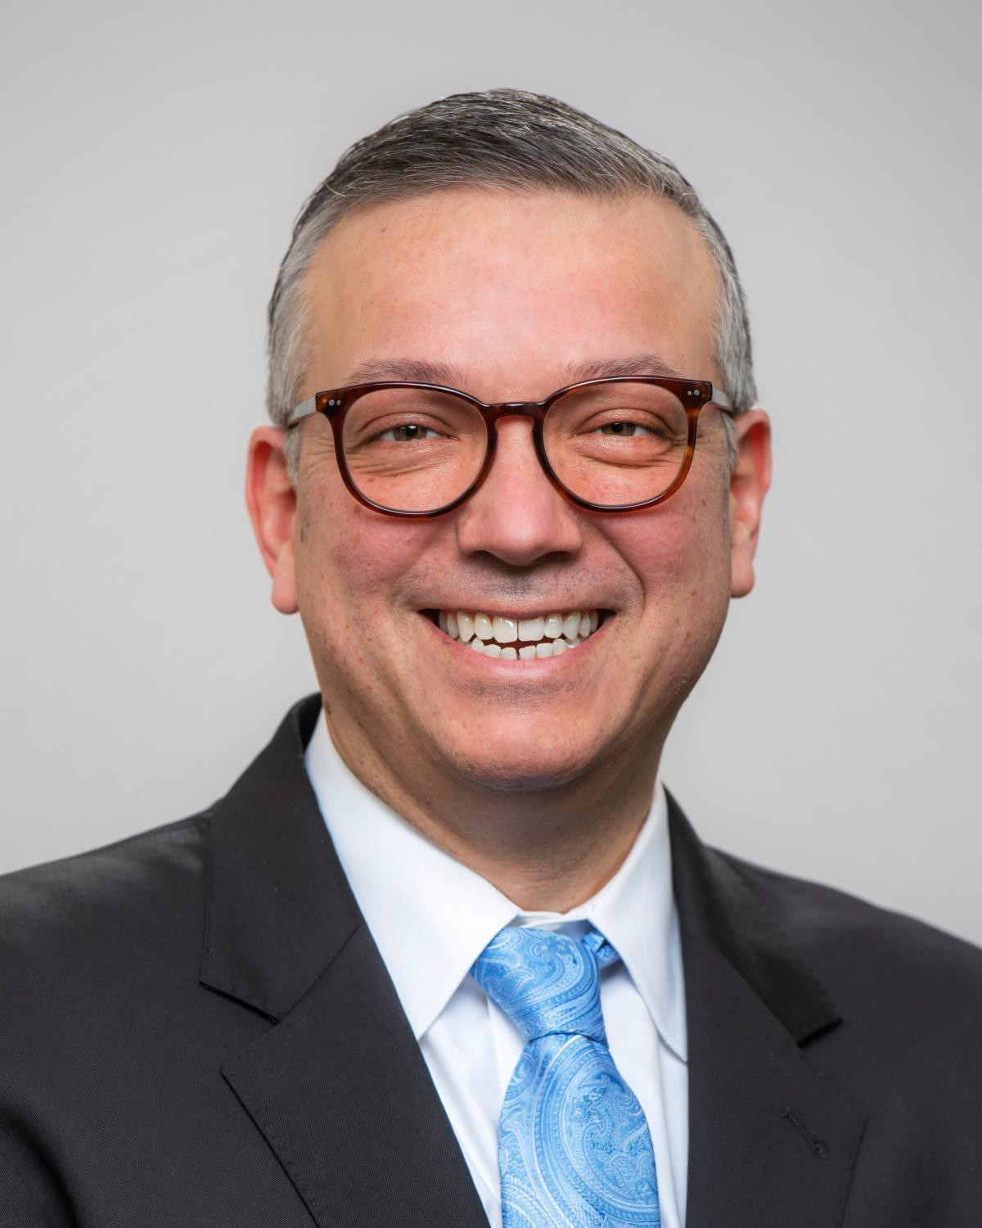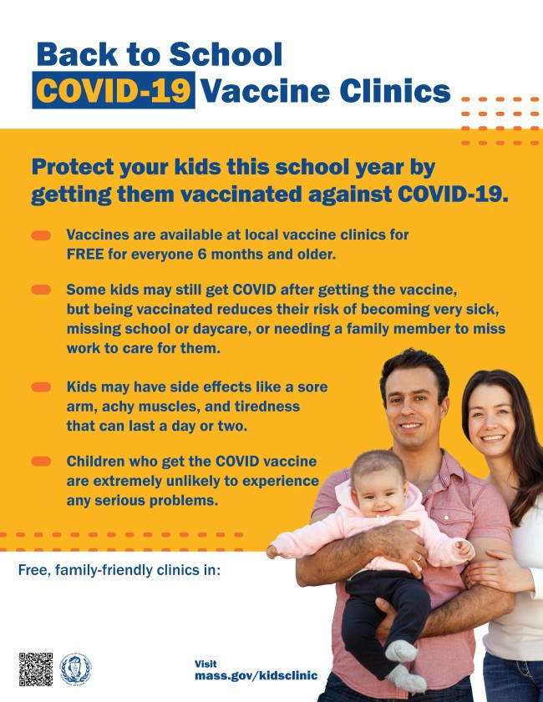HAPPENING TUESDAY (SEPTEMBER 20) — VACCINE CONFIDENCE TRAINING

On September 20, DPH and several partners are offering an upcoming training to help you improve confidence in COVID-19 vaccines.

Led by Merck Northeast Regional Medical Director Dr. Kimberly Daly (DNP, APRN, FNP- C) and DPH Chief Medical Officer Dr. Estevan Garcia (MD, DrPH, MPA), the training will help
you improve your COVID-19 conversations with families with young children.

Register and join the over 150 people who have signed up to attend!

The training is free, and all are welcome.

Please share! Flyers available
in English, Spanish, and Portuguese.

Above: Dr. Daly (top photo) and Dr. Garcia will lead a vaccine confidence training on Sept. 20.

VACCINATIONS CONTINUE FOR BACK TO SCHOOL

There's still time to add COVID-19 vaccination to your back-to-school checklist!

Being vaccinated reduces children's risk of becoming very sick, missing school or day care, or needing a family member to miss work to care for them. Learn more.

Throughout September, DPH is providing 170+ options for free COVID-19 vaccination clinics. Find a clinic near you.

Help spread the word with a customizable flyer! Click in the flyer's footer to add your organization's logo or clinic details.

Other materials are also available:
Flyers (in 12 languages)
Graphics for Twitter and Facebook Flyer for teachers and school staff

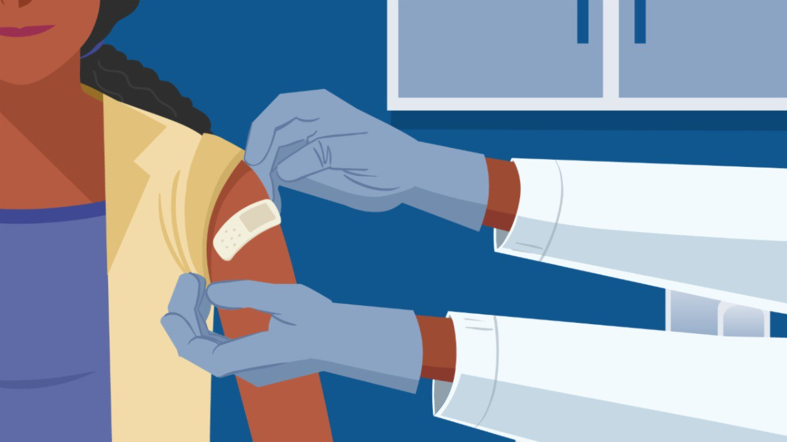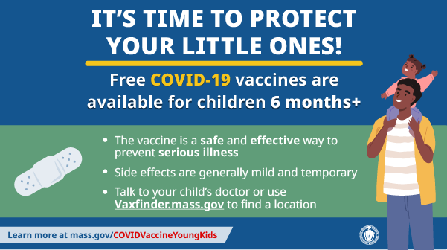UPDATED BOOSTERS NOW AVAILABLE IN MA
OUTREACH AND EDUCATION MATERIALS

COVID-19 Vaccine FAQs
COVID-19 Therapeutic Information (including telehealth) Weekly Provider Bulletin (latest edition published 9/15/22)
Trust the Facts, Get the Vax Campaign Materials (organized by audience, including general, parents and pregnant people, youth, young adults; available in 12 languages)
Key Resources

Updated COVID-19 boosters were recently authorized by the FDA and recommended by the CDC for people ages 12 and older. They are now available in Massachusetts.

Visit vaxfinder.mass.gov to make an appointment. If your vaccine of choice is not available, check back as vaccine shipments continue to arrive.

HIGH VACCINATION RATES IN MA HELPED PREVENT COVID DEATHS

As reported in the Boston Globe, a recent Lancet study showed that Massachusetts’ levels of immunity due to high COVID-19 vaccination rates helped residents avoid deaths during two surges in the pandemic (late February–June in 2021 and 2022).

COVID-19 VACCINATION FOR CHILDREN AGES 6 MONTHS AND OLDER

Several materials are available to help promote COVID-19 vaccination for children ages 6 months+:

Fact sheet (12 languages) DPH social media graphic FAQs and messages (multiple languages)
Short video about vaccine safety and efficacy (in English and Spanish)

Multilingual COVID-19 Materials (videos and printables; organized by language)
COVID-19 Funeral Assistance from FEMA (including one-pager with key info
available in multiple languages)
COVID-19 Vaccination Tools for Employers
Archive of COVID-19 Vaccine Communications Updates (past editions of VEI Roundup)
FIND A COVID-19 VACCINE OR BOOSTER

Mass.gov/KidsClinic (family-friendly clinics through September)
Vaccine Finder
Find, Schedule, or Sign Up for a Mobile COVID-19 Vaccination COVID-19 In-Home Vaccination Program
Request a Copy of Your Vaccine Card
Recent Highlights
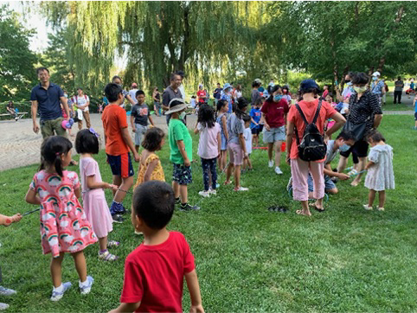Malden

In recent months, Chinese Culture Connection (CCC) has hosted three vaccine clinics in partnership with VEI. In July, they offered two vaccine clinics to children and families who attended the Beebe School's summer program. About 100 people were vaccinated at these clinics, where attendees also enjoyed ice cream. In August, CCC hosted “Exploring Malden River,” where community members could learn about the river, enjoy Chinese music performances and Tai Chi, and join races and circus activities (see photo). Over 300 people attended the event, with 68 people getting vaccinated at an on-site mobile clinic.

Read More Highlights

Share This Email
Share This Email
Share This Email

Visit the VEI Website

Vaccine Equity Initiative | 250 Washington Street, Boston, MA 02108

Unsubscribe vaccineequityinitiative@mass.gov Constant Contact Data Notice
Sent by vaccineequityinitiative@mass.gov in collaboration with
Try email marketing for free today!

