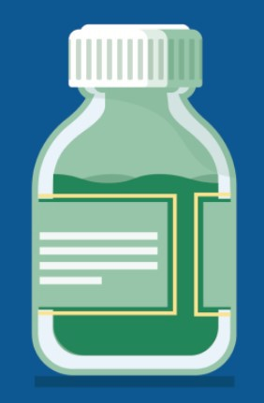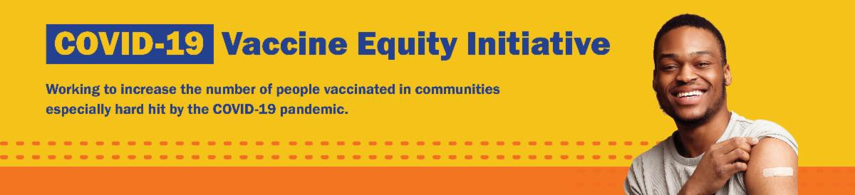
UPDATED COVID-19 BOOSTERS AVAILABLE SOON!

On September 1st, an updated COVID-19 booster vaccine was authorized by the FDA and recommended by the CDC for everyone 12 years of age and older.

Updated boosters are:
Safe, effective, and free

Clinics do not yet have the new booster vaccine, but it will be arriving soon.

To schedule an appointment for the updated booster, you can visit vaxfinder.mass.gov starting September 5.
BECOME A VACCINE CHAMPION: LEARN STRATEGIES FOR IMPROVING
CONFIDENCE IN THE COVID-19 VACCINE

DPH and several partners are offering an upcoming training to help you improve confidence in COVID-19 vaccines.
Meetings are free, and all are welcome. Register for September 20.
September 2, 2022
Here are the latest resources for promoting COVID-19 vaccination to share with your colleagues
and networks across Massachusetts. If you received this from a colleague, subscribe today.

View this email online.
What's New

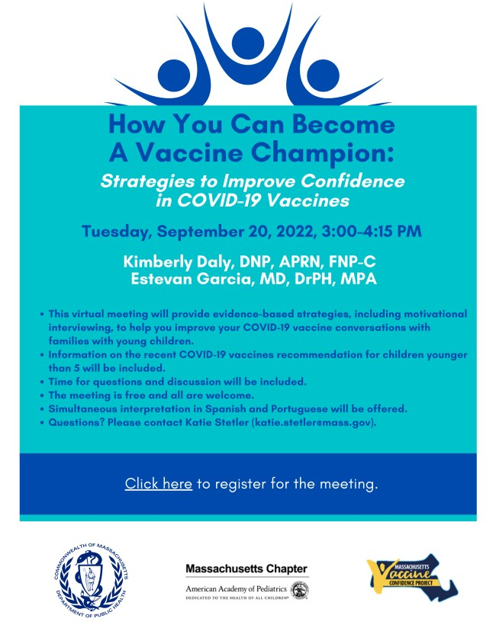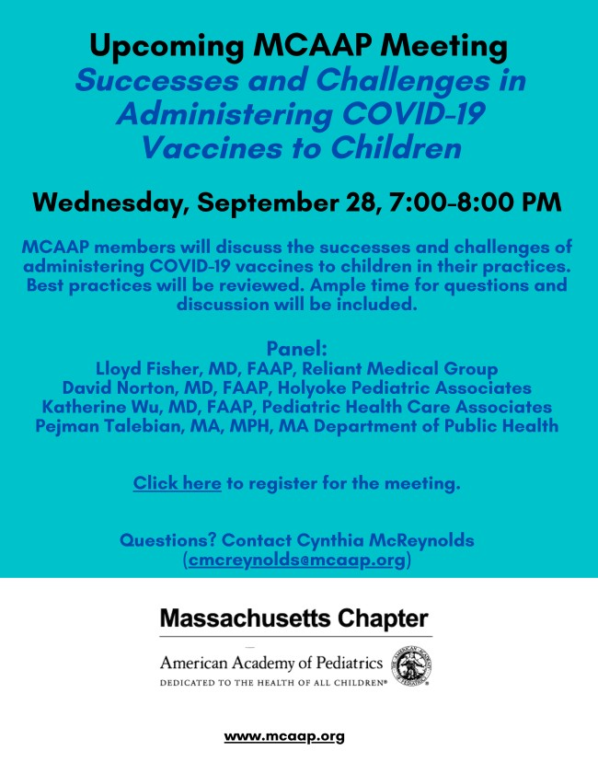Please share! Flyers available
in English, Spanish, and Portuguese.

FOR PROVIDERS: SUCCESS AND CHALLENGES IN ADMINISTERING COVID-19 VACCINES TO CHILDREN

On September 28, the Massachusetts Chapter of American Academy of Pediatrics (MCAAP) is hosting a meeting for medical professionals to discuss the successes and challenges of administering COVID-19 vaccines to children in their practices. The meeting is open to members and non-members, and there will be ample time for questions and
discussion. Learn more, and register here.

Reminders

VACCINATIONS FOR BACK TO SCHOOL

Getting ready for the return to school? Add COVID-19 vaccination to your back-to- school checklist!

Being vaccinated reduces children's risk of becoming very sick, missing school or day care, or needing a family member to miss work to care for them. Learn more.

Throughout August and September, DPH is providing 480+ options for free COVID-19 vaccination clinics. Find a clinic near you.

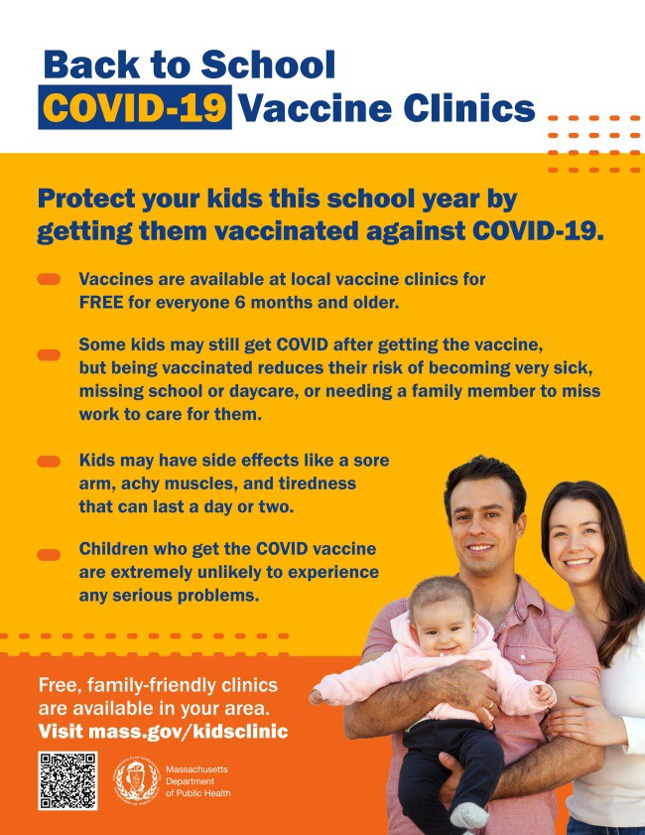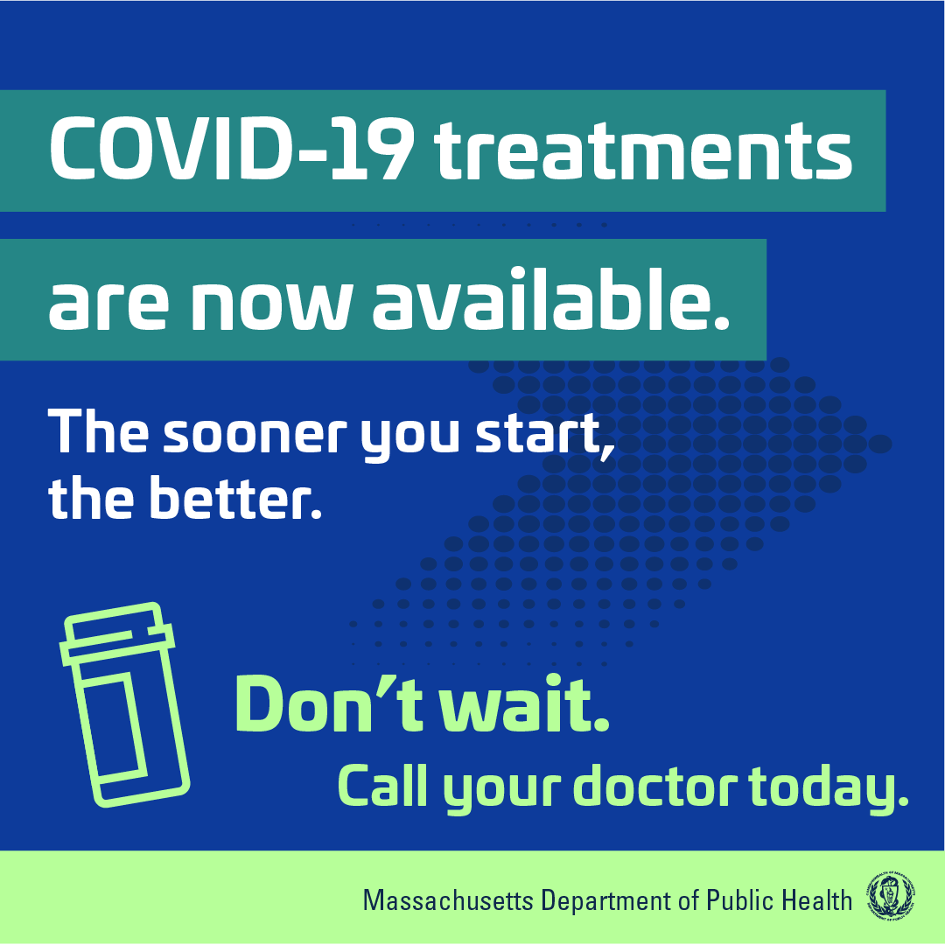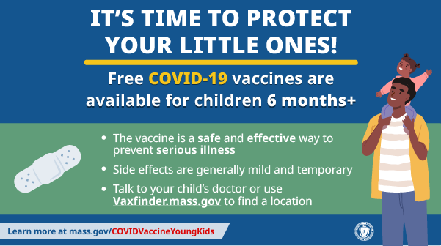Please note these clinics do not yet have
the new booster vaccine for ages 12+, but we will be sure you can get it as soon as possible.

Help spread the word:
Flyers (in 12 languages)
Graphics for Twitter and Facebook Flyer for teachers and school staff

FREE, SAFE, AND EFFECTIVE COVID-19 TREATMENTS AVAILABLE

Free, safe, and effective treatments for COVID-19 are available across MA. They can help prevent hospitalizations and reduce the risk of severe disease.

Several resources are available to help promote these treatments:

Telehealth flyer (in English, Haitian Creole, Khmer, Spanish, and Portuguese)
Shareable video and fact sheet Videos with local physicians discussing treatment options (in English, Spanish, and Haitian Creole)

Learn more about how to access treatment, including telehealth and in-home options.

COVID-19 VACCINATION FOR CHILDREN AGES 6 MONTHS AND OLDER

Several materials are available to help promote COVID-19 vaccination for children ages 6 months+:

Fact sheet (12 languages) DPH social media graphic
FAQs re: children 6 months+ in multiple languages
Messages for children 6 months+ in

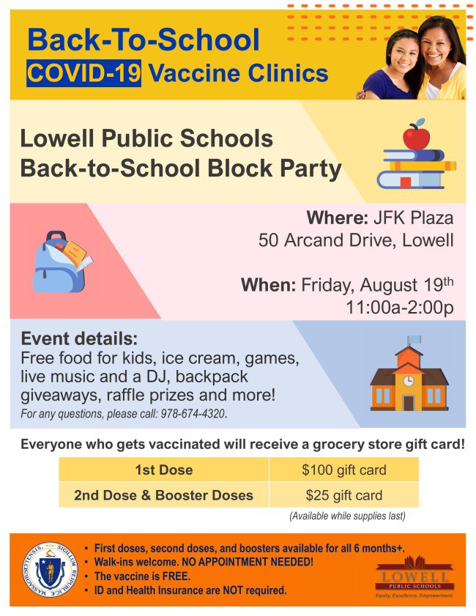
Lowell

VEI is partnering with a number of organizations to host back-to-school clinics in Lowell in August and September. Four recent clinics were held in partnership with Lowell Public Schools (see flyer), the Lowell Housing Authority, Coalition for a Better Acre, and RCS. Several of the clinics included back-to-school activities for kids and families, as well as giveaways for students like backpacks, school supplies, and comic books. Over 80 people were vaccinated at these back-to-school events, including 34 first doses.
Recent Highlights
multiple languages
Short video about vaccine safety and efficacy (in English and Spanish)
Key Resources

OUTREACH AND EDUCATION MATERIALS

COVID-19 Vaccine FAQs
COVID-19 Therapeutic Information (including telehealth) Weekly Provider Bulletin (latest edition published 8/31/22)
Trust the Facts, Get the Vax Campaign Materials (organized by audience, including general, parents and pregnant people, youth, young adults; available in 12 languages) Multilingual COVID-19 Materials (videos and printables; organized by language) COVID-19 Funeral Assistance from FEMA (including one-pager with key info available in multiple languages)

COVID-19 Vaccination Tools for Employers
Archive of COVID-19 Vaccine Communications Updates (past editions of VEI Roundup)

FIND A COVID-19 VACCINE OR BOOSTER

Mass.gov/KidsClinic (family-friendly clinics through September) Vaccine Finder (will include the new booster as soon as available) Find, Schedule, or Sign Up for a Mobile COVID-19 Vaccination COVID-19 In-Home Vaccination Program

Request a Copy of Your Vaccine Card

Read More Highlights

Share This Email
Share This Email
Share This Email

Visit the VEI Website

Vaccine Equity Initiative | 250 Washington Street, Boston, MA 02108 Unsubscribe vaccineequityinitiative@mass.gov
Constant Contact Data Notice
Sent by vaccineequityinitiative@mass.gov in collaboration with
Try email marketing for free today!

