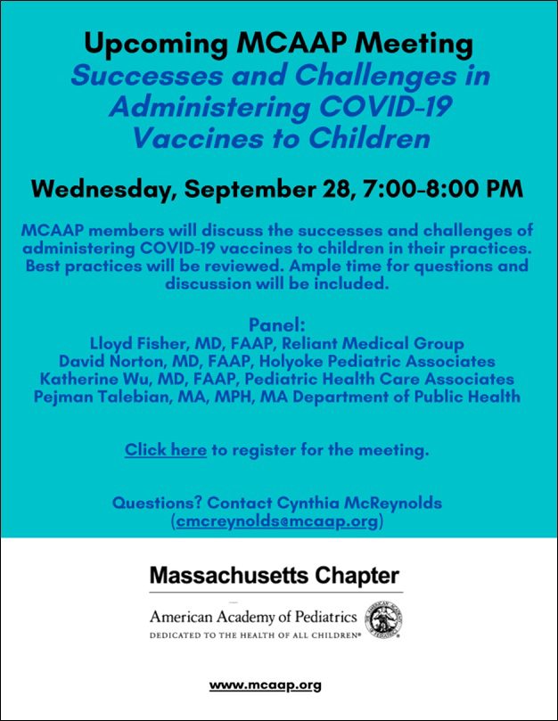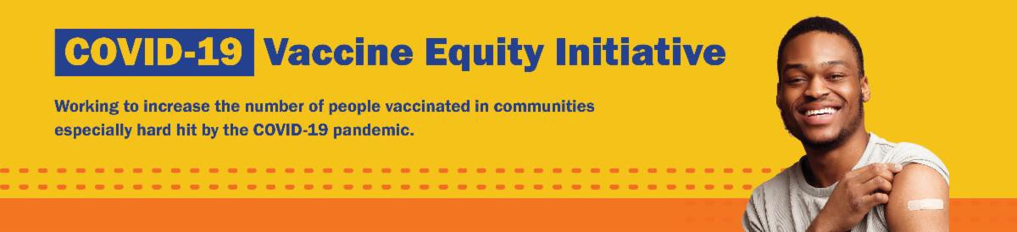
WEDNESDAY (SEPT. 28) — FOR PROVIDERS: BEST PRACTICES FOR
ADMINISTERING COVID-19 VACCINES TO CHILDREN

On September 28, the Vaccine Equity Initiative and Massachusetts Chapter of American Academy of Pediatrics will host a meeting for medical professionals to discuss the successes and challenges of administering COVID-19 vaccines to children in their practices.

The meeting is open to members and non- members, with ample time for questions and discussion.

Learn more, and register here.
FREE TELEHEALTH FOR COVID-19 TREATMENT — NEW FLYER AVAILABLE

Free, safe, and effective treatments for COVID-19 are available across MA. They can help prevent hospitalizations and
September 23, 2022
Here are the latest resources for promoting COVID-19 vaccination to share with your colleagues
and networks across Massachusetts. If you received this from a colleague, subscribe today.

View this email online.
What's New

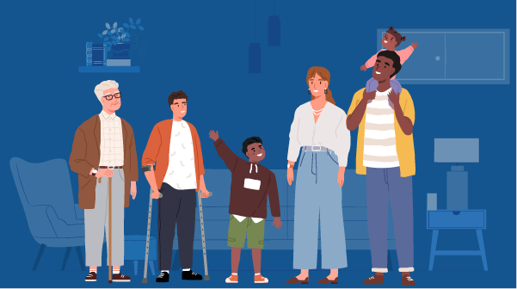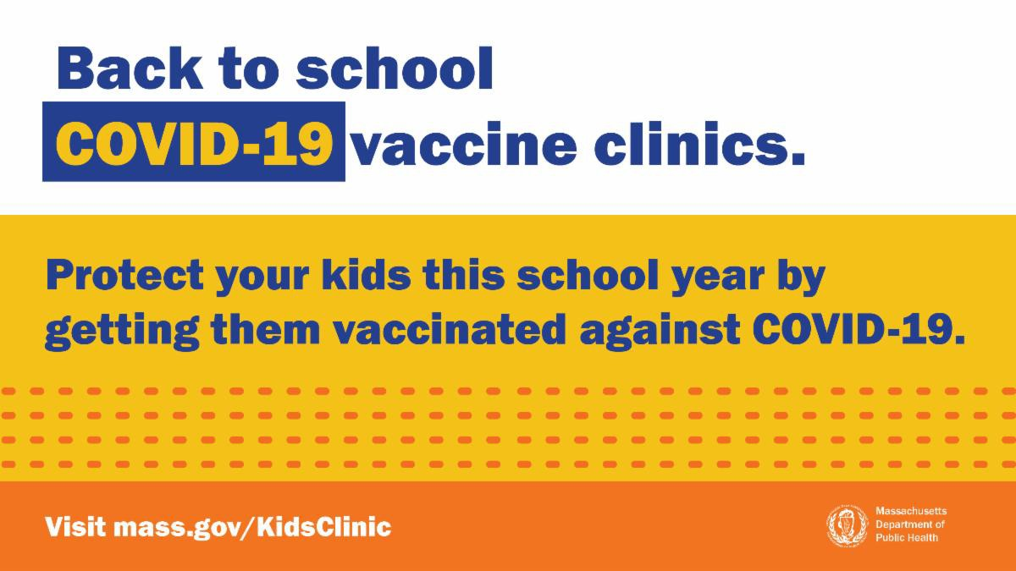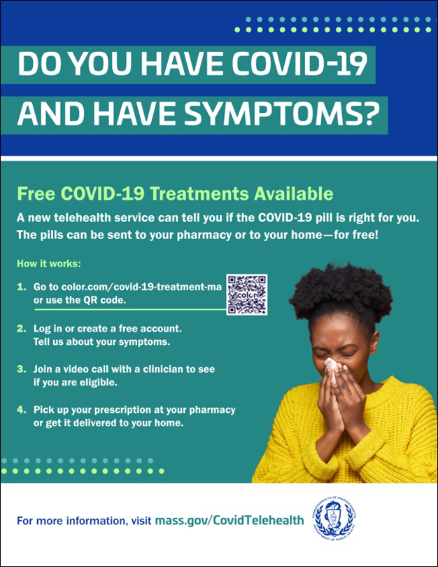
IN-HOME VACCINATION AVAILABLE, INCLUDING FOR YOUNG CHILDREN

Massachusetts offers in-home COVID-19 vaccinations for anyone who has difficulty getting to or using a community clinic, including young children. Learn more, or call 833-983-0485 to sign up for an appointment.
VACCINATIONS CONTINUE FOR BACK TO SCHOOL

There's still time to add COVID-19 vaccination to your back-to-school checklist!

Through the end of September, DPH is providing 170+ options for free COVID-19 vaccination.

Learn more, and find a clinic near you .

Help spread the word with a customizable flyer! Other materials available
include flyers (12 languages),
graphics for Twitter and Facebook, and a flyer for teachers and school staff.
reduce the risk of severe disease.

Telehealth consultations are now available via phone, in addition to video, once you’ve requested a
consultation online. Consultations can be accessed in 10+ languages.

NEW! Help spread the word with a customizable flyer. Click in the flyer's footer to add your organization's logo. Other flyers in additional languages are also available.

Please also share this new video about free COVID treatments.
Learn more about how to access treatment, including in-home options.
Reminders

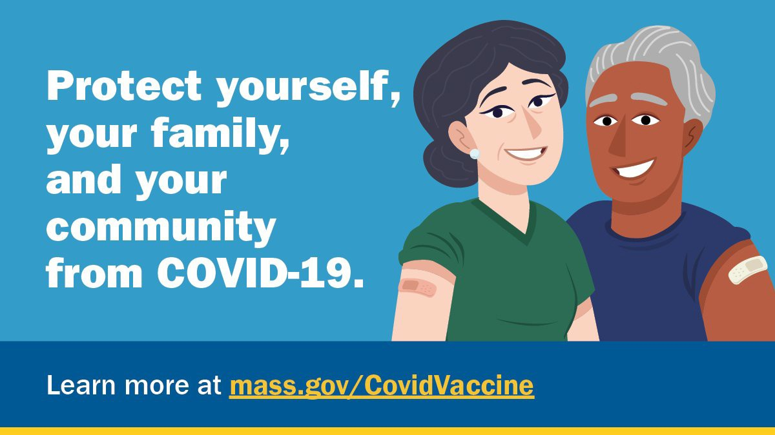

FOLLOW THESE SEVEN STEPS

There are a number of steps that you can take to help protect yourself, your family, and your community from COVID-19.

Available in multiple languages, this flyer features a checklist with these
steps. Please share it with your networks.
Key Resources

OUTREACH AND EDUCATION MATERIALS

COVID-19 Vaccine FAQs
COVID-19 Therapeutic Information (including telehealth) Weekly Provider Bulletin (latest edition published 9/15/22)
Trust the Facts, Get the Vax Campaign Materials (organized by audience, including general, parents and pregnant people, youth, young adults; available in 12 languages) Multilingual COVID-19 Materials (videos and printables; organized by language) COVID-19 Funeral Assistance from FEMA (including one-pager with key info available in multiple languages)
COVID-19 Vaccination Tools for Employers
Archive of COVID-19 Vaccine Communications Updates (past editions of VEI Roundup)

FIND A COVID-19 VACCINE OR BOOSTER

Mass.gov/KidsClinic (family-friendly clinics through September)
Vaccine Finder
Find, Schedule, or Sign Up for a Mobile COVID-19 Vaccination COVID-19 In-Home Vaccination Program
Request a Copy of Your Vaccine Card

Recent Highlights

Worcester

On August 28, VEI partnered with VaxAbilities and Transformative Healthcare to provide a back-to-school clinic at the EcoTarium (see flyer).
VaxAbilities is a partnership led by the Massachusetts Developmental Disabilities Network that provides clinics with a

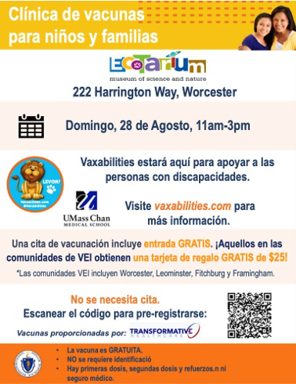disability and sensory-sensitivity friendly
environment. Twenty-seven people were vaccinated at the clinic and received free entry to the EcoTarium. A follow-up VaxAbilities clinic will take place at the EcoTarium on October 23.

Read More Highlights

Share This Email
Share This Email
Share This Email

Visit the VEI Website

Vaccine Equity Initiative | 250 Washington Street, Boston, MA 02108 Unsubscribe vaccineequityinitiative@mass.gov
Constant Contact Data Notice
Sent by vaccineequityinitiative@mass.gov in collaboration with
Try email marketing for free today!

