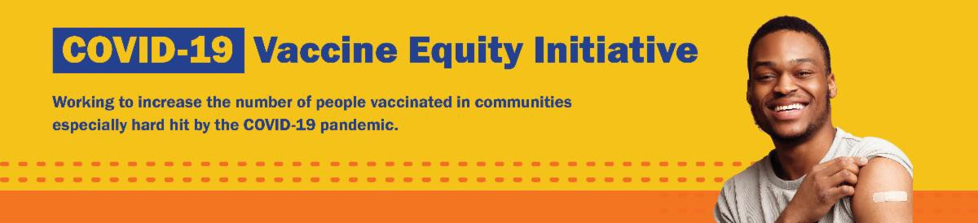
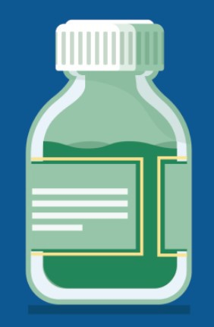
UPDATED COVID-19 VACCINE RECOMMENDATIONS
For fall 2023 and winter 2024, the CDC now recommends that everyone ages 6 months and older get one updated vaccine dose.
Key takeaway: Anyone aged 5 years and over only needs one dose of the updated vaccine to be up to date — even if they've never been vaccinated before!
You have had the updated COVID vaccine if you had a dose after September 12, 2023.
Wondering how to get a vaccine? You can search for appointments at vaccines.gov. Local community clinics will be posted on mass.gov/MobileVax.
ALL U.S. HOUSEHOLDS CAN ORDER FOUR FREE COVID RAPID TESTS
Got questions? This informational sheet gives an overview of what has changed regarding COVID-19 vaccination, treatment, and testing—and what has stayed the same. Available in more languages soon.
September 29, 2023
Here are the latest resources for promoting COVID-19 vaccination to share with your colleagues
and networks across Massachusetts. If you received this from a colleague, subscribe today.
View this email online.
What's New

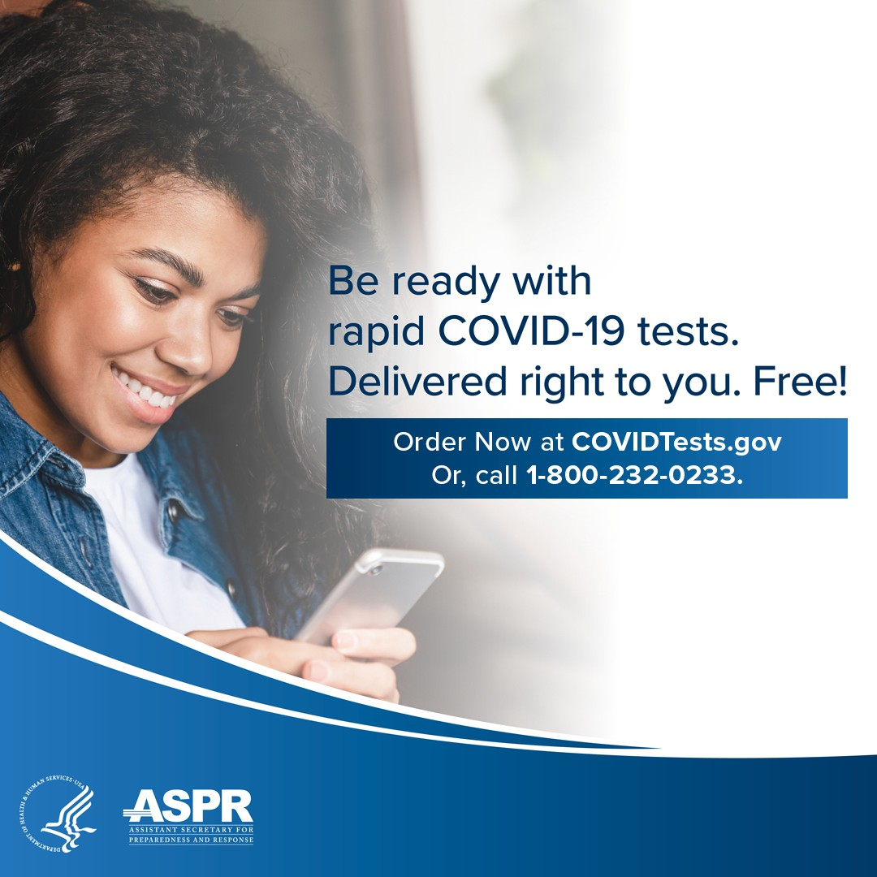
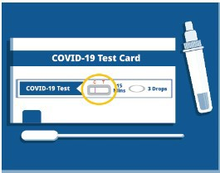
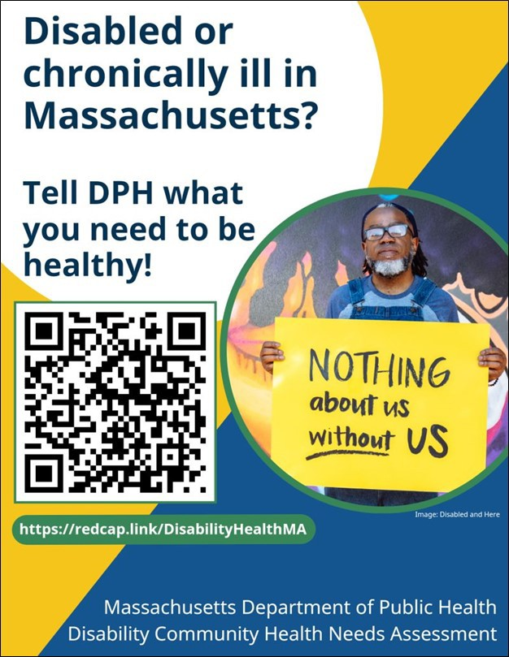
Every U.S. household can once again order four free COVID-19 rapid tests. Tests will be delivered directly to recipients' homes.
To order tests, visit COVID.gov/Tests.
Accessible COVID test kits are also available.
Don't forget: Many at-home COVID tests have had their expiration dates extended. Check updated expiration dates on the FDA's website.
Reminders

Q&A: WHY DO THE EXPIRATION DATES ON COVID TESTS CHANGE?

Q: Why does the expiration date on my COVID-19 test keep changing?
A: The companies that make the tests check them to see if they still work. If they do, the FDA extends the expiration date.
Learn more about COVID-19, including what to do if you test positive,
at mass.gov/COVID.

What other questions are you hearing? Let us know!

PLEASE SHARE: MA DISABILITY COMMUNITY HEALTH NEEDS ASSESSMENT
The Health and Disability Program in the Office of Health Equity recently announced the Massachusetts Disability Community Health Needs Assessment, a complement to the Community Health Equity Survey.
This online survey is available in 12 languages, including ASL, and will help identify and address the needs of people with disabilities throughout the Commonwealth.

If you are a person living with a disability in Massachusetts, please fill out the survey today — and please share it with

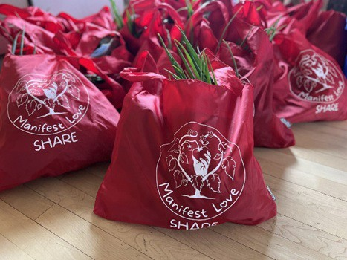
your networks, colleagues, and partners.
YWCA Southeastern Massachusetts has
partnered with Round the Bend Farm for their Manifest Love project — an effort to put fresh farm goods on the tables of families in New Bedford. The project, which runs from May to November 2023, includes weekly distributions of free food shares to the local community (see photo). The bags include cooking recipes for healthy, nutritional dishes, and the YWCA adds COVID-19 information and resources, which are translated into Spanish and Portuguese.
Read More Highlights
Share This Email
Share This Email
Share This Email
OUTREACH AND EDUCATION MATERIALS
COVID-19 Vaccine FAQs
COVID-19 Therapeutic Information (including telehealth) Archive of Weekly Provider Bulletins
Archive of COVID-19 Vaccine Communications Updates (past editions of VEI Roundup)
FIND A COVID-19 VACCINE DOSE
Use Vaccines.gov to sign up for a COVID-19 vaccine appointment Find a community COVID-19 vaccination clinic near you
Learn about the COVID-19 In-Home Vaccination Program and request a visit Request a copy of your vaccine card
Highlights
Key Resources
Help spread the word! This flyer is available in
English, Haitian Creole, and Spanish.

Visit the VEI Website

Vaccine Equity Initiative | 250 Washington Street, Boston, MA 02108 Unsubscribe vaccineequityinitiative@mass.gov
Constant Contact Data Notice
Sent by vaccineequityinitiative@mass.gov powered by
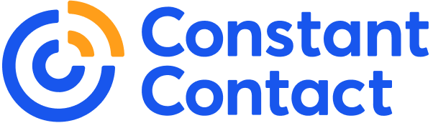
Try email marketing for free today!

