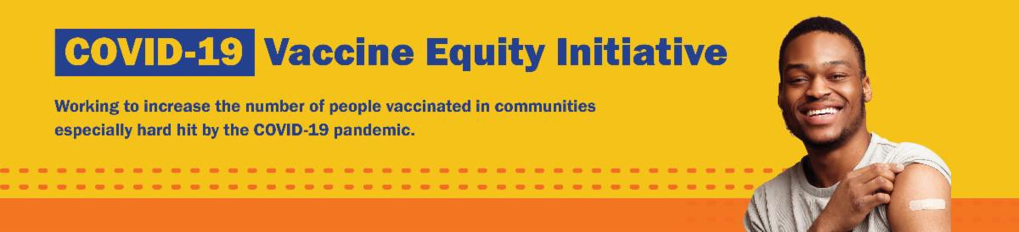
September 30, 2022
Here are the latest resources for promoting COVID-19 vaccination to share with your colleagues
and networks across Massachusetts. If you received this from a colleague, subscribe today.

View this email online.

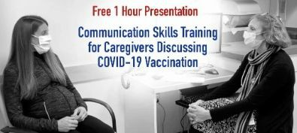

COMMUNICATION SKILLS TRAINING FOR CAREGIVERS DISCUSSING COVID- 19 VACCINATION DURING PREGNANCY AND POST-PARTUM

From the UMass Chan Medical School's Center for Integrated Primary Care, this free presentation offers skills training for caregivers with a focus on COVID-19 vaccination.

Although the presentation focuses on pregnant people, it will be of interest to anyone counseling patients about vaccination. Learn more.
Reminders
What's New

DO YOU USE MY VAX RECORDS? IT'S A DIGITAL COVID VACCINE CARD FOR MA RESIDENTS

Need a copy of your COVID-19 vaccination record? MA residents can use My Vax Records to get a digital vaccine card to show they’ve been vaccinated against COVID-19, if they choose. Learn more.

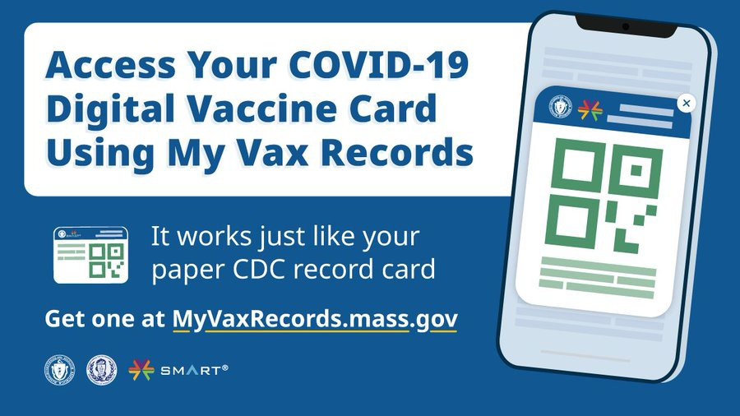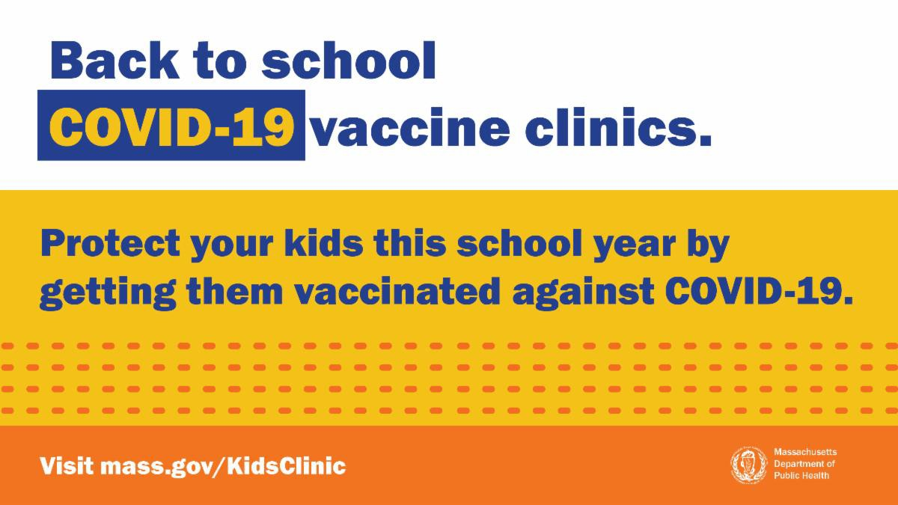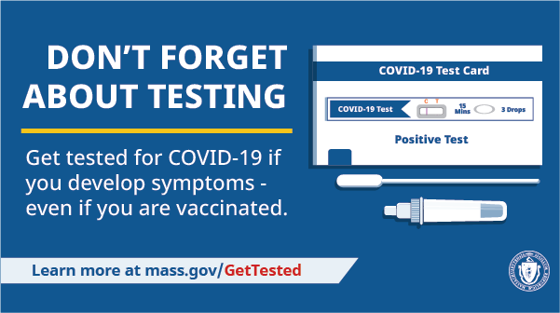

VACCINATIONS CLINICS CONTINUE

There's still time to add COVID-19 vaccination to your back-to-school checklist!

Through the end of September, DPH is providing 170+ options for free COVID-19 vaccination.

Learn more, and find a clinic near you .

Help spread the word with a customizable flyer! Other materials available
include flyers (12 languages),
graphics for Twitter and Facebook, and a flyer for teachers and school staff.

DON'T FORGET ABOUT TESTING

Testing is a critical tool in the fight against COVID-19. Get tested if you develop symptoms — even if you're vaccinated.
Visit mass.gov/GetTested.

FREE TELEHEALTH FOR COVID-19 TREATMENT — NEW FLYER AVAILABLE

Free, safe, and effective treatments for COVID-19 are available across MA. They can help prevent hospitalizations and reduce the risk of severe disease.

Telehealth consultations are now available via phone, in addition to video, once you’ve requested a
consultation online. Consultations can be accessed in 10+ languages.

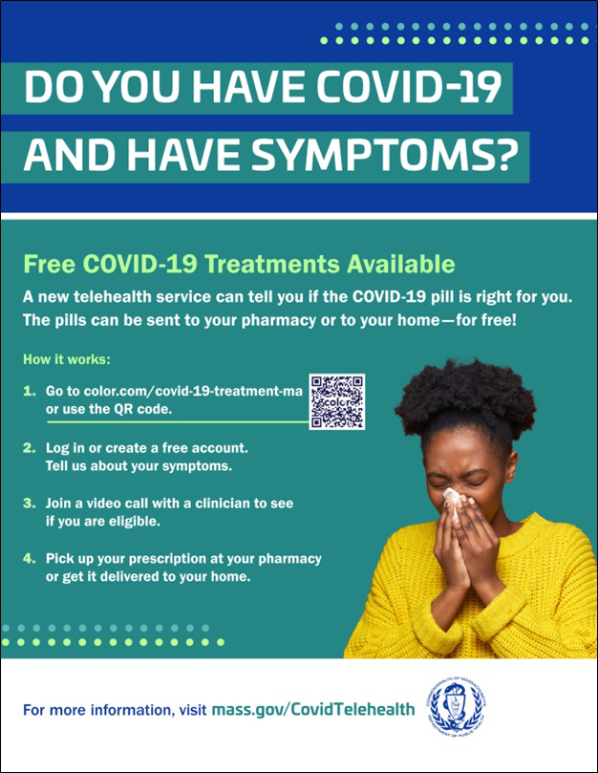
NEW! Help spread the word with a
customizable flyer. Click in the flyer's footer to add your organization's logo. Other flyers in additional languages are also available.

Please also share this new video about free COVID treatments.
Learn more about how to access treatment, including in-home options.
Key Resources

OUTREACH AND EDUCATION MATERIALS

COVID-19 Vaccine FAQs
COVID-19 Therapeutic Information (including telehealth) Weekly Provider Bulletin (latest edition published 9/28/22)
Trust the Facts, Get the Vax Campaign Materials (organized by audience, including general, parents and pregnant people, youth, young adults; available in 12 languages) Multilingual COVID-19 Materials (videos and printables; organized by language) COVID-19 Funeral Assistance from FEMA (including one-pager with key info available in multiple languages)
COVID-19 Vaccination Tools for Employers
Archive of COVID-19 Vaccine Communications Updates (past editions of VEI Roundup)

FIND A COVID-19 VACCINE OR BOOSTER

Mass.gov/KidsClinic (family-friendly clinics through September)
Vaccine Finder
Find, Schedule, or Sign Up for a Mobile COVID-19 Vaccination COVID-19 In-Home Vaccination Program
Request a Copy of Your Vaccine Card

Recent Highlights

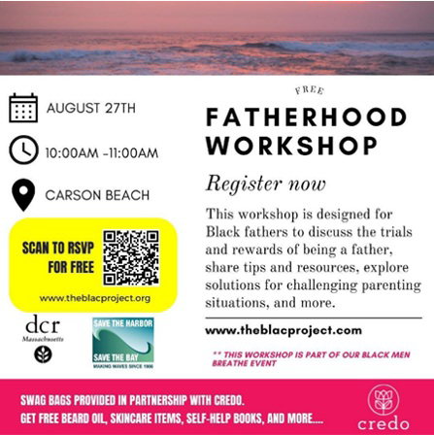Boston

On August 27, the Black Literacy & Arts Collaborative Project (the B.L.A.C. Project) held a “Fatherhood Workshop” on Carson Beach with 30 fathers and their teenage sons. Attendees came together at the event to discuss mental health and other health concerns, including COVID (see flyer). Following the event, five attendees registered for their first-ever COVID vaccines. Given overwhelmingly positive feedback from attendees, the B.L.A.C. Project will be organizing another similar workshop.

Read More Highlights

Share This Email
Share This Email
Share This Email

Visit the VEI Website

Vaccine Equity Initiative | 250 Washington Street, Boston, MA 02108 Unsubscribe vaccineequityinitiative@mass.gov
Constant Contact Data Notice
Sent by vaccineequityinitiative@mass.gov in collaboration with
Try email marketing for free today!

