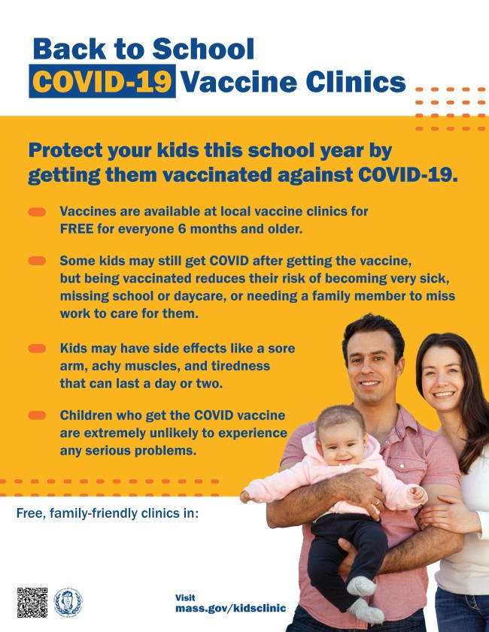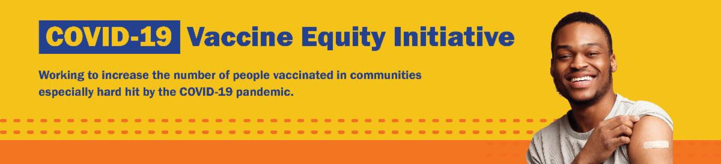
September 9, 2022
Here are the latest resources for promoting COVID-19 vaccination to share with your colleagues
and networks across Massachusetts. If you received this from a colleague, subscribe today.

View this email online.
What's New

VACCINATIONS CONTINUE FOR BACK TO SCHOOL

There's still time to add COVID-19 vaccination to your back-to-school checklist!

Being vaccinated reduces children's risk of becoming very sick, missing school or day care, or needing a family member to miss work to care for them. Learn more.

Throughout September, DPH is providing 170+ options for free COVID-19 vaccination clinics. Find a clinic near you.

NEW! Help spread the word with a customizable flyer! Click in the flyer's footer to add your organization's logo or clinic details.

Other materials are also available:
Flyers (in 12 languages)
Graphics for Twitter and Facebook Flyer for teachers and school staff

UPDATED BOOSTERS NOW AVAILABLE IN MA

Updated COVID-19 boosters were recently authorized by the FDA and recommended

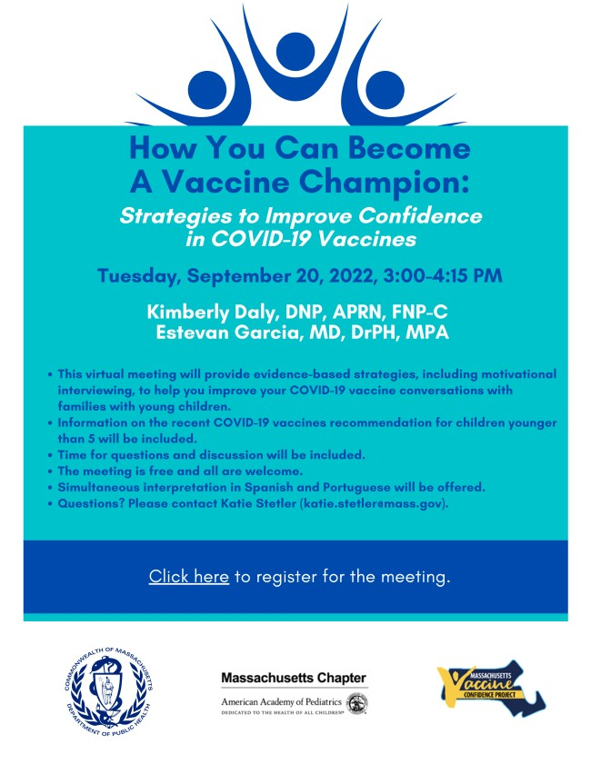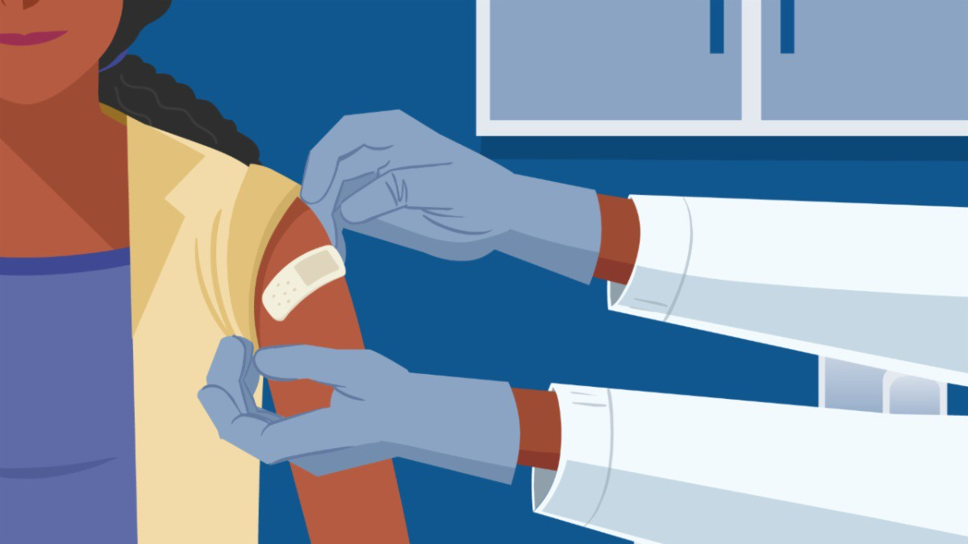
BECOME A VACCINE CHAMPION: LEARN STRATEGIES FOR IMPROVING
CONFIDENCE IN THE COVID-19 VACCINE

DPH and several partners are offering an upcoming training to help you improve confidence in COVID-19 vaccines.
Meetings are free, and all are welcome. Register for September 20.

Please share! Flyers available
in English, Spanish, and Portuguese.
FOR PROVIDERS: SUCCESS AND CHALLENGES IN ADMINISTERING COVID-19
Reminders
by the CDC for people ages 12 and older.
They are now available in Massachusetts.

Visit vaxfinder.mass.gov to make an appointment. More appointments will be added as shipments arrive.
NEW REPORT: HIGH VACCINATION RATES IN MA HELPED PREVENT COVID
DEATHS

As reported in the Boston Globe, a recent Lancet study showed that Massachusetts’ levels of immunity due to high COVID-19 vaccination rates helped residents avoid deaths during two surges in the pandemic (late February–June in 2021 and 2022).

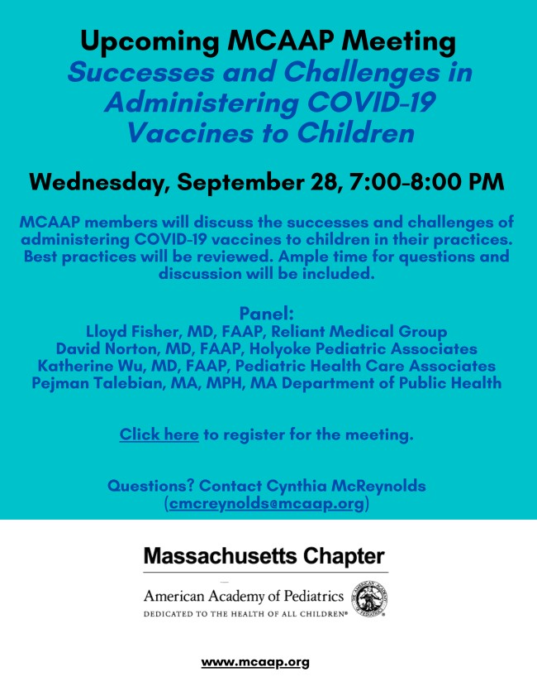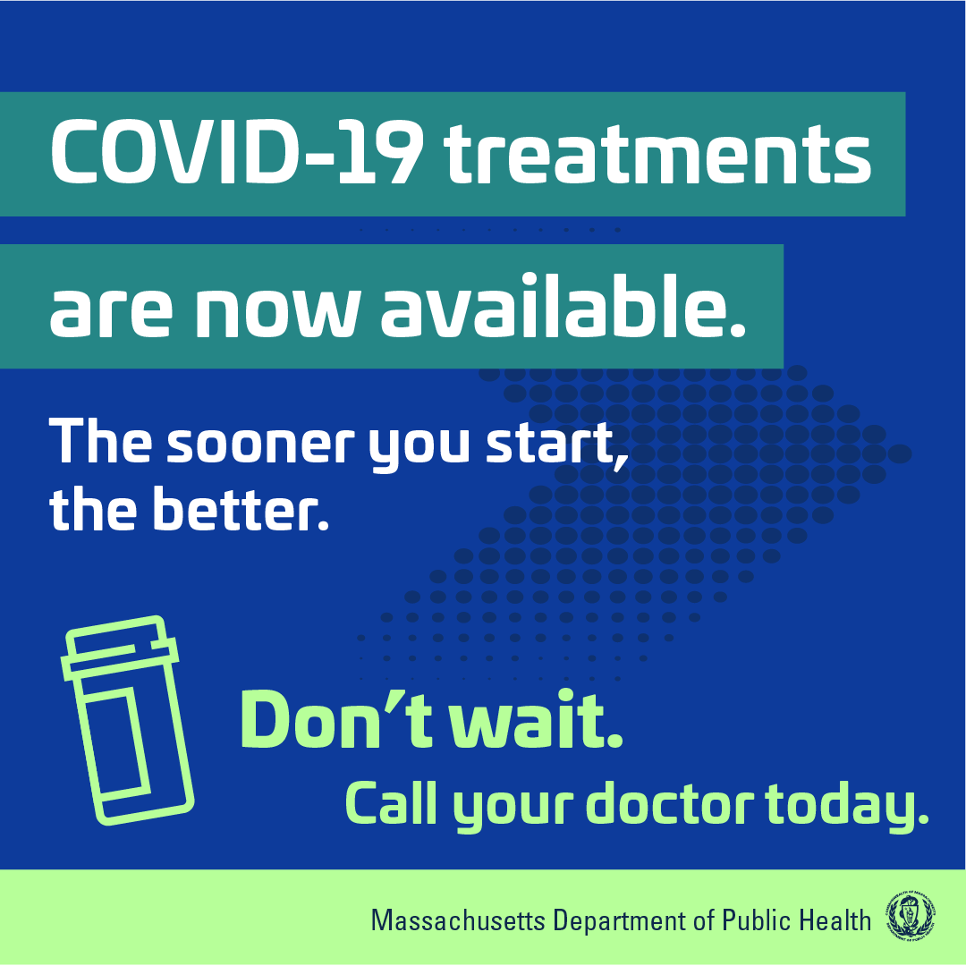VACCINES TO CHILDREN

On September 28, the Massachusetts Chapter of American Academy of Pediatrics (MCAAP) is hosting a meeting for medical professionals to discuss the successes and challenges of administering COVID-19 vaccines to children in their practices. The meeting is open to members and non-members, and there will be ample time for questions and
discussion. Learn more, and register here.

FREE COVID-19 TREATMENTS AVAILABLE — NOW WITH NEW PHONE OPTION FOR TELEHEALTH!

Free, safe, and effective treatments for COVID-19 are available across MA. They can help prevent hospitalizations and reduce the risk of severe disease.

Telehealth consultations are now available via phone, in addition to online. Consultations can be accessed in 10+ languages.

Several resources are available to help promote these treatments:

Telehealth flyer (in English, Haitian Creole, Khmer, Spanish, and Portuguese)
Shareable video and fact sheet Videos with local physicians discussing treatment options (in English, Spanish, and Haitian Creole)

Learn more about how to access treatment, including telehealth and in-home options.

COVID-19 VACCINATION FOR CHILDREN AGES 6 MONTHS AND OLDER

Several materials are available to help promote COVID-19 vaccination for children ages 6 months+:

Fact sheet (12 languages) DPH social media graphic

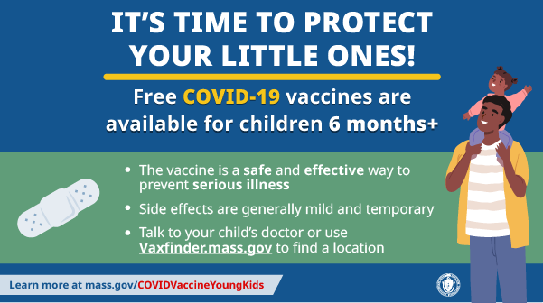
FAQs re: children 6 months+ in
multiple languages
Messages for children 6 months+ in multiple languages
Short video about vaccine safety and efficacy (in English and Spanish)
Key Resources

OUTREACH AND EDUCATION MATERIALS

COVID-19 Vaccine FAQs
COVID-19 Therapeutic Information (including telehealth) Weekly Provider Bulletin (latest edition published 9/7/22)
Trust the Facts, Get the Vax Campaign Materials (organized by audience, including general, parents and pregnant people, youth, young adults; available in 12 languages) Multilingual COVID-19 Materials (videos and printables; organized by language) COVID-19 Funeral Assistance from FEMA (including one-pager with key info available in multiple languages)
COVID-19 Vaccination Tools for Employers
Archive of COVID-19 Vaccine Communications Updates (past editions of VEI Roundup)

FIND A COVID-19 VACCINE OR BOOSTER

Mass.gov/KidsClinic (family-friendly clinics through September)
Vaccine Finder
Find, Schedule, or Sign Up for a Mobile COVID-19 Vaccination COVID-19 In-Home Vaccination Program
Request a Copy of Your Vaccine Card

Recent Highlights
Methuen

In Methuen, Melita Farms hosts a weekly clinic at their farm stand in partnership with the Vaccine Equity Initiative, the Methuen Health and Human Services Department, and Cataldo Ambulance. On August 27, Melita Farms held a back-to-school clinic with bouncy houses, games, and a backpack giveaway (see photo). 42 vaccines were administered, including 18 first doses. Since June, 251 vaccines have been administered at Melita Farms, including 68 first doses. They will host two more large family-friendly events at their clinics this fall.

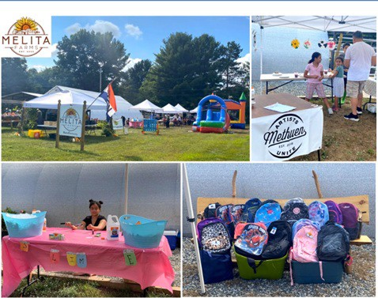

Read More Highlights

Share This Email
Share This Email
Share This Email

Visit the VEI Website

Vaccine Equity Initiative | 250 Washington Street, Boston, MA 02108 Unsubscribe vaccineequityinitiative@mass.gov
Constant Contact Data Notice
Sent by vaccineequityinitiative@mass.gov in collaboration with
Try email marketing for free today!

