COVID-19 Vaccine Equity
Update to the Legislature
January 2023

Statutory requirement
chapter 22 of the Acts of 2022
https://malegislature.gov/Laws/SessionLaws/Acts/2022/Chapter22
SECTION 30. Notwithstanding any general or special law to the contrary, the secretary of health and human services shall prepare and implement a detailed comprehensive COVID-19 vaccination equity plan, including interim goals, benchmarks and timelines, to significantly increase the proportion of adults and children who are fully vaccinated for COVID-19, including booster vaccinations, among communities in the commonwealth that have disproportionately low vaccination rates, which may include, but shall not be limited to, minority, immigrant and low-income communities. The goal of the plan shall be to eliminate disparities in the rates of vaccination. The plan shall include: (i) mechanisms necessary to directly deliver medically and scientifically accurate, culturally competent and linguistically diverse information about the safety and efficacy of vaccination, including particularly the COVID-19 vaccine, and the pathways to receiving a COVID-19 vaccine; (ii) a complete list of existing or new community-based partnerships for implementation of the plan, including an explanation of the role of local public health departments or boards of health, community-rooted faith-based organizations and locally-based health care providers in implementing the plan; and (iii) a budget for implementation with funding sources identified. The secretary shall provide the plan in writing to the house and senate committees on ways and means, the joint committee on COVID-19 and emergency preparedness and management and the joint committee on public health and make the plan publicly available on the website of the department of public health not later than 30 days after the effective date of this section. The secretary shall report progress towards achieving the equity plan goals by region, by municipality and statewide not less than every 60 days following the completion of the plan.

COVID-19 Vaccine Equity 60-Day Update to the Legislature

OVERVIEW
The Massachusetts Department of Public Health submitted its original Vaccine Equity Plan to the Legislature on March 15, 2022, a report that has since been updated every 60 days. This report represents the latest update to that plan, with details about our continuing efforts to increase access to and uptake of the COVID-19 vaccine. In the 60 days since the last report on November 8, 2022:
- Rates of first dose and booster doses are up in the VEI communities.
- First dose rates in the VEI communities increased by 1 percentage point to 85%. Fully vaccinated rates increased 0.5 percentage points to 72.5%.
- First dose pediatric (ages 5-11) vaccinations in VEI communities increased by 1 percentage point to 51%, while fully vaccinated pediatric rates increased 1 percentage point to 41%.
- First dose rates in children 6 months to 4 years old increased 2 percentage points to 14.6% for VEI communities.
- First dose booster rates in the VEI communities are currently at 39.6%, an increase of 1 percentage point from the previous report, based on the entire population, while second dose booster rates are currently 14%, up 3 percentage points from the previous report.
Massachusetts is a national leader in COVID-19 vaccination rates; according to the CDC, 93% of the state’s population age 6 months and over has received at least one dose, compared with 81% nationally. 64% of fully vaccinated individuals in Massachusetts have had a booster.
Building on these successes, VEI continues to identify and reduce barriers, increase access, and promote awareness regarding the effectiveness and safety of COVID-19 vaccines, and now variant boosters.

PROGRAM SPOTLIGHT: GET BOOSTED VACCINATION CLINICS (Incentive Program)
VEI launched the Get Boosted campaign on October 24, 2022 to increase vaccination rates, with a focus on boosters. The campaign’s webpage, mass.gov/GetBoosted, includes a continuously updated list of participating clinics, which offer a $75 gift card with each dose administered, whether primary series or booster.
In the first nine weeks of this campaign, nearly 45,000 doses have been administered, with nearly 45,000 gift cards distributed Over 90% of the doses were boosters. Doses have gone primarily to 50–59-year-olds, with 5–11-year-olds accounting for a large proportion of pediatric doses administered. Outreach efforts have proven to be effective, with 48% of all doses administered to individuals who self-identify as BIPOC.​ The campaign is scheduled to run through March 2023.
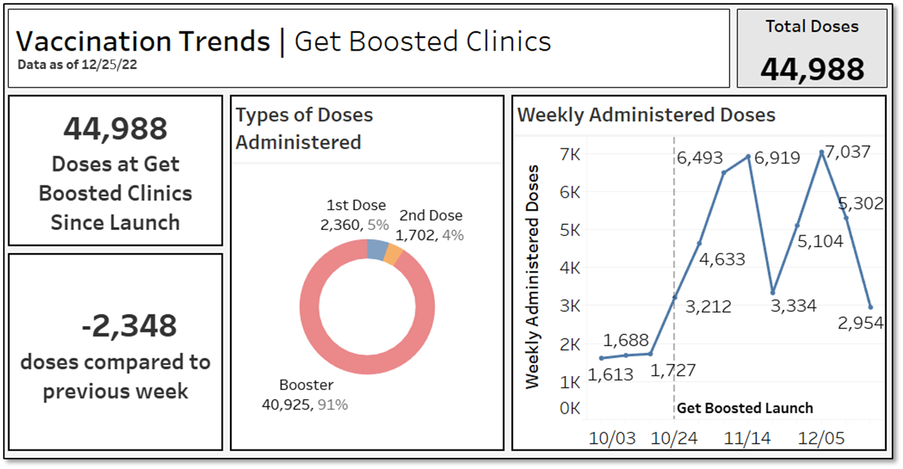

The Get Boosted initiative extends beyond the original 20 VEI communities to include 10 additional municipalities and three rural areas with the lowest booster rates and highest BIPOC populations. These municipalities and rural clusters include: Amherst, Attleboro, Avon, Chicopee, Dudley, Gardner, Southbridge, Taunton, Webster, and West Springfield; the Islands (Nantucket and Martha’s Vineyard), Northern Berkshires (Adams, Cheshire, Florida, North Adams, Savoy, and Williamstown), and Quaboag Valley (Belchertown, Brimfield, Brookfield, East Brookfield, Holland, Monson, North Brookfield, Palmer, Wales, Ware, Warren, and West Brookfield).
Tailored communications
Paid ads have been running in VEI communities, including billboards, convenience store ads, outdoor posters and digital displays in public venues (including ads in English, Spanish, and Portuguese); and digital and social media ads (in English and Spanish) directing people to clinics near them. All municipalities with participating clinics also receive customized media outreach to publicize clinics in local press outlets. This media outreach has produced over 40 media placements across 15 communities.
Impactful promotion of the campaign has also been a result of efforts by VEI partners, including community-based organizations and sister state agencies. For example, text messages sent by the Division of Transitional Assistance to its clients resulted in over 47,800 unique users visiting the Get Boosted webpage in a single day. Text messages were sent in six languages, including English, Spanish, Portuguese, Haitian Creole, Chinese, and Vietnamese.

IMPACT OF THE VACCINE EQUITY INITIATIVE SINCE ITS LAUNCH
Since the COVID-19 Vaccine Equity Initiative launched in February 2021:
- Over 200,000 residents in the VEI communities have been vaccinated with a first dose, closing a 7 percent gap between the VEI and non-VEI communities in January 2022 by more than half to a 3 percent gap in December 2022.
- Since vaccines became available to most age groups in May 2021, VEI communities have increased their fully vaccinated population by 125.4%, outpacing non-VEI communities at 98.4% (Graph 1).
- All 20 VEI communities made strides in fully vaccinated rates: the VEI municipalities fully vaccinated over 150,000 residents and increased their overall rate by 7 percentage points.
- The VEI communities have increased the fully vaccinated rates in their BIPOC communities by ~10 percentage points from January 2022 to December 2022. From May 2021 through December 2022, the fully vaccinated rate among BIPOC populations in the VEI communities increased 212% (Graph 2).
- Through VEI, DPH awarded $58M to 198 community organizations and over $4.7M to prioritized municipalities and local boards of health for vaccine access, education, and outreach and to help build local health capacity.

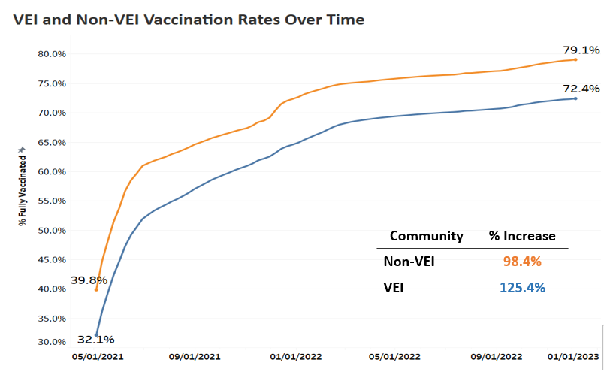
Graph 1

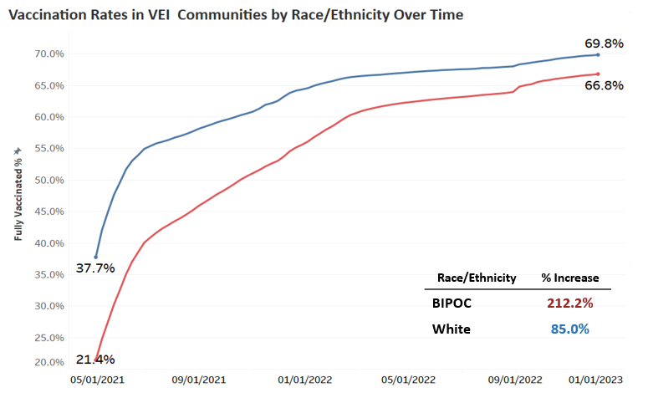
Graph 2

VEI MUNICIPALITY VACCINATION DATA
The Vaccine Equity Initiative publishes the latest vaccination data weekly on an interactive dashboard, available at https://www.mass.gov/info-details/covid-19-vaccine-equity-initiative-community-specific-vaccination-data#covid-19-vaccine-equity-initiative-data-dashboard-. The data are publicly available and stratify vaccination rates across sex, age, and race/ethnicity for each of the 20 VEI communities, as well as statewide. Monthly highlights of VEI community efforts can be seen at https://www.mass.gov/info-details/covid-19-vaccine-equity-initiative-highlights.

