COVID-19 Vaccine Equity
Update to the Legislature
July 12, 2022

Statutory requirement
chapter 22 of the Acts of 2022
https://malegislature.gov/Laws/SessionLaws/Acts/2022/Chapter22
SECTION 30. Notwithstanding any general or special law to the contrary, the secretary of health and human services shall prepare and implement a detailed comprehensive COVID-19 vaccination equity plan, including interim goals, benchmarks and timelines, to significantly increase the proportion of adults and children who are fully vaccinated for COVID-19, including booster vaccinations, among communities in the commonwealth that have disproportionately low vaccination rates, which may include, but shall not be limited to, minority, immigrant and low-income communities. The goal of the plan shall be to eliminate disparities in the rates of vaccination. The plan shall include: (i) mechanisms necessary to directly deliver medically and scientifically accurate, culturally competent and linguistically diverse information about the safety and efficacy of vaccination, including particularly the COVID-19 vaccine, and the pathways to receiving a COVID-19 vaccine; (ii) a complete list of existing or new community-based partnerships for implementation of the plan, including an explanation of the role of local public health departments or boards of health, community-rooted faith-based organizations and locally-based health care providers in implementing the plan; and (iii) a budget for implementation with funding sources identified. The secretary shall provide the plan in writing to the house and senate committees on ways and means, the joint committee on COVID-19 and emergency preparedness and management and the joint committee on public health and make the plan publicly available on the website of the department of public health not later than 30 days after the effective date of this section. The secretary shall report progress towards achieving the equity plan goals by region, by municipality and statewide not less than every 60 days following the completion of the plan.

COVID-19 Vaccine Equity 60-Day Update to the Legislature

OVERVIEW
Massachusetts continues to increase access to and uptake of COVID-19 vaccine across the Commonwealth. The Massachusetts Department of Public Health submitted its Vaccine Equity Plan to the Legislature on March 15, 2022. This report represents an update to that plan. In the 60 days since the last report on May 13, 2022:
- 18 of the 20 VEI communities have met or exceeded the statewide average in percent change in new fully vaccinated individuals over the past 60 days.
- First dose rates in the equity municipalities increased by 1 percentage point to 88%, while fully vaccinated rates increased 0.6 percentage points to 75%.
- First dose pediatric (ages 5-11) vaccinations increased by two percentage points to 46%.
- Fully vaccinated pediatric rates increased 1.5 percentage point to 37%.
As has been the case from the early days of the vaccine rollout, every dose counts. Our commitment to ensuring vaccine access in the Commonwealth has had results: Massachusetts is second only to Hawaii in the Commonwealth Fund’s 2022 State Scorecard rankings, based on overall performance across 56 measures of health care access and quality, service use and cost, health disparities, and health outcomes during the COVID-19 pandemic in 2020.
While Massachusetts leads the nation in vaccination rates of Black and Hispanic residents, according to Kaiser Family Foundation data, our continued efforts to close the gap in our equity communities serves as a reminder that we must continue to lean in to reduce barriers, increase access, and promote awareness regarding COVID-19 vaccines and boosters.

PROGRAM SPOTLIGHT: FAMILY-FRIENDLY SUMMER CLINICS
To build confidence in the vaccine’s efficacy, provide safe and culturally competent settings for vaccination, and to reduce barriers to access, VEI is prioritizing family-friendly clinics at festivals, day camps, schools, YMCAs, and food pantries during June-August 2022. Family-friendly clinics offer vaccinations, including boosters, for all members of a family or social network. To reduce cultural barriers to access, VEI partners with community- and faith-based organizations to support these clinics in areas where the people most impacted by COVID-19 live, work, play, and pray.
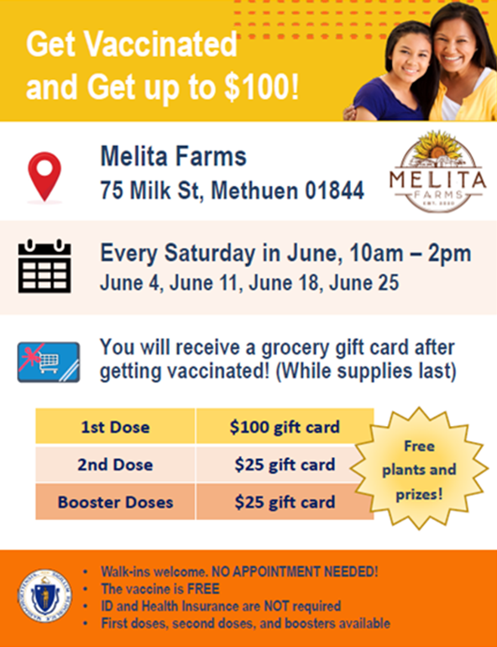
By addressing social determinants of health as part of vaccination efforts, VEI strengthens community resiliency while earning community trust. VEI is growing its partnership with food pantries as they offer a new, strong community connection. By partnering with food pantries, VEI meets individuals in a safe, convenient, and trusted environment. In June 2022, VEI held seven clinics at food pantries, including the Springfield Cupboard Food Pantry, Lowell's Dwelling House of Hope Food Distribution, and Malden's Bread of Life Food Pantry.
VEI held over 75 family-friendly clinics during the month of June in the 20 VEI communities, including at the Lawrence SALSA Festival, Lowell Pride, New Bedford Fire Station, and for Juneteenth. Many included themes or incentives to increase interest and engagement. In Methuen, for example, Melita Farms hosted clinics each Saturday in June where anyone receiving a vaccination received a grocery gift card and a small plant.

INCREASED FUNDING FOR COMMUNITY-BASED ORGANIZATIONS
To date, a total of 197 community organizations have been awarded over $58 million through the Vaccine Equity Initiative; this includes community- and faith-based organizations, Tribal and Indigenous People Serving Organizations, Community Health Centers, and other community-based healthcare organizations.
On June 29, the Baker-Polito Administration announced another $7 million in funding to support community organizations as they continue to reduce barriers to vaccine access and promote vaccines and boosters for communities and populations most disproportionately impacted by COVID-19.
The $7 million in new funding was awarded to Health Resources in Action (HRiA) and Health Care for All (HCFA) to provide technical assistance and grants for outreach and education to 79 community- and faith-based organizations, including Tribal and Indigenous People-serving organizations. The $7 million in funding supports:
- $6.3M in grants: $6,361,656 has been awarded to 79 community organizations. These programs are implementing tailored community interventions to increase vaccine acceptance, promote vaccination, and minimize the impact of COVID-19.
- $140,000 in technical assistance and grant administration provided by HRiA.
- $500,000 in direct outreach services by HCFA as a subcontractor to HRiA. The goal is to promote VEI vaccine clinics as well as provide direct contact to community health center patients about vaccination and availability of family-friendly vaccination clinics near them.

Award Recipients for Community Outreach and Education

- African Community Education Program, Worcester
- African Cultural Services, Inc., Waltham
- Asian American Civic Association, Boston
- Asian Women for Health, Boston
- Asociacion Ministerial Evangelica Del Area de Lawrence, Lawrence
- Autism Sprinter, Randolph
- Black Springfield COVID-19 Coalition, Springfield
- Boston Black COVID-19 Coalition, Boston
- BRIDGE (Berkshire Resources for the Integration of Diverse Communities), Lee
- Brockton Area Multi-Service, Inc., (BAMSI) Brockton
- Building Audacity, Lynn
- Cambodian Mutual Assistance Association of Greater Lowell (CMAA), Lowell
- Centro Comunitario de Trabajadores, New Bedford (TIPSO)
- Centro de Apoyo Familiar (CAF), Lawrence
- Chappaquiddick Tribe of the Wampanoag Indian Nation Corporation, Edgartown
- Chelsea Black Community, Chelsea
- Chica Project, Boston
- Chinese Culture Connection, Inc., Malden
- Coalition for a Better Acre, Lowell
- Community Economic Development Center, New Bedford
- DEAF, Inc., Allston
- Dwelling House of Hope, Inc., Lowell
- Extreme Kid Inc (Fiscal sponsor: New North Citizens Council), Springfield
- Fishing Partnership, New Bedford
- Greater Framingham Community Church, Framingham
- Greater Lowell Health Alliance, Lowell
- GreenRoots, Chelsea
- Haitian Community Partners, Brockton
- Haitian Health Institute, Boston
- Herring Pond Wampanoag Tribe, Plymouth (TIPSO)
- Immigrants Assistance Center, New Bedford
- JAHAN Women and Youth Intercultural, Boston
- Jewish Family Service of Metrowest, Framingham
- La Colaborativa/Chelsea Collaborative, Chelsea
- Latinos Unidos en Massachusetts, Everett
- Leaving the Streets Ministries, Inc, Haverhill
- Love Your Menses, Boston
- Massachusetts Coalition for Occupational Safety & Health (MassCOSH), Boston
- Massachusetts Council of Churches, Boston
- MOCHA (Fiscal sponsor: YMCA of Greater Springfield), Springfield
- New American Association of Massachusetts, Lynn
- New Life Community Empowerment Center, Brockton
- New North Citizens Council, Springfield
- Next Leadership Development, Boston
- Nigeria American Multiservice Association (NAMSA), Shrewsbury
- North American Indian Center of Boston, Boston
- Ohketeau Cultural Center, Ashfield
- OneHolyoke CDC, Holyoke
- People Affecting Community Change (PACC Global), Boston
- Pinnacle Partnerships Corp, Brockton
- Pioneer Valley Project, Springfield
- Pioneer Valley Workers Center, Northampton
- Randolph Community Partnership, Randolph
- Sarepta Women and Children Empowerment Center/Synergy Partnership, Taunton
- Somali Parents Advocacy Center for Education (SPACE), Everett
- South Asian Workers' Center, Boston
- Southeast Asian Coalition of Central Massachusetts, Worcester
- Spanish American Center, Leominster
- Springfield Boys and Girls Club, Springfield
- The Black Literacy and Arts Collaborative Project, Inc., Quincy
- The Boston Project Ministries, Dorchester
- The Center for Hope and Healing, Lowell
- The Everett Haitian Community Center, Everett
- The Joint Committee for Children's Health Care, Everett
- The Latino Health Insurance Program, Inc., Framingham
- The Massachusetts Coalition for the Homeless, Lynn
- UHAI for Health, INC, Worcester
- Who's Got Morale, Roxbury
- Women Encouraging Empowerment Inc., Revere
- Worcester Interfaith, Worcester
- YMCA of Greater Boston, Boston
- YWCA Southeastern Massachusetts, New Bedford

Focused Grassroots Outreach

- ACEDONE: African Communities in Greater Boston
- Authentic Caribbean Foundation: Boston, Brockton, Mattapan, Worcester, Springfield, and others
- Brazilian American Center: Framingham
- Making Opportunity Count: Fitchburg & Leominster
- NewVue: Fitchburg & Leominster
- The Learning Center for the Deaf: Framingham
- True Alliance Center: Mattapan, Brockton, Randolph, and other areas

INCREASED FUNDING FOR COMMUNITY HEALTH CENTERS

On June 30, the Baker-Polito Administration announced $12.5 million in funding to the League of Community Health Centers for 35 Community Health Centers (CHCs), increasing the amount from an original $5 million. Given high demand and need demonstrated by CHCs the Administration awarded an additional $7.5 million from a COVID-19 response reserve. This funding continues the administration’s commitment to ensuring COVID-19 vaccines and testing are readily available at trusted community health centers.

- 83% of the total funds are awarded to CHCs located in VEI communities. The funding supports the continued work of reducing barriers to accessing vaccines and testing.

- CHCs are using the funds to support staffing of employees focused on COVID-19 testing and vaccinations along with supply cost, mobile testing sites and renovations of facilities to create dedicated vaccination and testing space.

The Community Health Centers receiving funding are:

- Boston Health Care for the Homeless
- Brockton Neighborhood Health Center
- Caring Health Center
- Charles River Community Health
- CHC of Franklin County
- Codman Square Health Center
- Community Health Center of Cape Cod
- Community Health Connections
- Dimock Community Health Center
- DotHouse Health
- Duffy Health Center
- East Boston Neighborhood Health Center
- Edward M Kennedy Community Health Center
- Family Health Center of Worcester
- Fenway Community Health Center
- Greater Lawrence Family Health Center
- Greater New Bedford Community Health Center
- Greater Roslindale Medical & Dental Center
- Harbor Health Services
- Harvard Street Neighborhood Health Center
- HealthFirst Family Care Center
- Hilltown Community Health Centers
- Holyoke Health Center
- Island Health
- Lowell Community Health Center
- Lynn Community Health Center
- Manet Community Health Center
- Mattapan Community Health Center
- MGH Community Health Associates
- North End Waterfront Health
- North Shore Community Health Center
- South Boston Community Health Center
- SSTAR
- Upham’s Corner Community Health Center
- Whittier Street Community Health Center

VEI MUNICIPALITY VACCINATION DATA
The VEI publishes the latest vaccination data weekly on an interactive dashboard, available at the following link https://www.mass.gov/info-details/covid-19-vaccine-equity-initiative-community-specific-vaccination-data#covid-19-vaccine-equity-initiative-data-dashboard-. The data are publicly available and stratify vaccination rates across sex, age, and race/ethnicity for each of the 20 VEI municipalities, as well as statewide. A snapshot of the VEI Summary Page of the dashboard is shown in Figure 1 below with vaccination data as of 7/5/2022.
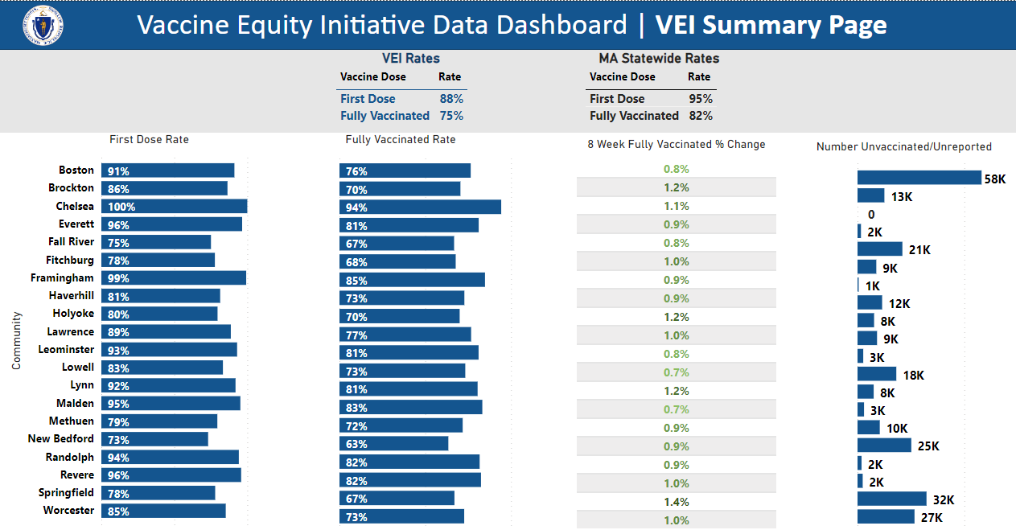
Figure 1: COVID-19 Vaccination rates for the 20 VEI Municipalities compared with MA statewide rates. Data current as of 7/5/2022.

