COVID-19 Vaccine Equity
Update to the Legislature
July 5, 2023

Statutory requirement
chapter 22 of the Acts of 2022
https://malegislature.gov/Laws/SessionLaws/Acts/2022/Chapter22
SECTION 30. Notwithstanding any general or special law to the contrary, the secretary of health and human services shall prepare and implement a detailed comprehensive COVID-19 vaccination equity plan, including interim goals, benchmarks and timelines, to significantly increase the proportion of adults and children who are fully vaccinated for COVID-19, including booster vaccinations, among communities in the commonwealth that have disproportionately low vaccination rates, which may include, but shall not be limited to, minority, immigrant and low-income communities. The goal of the plan shall be to eliminate disparities in the rates of vaccination. The plan shall include: (i) mechanisms necessary to directly deliver medically and scientifically accurate, culturally competent and linguistically diverse information about the safety and efficacy of vaccination, including particularly the COVID-19 vaccine, and the pathways to receiving a COVID-19 vaccine; (ii) a complete list of existing or new community-based partnerships for implementation of the plan, including an explanation of the role of local public health departments or boards of health, community-rooted faith-based organizations and locally-based health care providers in implementing the plan; and (iii) a budget for implementation with funding sources identified. The secretary shall provide the plan in writing to the house and senate committees on ways and means, the joint committee on COVID-19 and emergency preparedness and management and the joint committee on public health and make the plan publicly available on the website of the department of public health not later than 30 days after the effective date of this section. The secretary shall report progress towards achieving the equity plan goals by region, by municipality and statewide not less than every 60 days following the completion of the plan.

COVID-19 Vaccine Equity 60-Day Update to the Legislature

OVERVIEW
The Massachusetts Department of Public Health submitted its original Vaccine Equity Plan to the Legislature on March 15, 2022, a report that has since been updated every 60 days. This report represents the latest update to that plan, with details about our continuing efforts to increase access to and uptake of the COVID-19 vaccine.
The Vaccine Equity Initiative (VEI) is a strategic component of the Vaccine Equity Plan. VEI was established in February 2021 to work with the populations and communities hardest hit by COVID-19 to increase awareness and acceptance of the vaccine, access to vaccination locations, and vaccine administration rates. This approach is driven by community needs and is centered on equity.
By June 19, 2023, the vaccination rates in VEI communities were approaching the statewide rate, with a larger gap for booster doses received at September 1st and mainly corresponding to Bivalent boosters. As noted in previous reports, a slight lag in VEI communities often occurs when a new dose is authorized, as with the Bivalent booster.
 | At Least 1 Dose | Primary Series Complete | Boosted after 9/1/2022
VEI Communities | 86% | 80% | 28%
MA Statewide | 88% | 85% | 35%

VEI is building on the successes it has earned over the two years since it launched by evolving its programs and processes to align them with COVID-19’s endemic phase. As it gears up for the release of a new vaccine dose in the fall, VEI continues to identify and reduce barriers, increase access, and promote awareness regarding the effectiveness and safety of COVID-19 vaccines.
PROGRAM SPOTLIGHT: VACCINE ACCESS AND ADMINISTRATION IN COMMUNITY SETTINGS
The Vaccine Equity Initiative’s Vaccine Access and Administration (VAA) program was created to increase community-based access to COVID-19 vaccination for priority communities and populations. 31 community organizations have received funding under this component of the Vaccine Equity Initiative since April 2021.
Two components comprise the VAA program: Vaccine Access and Navigation; and Customized Vaccine Administration. Through the vaccine access and navigation component, community-based organizations, community health centers, and behavioral health centers assist individuals to plan for, access, and receive vaccination services. Direct services include guidance about vaccine eligibility, assistance to register for online appointments, transportation to and from appointments, translation services, mobility assistance, and other accompanied supports. Services are delivered by staff and Community Health Workers with cultural and linguistic competence and experience serving priority populations.
Through the customized vaccine administration component, qualified organizations are funded to directly administer vaccination to groups not effectively reached by other mechanisms. These organizations can be deployed to smaller venues, with populations that may require more intensive, one-on-one support to get vaccinated. VAA programs also coordinate with DPH’s Mobile Vaccination Program to bring vaccination services to communities.
Creative locations
A key strategy of the VAA program is to locate clinics in the spaces where people live their lives. To date, these locations have included: housing authorities, elderly housing, YMCAs and local community centers, restaurants in between shifts, housing encampments and shelters, food pantries, family planning clinics, night clubs, schools, grocery stores, religious institutions, drug treatment facilities, trampoline parks, and libraries.
The VAA’s outreach and education efforts have extended to local businesses, including barber shops, bakeries, autobody shops, laundromats, and nail salons. Festivals and fairs, farmers markets, block parties, drug user health programs, daycares, and other venues are also sites where VAA providers have engaged the community around the COVID-19 vaccine.
Results
From May 17, 2021 through June 17, 2023, the VAA program administered 100,856 vaccinations to almost 84,000 people in trusted community settings (Table 1). Of those vaccinated, almost 24,000 people received navigation services to help them access the vaccine. The VAA provided 5,761 clinics in partnership with communities and provided outreach and education about the vaccine at 2,629 events.
The VAA program made a deliberate effort to work with trusted community partners to reach people of color and ethnic minorities, and the numbers reflect that success. The majority of those served identified as BIPOC, and just over a third (38.3%) identified as white (Table 1).
Table 1: Race/Ethnicity of people vaccinated through the VAA 5/17/21 – 6/17/23
Race/Ethnicity | Number | %
White | 32,028 | 38.3%
Hispanic or Latino of any race | 26,170 | 31.3%
Black or African American | 10,181 | 12.2%
Unknown/Declined | 8,692 | 10.4%
Asian | 3,531 | 4.2%
Other | 1,935 | 2.3%
Multiethnic | 686 | 0.8%
Native American or Alaskan | 343 | 0.4%
Native Hawaiian/Pacific Islander | 81 | 0.1%

The VAA program is shifting to anticipate the changing needs of the people it serves as COVID-19 enters the endemic phase. In Fiscal Year 2024, a total of 13 organizations will continue to provide VAA services to communities hardest hit by COVID-19. As new guidance is released by CDC for the fall and winter, VAA providers will continue to connect with communities to provide outreach, education, and access to the latest COVID-19 vaccines.

IMPACT OF THE VACCINE EQUITY INITIATIVE SINCE ITS LAUNCH
Since the COVID-19 Vaccine Equity Initiative launched in February 2021:
- Nearly 1.9 million residents in the VEI communities have been vaccinated with a first dose, closing a 6 percentage point gap in vaccination rates between the VEI and non-VEI communities in March of 2021 by half to a 3 percentage point gap in June 2023.
- Since vaccines became available to most age groups in May 2021, VEI communities have increased the number of their population with a complete primary series by 105%, outpacing non-VEI communities at 75% (Graph 1).
- All 20 VEI communities made strides in primary series complete rates: the VEI municipalities vaccinated over 1.7 million residents to complete primary series. The VEI communities have increased the fully vaccinated rates in their BIPOC communities by ~46 percentage points from May 2021 through December 2022, an increase of 139% (Graph 2).
- Through VEI, DPH awarded $62.8M to 198 community organizations and over $4.7M to prioritized municipalities and local boards of health for vaccine access, education, and outreach and to help build local health capacity.

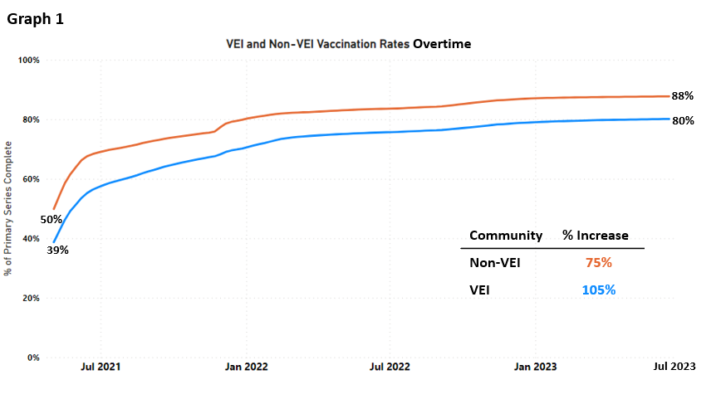

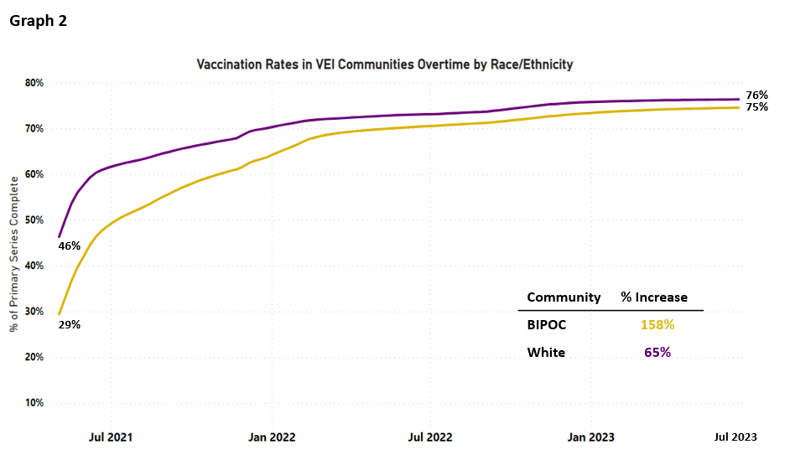

VEI MUNICIPALITY VACCINATION DATA
The Vaccine Equity Initiative publishes the latest vaccination data weekly on an interactive dashboard, available at https://www.mass.gov/info-details/covid-19-vaccine-equity-initiative-community-specific-vaccination-data#covid-19-vaccine-equity-initiative-data-dashboard-. The data are publicly available and stratify vaccination rates across sex, age, and race/ethnicity for each of the 20 VEI communities, as well as statewide. Monthly highlights of VEI community efforts can be seen at https://www.mass.gov/info-details/covid-19-vaccine-equity-initiative-highlights.

MOVING FORWARD
DPH continues to ensure that opportunities for education and community-based clinics continue as needed through the summer and into the fall, in anticipation of new CDC guidance around COVID-19 vaccinations. DPH Mobile and the Vaccine Access and Administration (VAA) program continue to provide clinics in collaboration with community partners, and DPH’s in-home vaccination program continues to provide services. To support these efforts and to build vaccine confidence, VEI is providing communications support.
VEI continues to communicate new information and guidelines about the vaccine to its communities, including new guidance issued by the CDC around bivalent doses. As such, preparations are underway to continue to support community partners with sharing new guidelines, building vaccine confidence and increasing the number of people protected from COVID-19 in VEI’s priority communities.

