COVID-19 Vaccine Equity
Update to the Legislature
March 7, 2023

Statutory requirement
chapter 22 of the Acts of 2022
https://malegislature.gov/Laws/SessionLaws/Acts/2022/Chapter22
SECTION 30. Notwithstanding any general or special law to the contrary, the secretary of health and human services shall prepare and implement a detailed comprehensive COVID-19 vaccination equity plan, including interim goals, benchmarks and timelines, to significantly increase the proportion of adults and children who are fully vaccinated for COVID-19, including booster vaccinations, among communities in the commonwealth that have disproportionately low vaccination rates, which may include, but shall not be limited to, minority, immigrant and low-income communities. The goal of the plan shall be to eliminate disparities in the rates of vaccination. The plan shall include: (i) mechanisms necessary to directly deliver medically and scientifically accurate, culturally competent and linguistically diverse information about the safety and efficacy of vaccination, including particularly the COVID-19 vaccine, and the pathways to receiving a COVID-19 vaccine; (ii) a complete list of existing or new community-based partnerships for implementation of the plan, including an explanation of the role of local public health departments or boards of health, community-rooted faith-based organizations and locally-based health care providers in implementing the plan; and (iii) a budget for implementation with funding sources identified. The secretary shall provide the plan in writing to the house and senate committees on ways and means, the joint committee on COVID-19 and emergency preparedness and management and the joint committee on public health and make the plan publicly available on the website of the department of public health not later than 30 days after the effective date of this section. The secretary shall report progress towards achieving the equity plan goals by region, by municipality and statewide not less than every 60 days following the completion of the plan.

COVID-19 Vaccine Equity 60-Day Update to the Legislature

OVERVIEW
The Massachusetts Department of Public Health submitted its original Vaccine Equity Plan to the Legislature on March 15, 2022, a report that has since been updated every 60 days. This report represents the latest update to that plan, with details about our continuing efforts to increase access to and uptake of the COVID-19 vaccine.
The Vaccine Equity Initiative (VEI) is a strategic component of the Vaccine Equity Plan. VEI was established in February 2021 to work with the populations and communities hardest hit by COVID-19 to increase awareness and acceptance of the vaccine, access to vaccination locations, and vaccine administration rates. This approach is driven by community needs and is centered on equity.
In the 60 days since the last report on January 5, 2023:
- First dose rates in the VEI communities increased by 0.6 percentage points to 85.6%. Fully vaccinated rates increased 0.4 percentage points to 72.9%.
- First dose pediatric (ages 5-11) vaccinations in VEI communities increased by 1.3 percentage point to 52.3%, while fully vaccinated pediatric rates increased 1 percentage point to 42%.
- First dose rates in children 6 months to 4 years old increased 2.2 percentage points to 16.8% for VEI communities.
- First dose booster rates in the VEI communities are currently at 40.7%, an increase of 1.1 percentage point from the previous report, based on the entire population, while second dose booster rates are currently 16.2%, up 2.2 percentage points from the previous report.
Massachusetts is a national leader in COVID-19 vaccination rates; according to the CDC, 93% of the state’s population age 6 months and over has received at least one dose, compared with 81% nationally. 64% of fully vaccinated individuals in Massachusetts have had a booster.
Building on the successes it has learned over the two years since it launched, VEI continues to identify and reduce barriers, increase access, and promote awareness regarding the effectiveness and safety of COVID-19 vaccines, and now variant boosters.

PROGRAM SPOTLIGHT: GET BOOSTED VACCINATION CLINICS (Incentive Program)
VEI launched the Get Boosted campaign on October 24, 2022 to increase vaccination rates, with a focus on boosters. The campaign’s webpage, mass.gov/GetBoosted, includes a continuously updated list of participating clinics, which offer a $75 gift card with each dose administered, whether primary series or booster.
In just over four months, nearly 70,000 doses have been administered, with nearly 70,000 gift cards distributed. 89% of the doses were boosters. Another 6% were first doses, an encouraging finding that people who have never been vaccinated for COVID-19 may still be willing to try. Participation at clinics has continued even after concerns of a winter surge subsided after the holidays.
Doses have gone primarily to adults aged 30-69, with 5–11-year-olds accounting for a large proportion of pediatric doses administered. Outreach efforts have proven to be effective, with 50% of all doses administered to individuals who self-identify as BIPOC.​ The campaign is scheduled to run through March 31, 2023.
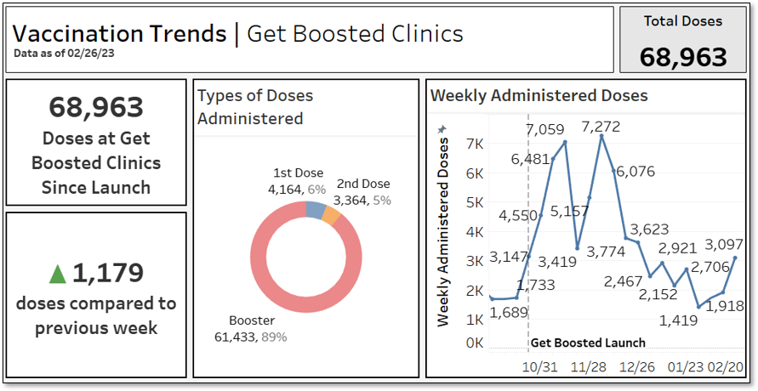
These clinics are designed to increase vaccine access and vaccination rates for Massachusetts residents in the 20 municipalities and 14 rural areas prioritized as part of the Vaccine Equity Initiative, and 10 additional municipalities with the lowest booster rates and highest BIPOC populations. These 10 additional municipalities are Amherst, Attleboro, Avon, Chicopee, Dudley, Gardner, Southbridge, Taunton, Webster, and West Springfield.
Tailored promotion of the Get Boosted campaign
DPH has been running paid ads in VEI communities, including billboards, convenience store ads, outdoor posters and digital displays in public venues (including ads in English, Spanish, and Portuguese); radio ads in Spanish, Portuguese, and Haitian Creole); and digital and social media ads (in English and Spanish) directing people to clinics near them.
All municipalities with participating Get Boosted clinics also receive customized media outreach to publicize clinics in local press outlets. This media outreach has produced over 85 media placements across 25 communities.
As trusted sources, VEI partners, including community-based organizations and sister state agencies, have collaborated with VEI to promote the Get Boosted campaign using their own channels and networks. For example, text messages sent by the Division of Transitional Assistance to its clients in mid-February resulted in an increase of 10,000 individual visits to the campaign webpage for the four days after the message was sent, and coincided with an increase in clinic participation for the following week. Text messages were sent in six languages, including English, Spanish, Portuguese, Haitian Creole, Chinese, and Vietnamese.

IMPACT OF THE VACCINE EQUITY INITIATIVE SINCE ITS LAUNCH
Since the COVID-19 Vaccine Equity Initiative launched in February 2021:
- Nearly 1.9 million residents in the VEI communities have been vaccinated with a first dose, closing a 6 percentage point gap in vaccination rates between the VEI and non-VEI communities in March of 2021 by half to a 3 percentage point gap in February 2023.
- Since vaccines became available to most age groups in May 2021, VEI communities have increased their fully vaccinated population by 127.1%, outpacing non-VEI communities at 99.7% (Graph 1).
- All 20 VEI communities made strides in fully vaccinated rates: the VEI municipalities fully vaccinated over 1.6 million residents. The VEI communities have increased the fully vaccinated rates in their BIPOC communities by ~32 percentage points from May 2021 through December 2022, an increase of 216% (Graph 2).
- Through VEI, DPH awarded $58M to 198 community organizations and over $4.7M to prioritized municipalities and local boards of health for vaccine access, education, and outreach and to help build local health capacity.

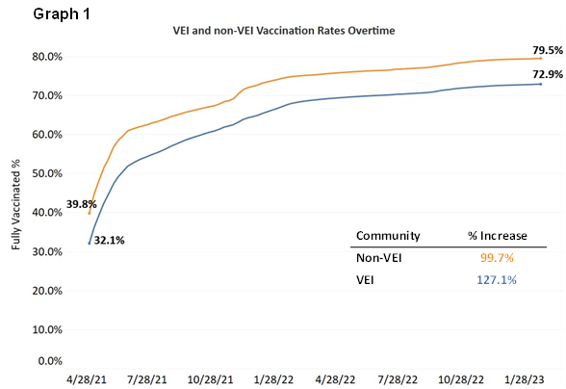

Graph 2
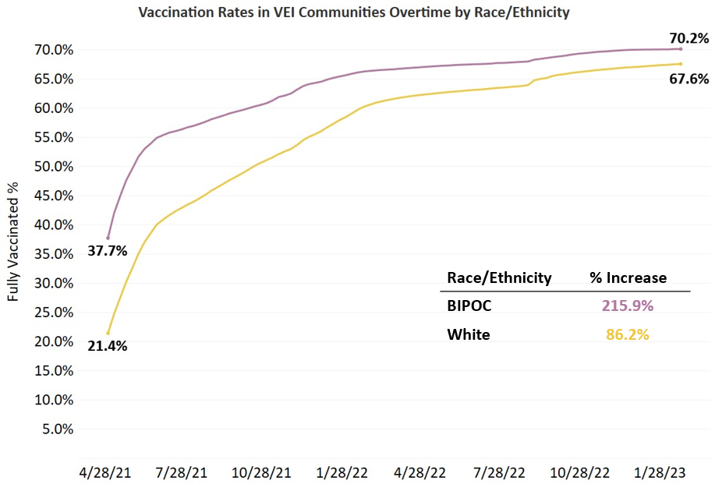
VEI MUNICIPALITY VACCINATION DATA
The Vaccine Equity Initiative publishes the latest vaccination data weekly on an interactive dashboard, available at https://www.mass.gov/info-details/covid-19-vaccine-equity-initiative-community-specific-vaccination-data#covid-19-vaccine-equity-initiative-data-dashboard-. The data are publicly available and stratify vaccination rates across sex, age, and race/ethnicity for each of the 20 VEI communities, as well as statewide. Monthly highlights of VEI community efforts can be seen at https://www.mass.gov/info-details/covid-19-vaccine-equity-initiative-highlights.

