COVID-19 Vaccine Equity Plan
60-Day Report
May 13, 2022

Statutory requirment
chapter 22 of the Acts of 2022
https://malegislature.gov/Laws/SessionLaws/Acts/2022/Chapter22
SECTION 30. Notwithstanding any general or special law to the contrary, the secretary of health and human services shall prepare and implement a detailed comprehensive COVID-19 vaccination equity plan, including interim goals, benchmarks and timelines, to significantly increase the proportion of adults and children who are fully vaccinated for COVID-19, including booster vaccinations, among communities in the commonwealth that have disproportionately low vaccination rates, which may include, but shall not be limited to, minority, immigrant and low-income communities. The goal of the plan shall be to eliminate disparities in the rates of vaccination. The plan shall include: (i) mechanisms necessary to directly deliver medically and scientifically accurate, culturally competent and linguistically diverse information about the safety and efficacy of vaccination, including particularly the COVID-19 vaccine, and the pathways to receiving a COVID-19 vaccine; (ii) a complete list of existing or new community-based partnerships for implementation of the plan, including an explanation of the role of local public health departments or boards of health, community-rooted faith-based organizations and locally-based health care providers in implementing the plan; and (iii) a budget for implementation with funding sources identified. The secretary shall provide the plan in writing to the house and senate committees on ways and means, the joint committee on COVID-19 and emergency preparedness and management and the joint committee on public health and make the plan publicly available on the website of the department of public health not later than 30 days after the effective date of this section. The secretary shall report progress towards achieving the equity plan goals by region, by municipality and statewide not less than every 60 days following the completion of the plan.

COVID-19 Vaccine Equity 60-Day Report

OVERVIEW
The Massachusetts Department of Public Health submitted its Vaccine Equity Plan to the Legislature on March 15, 2022. This report represents an update to that plan. In the 60 days since the plan submission:
- All VEI communities have met or exceeded the statewide average in percent change in new fully vaccinated individuals over the past 60 days.
- First dose and fully vaccinated rates in the 20 equity municipalities increased by one percentage point and current rates are 87% and 74% respectively.
- First dose pediatric (ages 5-11) vaccinations increased by two percentage points to 44%.
- Fully vaccinated pediatric rates increased three percentage points to 35%.
As has been the case from the early days of the vaccine rollout, we know that every dose counts. While Massachusetts leads the nation in vaccination rates of Black and Hispanic residents, our continued efforts to close the gap in our equity communities serves as a reminder that we must continue to lean in to reduce barriers, increase access, and promote awareness regarding COVID-19 vaccines and boosters.

PROGRAMMATIC SPOTLIGHT: APRIL SCHOOL VACATION WEEK CLINICS
VEI partnered with local businesses and organizations to host 43 free COVID-19 vaccination clinics across 11 VEI communities during April 18-24, School Vacation Week. ​ The clinics were held at family-friendly venues such as trampoline parks, skating rinks, zoos, bowling alleys, and Six Flags amusement park. Individuals vaccinated or boosted received a giveaway such as free admission tickets, free bowling, bounce time, or supermarket gift card. The clinics were free to everyone 5 and older and no ID or proof of health insurance were required.
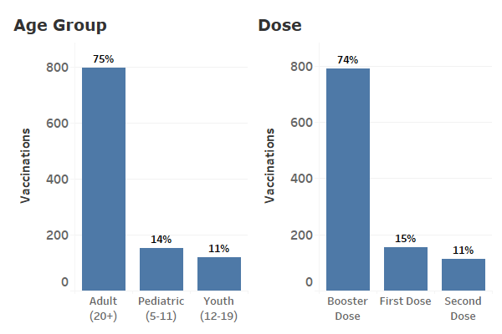
In total, 1,068 individuals, parents, and children were vaccinated that week in the VEI communities. The clinics reached individuals of all ages for primary and secondary doses and boosters.​ The majority of people who attended the clinics were people of color, and the age of participants covered the lifespan, from pediatrics to over 75. Exit surveys confirmed that the clinics offered a convenient, enjoyable way for families to get up to date on their COVID-19 vaccinations.
Figure 1: April School Vacation Week vaccinations. Vaccinations and % of vaccinations by age group (left) and dose (right) during April School Vacation week.

The April School Vacation Week clinics were a collaborative and strategic effort that resulted in vaccinations that may not otherwise have occurred.​ Positive media messages were a secondary effect of the clinics, and were more effective because they came from local, trusted sources amplified by English and Spanish media.
VEI will continue to employ models of community engagement to collaborate with vaccination providers, community-based organizations, and trusted sources to plan and host COVID-19 vaccination clinics in culturally relevant settings during the late spring and summer months.

NEWLY FUNDED ORGANIZATIONS
On April 8, the Baker-Polito Administration announced another $4.5 million in grants to support community organizations and community health centers as they continue the work to reduce barriers to vaccine access and promote vaccines and boosters for communities and populations most disproportionately impacted by COVID-19.
- To date, a total of 196 community organizations have been awarded over $51.1 million through the Vaccine Equity Initiative; this includes community- and faith-based organizations, Tribal and Indigenous People Serving Organizations, Community Health Centers, and other community-based healthcare organizations.
- The grants are the result of a major funding award from the US Centers for Disease Control and Prevention (CDC) to the Commonwealth, building on the state’s investment to increase vaccine awareness and acceptance. These funds support community organizations and community health centers to continue the work of reducing barriers to vaccine access and promoting vaccines and boosters for communities and populations most disproportionately impacted by COVID-19.
- This additional $4.5 million includes three components: Community Outreach and Education, Community Health Centers, and the Rural Vaccine Program.

Grant awardees include:
Community Outreach and Education
$1.1 million in new grants was awarded to 26 community- and faith-based organizations, including Tribal and Indigenous People-serving organizations, in partnership with Health Resources in Action (HRiA). In addition to 50 other community organizations currently funded, these organizations will provide culturally appropriate COVID-19 outreach and education and host and promote vaccine clinics for priority populations. Funded organizations will engage families and children for pediatric vaccinations and boosters. Funding levels range from $15,000 to $50,000 per organization.
- African Cultural Services, Inc.
- BRIDGE (Berkshire Resources for the Integration of Diverse Groups through Education)
- Centro de Apoyo Familiar (CAF)
- Chappaquiddick Tribe of the Wampanoag Indian Nation Corporation
- Chinese Culture Connection, Inc.
- Coalition for a Better Acre
- DEAF, Inc.
- Dwelling House of Hope, Inc.
- Extreme Kid, Inc.
- Haitian Community Partners
- Haitian Health Institute
- Leaving the Streets Ministries, Inc
- Love Your Menses
- Massachusetts Coalition for Occupational Safety & Health (MassCOSH)
- Metrowest Worker Center (Casa do Trabalhador/Casa del Trabajador)
- MOCHA
- Next Leadership Development Corporation
- Nigerian American Multi-Service Association (NAMSA)
- People Affecting Community Change (PACC Global)
- Pioneer Valley Workers Center
- South Asian Workers' Center
- Springfield Boys and Girls Club
- The Black Literacy and Arts Collaborative Project, Inc.
- UHAI for Health Inc.
- Women Encouraging Empowerment Inc.
- YMCA of Greater Boston

Community Health Centers
$3.1 million for the Massachusetts League of Community Health Centers supports 42 community health centers for critical workforce and equipment needs and outreach, education, and navigation support towards COVID-19 vaccination. This funding is in addition to $5 million being distributed to community health centers for walk-in vaccination services.
- Boston Health Care for the Homeless Program
- Bowdoin Street Health Center
- Brockton Neighborhood Health Center
- Brookside Community Health Center
- Cambridge Health Alliance
- Caring Health Center, Inc.
- Charles River Community Health Center
- Codman Square Health Center
- Community Health Center of Cape Cod
- Community Health Center of Franklin County
- Community Health Connections Family Health Center
- Community Health Programs
- The Dimock Center
- DotHouse Health
- Duffy Health Center
- East Boston Neighborhood Health Center
- Edward M. Kennedy Community Health Center (Framingham)
- Family Health Center of Worcester
- Fenway Community Health Center
- Greater Lawrence Family Health Center
- Greater New Bedford Community Health Center
- Greater Roslindale Medical and Dental Center
- Harbor Health Services Incorporated
- Harvard Street Neighborhood Health Center
- HealthFirst Family Care Center
- Hilltown Community Health Center
- Holyoke Health Center, Inc.
- Island Health Care
- Lowell Community Health Center
- Lynn Community Health Center
- Manet Community Health Center
- Mattapan Community Health Center
- North End Waterfront Health
- North Shore Community Health Center
- Outer Cape Health Services
- South Boston Community Health Center
- South Cove Community Health Center
- Southern Jamaica Plain Health Center
- Springfield Health Services for the Homeless
- SSTAR Family Healthcare Center
- Upham’s Corner Health Center
- Whittier Street Health Center

Rural Vaccine Program
Three community organizations received grants to expand the COVID-19 vaccine equity work in rural communities, in partnership with the New England Rural Health Association, funded with a total of $300,000. With the addition of these grants, the program now funds vaccine equity work serving 143 rural towns.
- Hilltown CDC
- Franklin Regional Council of Governments
- Nantucket Board of Health/ Health Imperatives/ Community Foundation for Nantucket

To date, $975,000 has been awarded to community-based organizations for this work.

VEI MUNICIPALITY VACCINATION DATA
The VEI publishes the latest vaccination data weekly on an interactive dashboard, available at the following link https://www.mass.gov/info-details/covid-19-vaccine-equity-initiative-community-specific-vaccination-data#covid-19-vaccine-equity-initiative-data-dashboard-. The data are publicly available and stratify vaccination rates across sex, age, and race/ethnicity for each of the 20 VEI municipalities, as well as statewide. A snapshot of the VEI Summary Page of the dashboard is shown in Figure2 below with vaccination data as of 5/10/2022.

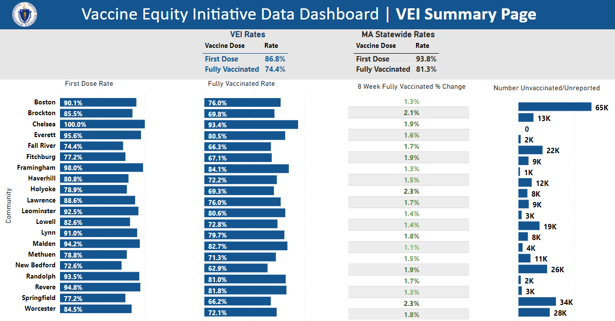
Figure 2: COVID-19 Vaccination rates for the 20 VEI Municipalities compared with MA statewide rates. Data current as of 5/10/2022.

