COVID-19 Vaccine Equity
Update to the Legislature
May 5, 2023

Statutory requirement
chapter 22 of the Acts of 2022
https://malegislature.gov/Laws/SessionLaws/Acts/2022/Chapter22
SECTION 30. Notwithstanding any general or special law to the contrary, the secretary of health and human services shall prepare and implement a detailed comprehensive COVID-19 vaccination equity plan, including interim goals, benchmarks and timelines, to significantly increase the proportion of adults and children who are fully vaccinated for COVID-19, including booster vaccinations, among communities in the commonwealth that have disproportionately low vaccination rates, which may include, but shall not be limited to, minority, immigrant and low-income communities. The goal of the plan shall be to eliminate disparities in the rates of vaccination. The plan shall include: (i) mechanisms necessary to directly deliver medically and scientifically accurate, culturally competent and linguistically diverse information about the safety and efficacy of vaccination, including particularly the COVID-19 vaccine, and the pathways to receiving a COVID-19 vaccine; (ii) a complete list of existing or new community-based partnerships for implementation of the plan, including an explanation of the role of local public health departments or boards of health, community-rooted faith-based organizations and locally-based health care providers in implementing the plan; and (iii) a budget for implementation with funding sources identified. The secretary shall provide the plan in writing to the house and senate committees on ways and means, the joint committee on COVID-19 and emergency preparedness and management and the joint committee on public health and make the plan publicly available on the website of the department of public health not later than 30 days after the effective date of this section. The secretary shall report progress towards achieving the equity plan goals by region, by municipality and statewide not less than every 60 days following the completion of the plan.

COVID-19 Vaccine Equity 60-Day Update to the Legislature

OVERVIEW
The Massachusetts Department of Public Health submitted its original Vaccine Equity Plan to the Legislature on March 15, 2022, a report that has since been updated every 60 days. This report represents the latest update to that plan, with details about our continuing efforts to increase access to and uptake of the COVID-19 vaccine.
The Vaccine Equity Initiative (VEI) is a strategic component of the Vaccine Equity Plan. VEI was established in February 2021 to work with the populations and communities hardest hit by COVID-19 to increase awareness and acceptance of the vaccine, access to vaccination locations, and vaccine administration rates. This approach is driven by community needs and is centered on equity.
By April 17, 2023, the vaccination rates in VEI communities were approaching the statewide rate, with a larger gap for booster doses received at September 1st and mainly corresponding to Bivalent boosters. As noted in previous reports, a slight lag in VEI communities often occurs when a new dose is authorized, as with the Bivalent booster.
 | At Least 1 Dose | Primary Series Complete | Boosted after 9/1/2022
VEI Communities | 87.9% | 76.1% | 21.3%
MA Statewide | 90.5% | 80.9% | 27.9%

Building on the successes it has earned over the two years since it launched, VEI continues to identify and reduce barriers, increase access, and promote awareness regarding the effectiveness and safety of COVID-19 vaccines, and now variant boosters.
PROGRAM SPOTLIGHT: GET BOOSTED VACCINATION CLINICS (Incentive Program)
From October 24, 2022, to March 31, 2023, VEI ran its Get Boosted campaign, a COVID-19 vaccination campaign that incorporated $75 gift card incentives, family-friendly community clinics, and robust communications support.
In less than six months, the Get Boosted campaign administered nearly 80,000 doses of the COVID-19 vaccine to people in priority communities, and distributed nearly 80,000 gift cards. 88% of the doses administered were boosters, and just over 5% were second doses. Another 6.5% were first doses, an encouraging finding suggesting that people who have never been vaccinated for COVID-19 may still be willing to try.
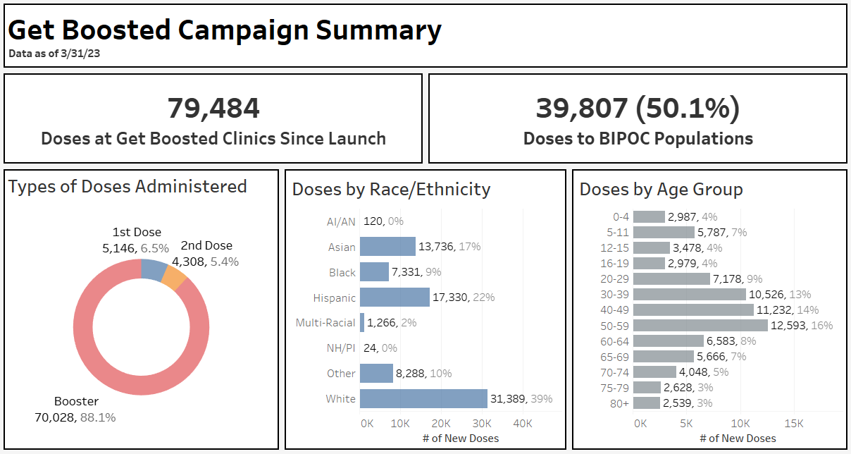
The Get Boosted campaign focused on family-friendly clinics that would appeal to multiple generations. Adults aged 30-69 received the greatest percentage of doses, with 5–11-year-olds accounting for a large proportion of pediatric doses administered. Outreach efforts have proven to be effective, with 50% of all doses administered to individuals who self-identified as BIPOC​.
Get Boosted clinics were designed to increase vaccine access and vaccination rates for Massachusetts residents in the 20 municipalities and 14 rural areas prioritized as part of the Vaccine Equity Initiative, and 10 additional municipalities with the lowest booster rates and highest BIPOC populations. These 10 additional municipalities are Amherst, Attleboro, Avon, Chicopee, Dudley, Gardner, Southbridge, Taunton, Webster, and West Springfield.

IMPACT OF THE VACCINE EQUITY INITIATIVE SINCE ITS LAUNCH
Since the COVID-19 Vaccine Equity Initiative launched in February 2021:
- Nearly 1.9 million residents in the VEI communities have been vaccinated with a first dose, closing a 6 percentage point gap in vaccination rates between the VEI and non-VEI communities in March of 2021 by half to a 3 percentage point gap in February 2023.
- Since vaccines became available to most age groups in May 2021, VEI communities have increased their fully vaccinated population by 127.1%, outpacing non-VEI communities at 99.7% (Graph 1).
- All 20 VEI communities made strides in fully vaccinated rates: the VEI municipalities fully vaccinated over 1.6 million residents. The VEI communities have increased the fully vaccinated rates in their BIPOC communities by ~32 percentage points from May 2021 through December 2022, an increase of 216% (Graph 2).
- Through VEI, DPH awarded $62.8M to 198 community organizations and over $4.7M to prioritized municipalities and local boards of health for vaccine access, education, and outreach and to help build local health capacity.

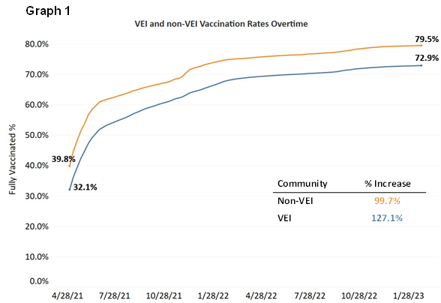

Graph 2
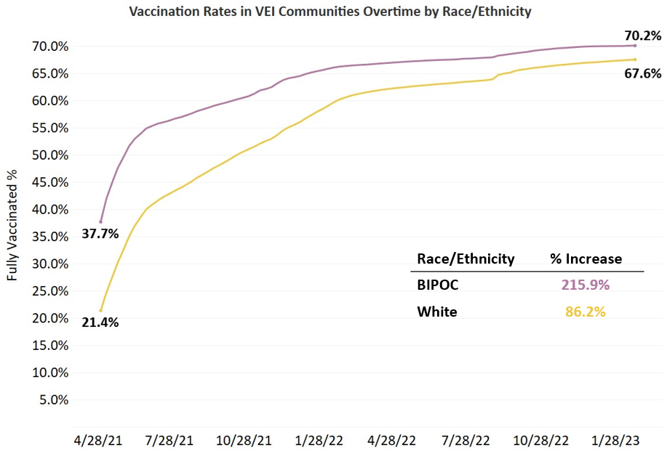

VEI MUNICIPALITY VACCINATION DATA
The Vaccine Equity Initiative publishes the latest vaccination data weekly on an interactive dashboard, available at https://www.mass.gov/info-details/covid-19-vaccine-equity-initiative-community-specific-vaccination-data#covid-19-vaccine-equity-initiative-data-dashboard-. The data are publicly available and stratify vaccination rates across sex, age, and race/ethnicity for each of the 20 VEI communities, as well as statewide. Monthly highlights of VEI community efforts can be seen at https://www.mass.gov/info-details/covid-19-vaccine-equity-initiative-highlights.

MOVING FORWARD
As the Get Boosted campaign ended on March 31, DPH ensured that opportunities for community-based clinics would continue as needed into the spring and summer. DPH Mobile and the Vaccine Access and Administration (VAA) program continue to provide clinics in collaboration with community partners, and DPH’s in-home vaccination program continues to provide services. Gift cards of $25 are available to use at clinics as incentives. To support these efforts and to build vaccine confidence, VEI is providing communications support.
VEI continues to communicate new information and guidelines about the vaccine to its communities, including new guidance issued by the CDC around bivalent doses. As such, preparations are underway to continue to support community partners with sharing new guidelines, building vaccine confidence and increasing the number of people protected from COVID-19 in VEI’s priority communities.

