COVID-19 Vaccine Equity
Update to the Legislature
November 15, 2023

Statutory requirement
chapter 22 of the Acts of 2022
https://malegislature.gov/Laws/SessionLaws/Acts/2022/Chapter22
SECTION 30. Notwithstanding any general or special law to the contrary, the secretary of health and human services shall prepare and implement a detailed comprehensive COVID-19 vaccination equity plan, including interim goals, benchmarks and timelines, to significantly increase the proportion of adults and children who are fully vaccinated for COVID-19, including booster vaccinations, among communities in the commonwealth that have disproportionately low vaccination rates, which may include, but shall not be limited to, minority, immigrant and low-income communities. The goal of the plan shall be to eliminate disparities in the rates of vaccination. The plan shall include: (i) mechanisms necessary to directly deliver medically and scientifically accurate, culturally competent and linguistically diverse information about the safety and efficacy of vaccination, including particularly the COVID-19 vaccine, and the pathways to receiving a COVID-19 vaccine; (ii) a complete list of existing or new community-based partnerships for implementation of the plan, including an explanation of the role of local public health departments or boards of health, community-rooted faith-based organizations and locally-based health care providers in implementing the plan; and (iii) a budget for implementation with funding sources identified. The secretary shall provide the plan in writing to the house and senate committees on ways and means, the joint committee on COVID-19 and emergency preparedness and management and the joint committee on public health and make the plan publicly available on the website of the department of public health not later than 30 days after the effective date of this section. The secretary shall report progress towards achieving the equity plan goals by region, by municipality and statewide not less than every 60 days following the completion of the plan.

COVID-19 Vaccine Equity 60-Day Update to the Legislature

OVERVIEW
The Massachusetts Department of Public Health submitted its original Vaccine Equity Plan to the Legislature on March 15, 2022, a report that has since been updated every 60 days. This report represents the latest update to that plan, with details about our continuing efforts to increase access to and uptake of the COVID-19 vaccine.
The Vaccine Equity Initiative (VEI) is a strategic component of the Vaccine Equity Plan. VEI was established in February 2021 to work with the populations and communities hardest hit by COVID-19 to increase awareness and acceptance of the vaccine, access to vaccination locations, and vaccine administration rates. This approach is driven by community needs and is centered on equity.
By June 19, 2023, the vaccination rates in VEI communities were approaching the statewide rate, with a larger gap for booster doses received at September 1st and mainly corresponding to Bivalent boosters. As noted in previous reports, a slight lag in VEI communities often occurs when a new dose is authorized, as with the Bivalent booster.
 | At Least 1 Dose | Primary Series Complete | Boosted after 9/1/2022
VEI Communities | 86% | 81% | 29%
MA Statewide | 88% | 86% | 35%

VEI is building on the successes it has earned over the two years since it launched by evolving its programs and processes to align them with COVID-19’s endemic phase. As it gears up for the release of a new vaccine dose in the fall, VEI continues to identify and reduce barriers, increase access, and promote awareness regarding the effectiveness and safety of COVID-19 vaccines.
PROGRAM SPOTLIGHT: COMMUNITY HEALTH EQUITY INITIATIVE
The Vaccine Equity Initiative’s Community Health Equity Initiative is using a new survey to collect input from residents across Massachusetts on the challenges communities face and where resources should be directed. Community Health Equity Initiative staff partnered with residents and community organizations across the state to design the new Community Health Equity Survey (CHES).
The CHES survey’s innovation is that it examines the root causes of health outcomes to identify community strengths, gaps, health needs, concerns, and inequities to guide public health policy and practice and inform more equitable responses to public health crises. DPH and its community partners will use the survey findings to build on the state’s efforts to provide access to social and economic opportunities that keep people healthy, like affordable housing, reliable transportation, and nutritious, affordable food.
Residents are asked to answer questions on topics such as:
- Access to basic needs, like health care and transportation
- Physical and mental health and wellbeing
- Experiences with COVID-19
- Experiences with housing, education, and work
- Demographic information, such as age, gender, and race.
In Fall 2020, DPH conducted the COVID-19 Community Impact Survey (CCIS), a precursor to the CHES. With over 36,000 responses from Massachusetts residents, the CCIS helped to identify and fill important gaps in public health data and surveillance systems and helped to promote and normalize the use of data standards and racial justice framing across DPH, other state agencies, and community partners. Survey results are accessible to the public through the COVID-19 Community Impact Survey Data Dashboard.

Data spurs action
Both the 2020 CCIS survey and the new Community Health Equity Survey ask questions in a way that inform solutions, and DPH works to ensure that the data is shared, accessible, and is usable at the community level.
Informing program priorities and resource deployment is one of the ways DPH and its partners have used CCIS data.
- The WIC program used CCIS data to prioritize and improve outreach to key populations, including LGBTQ+ families and families who speak languages other than English.
- Using data on young parents from CCIS, The Massachusetts Pregnant & Parenting Team Initiative prioritized providing housing/rent/utility assistance.
- The Mystic Valley Public Health Coalition used data on substance use to prioritize resource deployment.

CCIS data was also used by partners to secure funding to address community needs, bringing new resources to underserved populations.
- Tribal and Indigenous People Serving Organizations and rural health-focused organizations used CCIS results in their applications for COVID Community Grant funding, which resulted in over 2 million dollars of funding.
- The Alliance for Digital Equity in Western Mass used CCIS data to identify populations that most frequently reported barriers to accessing needed technology resources. They were able to successfully acquire a $5.1 million regional partnership grant from the Massachusetts Broadband Institute to support digital equity efforts in the region.
DPH and its partners will also use CHES data to improve programs, make decisions about funding and resources, and support policies to improve health inequities. The results from the new survey will be shared inside DPH and will be made available to the public and to community-based organizations so they can use the findings to better serve community needs.

Community outreach ensures representation
DPH is using a variety of communications strategies to encourage a broad range of Commonwealth residents to participate, intentionally reaching out to people and communities often disproportionately affected by health emergencies. Community partners have been important allies in this work, encouraging participation through flyers, social media, and conversations. An online toolkit provides social media posts, newsletter templates, flyers, and other materials to help partners spread the word about the survey.
The survey opened on July 31, 2023 and will be available through early fall 2023. It takes most people 15 to 25 minutes to complete and is available in 11 languages: Arabic, Cape Verdean Creole, Chinese (simplified), Chinese traditional, English, Haitian Creole, Khmer, Portuguese, Russian, Spanish, and Vietnamese. The survey will also be available in American Sign Language.
To participate in this online survey, Massachusetts residents should visit https://www.mass.gov/HealthSurvey.

IMPACT OF THE VACCINE EQUITY INITIATIVE SINCE ITS LAUNCH
Since the COVID-19 Vaccine Equity Initiative launched in February 2021:
- Nearly 1.9 million residents in the VEI communities have been vaccinated with a first dose, closing a 6 percentage point gap in vaccination rates between the VEI and non-VEI communities in March of 2021 by half to a 3 percentage point gap in September 2023.
- Since vaccines became available to most age groups in May 2021, VEI communities have increased the number of their population with a complete primary series by 107%, outpacing non-VEI communities at 76% (Graph 1).
- The bivalent booster vaccines became available to most age groups in September 2022, VEI communities have increased the number of their population with boosters after 9/1/2022 by 29%, while the non-VEI communities are at 39% (Graph 2).
- All 20 VEI communities made strides in primary series complete: the VEI municipalities vaccinated over 1.8 million residents in completed series. The VEI communities have increased the completed series rates in their BIPOC communities by ~46 percentage points from September 2022 through August 2023, which was 150% increase (Graph 4).
- All 20 VEI communities made strides in booster rates: the VEI municipalities vaccinated over 600,000 residents with boosters. The VEI communities have increased the booster rates in their BIPOC communities by ~29 percentage points from September 2022 through August 2023 (Graph 4).
- Through VEI, DPH awarded $62.8M to 198 community organizations and over $4.7M to prioritized municipalities and local boards of health for vaccine access, education, and outreach and to help build local health capacity.
Graph 1
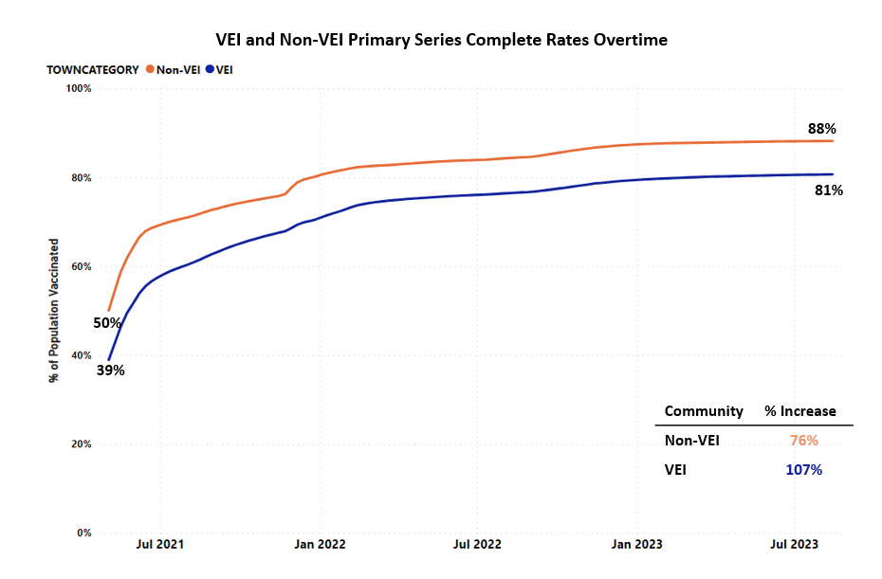
Graph 2
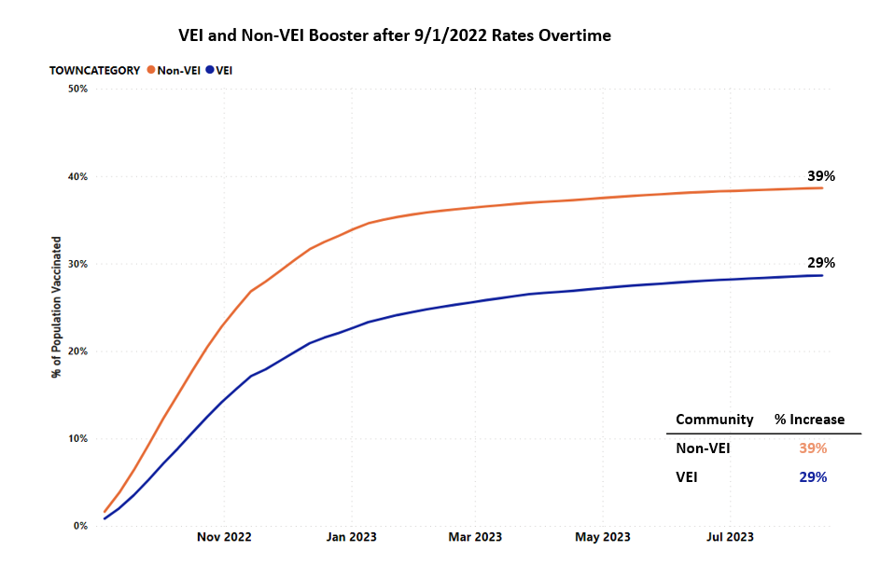

Graph 3
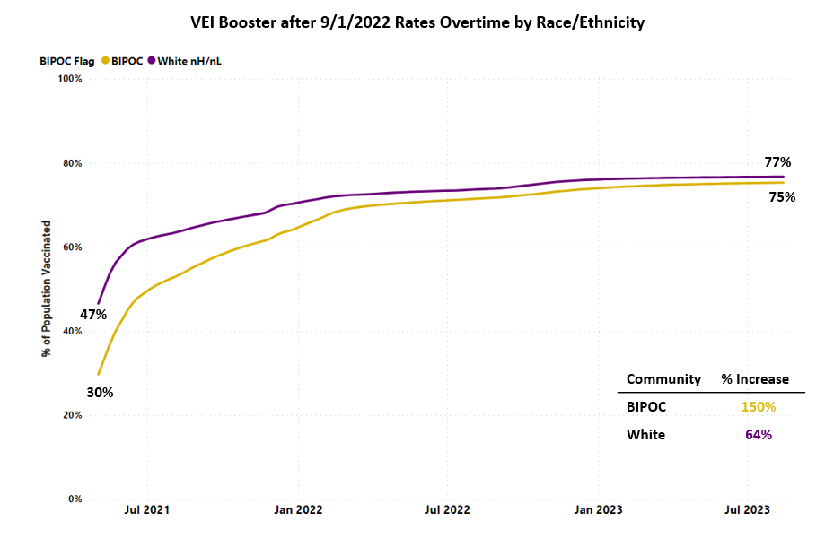
Graph 4

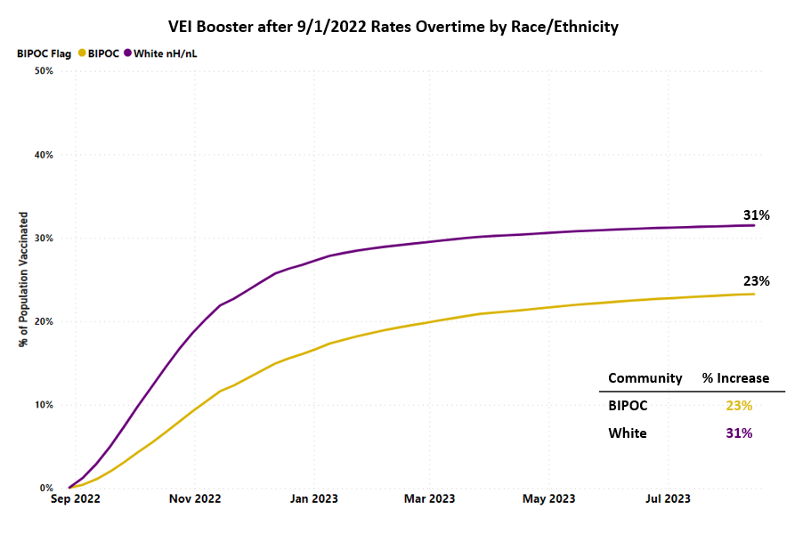

VEI MUNICIPALITY VACCINATION DATA
The Vaccine Equity Initiative publishes the latest vaccination data weekly on an interactive dashboard, available at https://www.mass.gov/info-details/covid-19-vaccine-equity-initiative-community-specific-vaccination-data#covid-19-vaccine-equity-initiative-data-dashboard-. The data are publicly available and stratify vaccination rates across sex, age, and race/ethnicity for each of the 20 VEI communities, as well as statewide. Monthly highlights of VEI community efforts can be seen at https://www.mass.gov/info-details/covid-19-vaccine-equity-initiative-highlights.

MOVING FORWARD
DPH continues to ensure that opportunities for education and community-based clinics continue as needed through the fall and into the winter, as the updated vaccine becomes available. DPH Mobile and the Vaccine Access and Administration (VAA) program continue to provide clinics in collaboration with community partners, and DPH’s in-home vaccination program continues to provide services. DPH is also educating providers, partners, and the public about the availability of the Bridge Access Program to provide vaccines to adults who are uninsured or underinsured. To bolster these efforts and to build vaccine confidence, VEI is providing communications support.
VEI continues to communicate new information and guidelines about the vaccine to its communities, including new guidance issued by the CDC around updated doses. As such, VEI continues to support community partners with sharing new guidelines, building vaccine confidence and increasing the number of people protected from COVID-19 in VEI’s priority communities.

