COVID-19 Vaccine Equity
Update to the Legislature
September 9, 2022

Statutory requirement
chapter 22 of the Acts of 2022
https://malegislature.gov/Laws/SessionLaws/Acts/2022/Chapter22
SECTION 30. Notwithstanding any general or special law to the contrary, the secretary of health and human services shall prepare and implement a detailed comprehensive COVID-19 vaccination equity plan, including interim goals, benchmarks and timelines, to significantly increase the proportion of adults and children who are fully vaccinated for COVID-19, including booster vaccinations, among communities in the commonwealth that have disproportionately low vaccination rates, which may include, but shall not be limited to, minority, immigrant and low-income communities. The goal of the plan shall be to eliminate disparities in the rates of vaccination. The plan shall include: (i) mechanisms necessary to directly deliver medically and scientifically accurate, culturally competent and linguistically diverse information about the safety and efficacy of vaccination, including particularly the COVID-19 vaccine, and the pathways to receiving a COVID-19 vaccine; (ii) a complete list of existing or new community-based partnerships for implementation of the plan, including an explanation of the role of local public health departments or boards of health, community-rooted faith-based organizations and locally-based health care providers in implementing the plan; and (iii) a budget for implementation with funding sources identified. The secretary shall provide the plan in writing to the house and senate committees on ways and means, the joint committee on COVID-19 and emergency preparedness and management and the joint committee on public health and make the plan publicly available on the website of the department of public health not later than 30 days after the effective date of this section. The secretary shall report progress towards achieving the equity plan goals by region, by municipality and statewide not less than every 60 days following the completion of the plan.

COVID-19 Vaccine Equity 60-Day Update to the Legislature

OVERVIEW
As has been the case from the early days of the vaccine rollout, every dose counts. Massachusetts continues to increase access to and uptake of COVID-19 vaccine across the Commonwealth. The Massachusetts Department of Public Health submitted its Vaccine Equity Plan to the Legislature on March 15, 2022. This report represents an update to that plan. In the 60 days since the last report on July 12, 2022:
- 12 of the 20 VEI communities have met or exceeded the statewide average in percent change in new fully vaccinated individuals over the past 60 days.
- First dose rates in the equity municipalities increased by 0.65 percentage point to 82.8%, while fully vaccinated rates increased 0.5 percentage points to 70.7%.
- First dose pediatric (ages 5-11) vaccinations increased by 1.6 percentage points to 48.5%.
- Fully vaccinated pediatric rates increased 1.2 percentage point to 38.8%.
In the past year (August 2021 – August 2022):
- Fully vaccinated rates have increased 28.5% in VEI communities, compared to 22% in non-VEI communities.
- Individuals identifying as multiple races/ethnicities, Hispanic/Latinx, and Black have seen the greatest increase in fully vaccinated rates at 84%, 54%, and 46% respectively.
- Lawrence, Springfield, Brockton, and New Bedford have seen the greatest increase in fully vaccinated residents, increasing 43%, 42%, 42%, and 40% respectively.
*Data Note: Population estimates were updated to reflect the latest population estimates based on the 2020 census. Thus, overall vaccination numbers in this report should not be compared with previous reports that used older population estimates.

Our commitment to ensuring vaccine access in the Commonwealth is yielding positive results. In a recent Lancet study, Massachusetts’ high levels of immunity due to COVID-19 vaccination have helped Massachusetts residents avoid “excess mortality,” or deaths, during two surges in the pandemic (late February 2021 – June 2021 and late February 2022 – June 2022).
Utilizing data from national organizations, including the Kaiser Family Foundation and the Commonwealth Fund, by any objective measure, Massachusetts is a national leader in vaccination rates with over 84.5 percent of residents over 5 fully vaccinated and over half of adults boosted. Massachusetts has some of the highest vaccination rates in the nation for each racial demographic. We rank 3rd in the US for the percentage of Black residents vaccinated (85%) and tied for 3rd for the percentage of Hispanic residents vaccinated (82%). (This is the most recent Kaiser Family Foundation data (July 2022); compared to White residents at 88% vaccinated).
We must build on these successes and continue to lean in to identify and reduce barriers, increase access, and promote awareness regarding the effectiveness and safety of COVID-19 vaccines and boosters.

PROGRAM SPOTLIGHT: BACK-TO-SCHOOL CLINICS
To provide access and encourage parents and caregivers to vaccinate their families before going back to school, VEI is supporting 480+ family-friendly clinics and 21 vaccination clinics with the Summer Eats Program across the Commonwealth throughout the summer, including in rural areas.
Based on recent research regarding vaccine hesitancy, VEI has updated communications about vaccination reducing the risk of children missing school or daycare, or caregivers missing work to care for children. This messaging has been reinforced on a back-to-school website with a searchable list of clinics; a back-to-school flyer in 12 languages; direct mailing of information in English and Spanish to 150,000 families who receive DTA benefits; a flyer for teachers, staff, and early childhood educators; paid social media ads; and texts from DTA to its clients in six languages.

RESEARCH SPOTLIGHT: PILOT PROGRAM TO ASSESS INCENTIVE EFFECTIVENESS
VEI launched a pilot program using state funding to evaluate the effectiveness of financial incentives in encouraging first doses. Starting in June 2022, select clinics from Everett, Lowell, Malden, Methuen/Lawrence, Springfield, Fall River, and New Bedford participated in the pilot to study the effectiveness of $25 gift cards compared to $100 gift cards for first doses. The selected clinics were active in May and June thus allowing for a standardized comparison between the same clinics to evaluate the effect of increasing incentive value on first dose vaccinations. Vaccination rates for May ($25 incentive) and June ($100 incentive) were compared.
In addition to the pilot study conducted to determine the impact of using $100 gift cards at specific clinic sites, VEI also implemented a motivations survey in five languages to gather insight into motivations for all individuals receiving vaccines at the clinics. This allowed VEI to not only assess the impact of the increased incentive but to place it in context of a broader understanding of vaccine motivation.
During the pilot in May and June, first dose vaccinations tripled, with the largest increases among Hispanic/Latinx populations and children ages 5-11. Accessibility was an important factor in vaccination; the top three motivators were that the location was easy to get to (53%), the time was convenient (38%), and trust in the sponsoring organization (18%).
The results indicate that the increases in first dose vaccines in June were greater, and are, in part, attributed to the $100 gift card incentive. Therefore, VEI plans to continue its $100 incentive initiative for priority populations.

VEI MUNICIPALITY VACCINATION DATA
The VEI publishes the latest vaccination data weekly on an interactive dashboard, available at the following link https://www.mass.gov/info-details/covid-19-vaccine-equity-initiative-community-specific-vaccination-data#covid-19-vaccine-equity-initiative-data-dashboard-. The data are publicly available and stratify vaccination rates across sex, age, and race/ethnicity for each of the 20 VEI municipalities, as well as statewide. A snapshot of the VEI Summary Page of the dashboard is shown in Figure 1 below with vaccination data as of 9/5/2022.
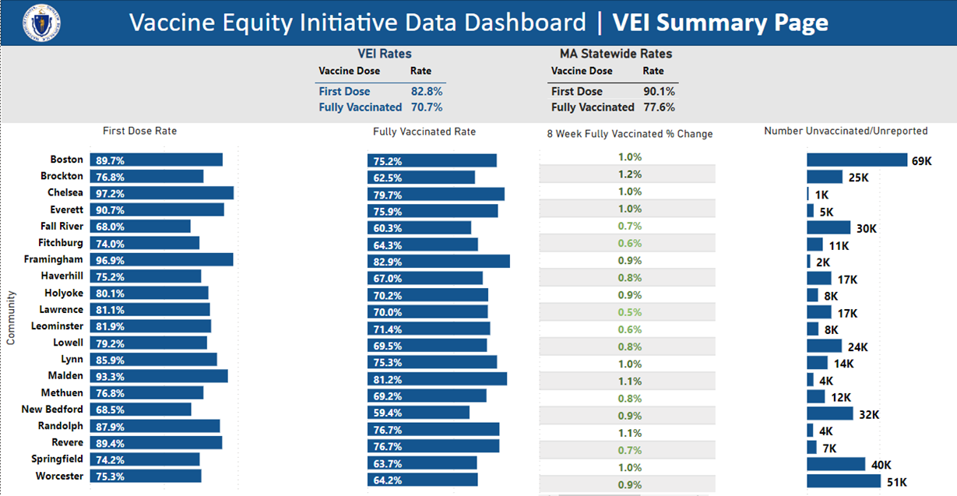
Figure 1: COVID-19 Vaccination rates for the 20 VEI Municipalities compared with MA statewide rates. Data current as of 9/5/2022.

