Overview

Since December 2020, the Massachusetts Department of Public Health has worked with COVID-19 vaccination providers to efficiently allocate an extremely limited supply of vaccine. As of early May, more than 70% of Massachusetts adults have received at least one dose of the COVID vaccine. As supply is now more widely available, providers will be able to order vaccine directly from the MIIS as needed, within certain limits. Primary care providers (PCPs) and community health centers (CHCs) must administer requested vaccine within 4 weeks of receipt; all other providers must administer within 10 days. All providers must deplete existing inventory before an additional order will be approved. This direct ordering process will allow providers more flexibility in identifying their vaccine needs and in planning their order timing. Moving forward, all new providers receiving vaccine will use this direct ordering process. Existing providers will be transitioned to this new process within the next couple weeks.

Providers ordering directly through the MIIS will have a ceiling limit for each vaccine formulation within which they can order vaccine. Each week, this amount will be increased by a constant weekly allocation to allow providers to order more doses.

PCPs and CHCs must administer vaccine within 4 weeks of receipt; all other providers must administer vaccine within 10 days of receipt. Providers whose inventory on-hand exceeds 50% of their weekly allocation amount will not be able to order additional vaccine.

Ordering Process

Detailed instructions for placing orders through the MIIS can be found at the MIIS Resource Center.

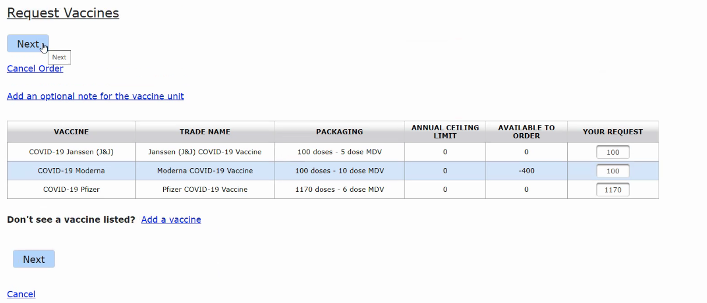

Certain fields will be visible in the ordering window:
- Vaccine: Product type (e.g., COVID-19 Moderna)
- Trade Name: Trade name of the vaccine (e.g., Moderna COVID-19 Vaccine)
- Packaging: Additional detail on the way the product is packaged (e.g., 100 doses – 10 dose MDV). Vaccine must be ordered in multiples of the package size.
- Ceiling Limit: The cumulative ceiling limit that providers have been allocated for each NDC since the beginning of COVID-19 vaccine distribution. Each week, this amount will be increased to ensure you have access to your constant weekly allocation to allow providers to order more doses.
  - Example: A site’s constant weekly allocation is 1,000 doses per week. On Week 1, the site uses 900 of the 1,000 doses that were allocated. On Week 2, the site’s cumulative ceiling limit is increased to 1,900. After subtracting the 900 doses that have already been shipped to date, the site has 1,000 doses available to order.
- Available to Order: Maximum number of doses providers can order. This is the difference between the “Ceiling Limit” and the number of doses that have been shipped since the beginning of COVID-19 vaccine distribution. If a provider orders more than what is available, a soft warning is presented to the user – the user is still able to submit the order, but it may be rejected or deferred by the Vaccine Unit.
- Your Request: Provider can order vaccines in multiples of the package size as described in the “Packaging” field.

If provider has a specific request or needs more vaccine, they should select the hyperlink “Optional Note for the Vaccine Unit” and leave an explanation. In rare cases where a provider can administer more than their weekly allocation, providers should include a note explaining the need in the order to request an increase to their ceiling limit.

Providers should ensure that their shipping contacts and hours of operation are up to date. If the shipping information is incorrect, the user should contact the Vaccine Unit before submitting the order.

Order Approvals

Orders are reviewed by the Vaccine Unit every business day, and if approved, are transmitted to CDC within one business day. The Vaccine Unit will reach out to the site’s Primary and Back-up Vaccine Coordinator if there are any questions about the order.

The Primary and Back-up Vaccine Coordinator will receive an email confirmation once the order is approved. If any changes are needed, the site must contact the Vaccine Unit prior to transmission to CDC. Once orders have been transmitted, they cannot be modified or cancelled.

Shipments and Deliveries

Once an order is submitted, the user can check the status of the order in the “Orders” section of the Vaccines module.
- Submitted to State: Order has been submitted by user
- Accepted by State: Order has been approved by the Vaccine Unit
- Pending CDC Approval: Order has been transmitted to CDC
- Partial Shipment Received: Some of the order has shipped, tracking numbers for shipped items are available
- Full Shipment Received: Full order has shipped, tracking numbers for all items are available

Once the order is packaged, McKesson and/or Pfizer will send the Primary Vaccine Coordinator an email with tracking number.

Providers will receive an email confirming vaccine order within one business day of submitting an order. Moderna and Janssen vaccine will ship within 72 hours of approval. Pfizer vaccine will ship within 96 hours of approval. Ancillary kits may arrive before vaccine. If a provider has order full trays of Pfizer vaccine, then they will receive a dry ice kit within 24 hours of vaccine shipment.

UPS/FedEx should hand vaccines directly to a person. If there is an issue with the delivery of vaccines or ancillary kits, it must be reported immediately to the carrier, Vaccine Unit and McKesson.

Additional Resources

How often can I order?
There is no limit to how often a site can order. However, if a site places additional orders prior to receiving shipments, their order will be cancelled unless the user includes a note explaining the reason for the need to the Vaccine Unit.

Who can order?
Sites with a completed MCVP agreement may order vaccine. Users must have access to the Vaccines module to submit an order.

Why is no one at my site able to order vaccine?
Contact the MIIS Help Desk about user access/roles.

How can I correct my inventory amount in the MIIS?
This tool can help troubleshoot your inventory issues.

Immunization Division Important Contacts

Vaccine Unit – Processing of orders and storage and handling issues. Provider should contact the Vaccine Unit for questions about orders and the “Vaccines” module in the MIIS.
- Phone: 617-983-6828
- Email: DPH-Vaccine-Management@massmail.state.ma.us

MIIS Help Desk – User access, roles and permissions, and immunization reporting.
- Email: MIISHelpdesk@mass.gov

